Exercise 5. Processing Schematic Networks in ArcGIS
GIS in Water Resources
Fall 2011

Prepared by Tim Whiteaker, David Maidment and Alison Wood

Table of Contents
Introduction 1
Goals of the Exercise 1
Computer Requirements 2
Installing the Tutorial Data and Schematic Processor 2
Running the Tools 3
Assigning Processing Order 4
Processing the Network 5
Acknowledgements 9
References 9

Introduction
Geographic features and the relationships between them can be represented as an interconnected schematic network of links and nodes. Schematic networks can be created in a Geographic Information System (GIS) using tools such as the Arc Hydro Tools. Not just limited to a pretty display, these schematic links and nodes have the potential to serve as the elements at which processes occur in a simulation of some phenomenon. The Schematic Processor unlocks this potential.

The Schematic Processor is a set of ArcGIS (version 10) geoprocessing script tools for processing Arc Hydro schematic networks. The tools give you the ability to associate behavior with schematic features. For example, if you are simulating the movement of bacteria through a stream network, the schematic processor can decay the bacteria as they move along schematic links representing stream segments (Figure 1).
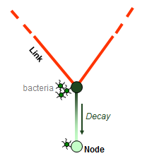
Figure 1 Bacteria decay as they move down the stream network

The behaviors assigned to schematic features are implemented with snippets of Python code called processing ops. A few ops for handling tasks such as simple accumulation of values downstream and first order decay are included with the Schematic Processor. You can also write your own ops to simulate whatever behavior is desired.

In this exercise, you will use the schematic processor to simulate the movement of bacteria from subwatersheds through the stream network and finally to the outlet of a watershed.

Goals of the Exercise
This exercise seeks to introduce you to the Schematic Processor. After completing the workshop, you should be able to:
- Understand the conceptual framework behind the Schematic Processor.
- Understand the requirements that a schematic network must meet in order to be compatible with the Schematic Processor.
- Apply the Schematic Processor to a schematic network in ArcGIS using ArcToolbox.

Computer Requirements
The Schematic Processor requires ArcGIS 10. An internet connection is required to download the Schematic Processor files and tutorial data.

Installation of the Schematic Processor is part of the exercise procedure and does not require administrator privileges.

A tutorial ArcMap document and geodatabase are available on the course website.

Installing the Tutorial Data and Schematic Processor
To download the tutorial data:
- Navigate to the course website.
- Download Ex5Data.zip, http://www.ce.utexas.edu/prof/maidment/giswr2011/Ex5/Ex5Data.zip , which includes an ArcMap document and geodatabase.
- Unzip all file contents to a convenient place on your computer.
- Open Ex5.mxd. If you see an error message about not having a VBA license, click OK and ArcMap should continue to open.
Installing the Schematic Processor involves downloading the files to your computer and adding the toolbox to ArcGIS. No administrator privileges are required.

To install the Schematic Processor:
- Navigate to http://tools.crwr.utexas.edu/.
- Click the link for Schematic Processor.
- Click the DOWNLOAD link.
- Save the zip file to your computer.
- Unzip all contents of the zip file to a convenient location on your computer, such as your desktop.
- Open the SchematicProcessor folder on your desktop, or wherever you unzipped the file contents.
In this folder you will find documentation, sample data, and the tools themselves.
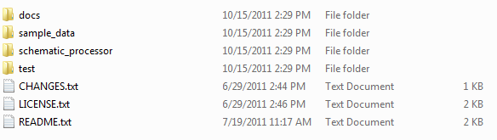
Figure 2 Contents of SchematicProcessor folder
- In ArcMap where you have opened Ex5.mxd, if ArcToolbox isn’t visible, then click the ArcToolbox window button .
- If you don’t see a toolbox called Schematic Processor Tools, then:
  - Right-click in the ArcToolbox window and click Add Toolbox.
  - Navigate to the SchematicProcess\schematic_processor folder and open Schematic Processor Tools.tbx. Remember to “Connect to Folder” if necessary to reach the correct folder.
The Schematic Processor Tools toolbox should now be visible in ArcMap (Figure 3).
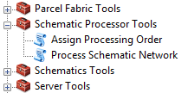
Figure 3 Schematic Processor Tools toolbox

Running the Tools
In the ArcMap document that you opened, you can see a simple schematic network connecting subwatersheds and streams. The green subwatershed nodes are located at subwatershed centroids, and they are connected to nodes at the subwatershed outlets via the green dashed links. The red stream nodes are located at the endpoints of stream segments, while the blue links connect the stream nodes. This schematic network was created using the Arc Hydro Tools.

Suppose that runoff from subwatersheds brings bacteria to the stream network. The bacteria decays as it travels along stream segments before finally reaching the stream network outlet. In a real case study, one would estimate the amount of bacterial loading contributed by subwatersheds based on parameters such as land use, animal populations, and presence of septic tanks. In this example, these numbers have already been tallied for you. Let’s take a closer look at these GIS features.

Get to know the data:
- Open the attribute table for the Subwatershed layer.
You can see that each subwatershed feature has been attributed with its area and an estimate of the number of coliform forming units (CFU) per year from a variety of bacteria sources such as cattle. The field called Total_CFU_yr stores the sum of all bacterial loads for a given watershed. And like all Arc Hydro features, the HydroID field serves as a unique identifier for each feature in this layer.
- Open the attribute table for the Node layer.
The nodes have a HydroID so that they are uniquely identified, and they also have a FeatureID that points to the HydroID of the feature that they represent. Some of these FeatureIDs point to subwatersheds, while others point to stream network junction features (not shown in this map). The SrcType field indicates the type of feature which the node represents (subwatersheds vs. stream junctions). All of these fields were populated automatically by the Arc Hydro Tools.

The remaining fields are directly related to the Schematic Processor. They include:
- IncVal – Incremental value that a feature contributes to the network. Subwatersheds contribute bacteria and have a large value in this field. These values were copied from the Total_CFU_yr field in the subwatershed layer. Stream junctions do not contribute bacteria themselves and thus store a value of zero in this field.
- TotVal – Total value for a feature including all values received from upstream features and the current feature’s incremental value. This value is zero because the network has not yet been processed.
- PassVal – Value that a feature passes to the next downstream feature in the network. This value is zero because the network has not yet been processed.
- SortOrder – Indicates the order (ascending) in which features in the schematic network should be processed. You can assign this field manually, or a Schematic Processor tool can do it for you.
3. Open the attribute table for the Link layer.

In the Link attribute table you’ll see many of the same schematic network fields as described above. Also notice DecayConst and TravelTime fields (in units of 1/year and year, respectively). One of the processing ops that you’ll use in this exercise expects those attributes to be present on the Link layer. They are used in the first-order decay calculation.
Tip
You can add as many fields to schematic network features as needed to support your analysis.

4. Close the attribute tables.

As you run the Schematic Processor, you will expect the incremental values from subwatershed nodes to make it into the stream network and travel downstream, with the resulting load values showing up in the TotVal and PassVal fields. Before you can process the network, the Schematic Processor needs to know in what order features should be processed. The Assign Processing Order tool can compute the sort order for you based on FromNodeID and ToNodeID fields on schematic features.

Assigning Processing Order
The schematic processor processes features from upstream to downstream. Once a schematic network has been created, you typically only need to determine this processing order once. The Assign Processing Order tool handles this task and writes results to the SortOrder field in the link and node feature classes.

To assign processing order:
- In the Schematic Processor Tools toolbox, double-click Assign Processing Order to run that tool. Click Show Help in the tool dialog if you want to see help for the tool and its inputs.
- Select Link as the link features and Node as the node features by dragging them from the table of contents and dropping them into the appropriate fields in the dialogue box (Figure 4).
Figure 4 “Link” and “Node” entered in the Assign Processing Order tool
- Click OK to run the tool.
- Close the tool progress dialog when the tool is finished.
The features in the map are labeled according to their processing order. You can now see that upstream features are to be processed before downstream features receive data from them.

Now you are ready to process the network.

To be turned in: How many Subwatersheds are there in the study? Prepare a table that lists COMID’s and the HydroID’s of the Subwatersheds in the study and alongside each one the HydroID and FeatureID of the node that represents that Subwatershed in the Schematic Processor. How are the Subwatersheds and Nodes related? What kind of Node represents a Subwatershed? What do the other Nodes represent? How many Links are there? What do the Links represent? How are the Links and Nodes connected?

Processing the Network
Recall that, in this example, subwatershed nodes use the IncVal attribute to store the amount of bacterial load that they contribute. In this portion of the exercise, you will process the network to simulate the accumulation of bacterial loads from upstream to downstream, taking into account bacterial (first-order) decay along the stream segments.

Because simple accumulation of values (i.e., add them up and pass them downstream) is such a common task, this is the default behavior that the Schematic Processor applies to features. This will suffice for most of the interactions between schematic features in this example. The only exception is that you’ll specify the decay processing op to handle decay along the stream segments as they pass loads to the next downstream feature.

To process the network:
- Double-click Process Schematic Network to run that tool.
- Select Link as the link features by dragging and dropping. Then select the IncVal, TotVal, and PassVal attributes from the Link layer as the “Link Incremental Value Field”, “Link Total Value Field”, and “Link Passed Value Field”, respectively (from the drop-down menus).
- Select Node as the node features (drag and drop). Then select the IncVal, TotVal, and PassVal attributes from the node layer (from drop-down menus, Figure 5).
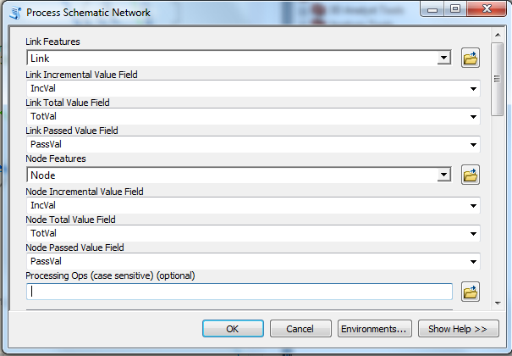
Figure 5 Setting layers and fields in the Process Schematic Network tool

Now you will tell the Schematic Processor which processing ops to use. You only need to specify a decay op for this example.
- For processing ops, type decay (case sensitive!) and click the plus sign to add decay to the list of processing ops. Each op must be associated with a source type, feature type, and behavior type, so you’ll specify those items next.
- For source types, type 2 and click the plus sign. (Figure 6)
- For feature types, type LINK and click the plus sign.
- For behavior types, type PASS and click the plus sign. (Figure 7)
Tip
If you’d like to learn how to write your own processing ops, please see the tutorial on the Schematic Processor page at http://tools.crwr.utexas.edu.

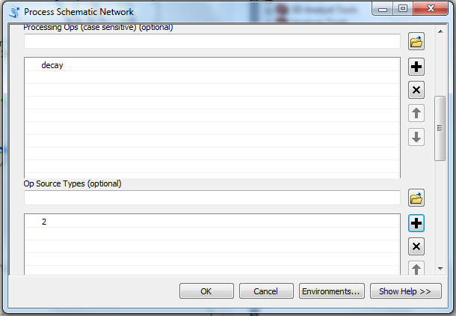
Figure 6 Setting Op name and source type
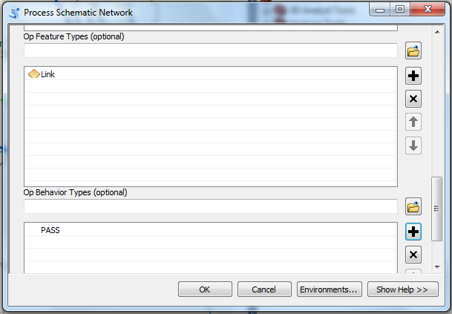
Figure 7 Setting feature type and behavior type
- Click OK to run the tool.
- Close the tool progress dialog when the tool is finished.
The labels on stream links should now indicate total and passed values of bacterial load (you may need to zoom in to see the labels – even if some are visible in this view, others may not be) (Figure 8 and Figure 9). You can use the Identify tool to check out the total value at the basin outlet.

To be turned in: Make an analysis of the most downstream subwatershed draining to the Outlet. What is the annual bacterial loading (CFU/yr) that drains into the subwatershed from upstream? What percentage of that load is lost by decay as it flows through the subwatershed? Show that this amount of load reduction is what would be expected by the exponential decay formula applied to bacterial decay in the stream. What bacterial load(CFU/yr) is contributed directly to the Outlet from the local subwatershed? What is the total load at the Outlet (CFU/yr)? What percentage of that load comes from the local subwatershed?
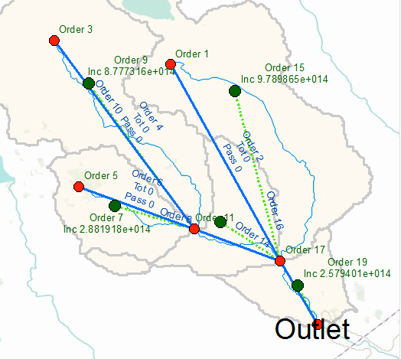
Figure 8 Map with processed data
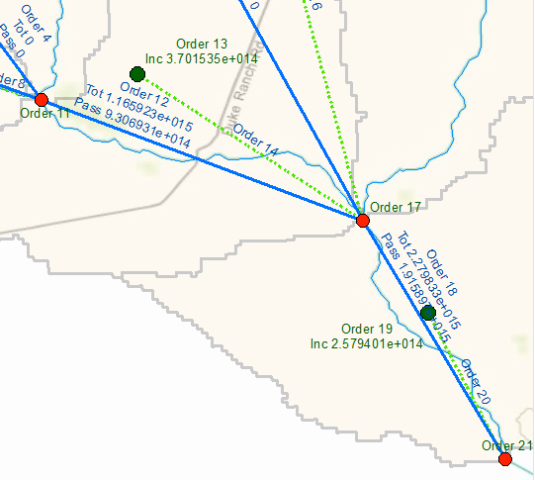
Figure 9 Map with processed data - higher zoom level

Now that the tool is set up, you can imagine how easy it would be to evaluate different strategies to control bacterial load. These strategies would result in different loads associated with each watershed. Once the loads were computed for each watershed, you would assign those loads to the IncVal field of Node layer (or create a new field called Scenario1) and run the tools again to see the result at the basin outlet.

Congratulations! You have completed the exercise. Feel free to try the schematic processor on more complex networks or to write your own processing ops.

For more complex applications of the schematic processor see Whiteaker et al., 2006 and Johnson, 2009.

To be turned in:
(1) How many Subwatersheds are there in the study? Prepare a table that lists COMID’s and the HydroID’s of the Subwatersheds in the study and alongside each one the HydroID and FeatureID of the node that represents that Subwatershed in the Schematic Processor. How are the Subwatersheds and Nodes related? What kind of Node represents a Subwatershed? What do the other Nodes represent? How many Links are there? What do the Links represent? How are the Links and Nodes connected?

(2) Make an analysis of the most downstream subwatershed draining to the Outlet. What is the annual bacterial loading (CFU/yr) that drains into the subwatershed from upstream? What percentage of that load is lost by decay as it flows through the subwatershed? Show that this amount of load reduction is what would be expected by the exponential decay formula applied to bacterial decay in the stream. What bacterial load (CFU/yr) is contributed directly to the Outlet from the local subwatershed? What is the total load at the Outlet (CFU/yr)? What percentage of that load comes from the local subwatershed?

Acknowledgements
The authors would like to thank Dr. Stephanie Johnson for her contributions to this work.

References
Johnson, S. (2009). “A General Method for Modeling Coastal Water Pollutant Loadings.” Ph.D. Dissertation, The University of Texas at Austin, Austin, Texas.
Whiteaker, T., D. R. Maidment, J. L. Goodall, M. Takamatsu (2006). “Integrating Arc Hydro Features with a Schematic Network.” Transactions in GIS 10(2) pp. 219-237. (DOI: 10.1111/j.1467-9671.2006.00254.x)

