Exercise 5 Solution
GIS in Water Resources
Fall 2010
Prepared by David Maidment
(1) Make a screen capture of the related catchments and flowlines to the USGS gage near the Blanco River at Wimberley. Find the number and the total area of the catchments associated with gaging station. What percent of the total San Marcos basin does this constitute? Compare it with the area given in the USGS gage feature class.
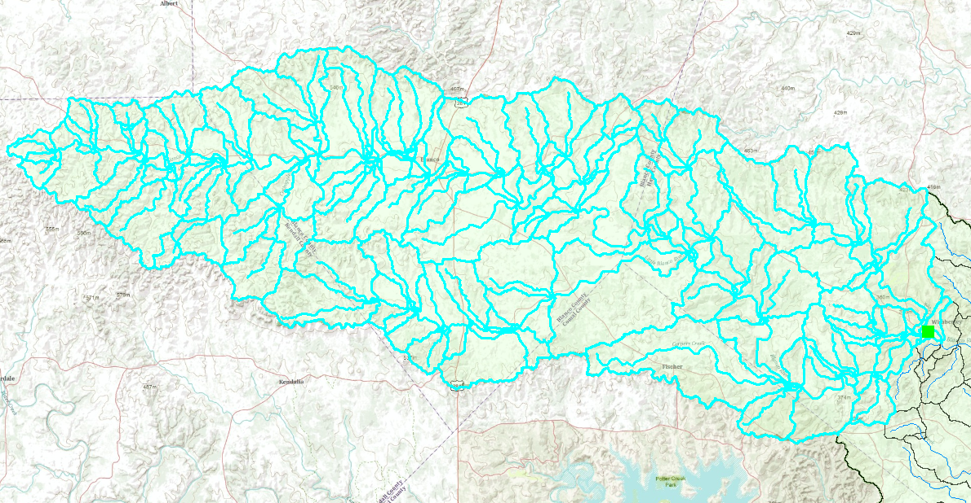
There are 127 catchments selected by this process including the one that contains the gage for the Blanco River at Wimberley. The statistics of this set of catchments are summarized as shown below, from which it can be read that the total area (Sum) is 922305450.9 m², or 922.305 km². With a conversion of 1 km² = 0.386102, mi², this corresponds to 922.305 * 0.386102 = 356.1 mi². This is in close agreement with the 355 mi² drainage area in the DA_SQMILE attribute of the USGSGageEvent feature class for the gage at the Blanco River at Wimberley. Indeed, we should expect that the drainage area selected this way is slightly larger than that recorded on the gage site because it includes the NHDPlus catchment that surrounds the Wimberley Gage, as shown in the illustration below.
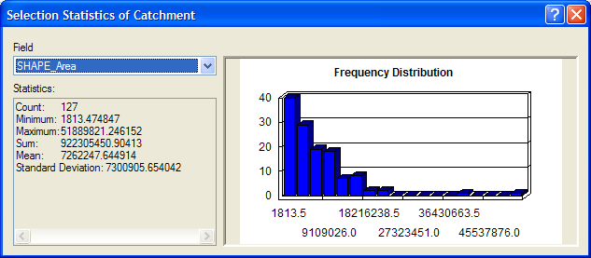
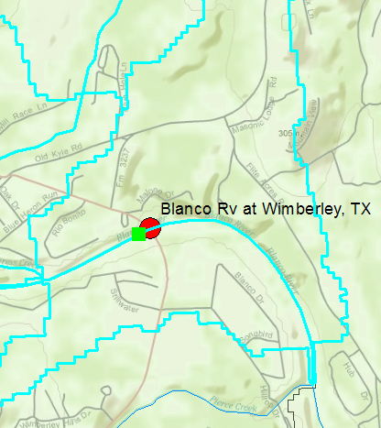
If a summary is made of the statistics of the Catchment feature class with none selected, as shown below, the total area of the San Marcos basin is given as 3519.4 km², so the selected area above the Wimberley gage corresponds to (922.3/3519.4)*100 = 26.2% of the basin area.
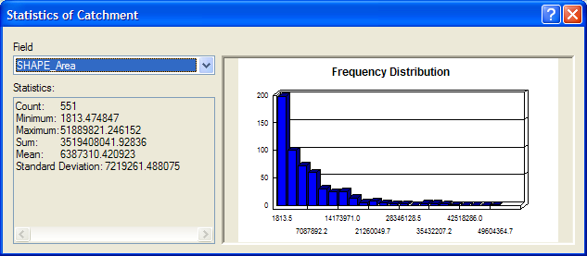

(2) What is the total flow length from top to bottom of the San Marcos Basin (km). What is the average length of the 93 NHDFlowlines on this flow path (km).
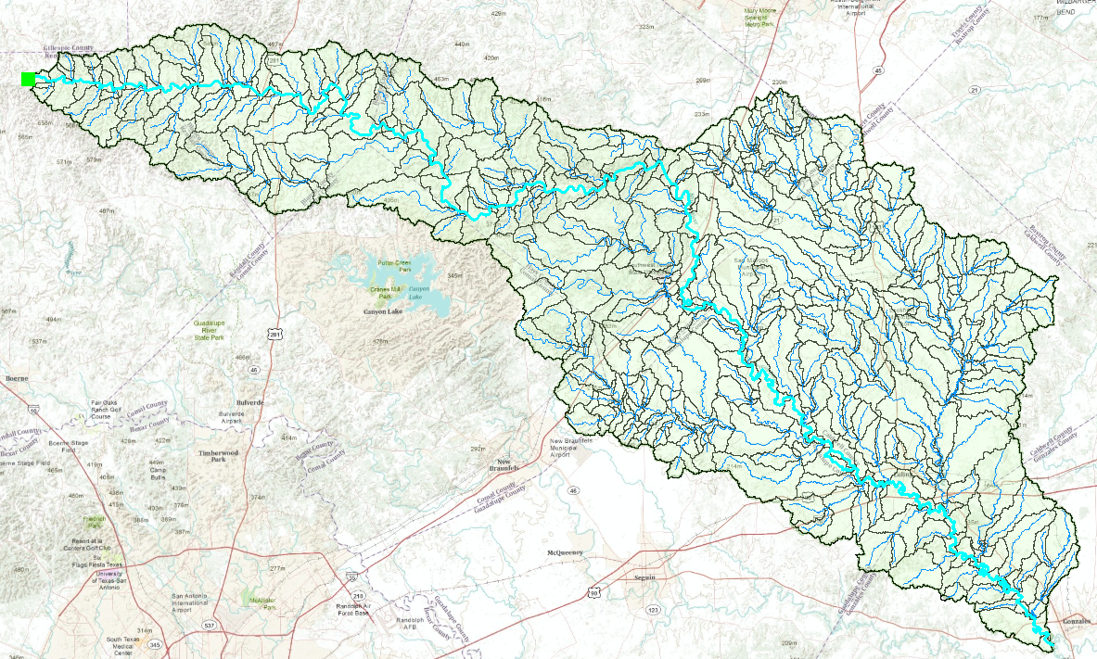
There are 93 features selected in a downstream trace from the top end of the basin to the outlet. Their total length is 270.1 km. It is notable that there are few places where there are loops in the stream network with parallel paths for the water to flow, one of which is shown below. The average length = 270.1/93 = 2.90 km, as also indicated in the table below.
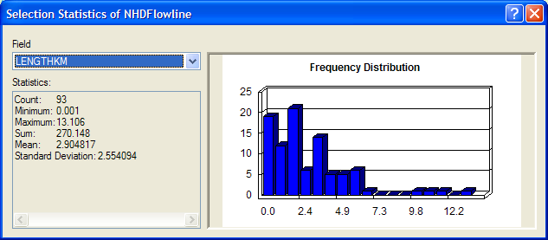
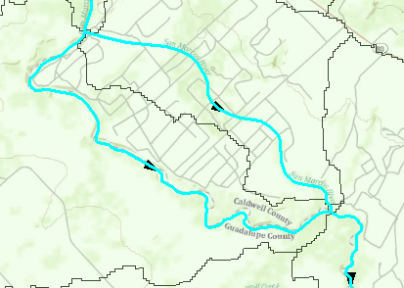
Another way of making this computation is to put an edge flag at the top and bottom of the basin and use the “Find Path” function in the Utility Network Analyst toolbar to get a single path between the two flags that omits counting both sides of each loop, a shown in the image below. The resulting set of selected edges contains 88 features and has a total length of 262.7 km. This is probably a better estimate of the longest flow path in the basin.
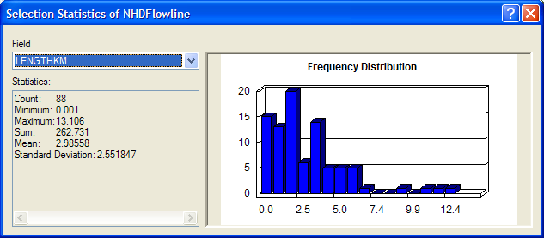
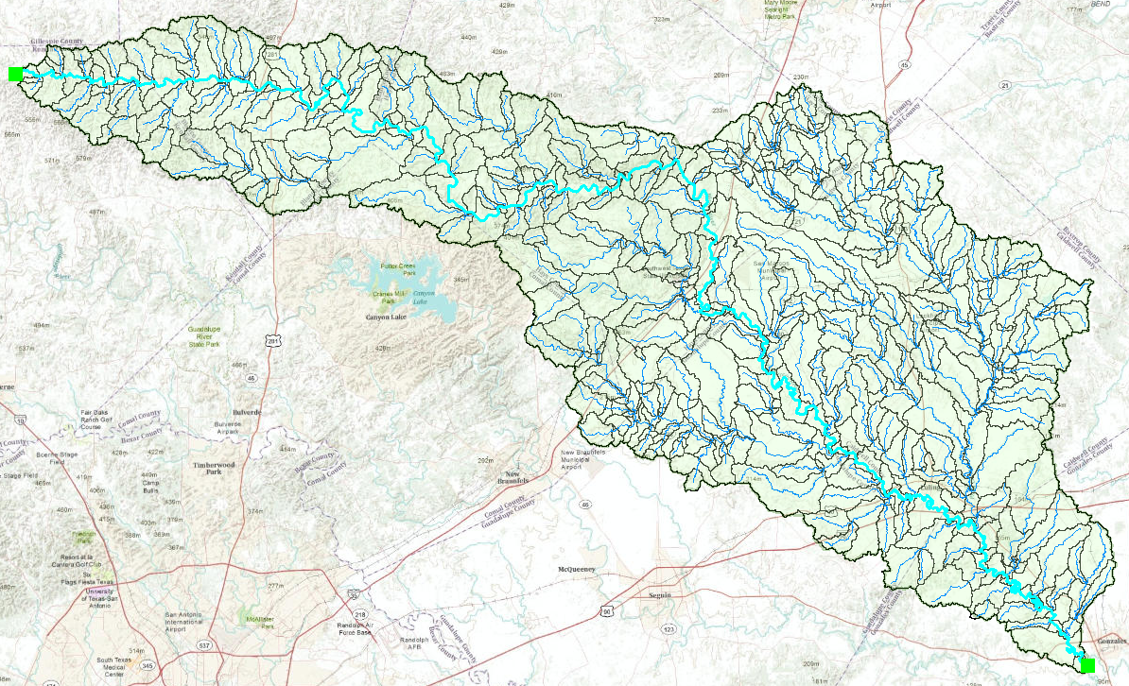

The illustration below shows how the “Find Path” function selects only one side (the shortest path) when there is a loop in the stream network between two points.
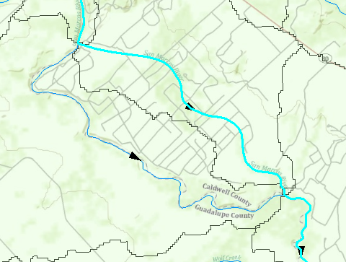

(3) Make a screen capture of the BFI_Ave points displayed on the basin streams and basin outline as background. Make a table of the 7 stream gages that shows the drainage area and mean annual base flow for each gage. Comment on the values in this table. Are they consistent?
The screen capture of the BFI_Ave is shown below, and below that is a table and map that shows the product of the BFI_Ave * Ave (base flow percentage * mean annual flow) which gives the mean annual base flow in cfs. The accompanying map of these quantities shows that there are some discrepancies, such as the base flow of 248 cfs for the San Marcos River at Ottine being lower than the 274 cfs for the San Marcos River at Luling plus 15.6 cfs added from Plum Creek near Luling. The large baseflow rate of 166 cfs for the San Marcos River at San Marcos is remarkable for a drainage area of 49 square miles, while the next smallest drainage area, Plum Creek near Lockhart, has 4.4 cfs base flow from a drainage area of 112 square miles! This shows how critical groundwater discharge is to the base flow in these rivers.
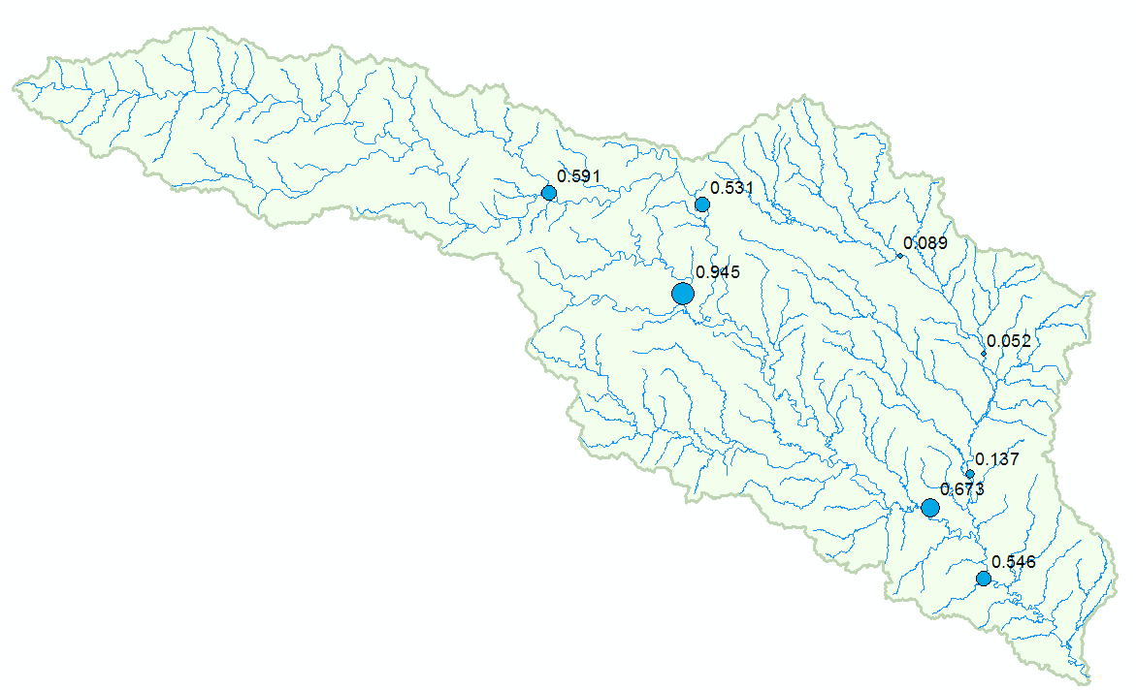
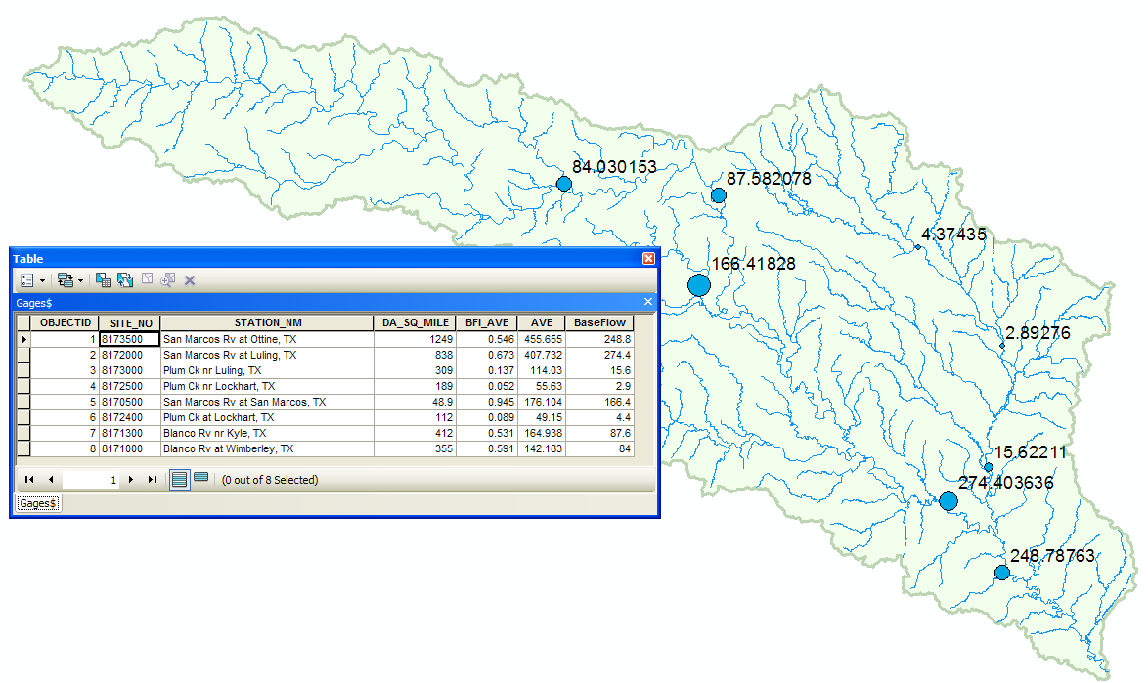
(4) Make a layout combining a map of the rainfall distribution for June 30 with a graph of the distribution of rainfall through time averaged over the basin. What is the maximum rainfall daily amount in any Nexrad cell at any time during the storm? Where does it occur? What is total average rainfall over the San Marcos basin from 28 June to 28 July 2002? What is the total average rainfall over the basin from 30 June through July 6?

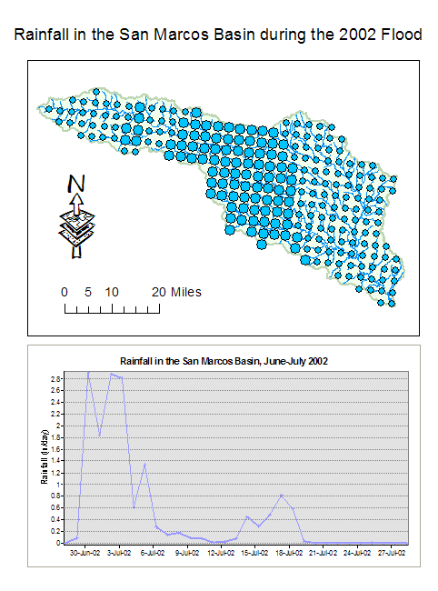

The illustration below shows the rainfall table with its TsValue field ordered from highest to lowest. The largest daily rainfall is 10.57 inches recorded in Nexrad cell (289,730) on 1 July 2002. This falls in the upper part of the San Marcos basin, as shown by the highlighted dot there.
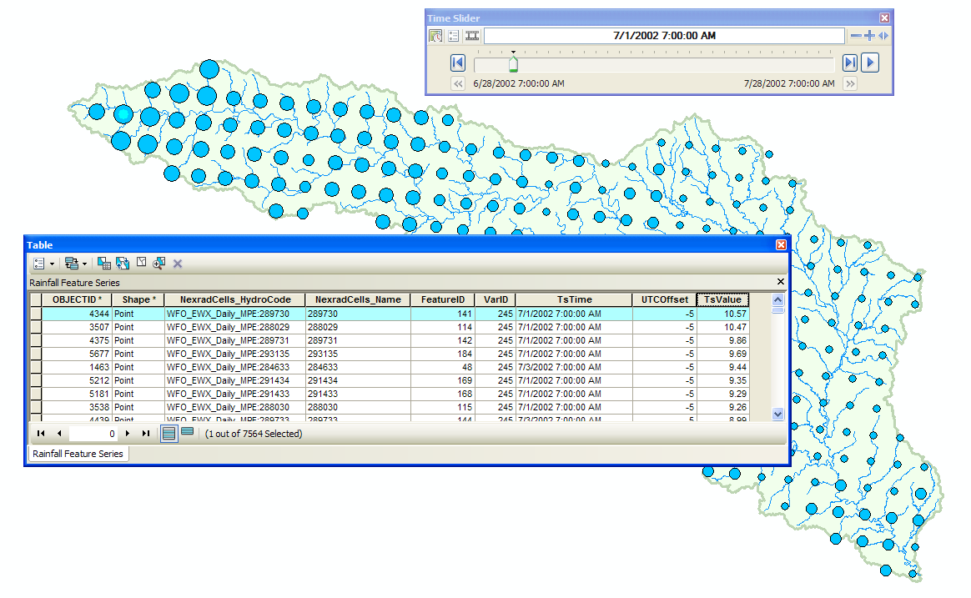

If the table of the RainfallFeatureSeries_Statistics is opened, and the MeanTsValue field summarized, the resulting Sum is 15.99 inches for the period 28 June 2002 through 28 July 2002. The average rainfall for each day during this period is 15.99/31 = 0.52 inches per day.

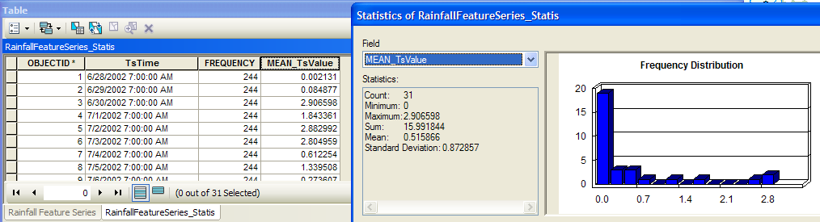

Using “Select by Attributes” on this table, and then summarizing the resulting MeanTsValues, the total average rainfall over the basin between 28 June and 6 July is 12.75 inches. The daily average rainfall for this period is 12.75/9 = 1.41 inches per day.

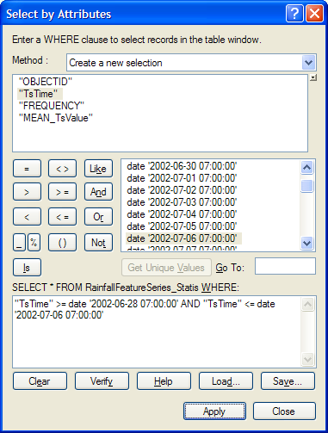

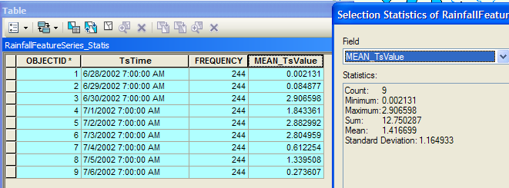

Ok, that is it, the end of this Exercise 5 Solution!

