CE 394K.2 Hydrology Homework #3 Spring 2010

An ArcGIS personal geodatabase containing rainfall for January 27 through February 1, 2010, over the United States and some geographic data for reference is obtainable at:
http://www.ce.utexas.edu/prof/maidment/GradHydro2010/Nexrad/rainfall.gdb.zip
The contents of this geodatabase include:
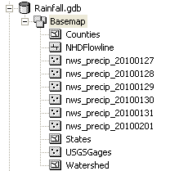
The precipitation data contained in this geodatabase were downloaded from the National Weather Service’s Advanced Hydrologic Prediction Service download page at http://water.weather.gov/download.php as a shape file for each calendar day with dots at the center of each Nexrad cell, and values for daily rainfall given as “Globval” in inches.
(1) There was heavy rainfall over Texas on January 29:
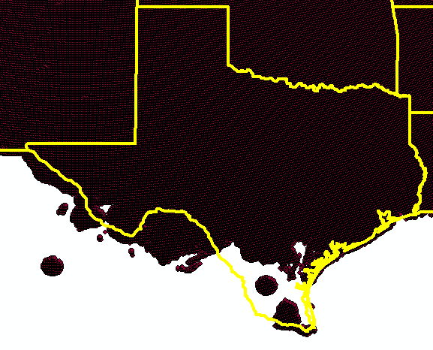
Prepare a map of the rainfall depth in inches for Texas for January 29. If you have not taken my GIS in Water Resources class, please buddy up with somebody in the class who has taken that course and work with them to achieve this goal.
(2) The watersheds from the Watershed Boundary Dataset (WBD) and USGS Gages are shown below in the San Marcos basin. It turns out that the WBD watersheds rather nicely define the drainage area of the USGS gage on the Blanco River at Wimberley, Texas, USGS Gage 08171000.
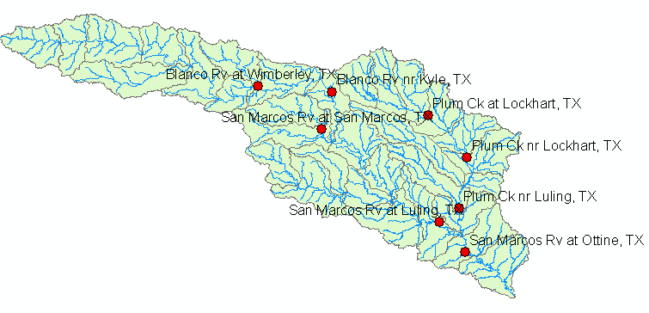

Develop a daily rainfall hyetograph for the watershed of the Blanco River at Wimberley for the period January 27 through February 1, 2010. What volume of water fell on the watershed (m³) during this period?
(3) Below is shown a hydrograph of the outflow from the Blanco River at Wimberley. These data were obtained from http://waterwatch.usgs.gov/
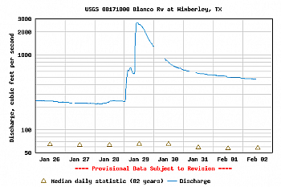
Obtain the corresponding discharge data and plot the flow hydrograph for the period January 27 through February 1, 2010. What volume of water (m³) flowed through the gage site during this period?
(4) Solve problems 3.2.1 and 3.2.5 in Applied Hydrology

