- The area of Williamson County in Square Miles?
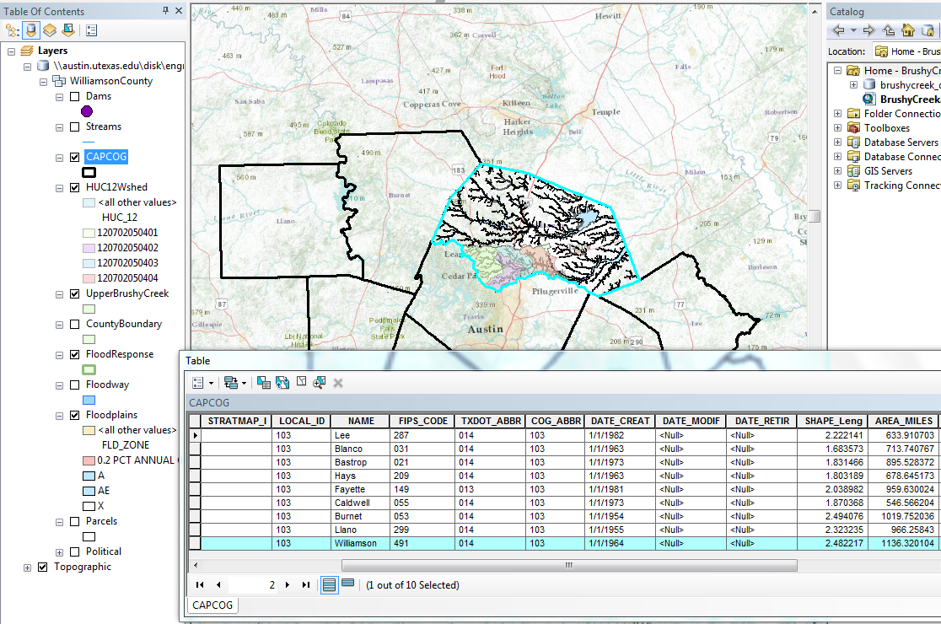
The Area of Williamson County is 1,136mi²
- A flood map of Williamson County.
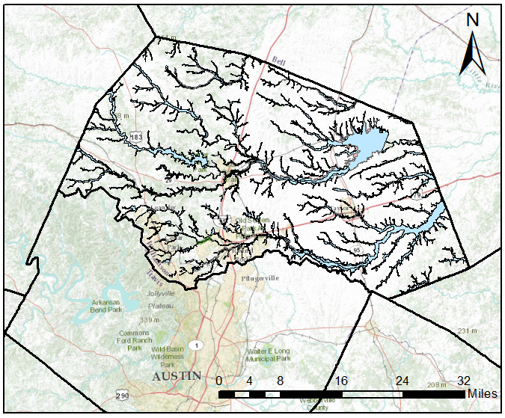
- The length of Brushy Creek in miles.

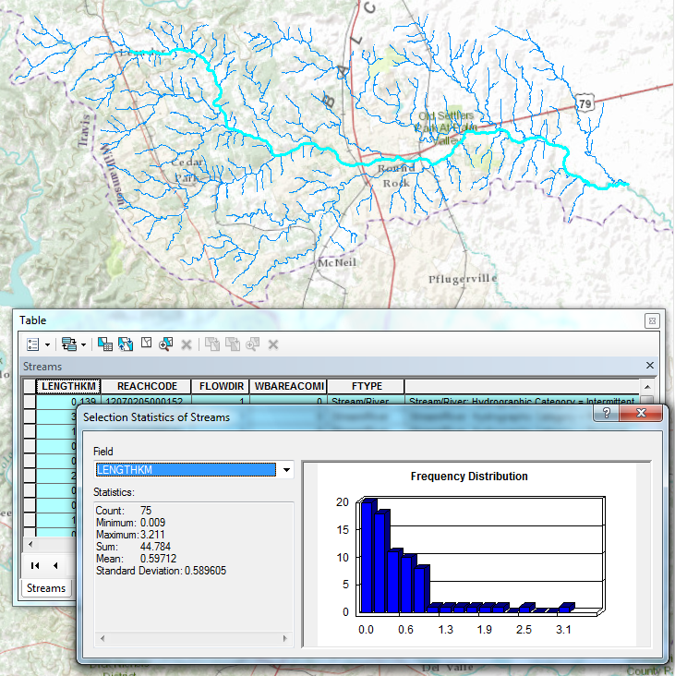

Length=44.784 km / 1.609 mi / km
Length=27.83 mi

