Wells and Groundwater in the Selwyn Aquifer

Prepared by David R. Maidment
Waterways Centre for Freshwater Research
University of Canterbury
March 2018

Table of Contents
Goals of the Exercise, and Computer and Data Requirements 1
Procedure 2
- Map of Observation Wells 2
- Story of a Well …………………………………………………………………………………………………………………………..… 7
- Description of the Selwyn Aquifer 13
- Water Level Map and Travel Time in the Aquifer ………………………………………………………………………. 19
- Items to be Turn In ……………………………………………………………………………………………………………………. 28

Goals of the Exercise
This exercise introduces you to the monitoring wells in the Selwyn aquifer, examines one well in particular so you can see the details of its construction and the water levels recorded in it. Then you’ll work with the mesh for a Modflow model of the aquifer and see how this relates to the well you’ve just studied. You’ll make a map of the water level across the Selwyn aquifer and estimate the travel time of groundwater contamination to travel to Te Waihoro/Lake Ellesmere.

Computer and Data Requirements
To carry out this exercise, you need to have a computer, which runs ArcGIS version 10.5. Version 10.4.1 should work fine also. The data to be used for this exercise are available in the Learn system for Ex5 and at: http://www.caee.utexas.edu/prof/maidment/Canterbury/Ex5/Ex5Data.zip They consist of two Excel files of Monitoring Well information and an ArcGIS shape file describing a Selwyn aquifer Modflow grid. The monitoring well data were provided by Fouad Alkhaier of Environment Canterbury and the Model Grid by Julian Weir of Aqualinc. Thanks Fouad and Julian!! Modflow is a standard US Geological Survey model used for simulating the flow in groundwater aquifers. https://water.usgs.gov/ogw/modflow/ You won’t actually run this model but instead use the data compiled to create the model to illustrate the nature of the Selwyn aquifer.
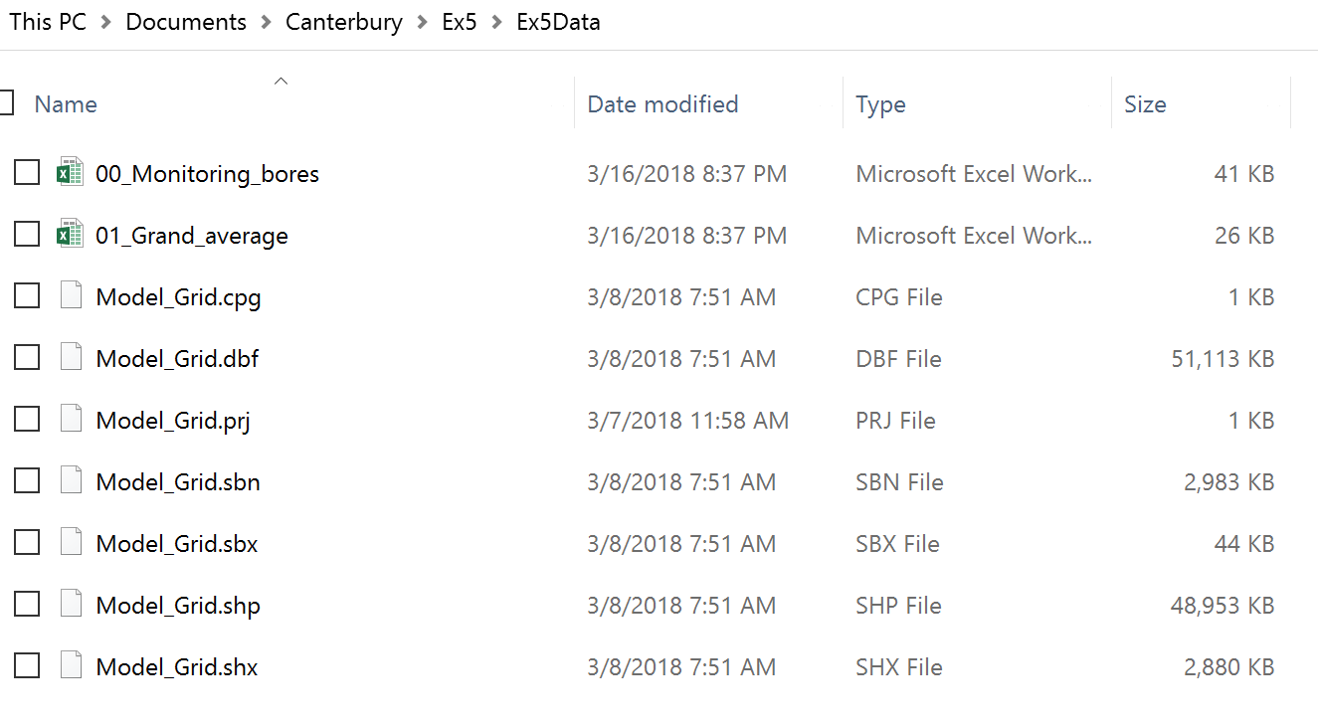

Procedure
- Map of Observation Wells
Open ArcMap and add Sheet1$ of the 00_Monitoring_Bores.xlsx spreadsheet to the map display
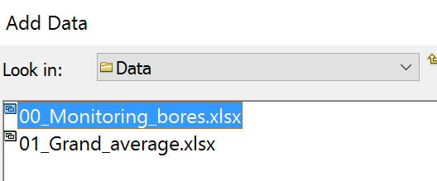
Open the Attribute Table of this Spreadsheet and you’ll see a lot of details about these wells, at the end of which are the NZTMX and NZTMY attributes which show the location of the well in New Zealand Transverse Mercator coordinates.
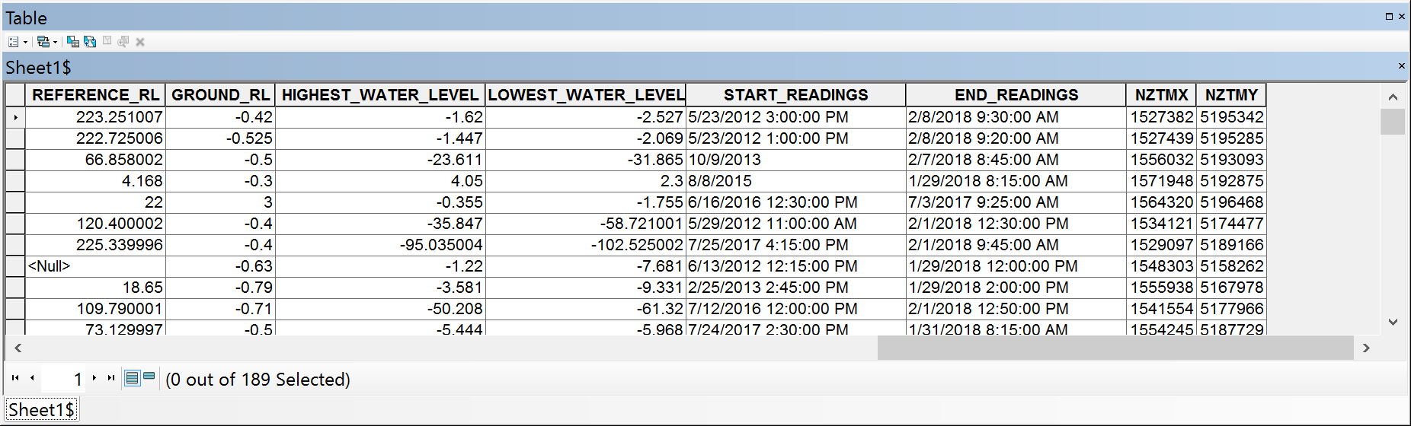
Right click on this spreadsheet and select Display XY Data
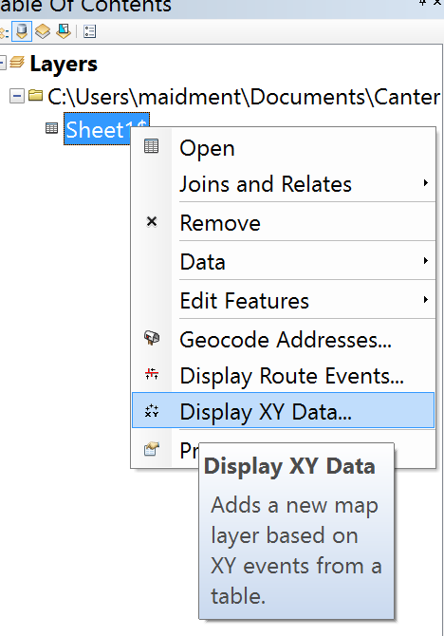
Use NZTMX and NZTMY as the X and Y fields
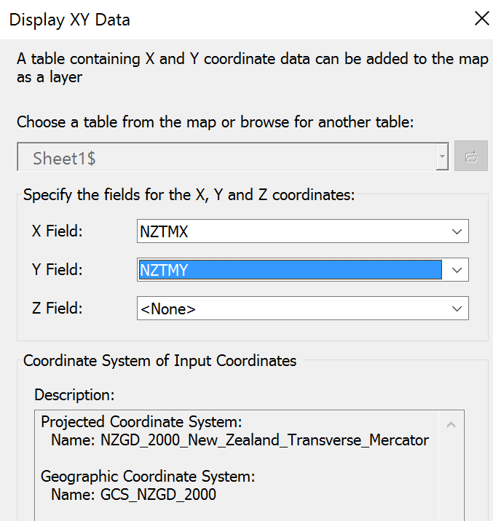
You’ll see a lot of dots appear in the map display and you can see where they are located if you add the NZ Community Map as your Basemap.
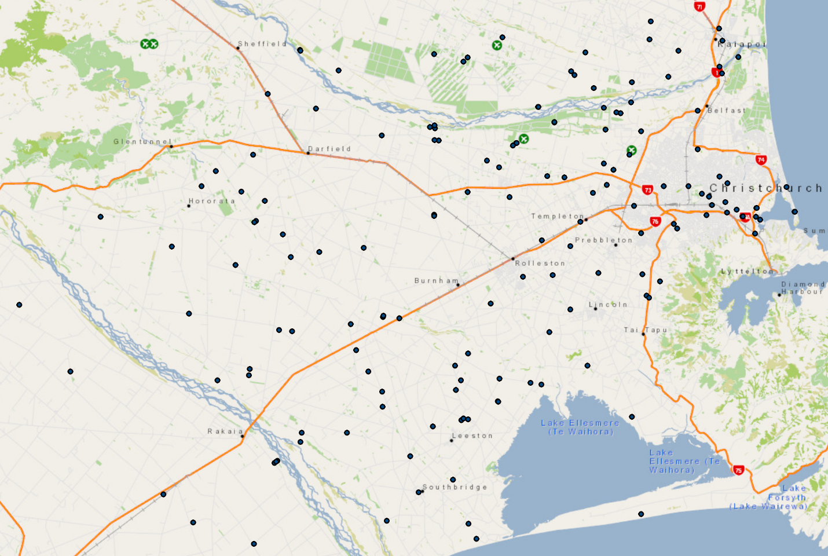
Click on the Catalog tab at the top right of the ArcMap display and establish a New File Geodatabase in the folder you are using to store your data in for this exercise.
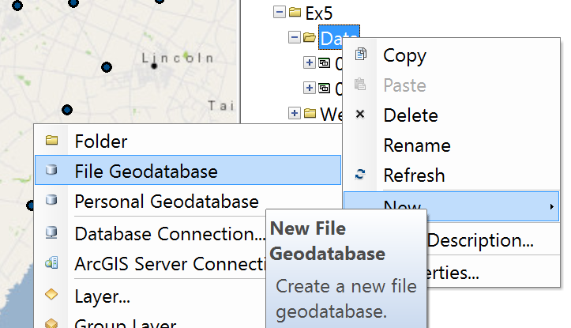
and let’s call this Canterbury. Within this establish a new Feature Dataset called Groundwater withas the horizontal coordinate system and NZVD2009 as the vertical coordinate system.
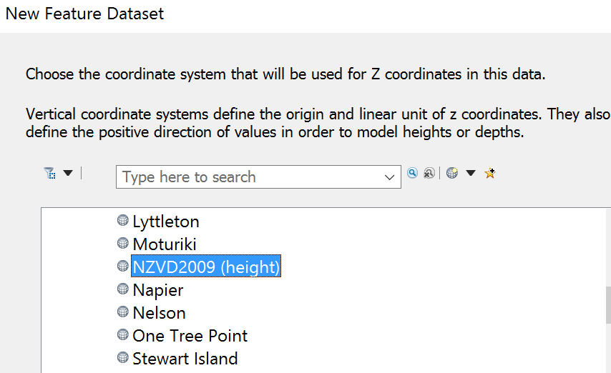
Right Click on the Event feature class and export it to the Groundwater Feature Data Set as a new feature class called Wells.
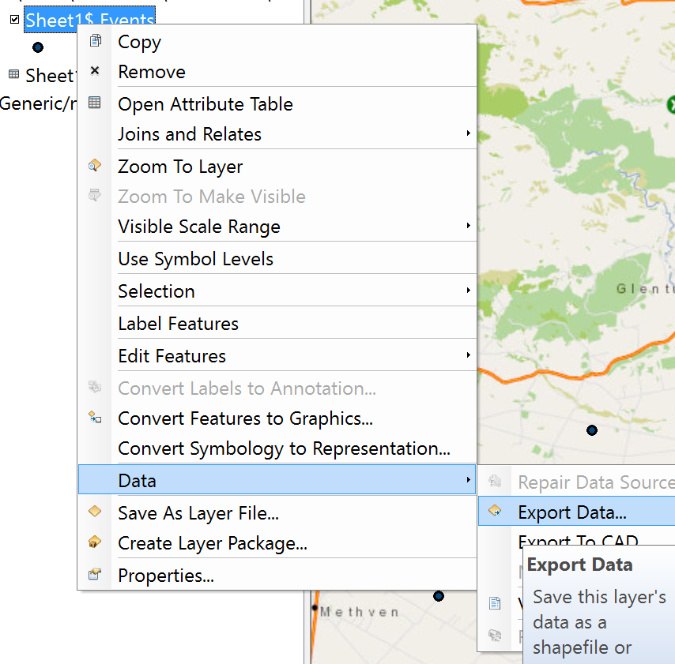
Label the Wells feature class with Well_No as the descriptor
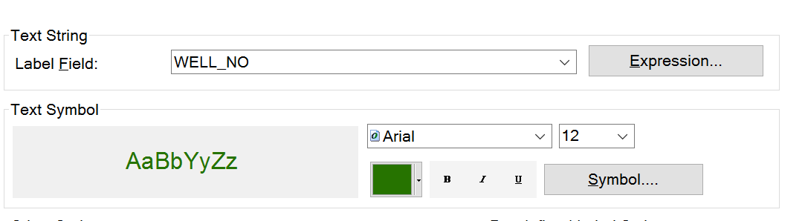

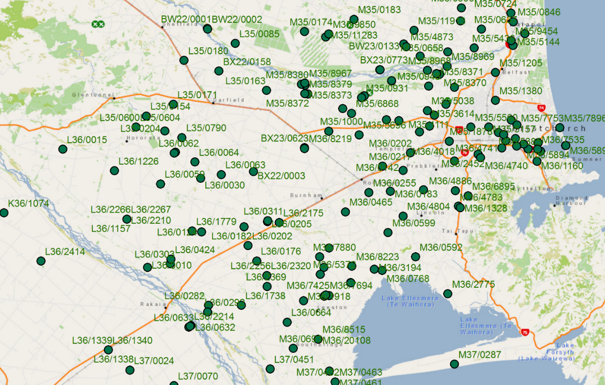
Save your map display as Ex5.mxd
To be Turned in: A map of the observation wells over the Selwyn aquifer. How many wells are there? How many observations have been made at these wells (Hint: Use the Reading_Count attribute). What is the average number of observations per well in the region?

- Story of a Well
Let’s zoom in to Highway 1 just south of Burnham and choose well L36/2175.
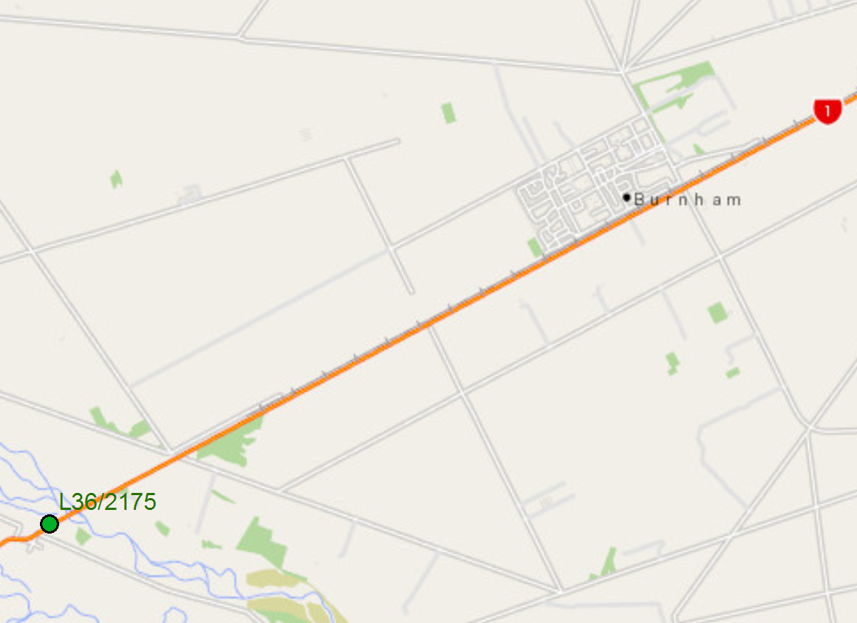
If we query the attributes of this well, we can see that it was drilled on 23 April 2007. Its horizontal coordinates are
UTMX = 1537887 m
UTMY = 5167030 m
and its Reference level (top of the well pipe) = 67.25m above geodetic datum (Vertical coordinate system)
The well diameter is 150 mm
Measurements have been made since 17 May 2007 and since that time 407 water level measurements have been made for this well which vary in water elevation between -1.39m and -13.356m below the top of the well.

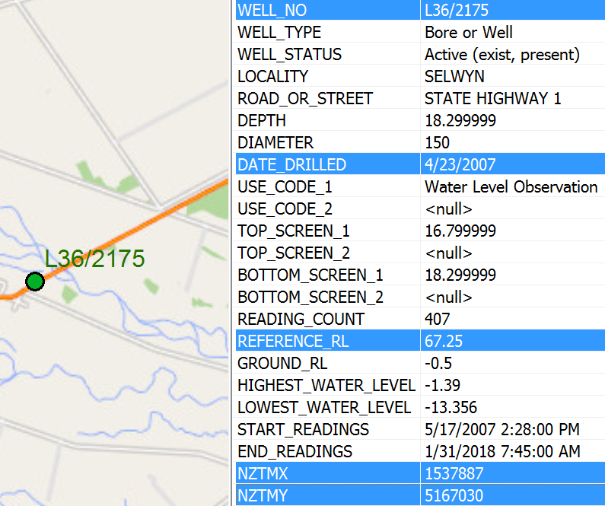

Use the Select tool 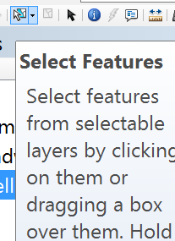 to select Well feature L36/2175 and export it to a new feature class called SelectWell and add it to the map display in ArcMap.
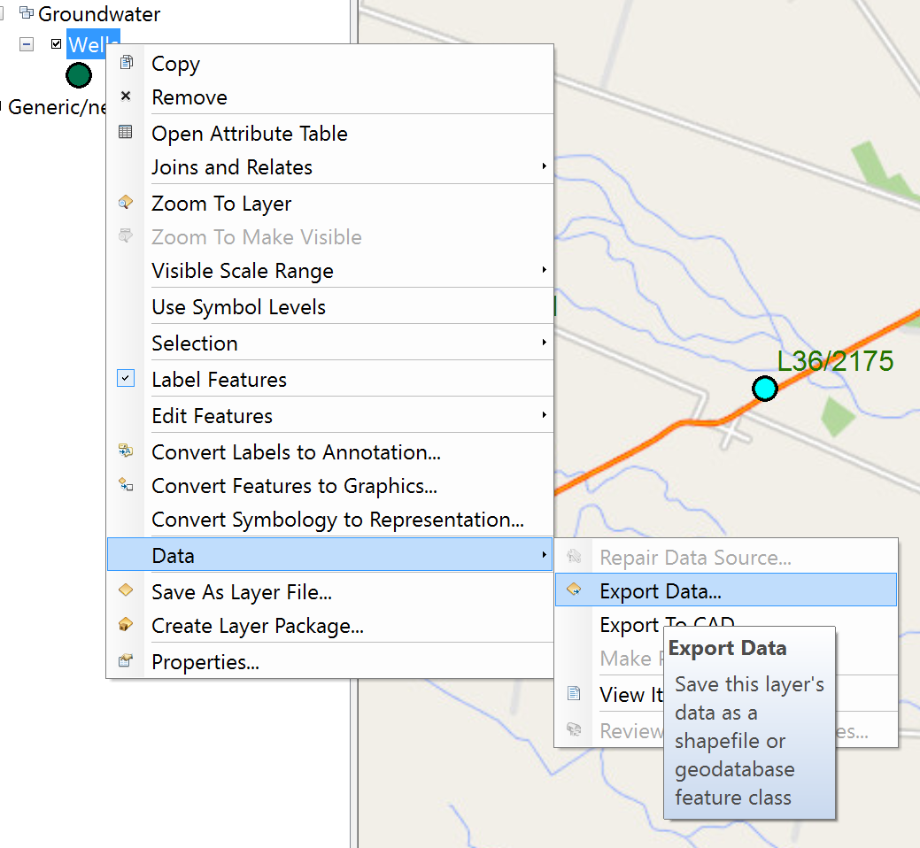

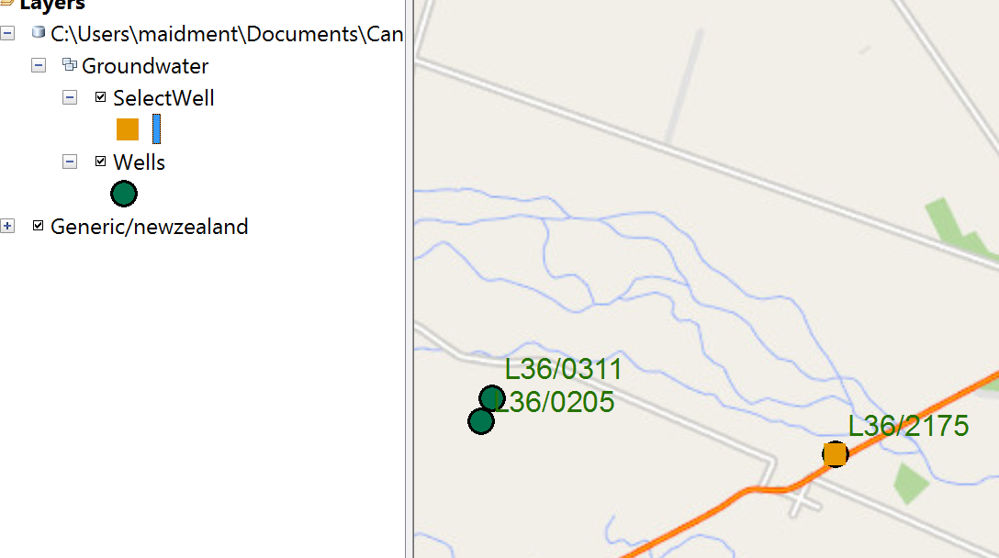

To find more descriptive information about this well, go to the web site https://www.ecan.govt.nz/data/well-search/
and put in L36/2175 as the well number
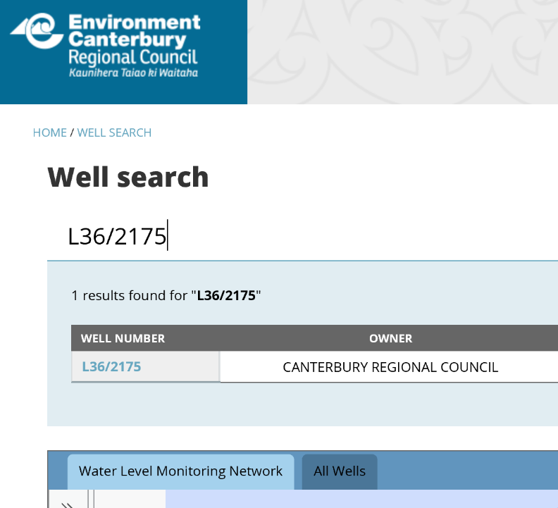
You’ll see one record selected, and indication that this well is in the Water Level Monitoring Network, which means that its purpose is to observe water levels not to supply pumped water. Click on the well number and you’ll see a category for Bore Log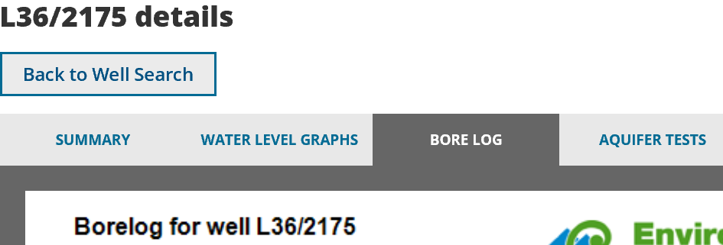
This provides details of the geological strata encountered as the well was drilled, the depth of the well, and where it is screen to permit water entry (at the bottom).
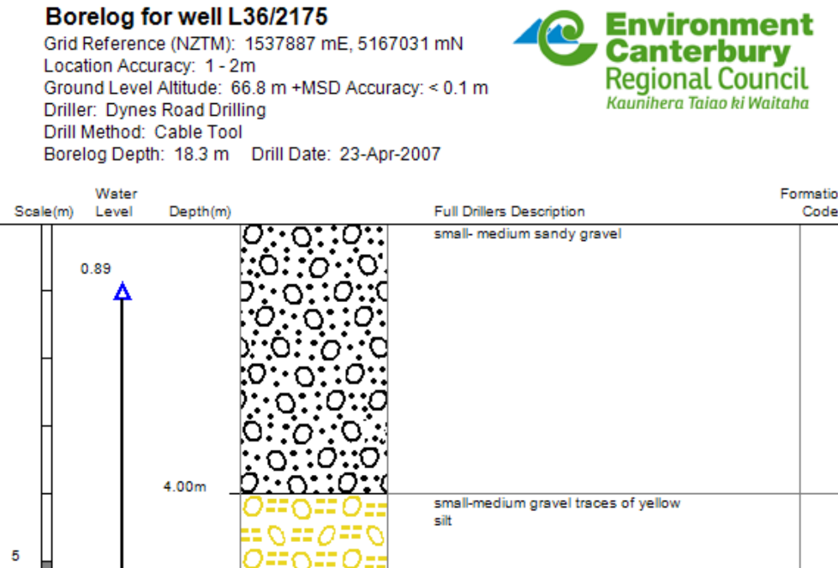 | The reference level is the top of the well (67.25m). The ground level is -0.5m below the top of well, or 66.75m above geodetic datum.
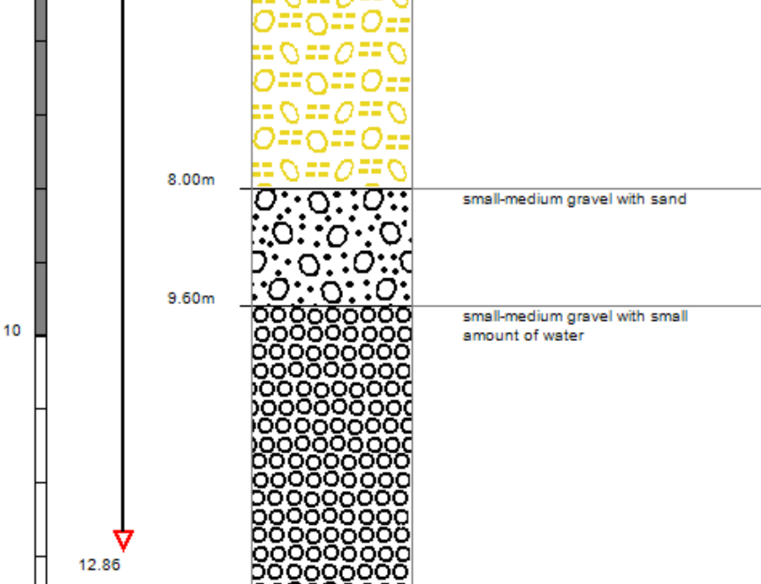 | The average water level is 6.11m below the top of the well in the stratum labelled “Small-medium gravel with traces of yellow silt”.
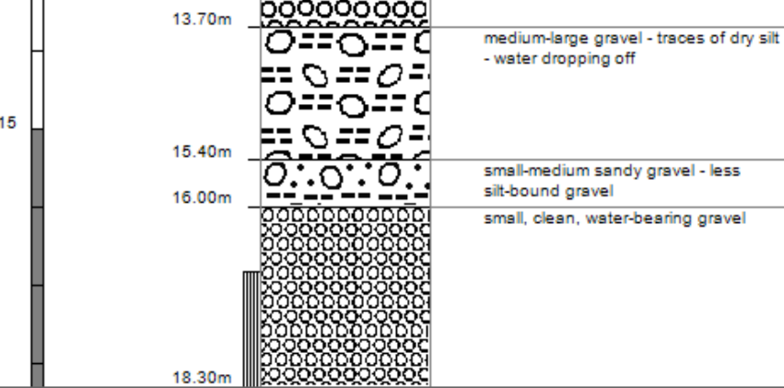 | The well is screened for entry of water right at the bottom of the well between 16.8m and 18.3m from top of well.

If you switch to Water Level Graphs, you’ll see a chart of current year levels (in blue compared to the minimum, maximum and average for past years. This year is a relatively wet year with water levels near the highest recorded.
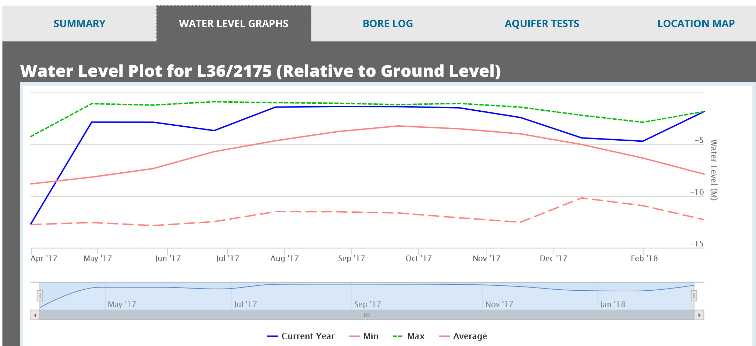
If you scroll down to the next chart, you’ll see that the water levels in this well fluctuate between about 2m below top of well to 13m below top of well.
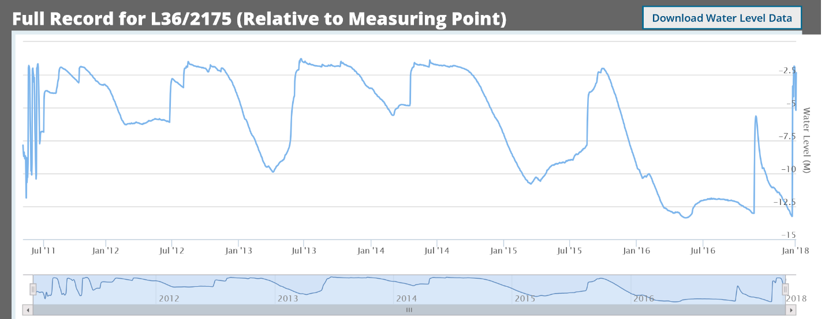
To be Turned in: Choose another observation well from the dataset and prepare a similar description of it like the one presented above for L36/2175. How does your well compare with L36/2175? [Hint make sure this well is upstream of Te Waihora/Lake Ellesmere because this is important for Question 4].

- Description of the Selwyn Aquifer
The physical and flow properties of the hydrogeology of the Selwyn aquifer are contained in a data set developed to support Modflow groundwater modeling of the aquifer, compiled by Julian Weir and colleagues at Aqualinc. Go to the dataset you downloaded for this exercise and add the Model_Grid shape file to your map display.
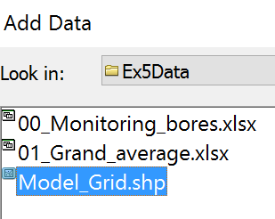
Turn off the Wells feature class but leave the SelectWell feature displayed.
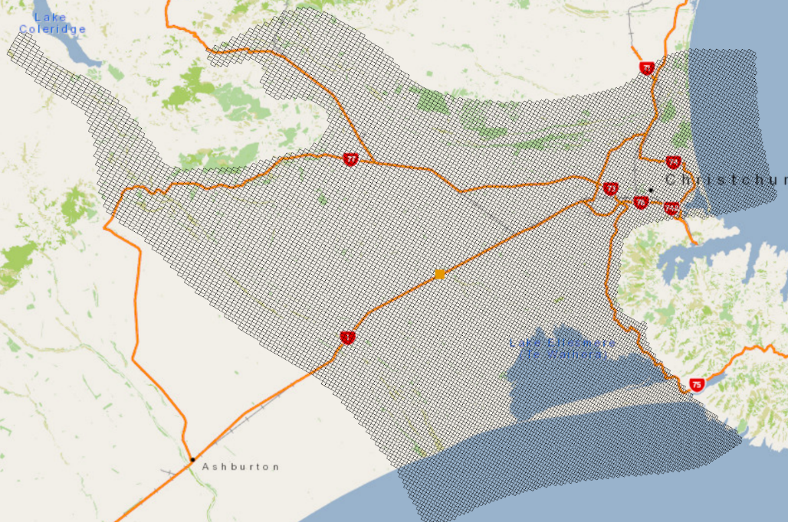
Now, let’s get a geology map to add to this display. Select Add Data from ArcGIS Online
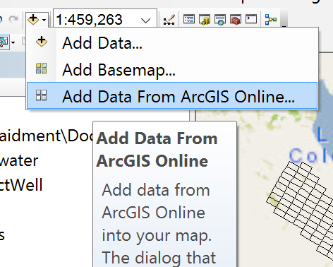
And search for Geological Map of New Zealand You’ll see that a map becomes available produced by the project QMAP of the Crown Research Institute: Geological and Nuclear Sciences (GNS)
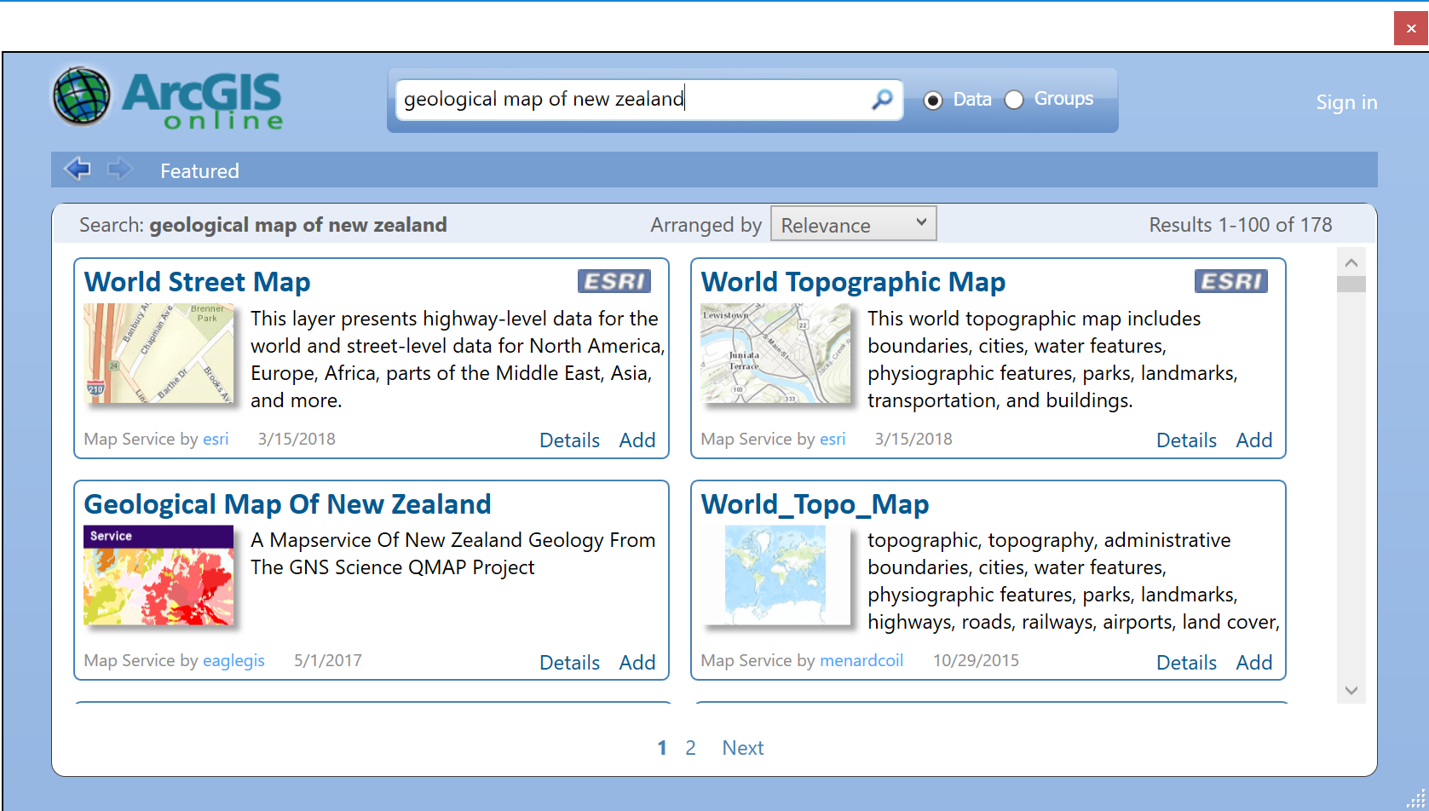
If you add this map to your display, you’ll see a coloured image of the geology of this region. The purple areas are volcanic rocks of Banks Peninsula (Lyttleton Harbour and Akaroa Harbour are flooded calderas of ancient volcanos). The white areas are regions where river gravel depositions dominate the surface geology – in the case of the Selwyn aquifer, these are the Waimakariri River to the north, the Rakaia River to the south and the Selwyn River in the center of the model grid.
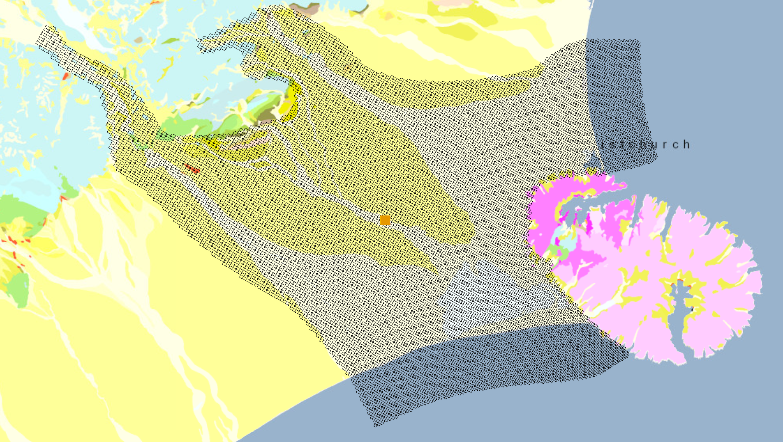
A three-dimensional view of the Selwyn groundwater system is shown below.

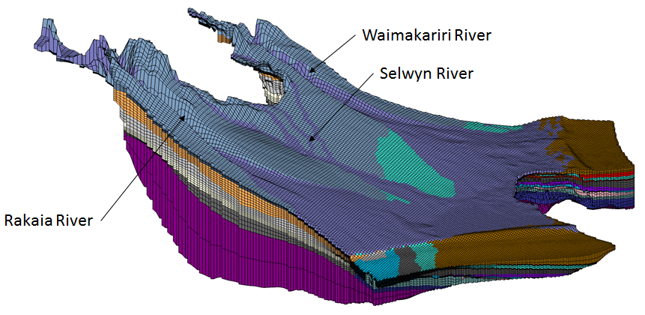
Three-Dimensional Model of the Selwyn Groundwater System Source of Image: Julian Weir, Aqualinc
And if you zoom in to Well L36/2175, and use the Identify tool to query the Model_Grid cell in which this well is located, you’ll see parameters I, J, K, which refer to the row, column and layer indices of the Modflow model. In the display shown below, the “Top” elevation of 67.5 meters refers to the ground surface elevation for layer 1 (K = 1). The white colour in the map below represents the gravels in and around the Selwyn River bed.
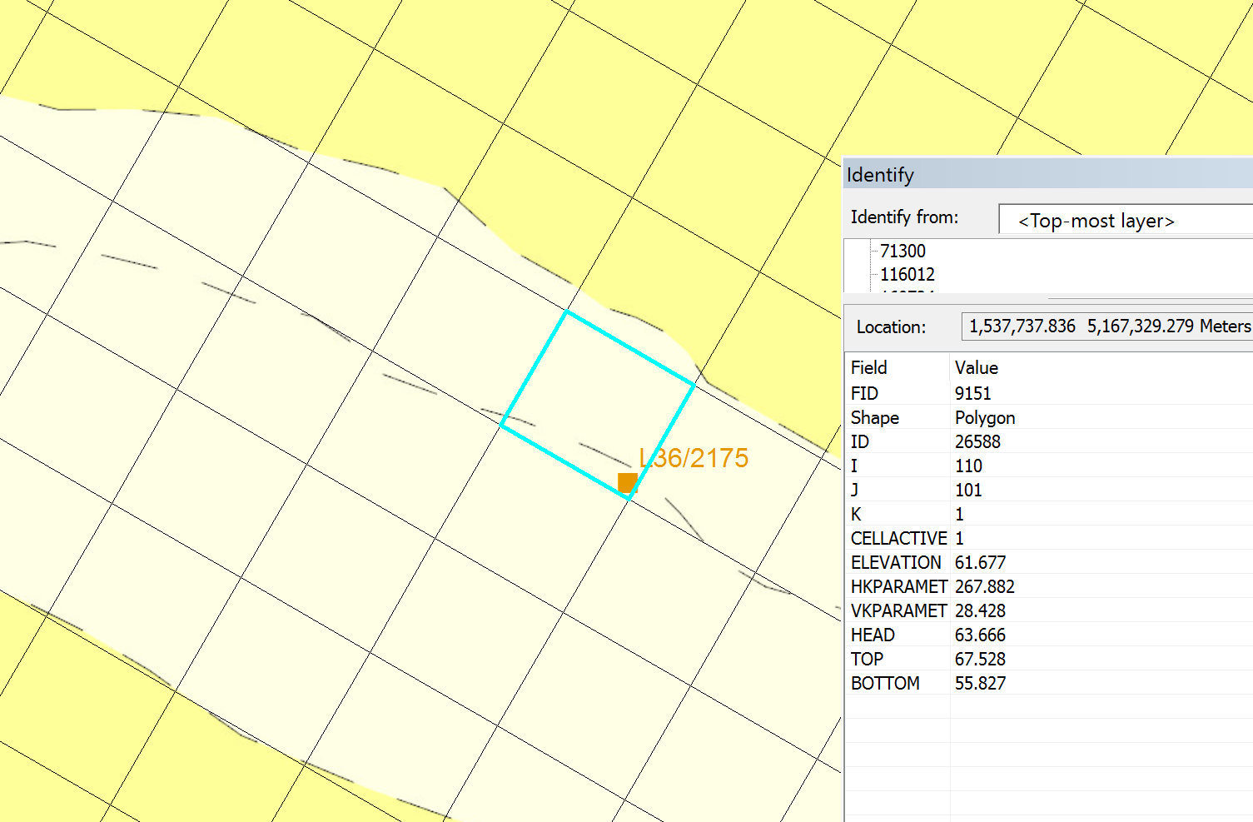
Use Select to select the grid cell containing well L36/2175, open the Model_Grid attribute table, and hit the Show Selected Records in the tab at the bottom of the table display
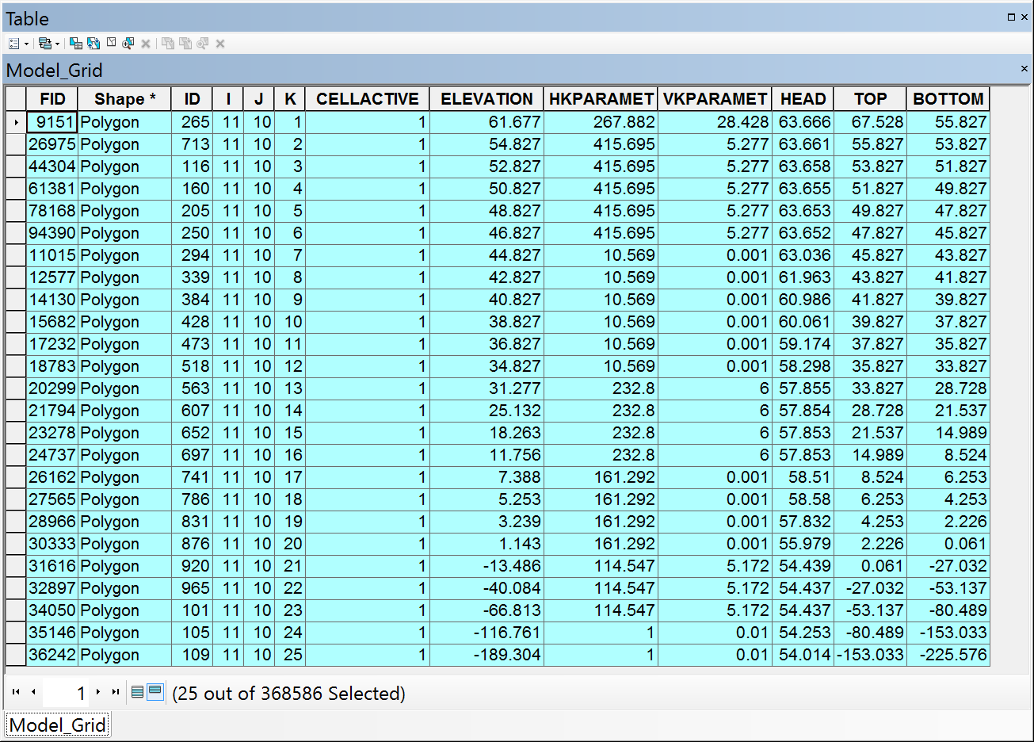
In the top left corner of the Attribute Table, with the rows selected as shown above, you can export this table
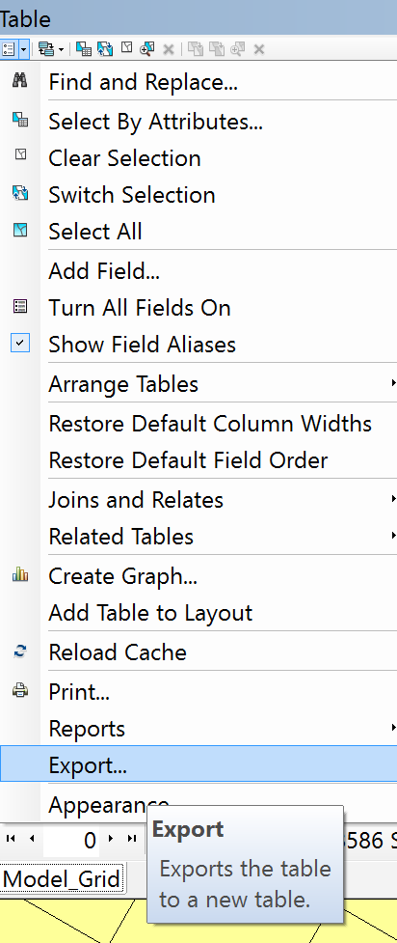
Export this as a text file GridData.txt
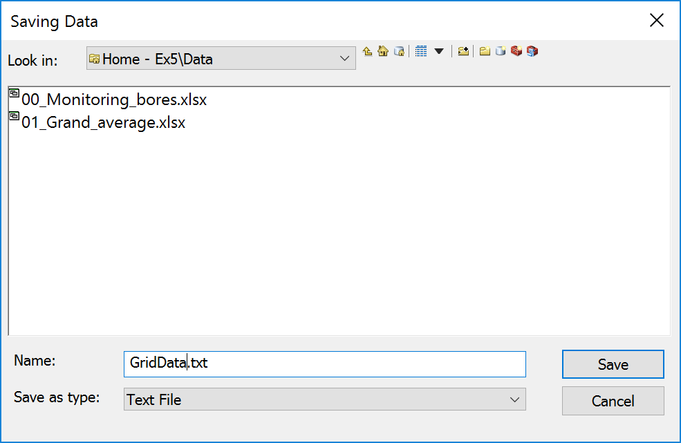
Import this table into Excel as a Comma Delimited text file
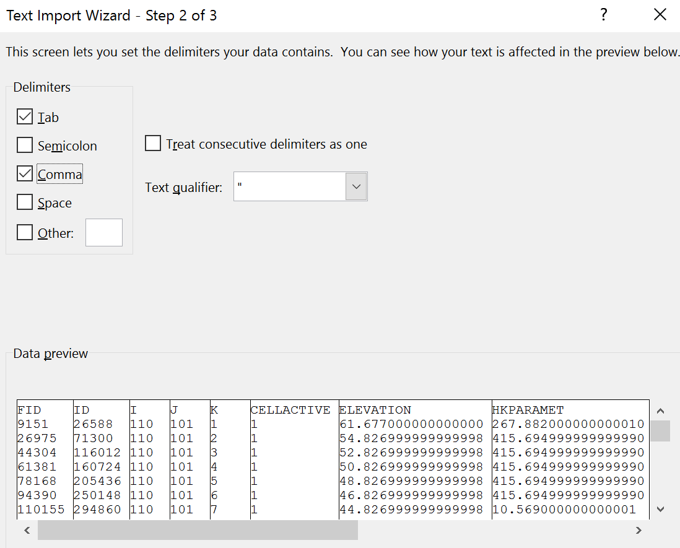
If you look in the Excel file, you’ll see two columns labeled HKPARAMET and VKPARAMET that refer to values of the horizontal and vertical Hydraulic Conductivity of the aquifer in meters per day. This is a measure of the “ease of flow” of the water in the aquifer. Notice that the water flows much more readily in the horizontal direction than it does in the vertical, and also that some hydrogeological layers are much more free flowing than others are. The free flowing layers are “aquifers” and the slow flowing layers are “aquitards”.
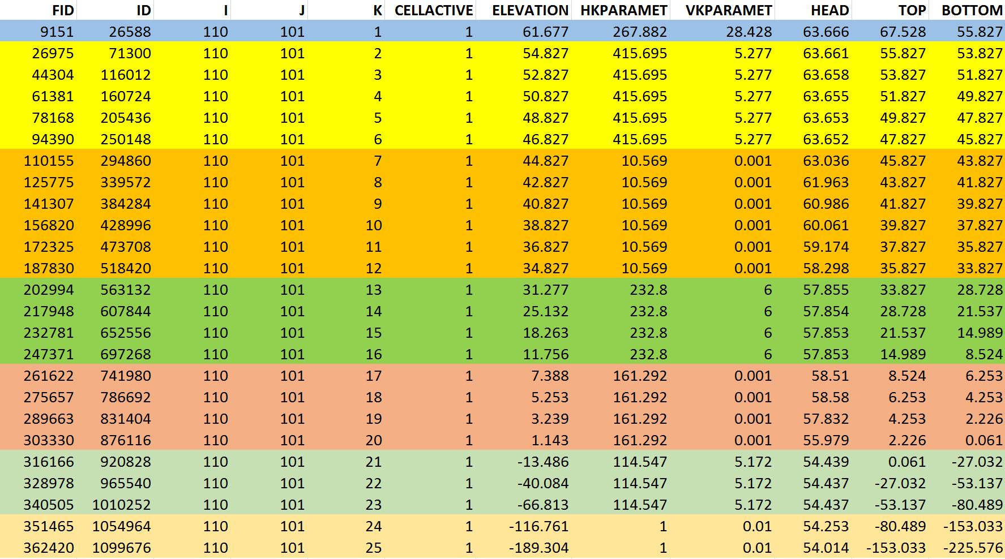
Effectively, you can see that there are 7 hydrogeological layers at this location denoted by the colours. I have summarized the data in the following table on the following page to show the properties of the layers. If you multiply the horizontal Conductivity, K, by the layer thickness, B, you get a quantity called Transmissivity, T, which indicates how much flow can pass though this layer.
$$T=KB$$
Adding all the Transmissivity values for the 7 layers, T_{i}, i= 1,2,…7, a total Transmissivity of 24,020 m²/day is obtained.
$$T_{tot}=\sum_{i=1}^{7}{T_{i}=24,020 m^{2}/day}$$
I’ve used this value to compute the % of the total transmissivity and in the final column and you can see that layers A, B, D, and F are the aquifers in this system while C, E and G are aquitards. Similarly, the total thickness of the hydrogeological system at this location is the sum of the individual layer thicknesses:
$$B_{tot}=\sum_{i=1}^{7}{B_{i}}=293m$$
We can get an average value for the horizontal conductivity = Total Transmissivity/Total Thickness:
$$K_{avg}=\frac{T_{tot}}{B_{tot}}= \frac{24020}{293}=82 m/day$$
We’ll use this value later in the exercise.
Layer | Top | Bottom | Conductivity (m/day) | Thickness (m) | Transmissivity (m²/day) | % of Transmissivity
A | 67.5 | 55.8 | 267 | 12 | 3124 | 13.0
B | 55.8 | 45.8 | 416 | 10 | 4160 | 17.3
C | 45.8 | 33.8 | 11 | 12 | 132 | 0.5
D | 33.8 | 8.5 | 233 | 25 | 5895 | 24.5
E | 8.5 | 0.1 | 161 | 8 | 1352 | 5.6
F | 0.1 | -80 | 115 | 80 | 9212 | 38.3
G | -80 | -225 | 1 | 145 | 145 | 0.6
Total |  |  |  | 293 | 24020
Aquifer Layer Table for Model_Grid Cell (I,J) = (110,101)
To be turned in: Prepare an aquifer layer table like the one above for the Model_Grid cell that contains the observation well that you chose for Question 2.
- Water Level Map and Travel Time in the Aquifer
When water levels are measured in wells, the Reference Level is the level of the top of the well. This elevation is measured above Geodetic Datum, using a GPS unit or land surveying. From that point, all measurements are made down from the top of the well. The water level in the well reflects the hydraulic pressure that exists in the aquifer in which the well screen is located.
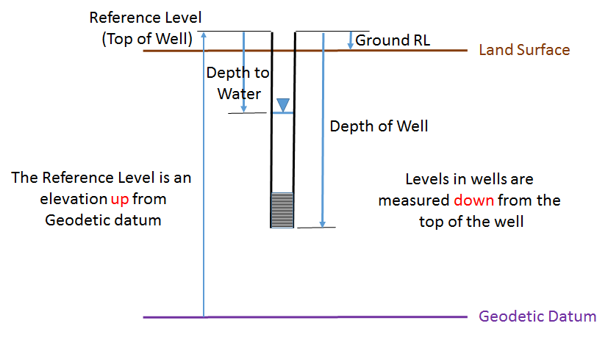
We are going to make a water level map (or piezometric head map) from the average water levels recorded in the ECan monitoring wells. These levels are averaged through time over the period of record of measurements from each well. We are also not allowing for different hydraulic pressures that may exist in the difference aquifers. Please bear in mind these simplifications as we do this part of the exercise.
From the original data provided for the exercise, add the Excel Spreadsheet 01_Grand_average to ArcMap. Choose worksheet Query$4.
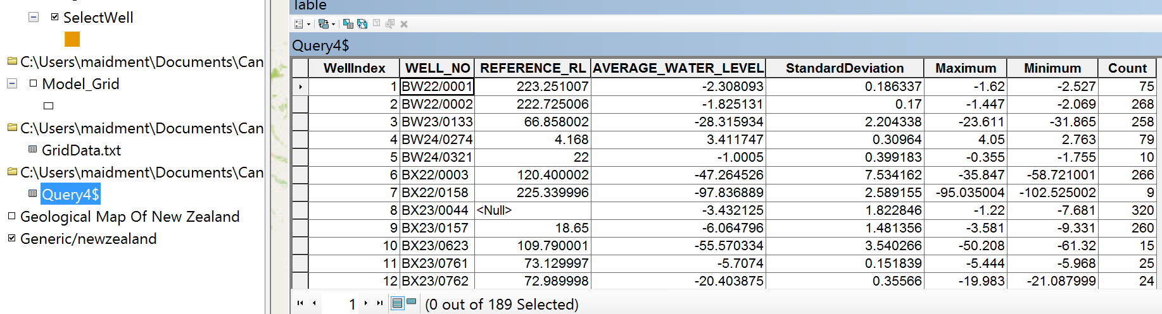
Right click on this table and Export the Table as AverageLevel in the Canterbury geodatabase (cannot put this in the Groundwater feature dataset because that only holds feature classes not simple tables).

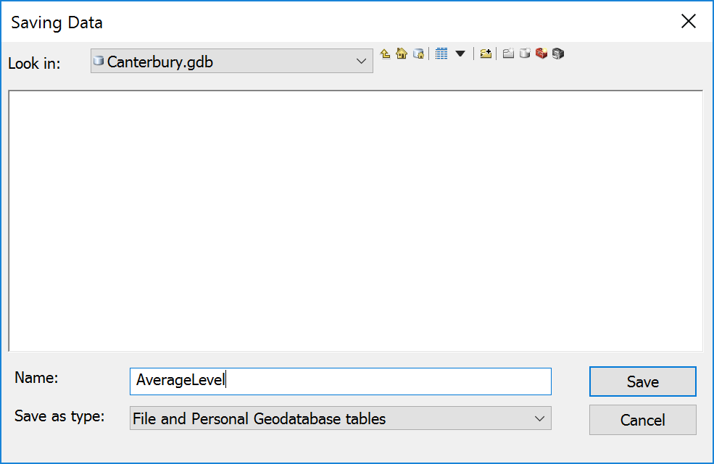
Now, we’ve got a Feature Class of Wells and a Table that stores the AverageLevel recorded in each well.
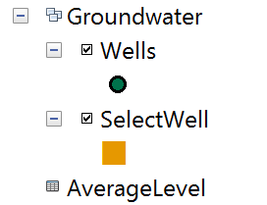
Now let’s Join these two tables using the WellIndex field present in both tables as a common key field.
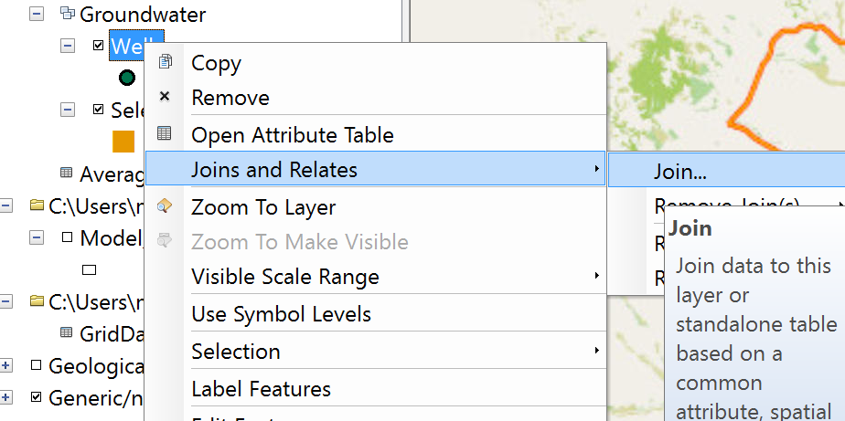
Right click on the Wells feature class and select Joins and Relates/Join
Use AverageLevel as the Table you want to join and WellIndex as the field with common values between the two tables that will establish their association.
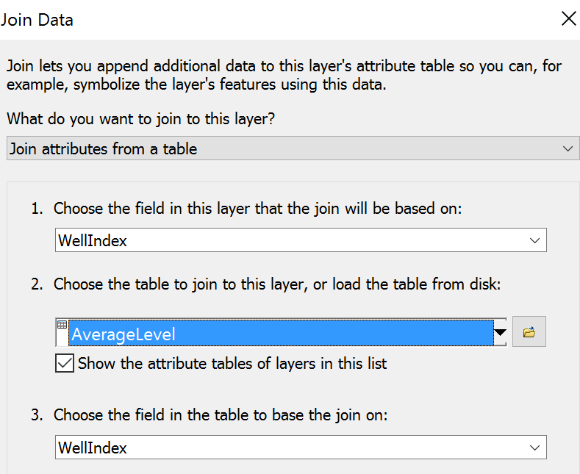
Now, when you navigate over to the right hand side of the Wells Attribute table, you’ll see more fields that have been added since the Join was made.
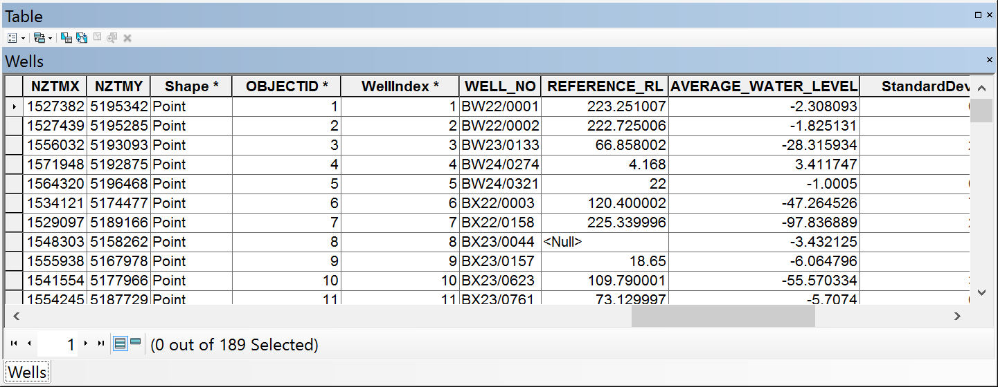
Now, let’s make a new field to compute the Water Level above geodetic datum.
In the top left of the Attribute Table, Select Add Field
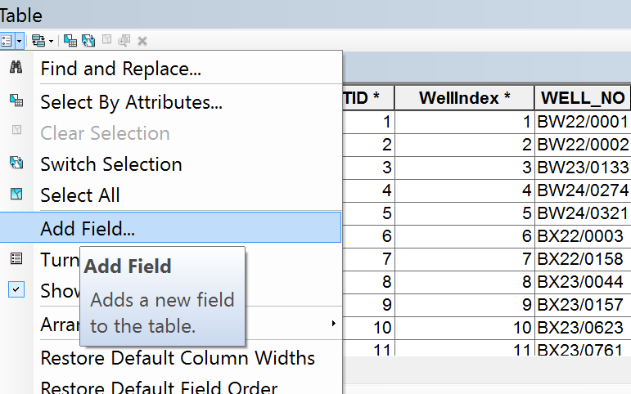
Call this field WaterLevelAboveGD and make its Type Double.
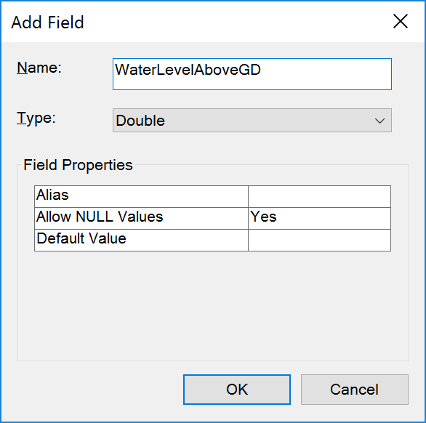
In this new field, open the Field Calculator
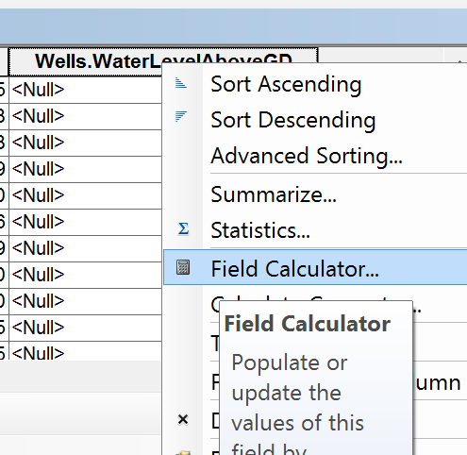
And add together the Reference_RL (elevation of top of well above Geodetic Datum) and the Average_Water_Level (drop from top of well to the water level as a negative number).
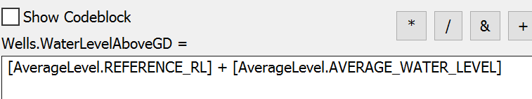
Now we have Average Water Level in the well above Geodetic datum.
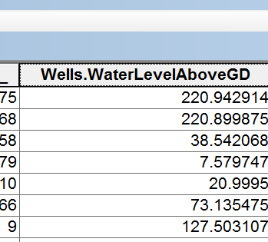
In Customize/Extensions make sure the Spatial Analyst extension is turned on
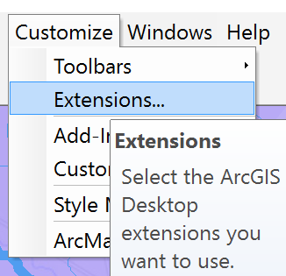
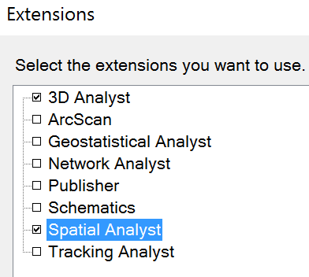
Now let’s draw a water level map using the Inverse Distance Weighting (IDW) method. Search for IDW in the Search tab at the top right of ArcMap.
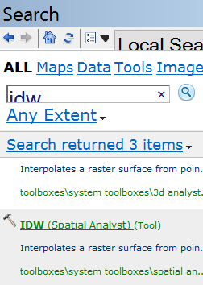
Open the IDW tool and use Wells as the Input Point Features, and Z value field as WaterLevelAboveGD.
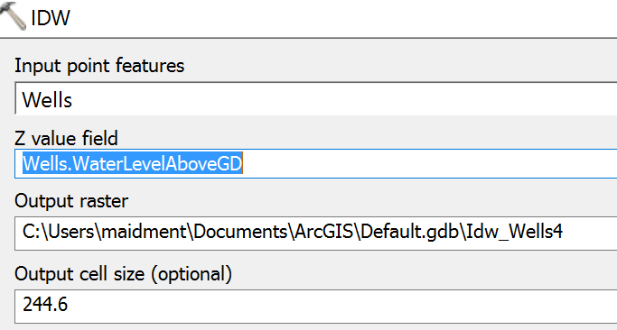
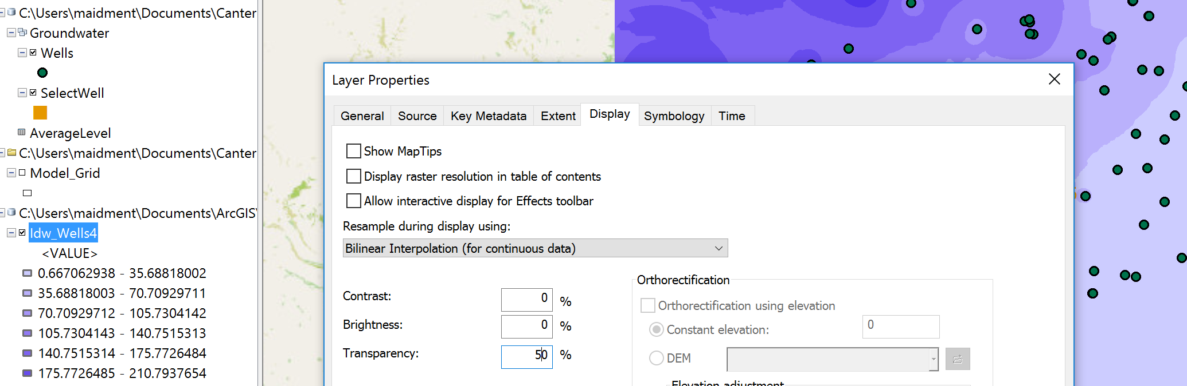
Color the map in shades of Blue and make the Display have 50% transparency so you can see other things below the map.
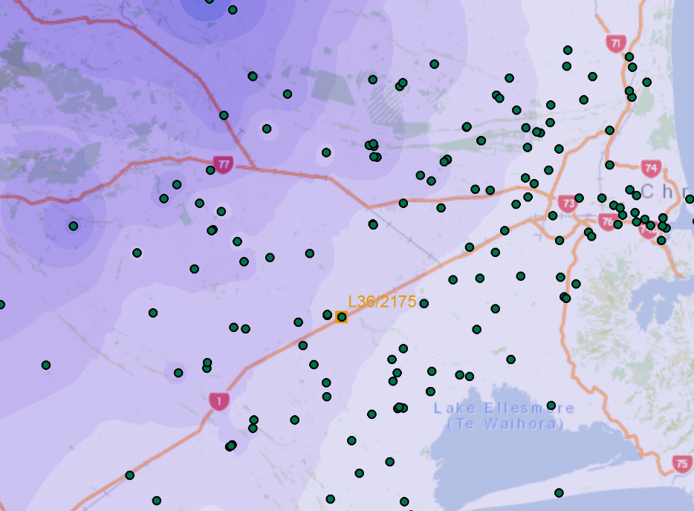
And you’ll get a rather nice map that shows how groundwater levels are higher near the mountains and diminish towards the coast in a fairly uniform pattern.
Export the WaterLevelMap grid to the Canterbury geodatabase.
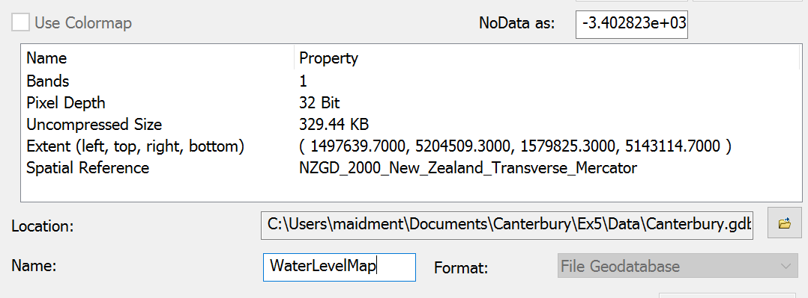
Add the RiverLines for the Selwyn catchment that we used in Exercise 3. Zoom in again to the area downstream of well L36/2175
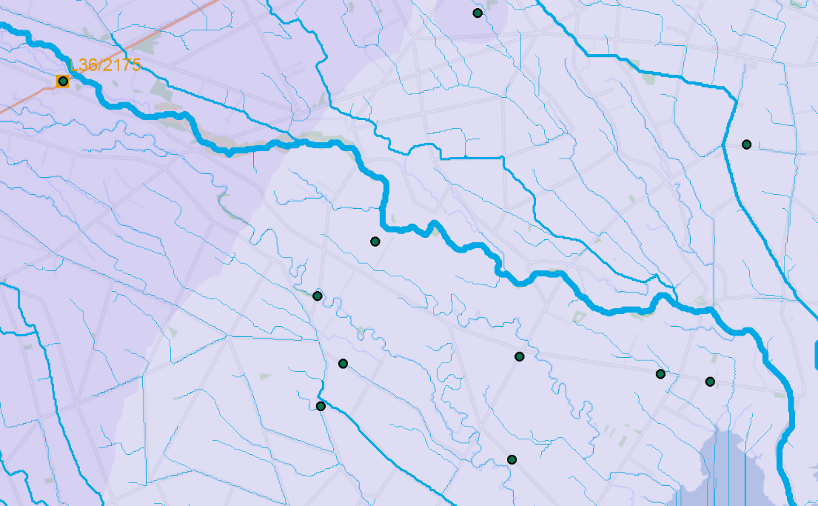
Open the Measure tool in ArcMap
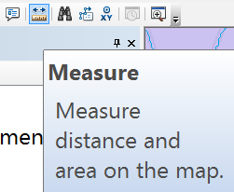
and set the Distance measure in meters.
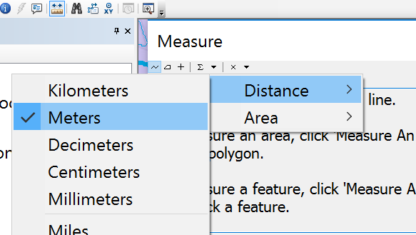
The straight line measure between this well and Te Waihora/Lake Ellesmere is 17,099 meters
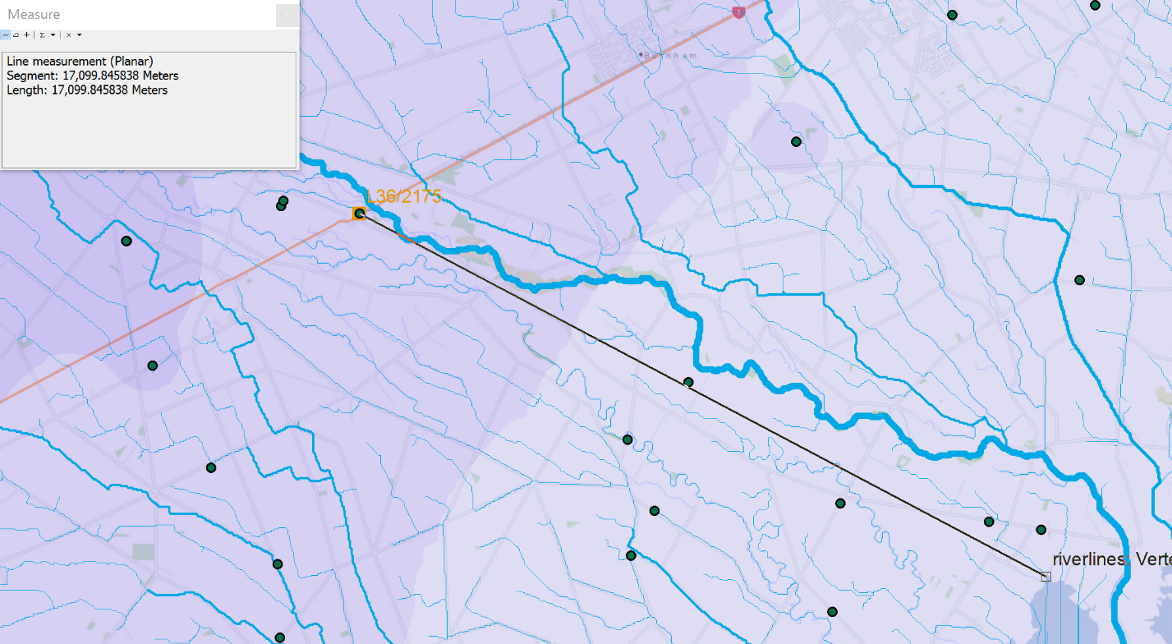
If you query the WaterLevelMap near the L36/2175 well, you’ll get a value of approximately 61 meters
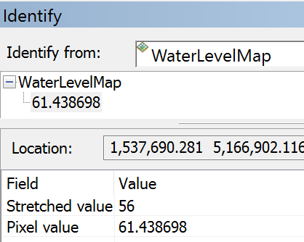
And if you similarly query the WaterLevelMap near Te Waihora/Lake Ellesmere, you’ll get a value of about 7 meters. Since Te Waihora/Lake Ellesmere is at approximately sea level (Geodetic Datum ~ 0), what this means is that the aquifer is artesian and water flows freely from wells without being pumped when you are near the coast.
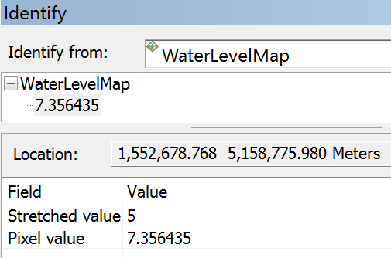
We can compute the slope of the WaterLevelMap along this line as
$$\frac{dh}{dL}=\frac{61.43-7.35}{17099}=0.003163 m/m$$
This means that the fall of the water level (dh) is about 3 meters per km of flow distance (dL). If we take this gradient and multiply it by an estimate of the average conductivity that we worked out earlier (82 meters/day), you get a measure of the Darcy Velocity
$$q=K_{avg}\frac{dh}{dL}=82*0.003163=0.259 m/day$$
and if we divide the Darcy Velocity by the average porosity, n, of about 0.1, we get an estimate of the actual seepage velocity V_{s} of water in this aquifer
$$V_{s}=\frac{q}{n}=\frac{0.259}{0.1}=2.59 m/day$$
This means that water seeping through the aquifer from the area of Well L36/2175, would reach Te Waihora/Lake Ellesmere:
$$Travel Time= \frac{L}{V_{s}}=\frac{17099}{2.59}=6593 days=18.1 years$$
If you compare this to the estimate of travel time in the adjacent Selwyn River that we did in Exercise 3, of about 2 hours you can see the huge difference in travel times of contaminants in surface and groundwater systems. Please bear in mind that the Selwyn aquifer is a 3D flow system and many approximations have been made to get the travel time estimate we’ve made here. More detailed modeling using Modflow and related programs is needed to get a more accurate estimate of this time.
To be turned in: Make a WaterLevelMap of the Selwyn aquifer and estimate the travel time to Te Waihora/Lake Ellesmere from the well you chose in Question 2.
- Items to be Turned In
- Make a map of the observation wells over the Selwyn aquifer. How many wells are there? How many observations have been made at these wells (Hint: Use the Reading_Count attribute). What is the average number of observations per well in the region?
- Choose another observation well from the dataset and prepare a similar description of it like the one you’ve seen above for L36/2175. How does your well compare with L36/2175? [Hint make sure this well is upstream of Te Waihora/Lake Ellesmere because this is important for Question 4].
- Prepare an aquifer layer table like the one above for the Model_Grid cell that contains the observation well that you chose for Question 2. Does your cell have a greater or lesser transmissivity than the one I selected?
- Make a WaterLevelMap of the Selwyn aquifer and estimate the travel time to Te Waihora/Lake Ellesmere from the well you chose in Question 2.

