Building a Hydrologic Base Map
Prepared by David R. Maidment
Waterways Centre for Freshwater Research
University of Canterbury

14 March 2018

Goals of the Exercise
This exercise shows how to develop a hydrologic base map for a catchment showing the catchment boundary and the rivers and streams within it. This is done in two ways – for the Rakaia river in Canterbury using the NZ Digital River Network, and for the Puriri river catchment in Papua-New Guinea using ArcGIS Online ready to use Hydro Services.

Computer and Data Requirements
To carry out this exercise, you need to have a computer, which runs ArcGIS Desktop version 10.5. This exercise will also work with version 10.4.1 if you do not have access to Version 10.5. You will need a login and password for the University of Canterbury Organizational Account for ArcGIS Online.

Part One: Basemap using the NZ Digital River Network
Check out information about the New Zealand Digital River Network, or REC (River Environment Classification) at https://www.niwa.co.nz/freshwater-and-estuaries/management-tools/river-environment-classification-0 You can download a copy of the dataset for all of New Zealand at: https://www.niwa.co.nz/static/web/nzRec2_v4.gdb.zip This is a 487 MB file, so you need a good Wifi connection or wired internet connection to do this. When you uncompress this file, it looks like this
The nzRec2_V4.gdb is a 2.2 GB geodatabase covering all of New Zealand.
If you have the full REC database and you open ArcMap and look at the REC Geodatabase, below is what you see. The key items are the two Feature Datasets called Hydro and rec2-watersheds The other items shown are related attribute tables dealing with details of the REC classication of New Zealand Rivers that we are not going to get too much into in this class.
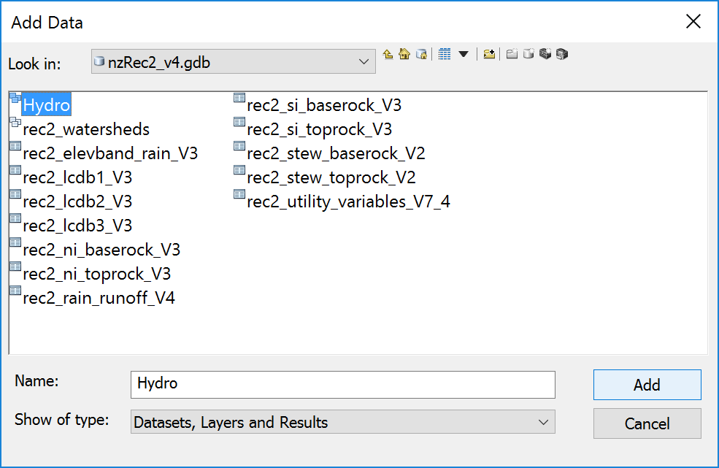
Click on the Hydro Feature Dataset and add it to the map display, and you’ll see a detailed layout of all of New Zealand.
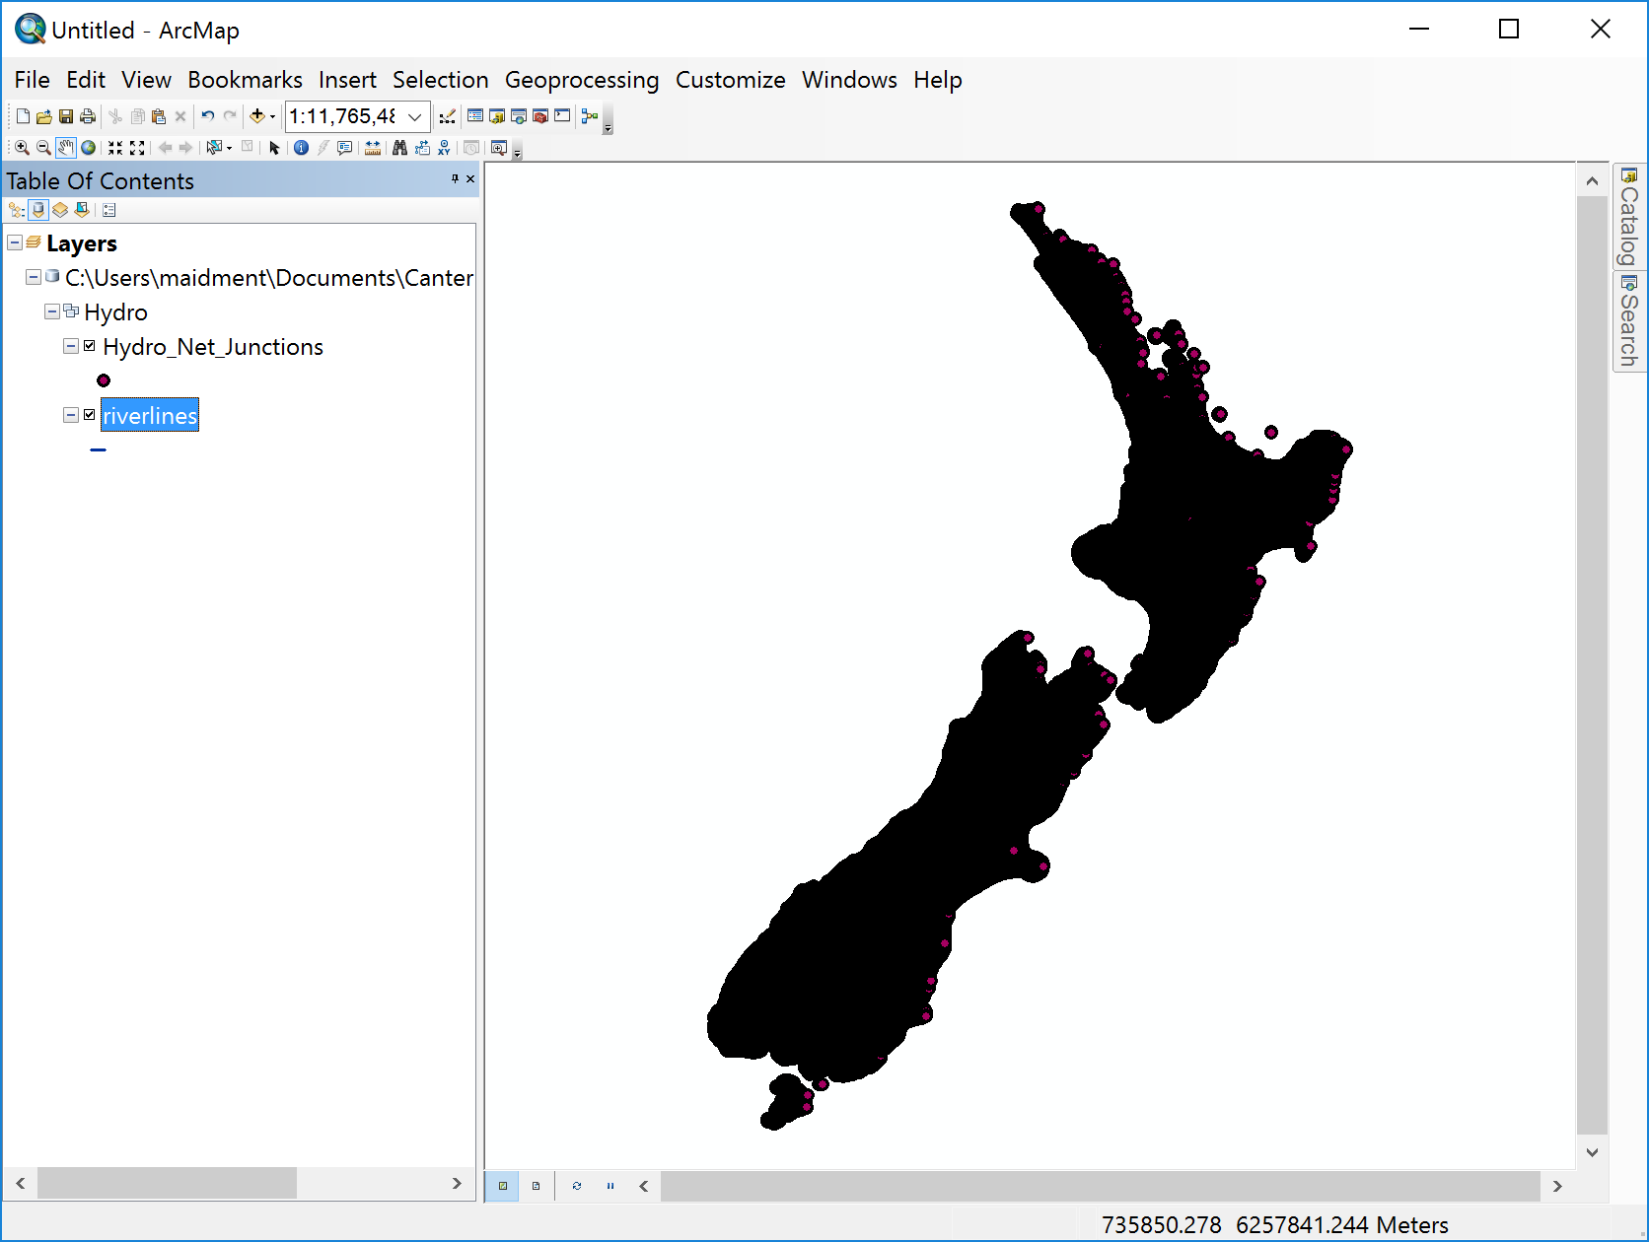
Let’s zoom into Christchurch and see what is there. Turn off the Hydro_Net_Junctions layer and add the NZ Topographic basemap (scroll down in the Basemap layer display if all you see are world maps).
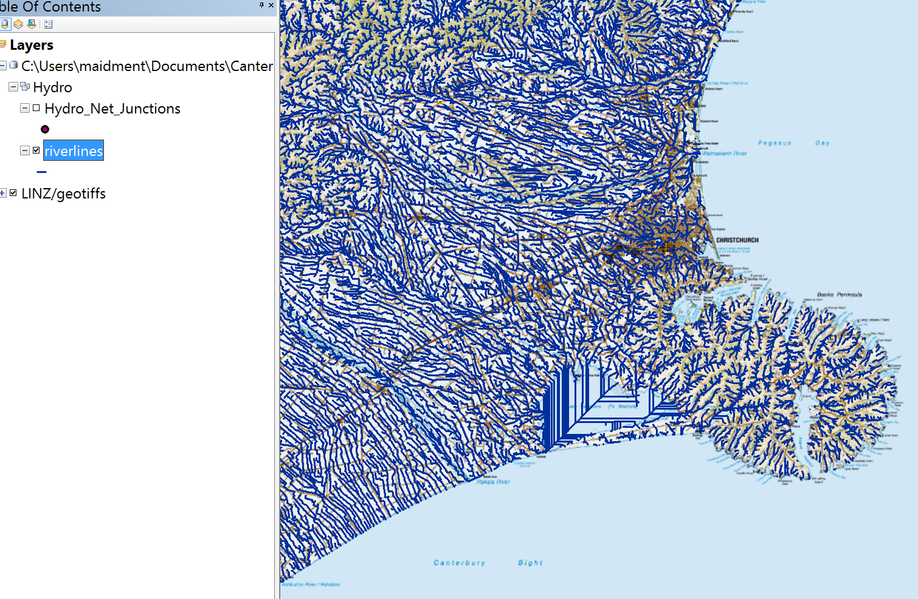
Let’s zoom in to the mouth of the Rakaia River just south of Christchurch. Open the Utility Network Analyst toolbar and use the Flow/Display Arrows to show that the network has flow directions assigned on it.
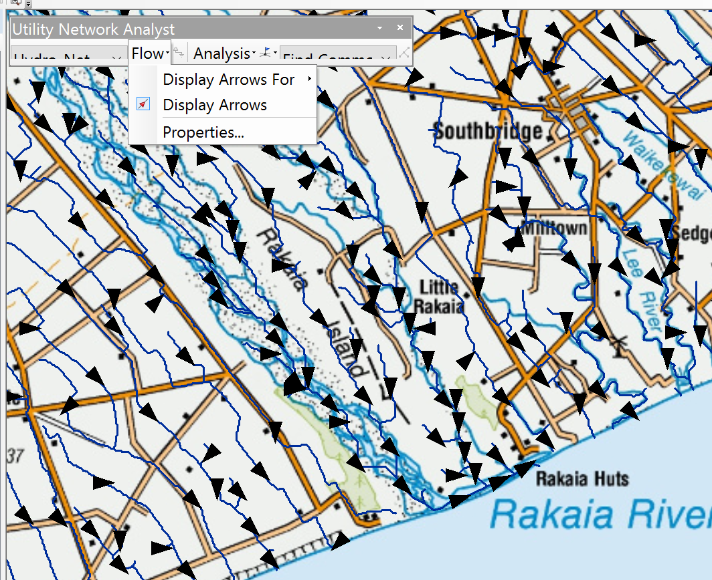
Add an Edge Flag on a riverline at the mouth of the Rakaia River and select Trace Upstream from the Trace Tasks toolbar. Hit the little Solve button the right of the Trace Tasks toolbar and you’ll get a nice upstream trace graphic in red for the Rakaia River drainage network.
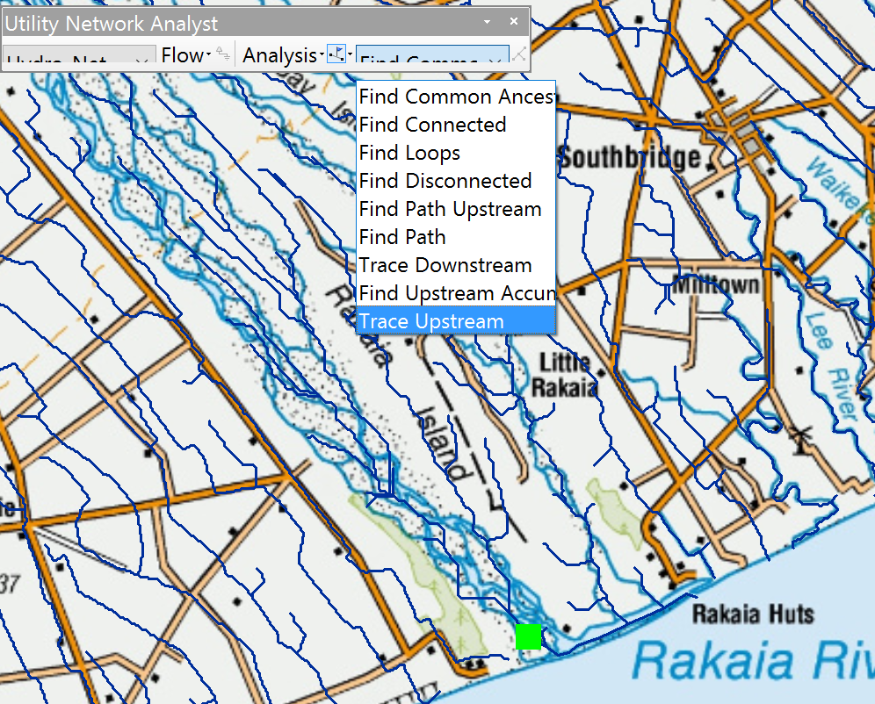
and if you zoom out, you’ll see the upstream trace as a simple graphic.
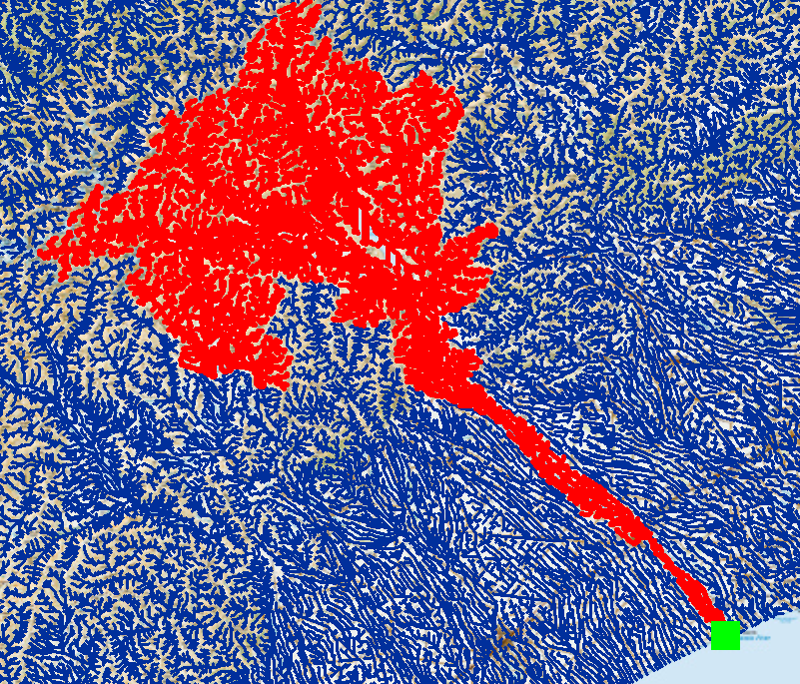
Now, let’s establish a new geodatabase for the Rakaia River data.
Click on the Catalog tab in the top right of the map display and in your folder for Exercise 4, create a New Personal Geodatabase.
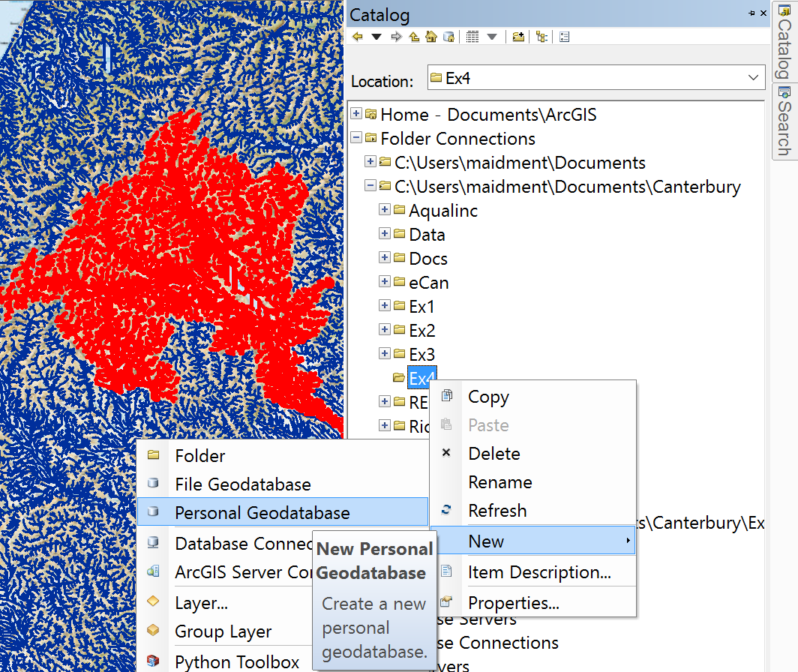
Let’s call this Rakaia. Within this geodatabase, we’ll create a new Feature Dataset.
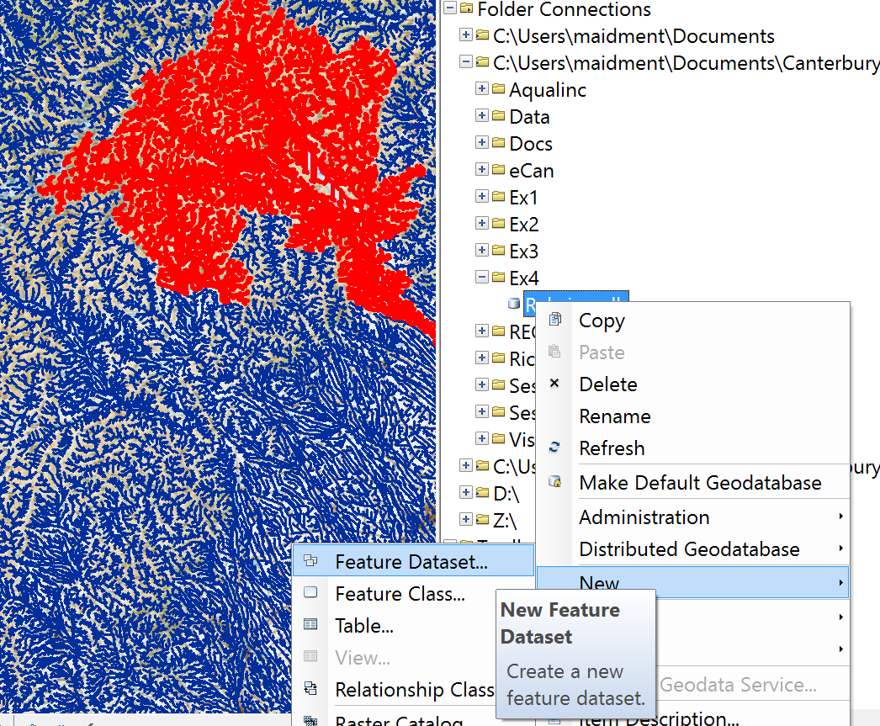
Let’s call this Network (the specific name doesn’t really matter)
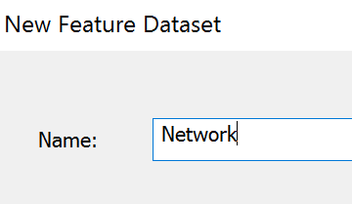
And hit Next to bring up a screen that defines the coordinate system to be used for this Feature Dataset. We’ll use the standard New Zealand Transverse Mercator map projection which is used to define the Riverlines layer that we brought in from the REC:
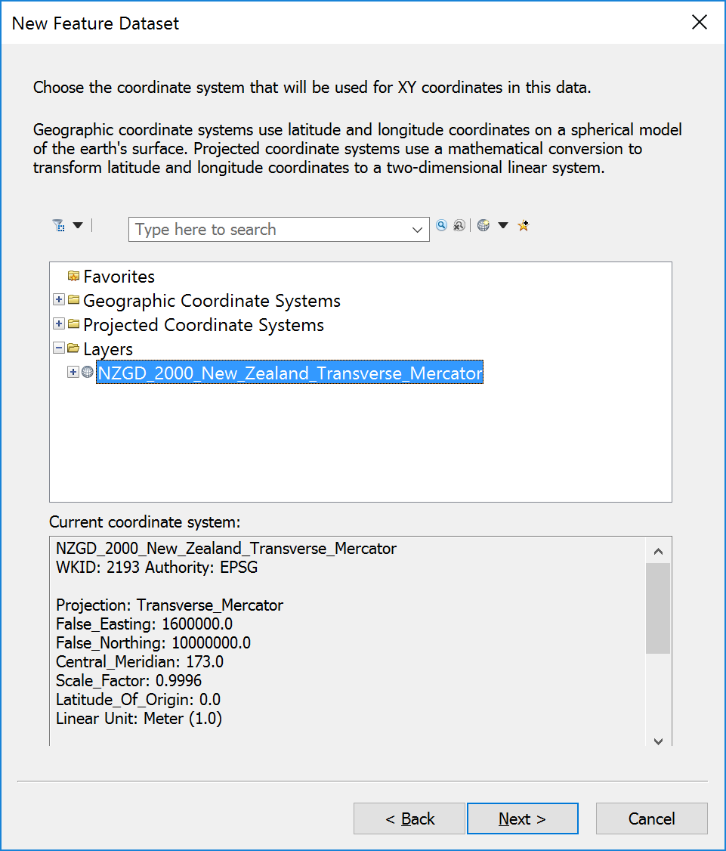
And hit Next again to choose a Vertical Coordinate System, which we’ll ignore in this exercise,
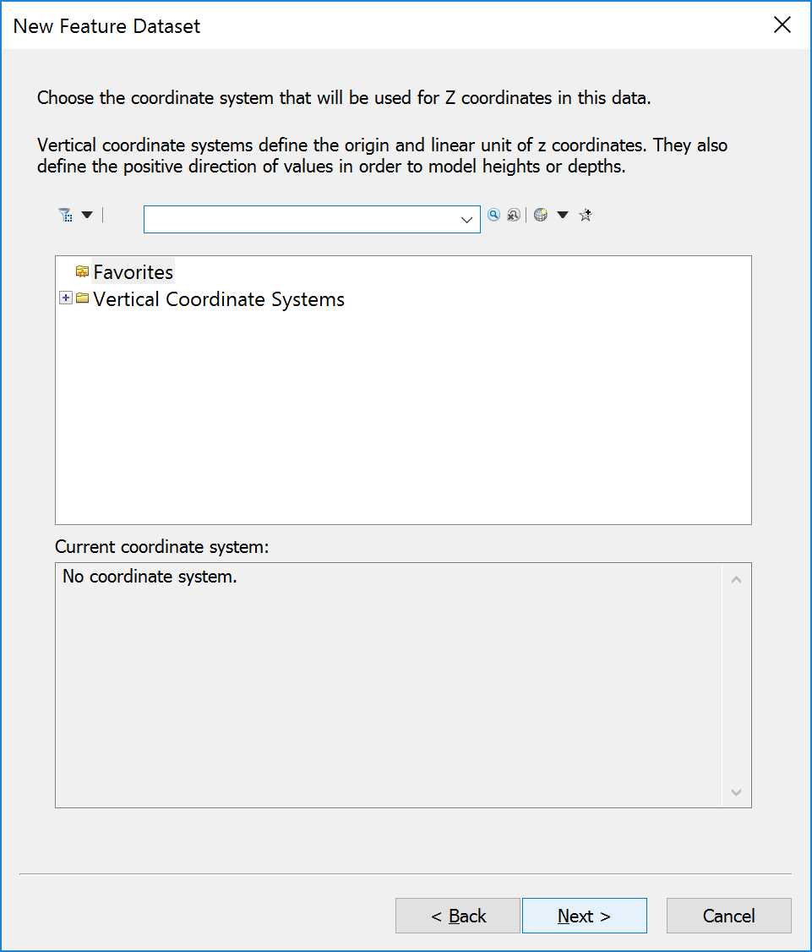
And in the following screen hit Finish and your Network Feature Dataset will be created.
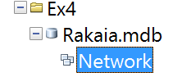
This is a container to put the feature classes in for the Rakaia catchment. Now let’s get some data to put in this Feature Dataset.
In the Utility Network Analyst toolbar, select Analysis/Clear Results
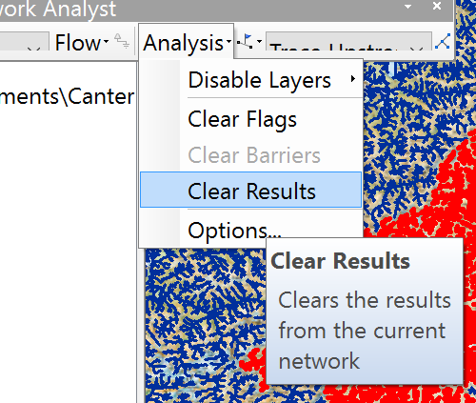
And then in Analysis/Options/Results choose Selection.
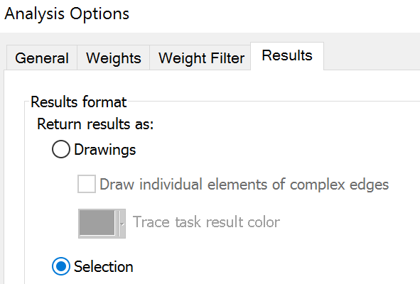
And let’s execute the Trace Upstream task in the Utility Network Analyst toobar again, and we’ll get a set of selected RiverLines.
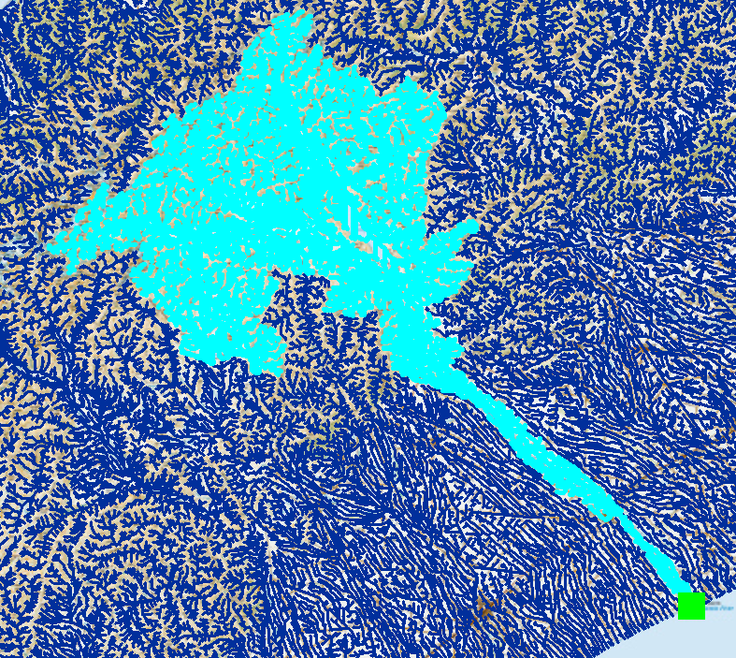
If you open the Attribute Table of the Riverlines feature class, you’ll see the selected reaches and hit the selection button at the bottom of the table, you’ll see that we’ve selected 6081 reaches.
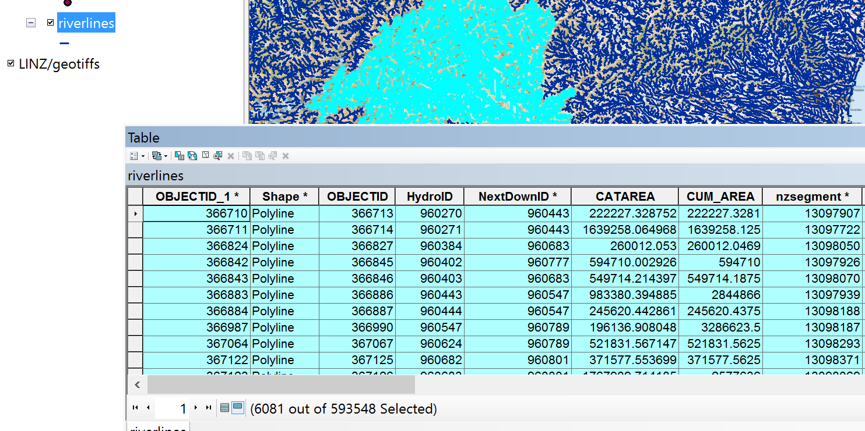
Now let’s export these Riverlines to our Rakaia geodatabase. Right click on the Riverlines feature class and select Data/Export Data
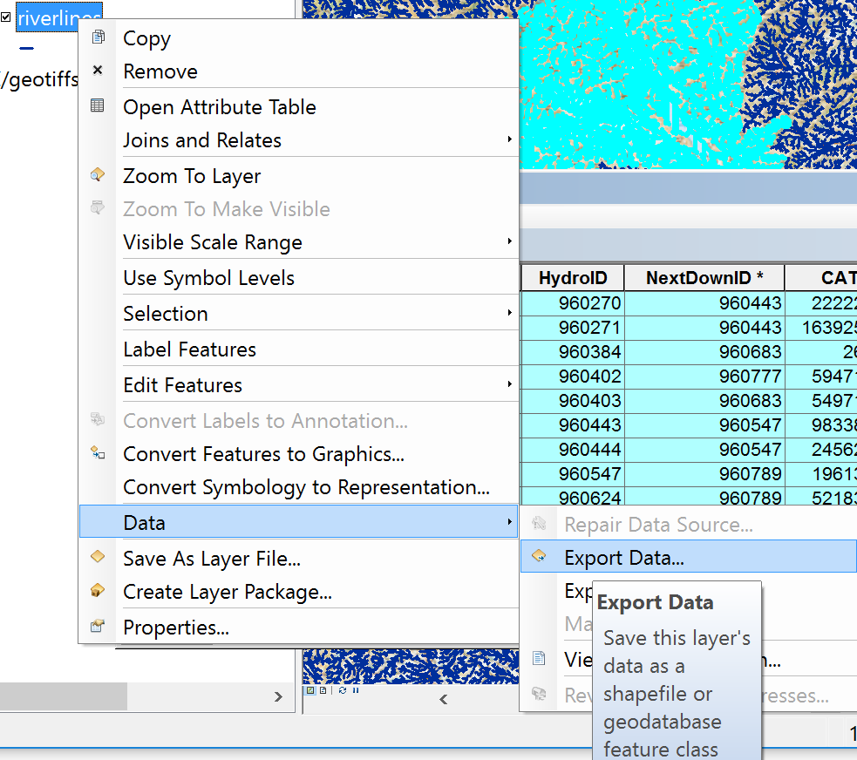
And navigate to the Network Feature Dataset, and save the selected features as a new RiverLines feature class.
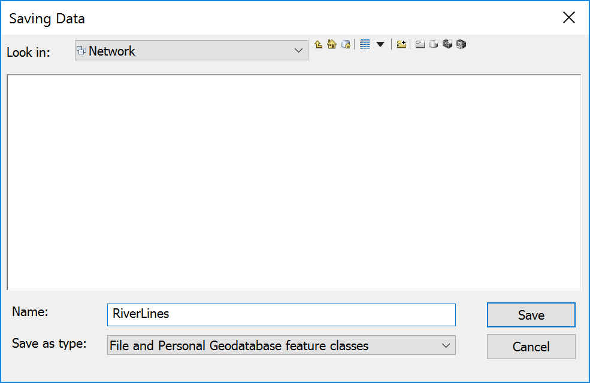
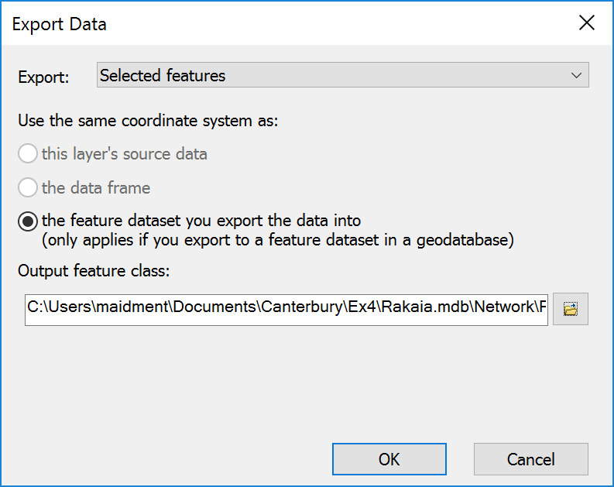
then add the resulting dataset to the map display. Remove the original REC network from the map display
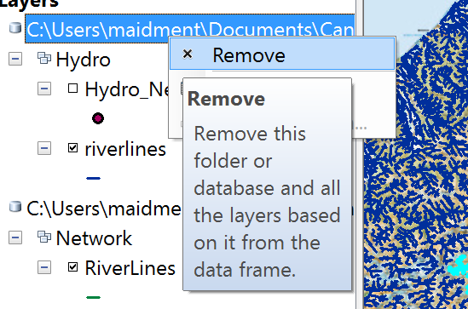
And color the resulting RiverLines in blue. Pretty cool!
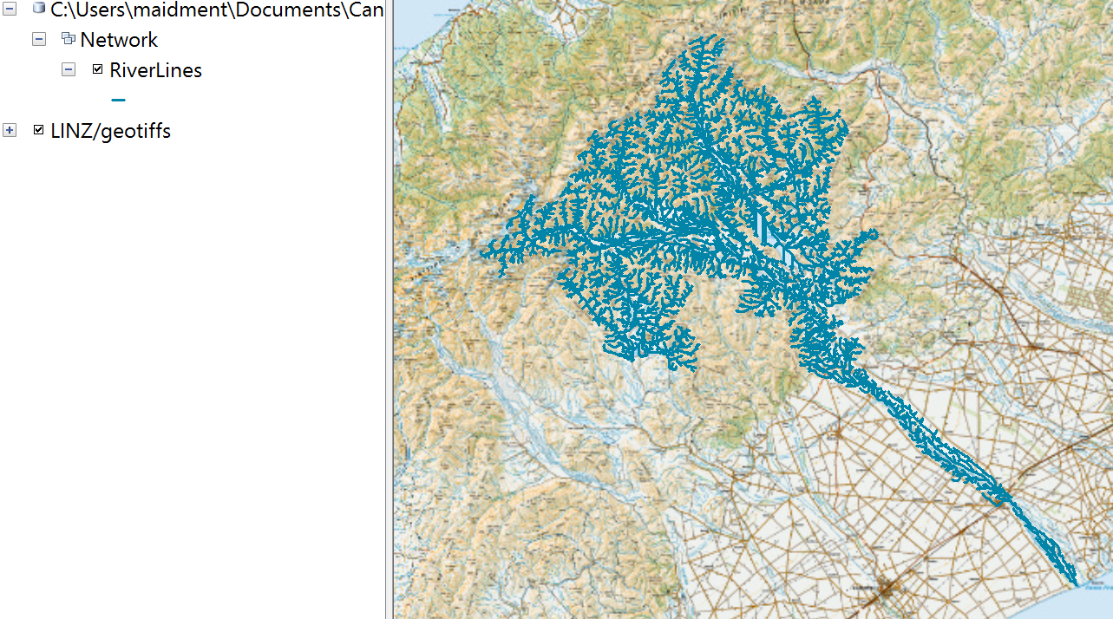
Now let’s symbolize the RiverLines with Graduated Symbols using StreamOrde as the Value Field with 7 Classes and a Blue Template color
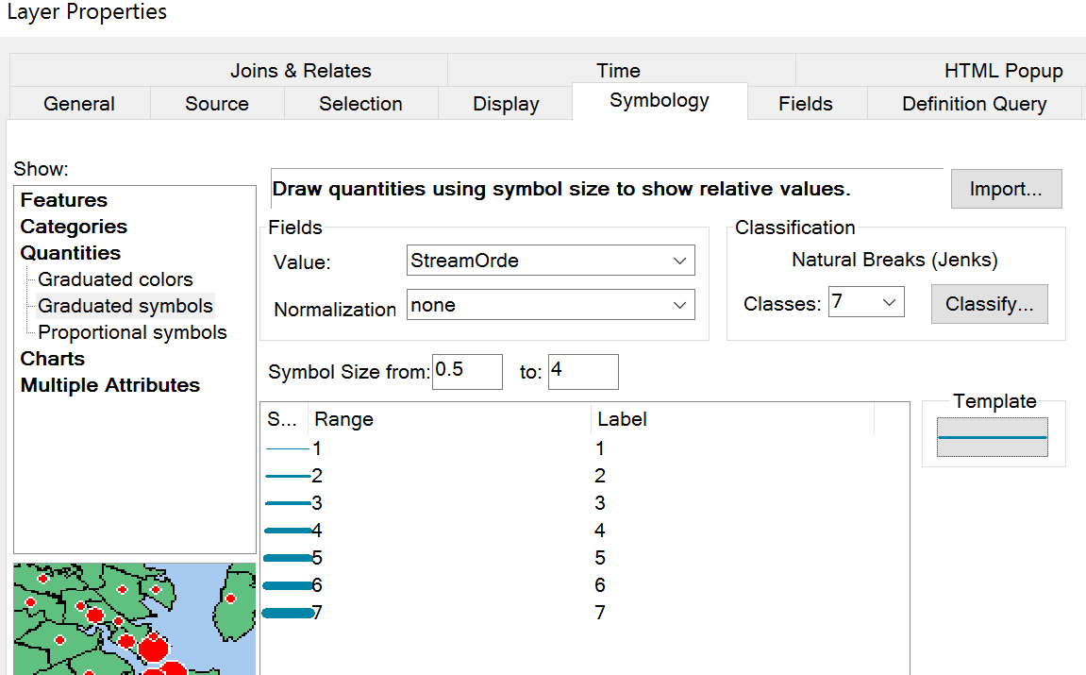
And you’ll end up with a rather beautiful river map.

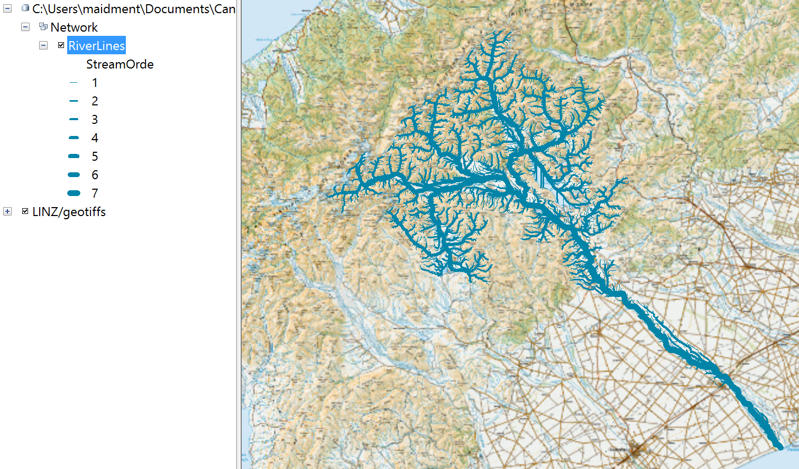
If you zoom in to the upper part of the catchment, you’ll see a nice map of the headwaters of the Rakaia River, including Lake Coleridge.
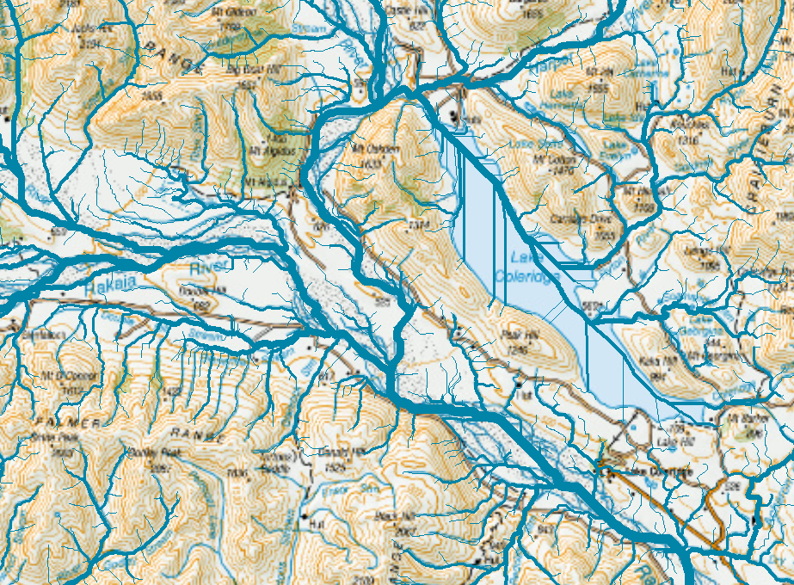
Save your map display using File/Save As in ArcMap as Ex4.mxd
To be Turned In: A map of the riverlines in the Rakaia Catchment. How many RiverLines do we have in the map? What is their total length (Km)? What is their average length (Km)?

Now let’s get some drainage areas to go along with these stream lines. Go back to the REC geodatabase that we started with and add the rec2_watersheds feature dataset,
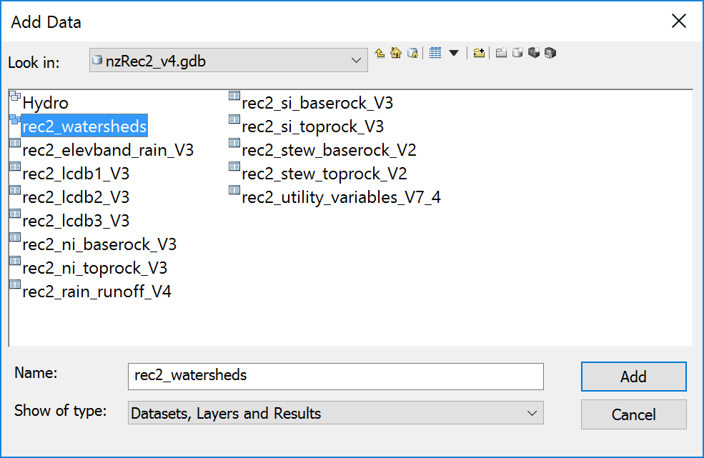
that has only the rec2ws feature class within it.
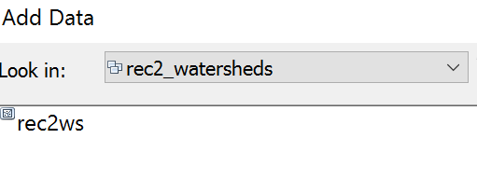
And if you color this in a nice green color, you’ll see an intricate pattern of local drainage areas associated with each reach.
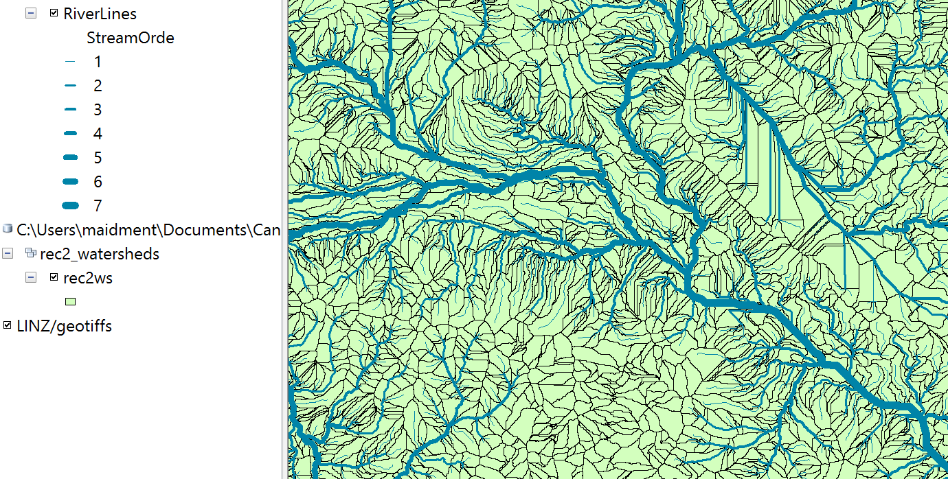
Here is a zoom in to a local area
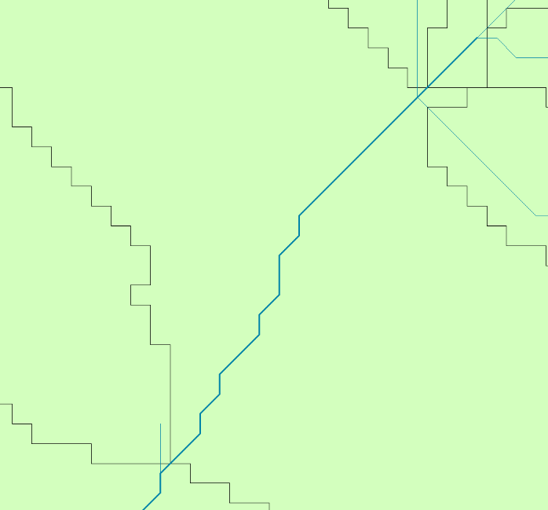
Let’s set the Label properties for the rec2_ws feature class with Label Field nzsegment and green color with Arial 12 symbol size.
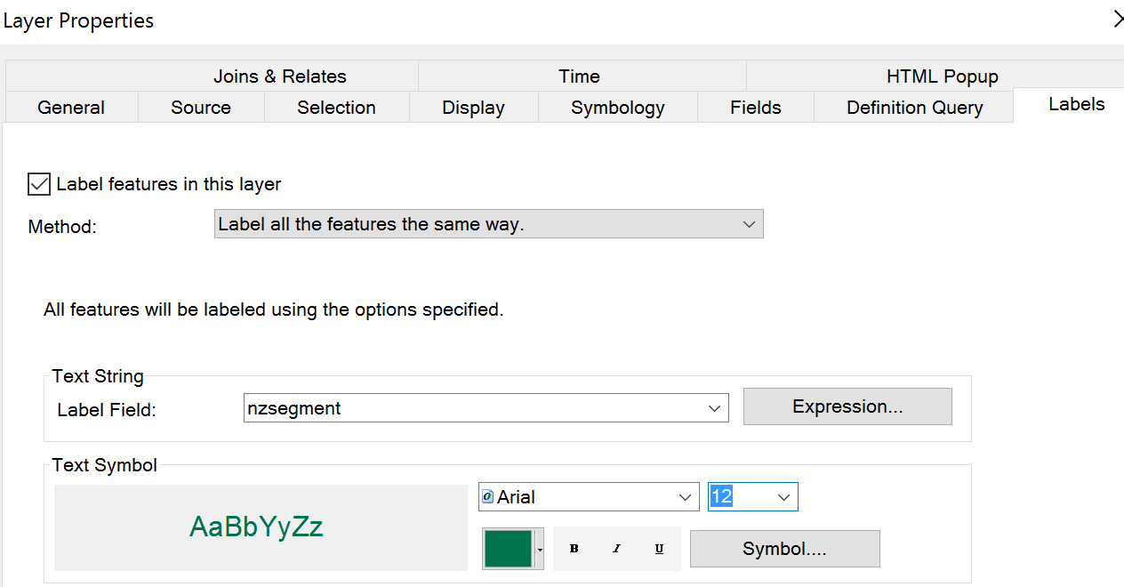
And similarly label the RiverLines with Label Field nzsegment and a blue color with text size 12.
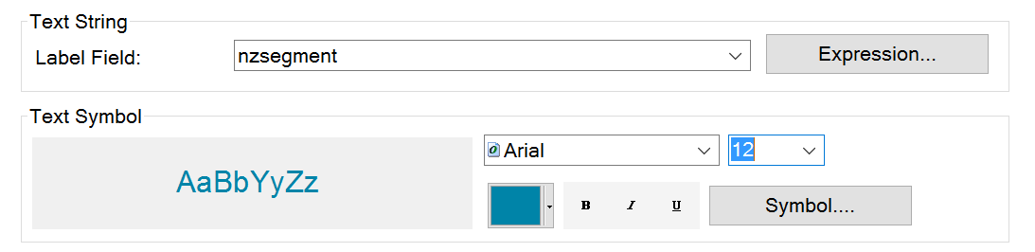
And you’ll see that each RiverLine has an associated local drainage area with the same nzsegment ID number. Pretty cool!
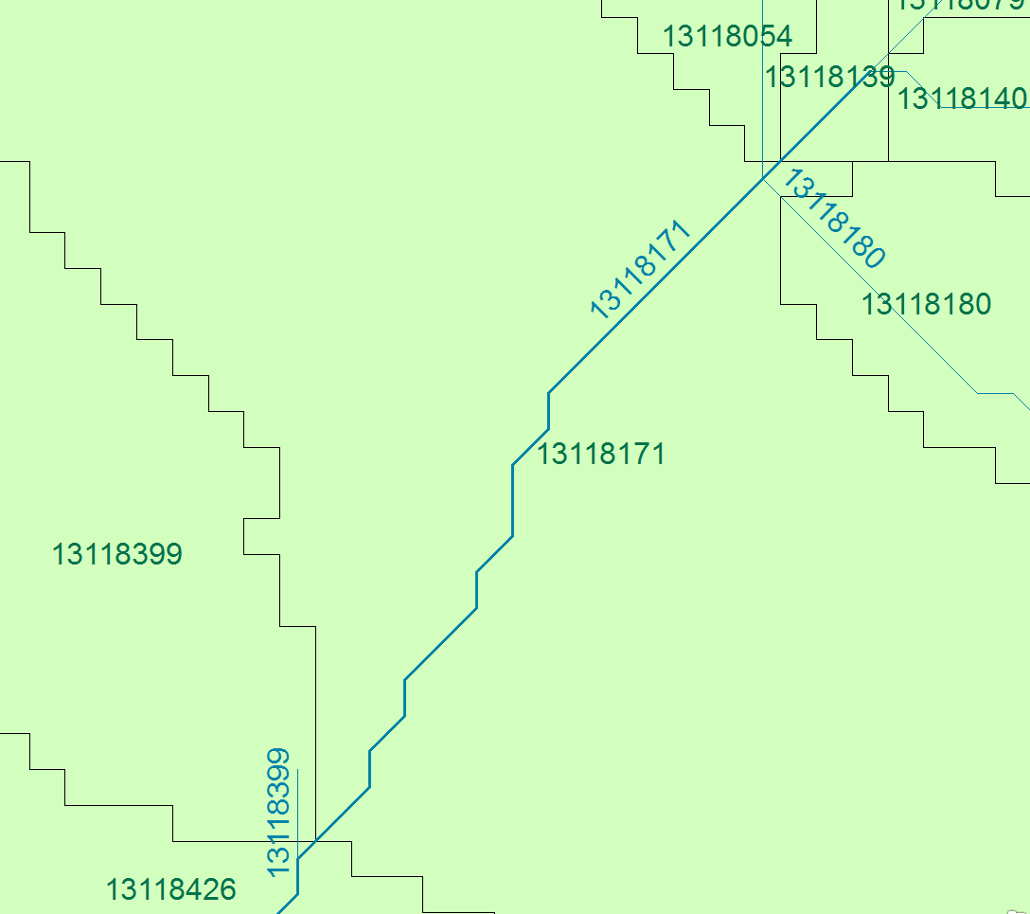
Let’s use this association to choose the rec2_ws features that encompaass the Rakaia drainage basin.
Turn off the display of Labels on the RiverLine and Rec2_ws feature classes.
Right Click on the RiverLine feature class and select Joins and Relates/Relate
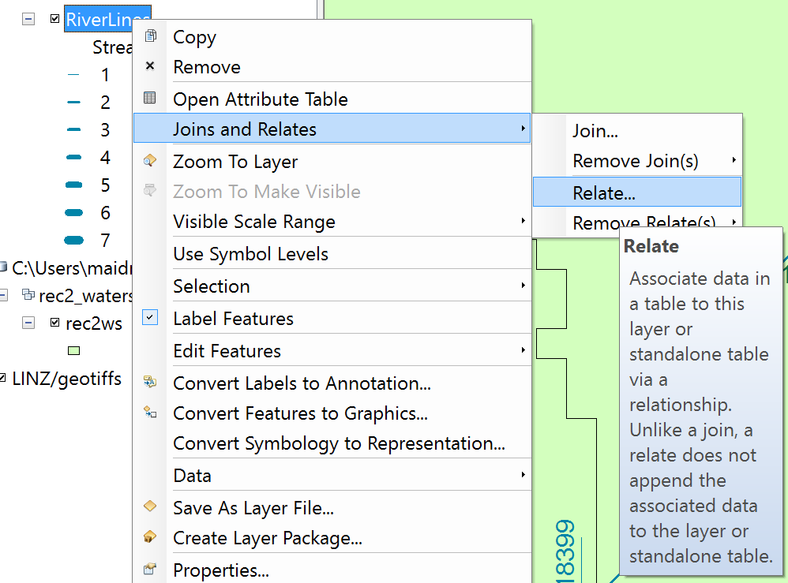
And in the resulting table, select nzsegment as the field that the relate will be based on and rec2_ws as the related layer. I have named this relate RiverLineHasWs to signify the connection between the two feature classes but any name will do.
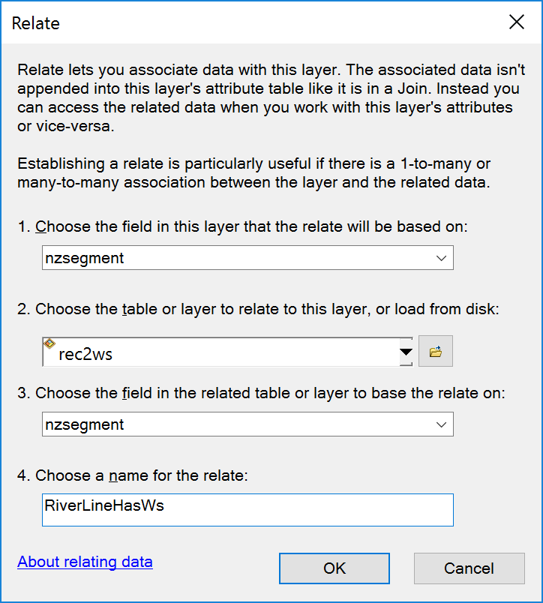
Now let’s Select all the RiverLines
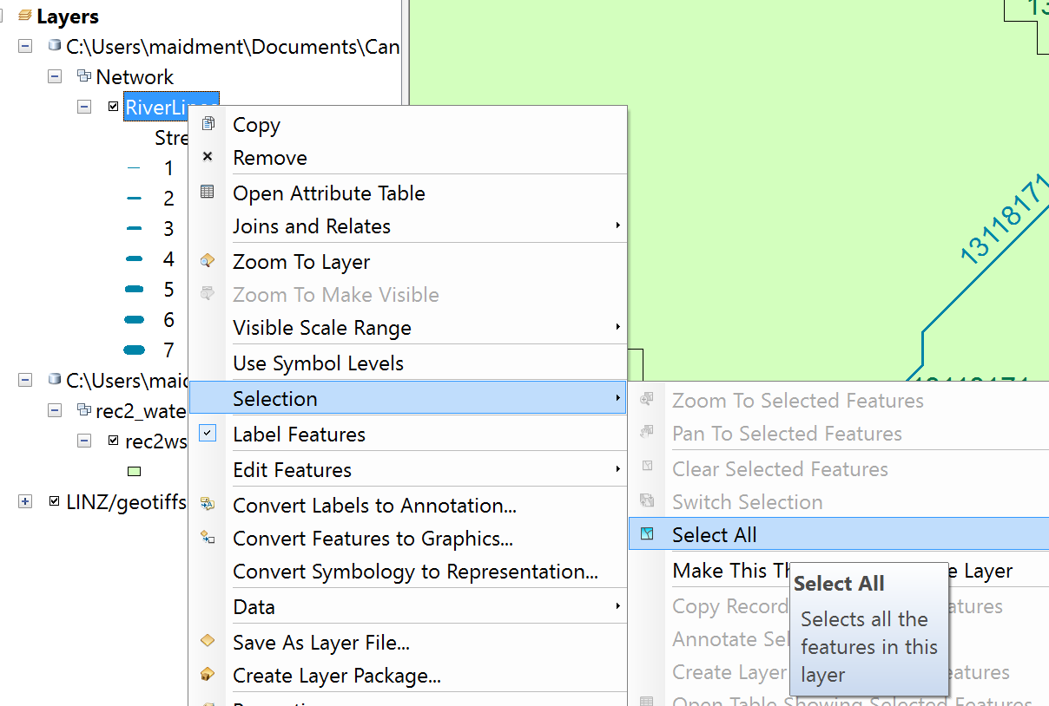
Open the Riverline feature class Attribute Table and select the Table Options in the top left corner of the Table
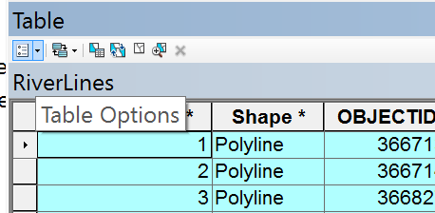
And select the Related Tables/RiverLineHasWS:rec2ws
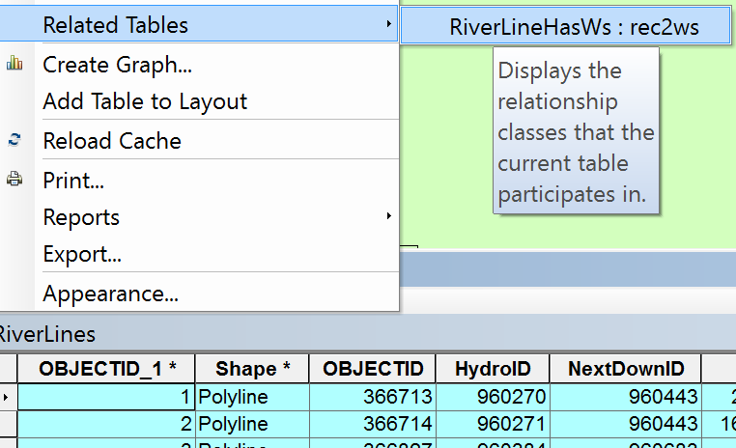
And you’ll see the Attribute Table of the RiverLines feature class pops up with 6081 features selected
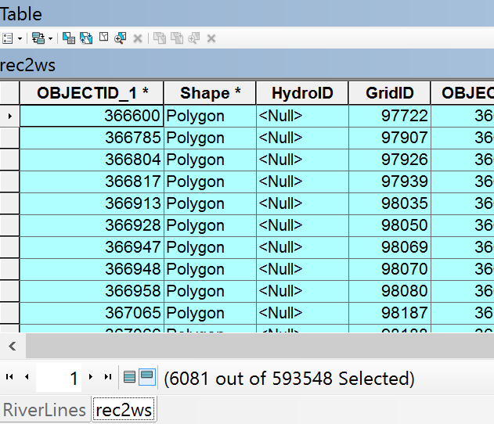
Now right click on the re2ws feature class and select Data/Export Data to export the selected catchment areas for the Rakaia basin
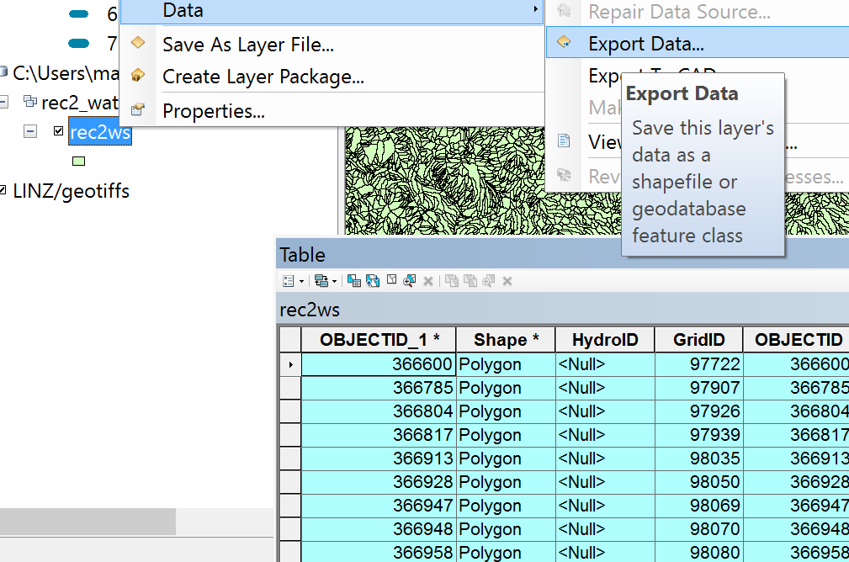
Save the data in the Network feature dataset as before, and call the feature class RiverLineCatchment
Remove the display of the national rec2ws features
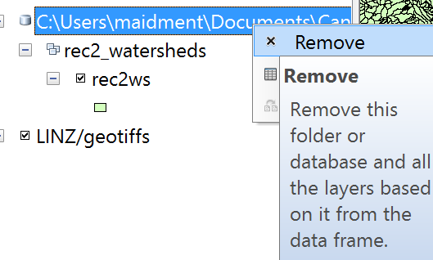
Clear the selected RiverLine features
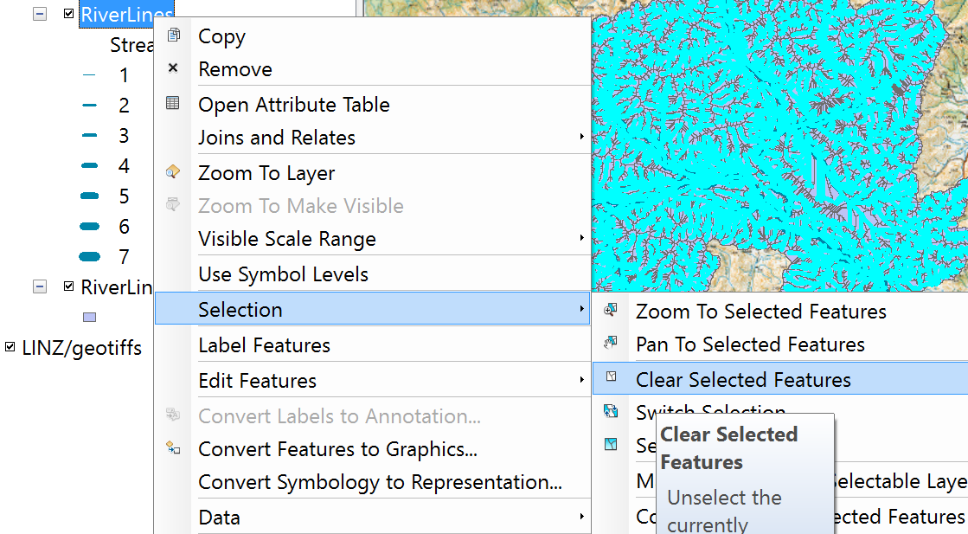
And now you’ll have just the features we want. Let’s color the RiverLineCatchments green and zoom in to check out what we’ve got and you’ll see we have a complete coverage of the land area that drains to these river features! Wow. That is really cool! This is a beautifully constructed geospatial dataset.

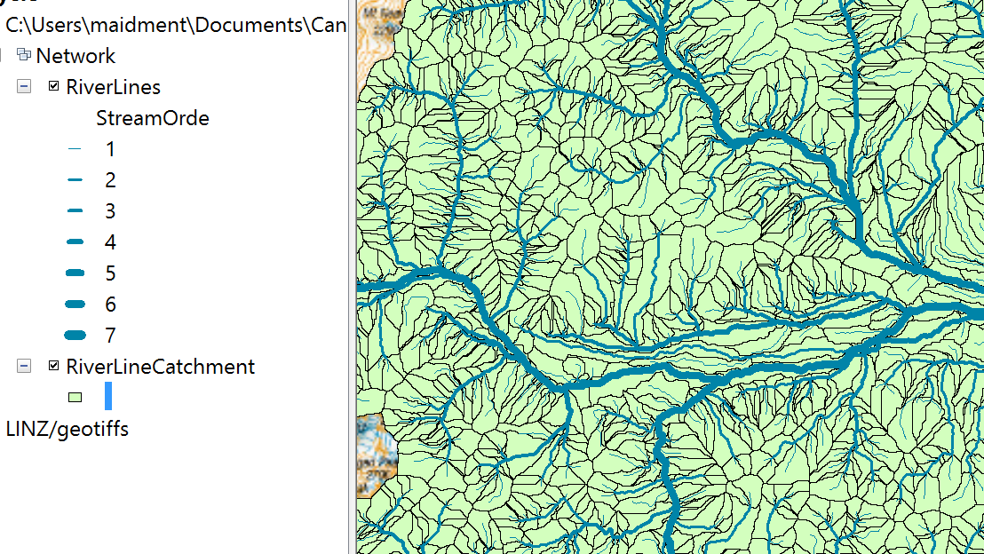
Let’s make a single polygon that is the whole Rakaia catchment boundary. In the Search box in the upper right hand corner of ArcMap, select Dissolve (Data Management).
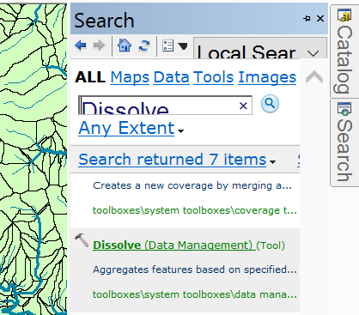
Select the Input Features as RiverLineCatchment and the Output Features as a new feature class called Boundary in the Network feature dataset.
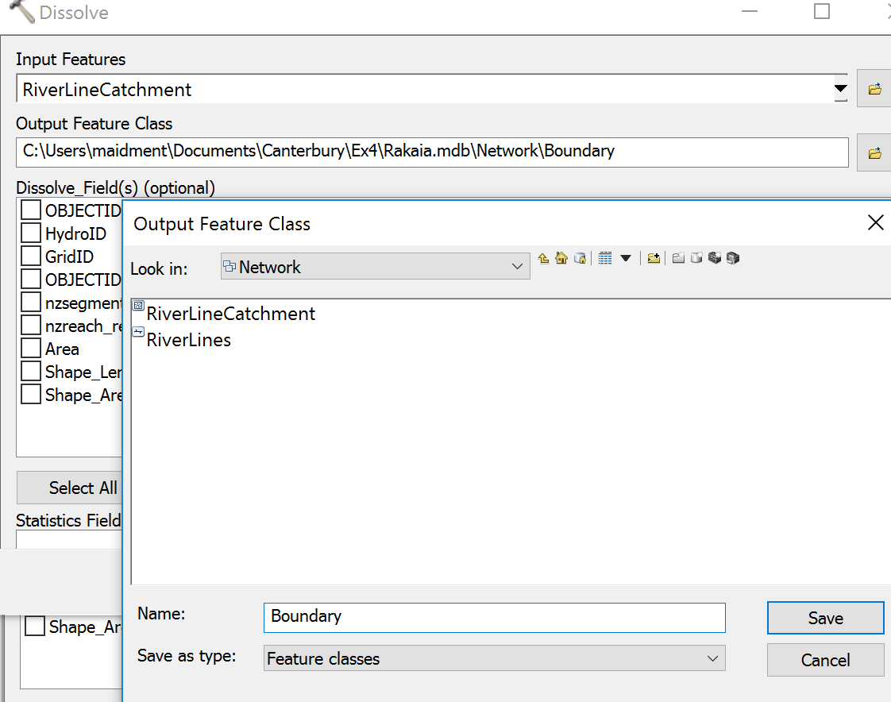
It looks like nothing is going on but then after a little while the screen display shakes a bit and you’ll see a new boundary polygon appears
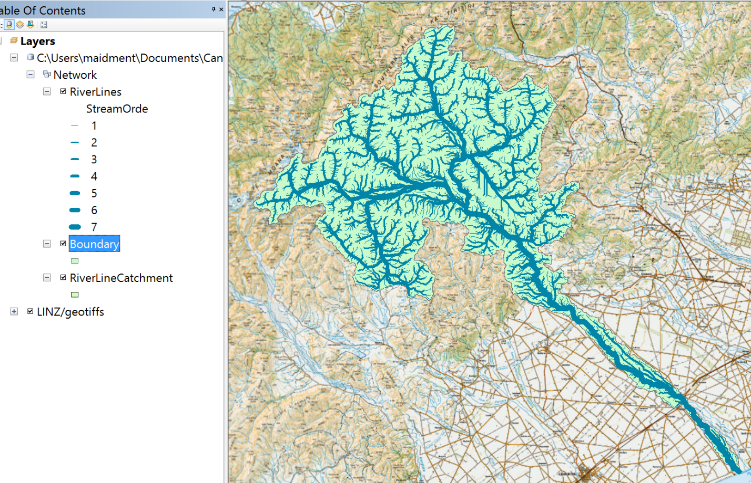
Lets symbolize the Boundary feature class as Hollow, with a Green outline width of 2
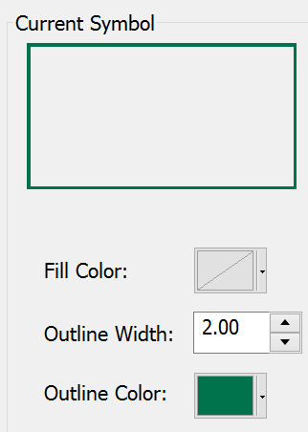
And now you’ve got a pretty nice hydrologic basemap for a study of the Rakaia River Catchment
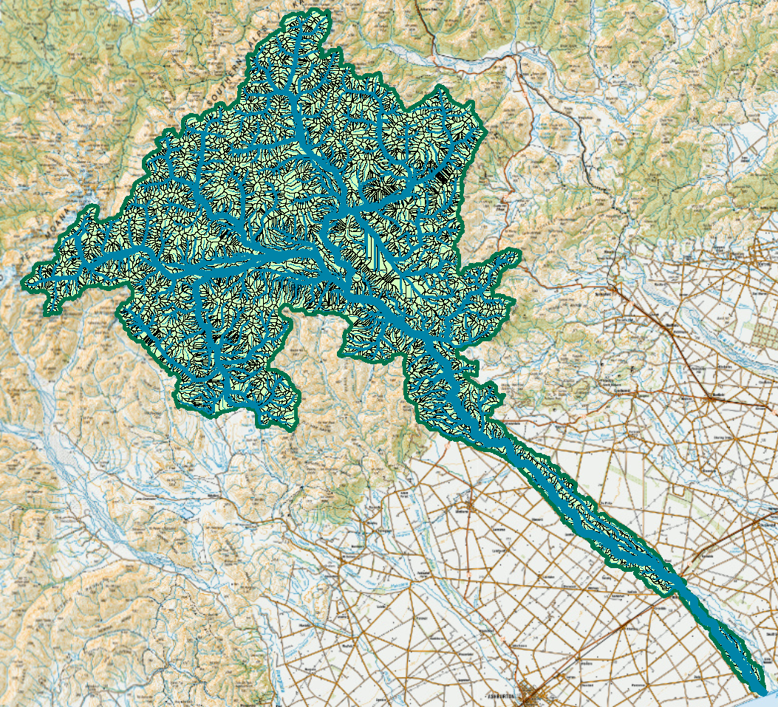
Save the Ex4.mxd project file
To be Turned in: A Basemap of the Rakaia River Catchment. What is the drainage area (Sq Km) of this catchment?

Part Two: Basemap using ArcGIS Online Hydro Services
Now let’s suppose we are not in a country like New Zealand that has a Digital River Network dataset. We are going to construct a Basemap for the Purari River in Papua New Guinea using ArcGIS Online Hydro Services.
Make sure you’ve saved the Ex4.mxd project file from the first part of this exercise. Let’s open a new ArcMap document
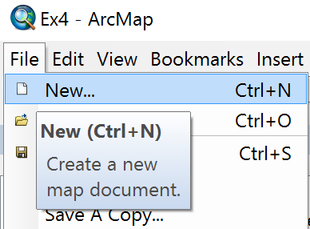
Add the World Topographic Basemap
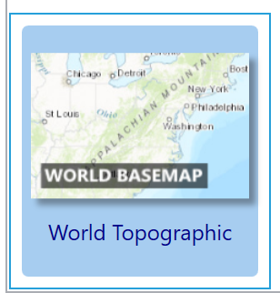
And lets zoom into Papua New Guinea
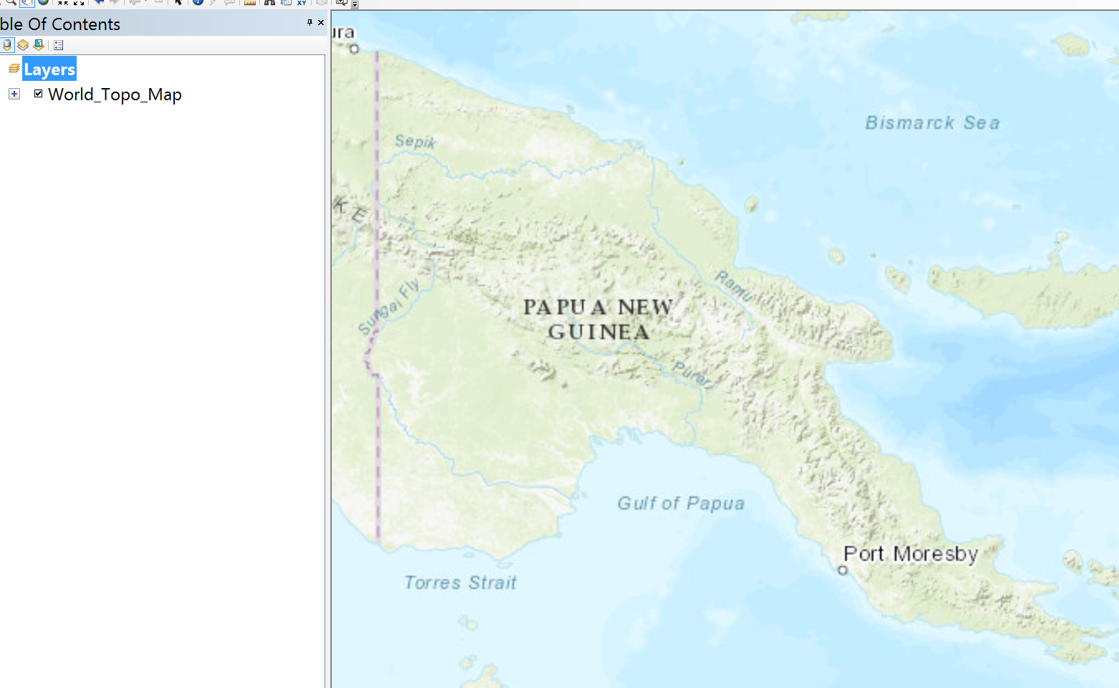
Let’s save this Map Document as Ex4World.mxd
Now we are going to use Geospatial services that ESRI has mounted in the cloud. File/Sign In to ArcGIS Online using your University of Canterbury Organizational Account login
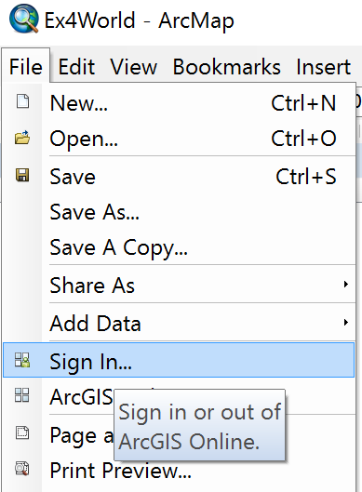
Your Username is WATR_Surname, whatever your surname is, and the password is whatever you established as when you responded to the request from the UC Organizational account request you received recently.
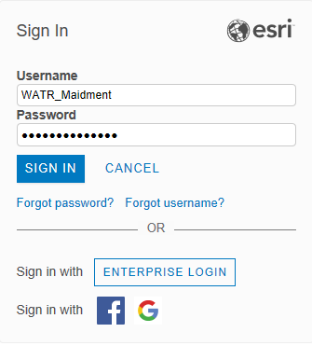
In the Catalog tab at the top right of ArcMap if you look right down on the bottom, you’ll see Ready to Use Services (University of Canterbury) which are services you now have access to by virtue of belonging to the ArcGIS Online Organizational Account at UC. One of these categories of services is for Hydro
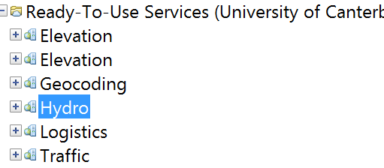
And if you expand this out, you’ll see that there are Trace Downstream and Watershed tools that are like those we’ve been using with the New Zealand Digital River Network, except that these tools apply anywhere in the world and they operate from remote land surface terrain datasets in the cloud that you don’t have to download to use.
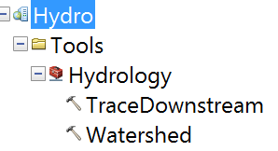
In the center of Papua-New Guinea, there is a rather large river called the Purari which flows near the town of Mendi.
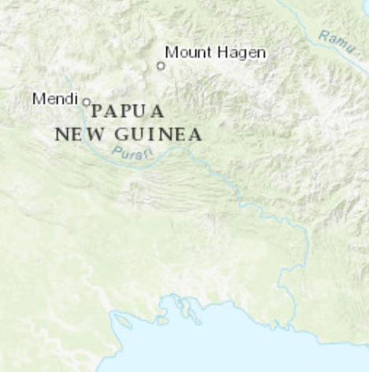

Click on Trace Downstream and in the resulting box, select the FINEST dataset to work with and move the cursor to a point near Mendi and click a point location to begin your trace from.
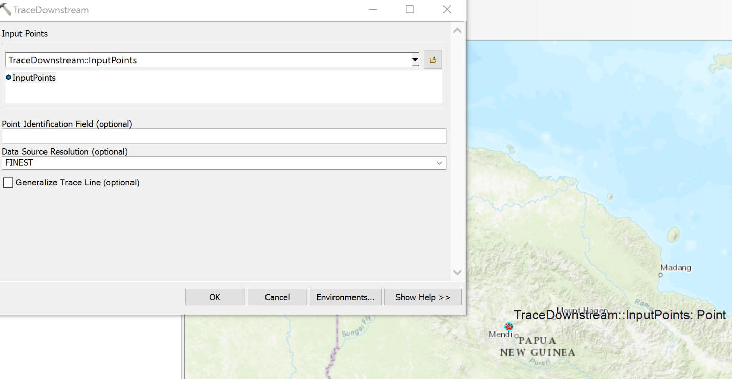
And now you’ll see a nice Trace Downstream river line from Mendi to the coast
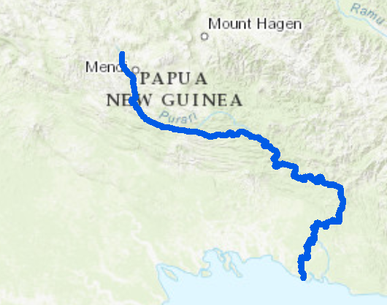
Now let’s zoom in near the coast and click on the Watershed tool. Make the snap distance 500 meters, and Data Source Resolution FINEST and click on a point on the Purari River trace near the outlet at the coast.
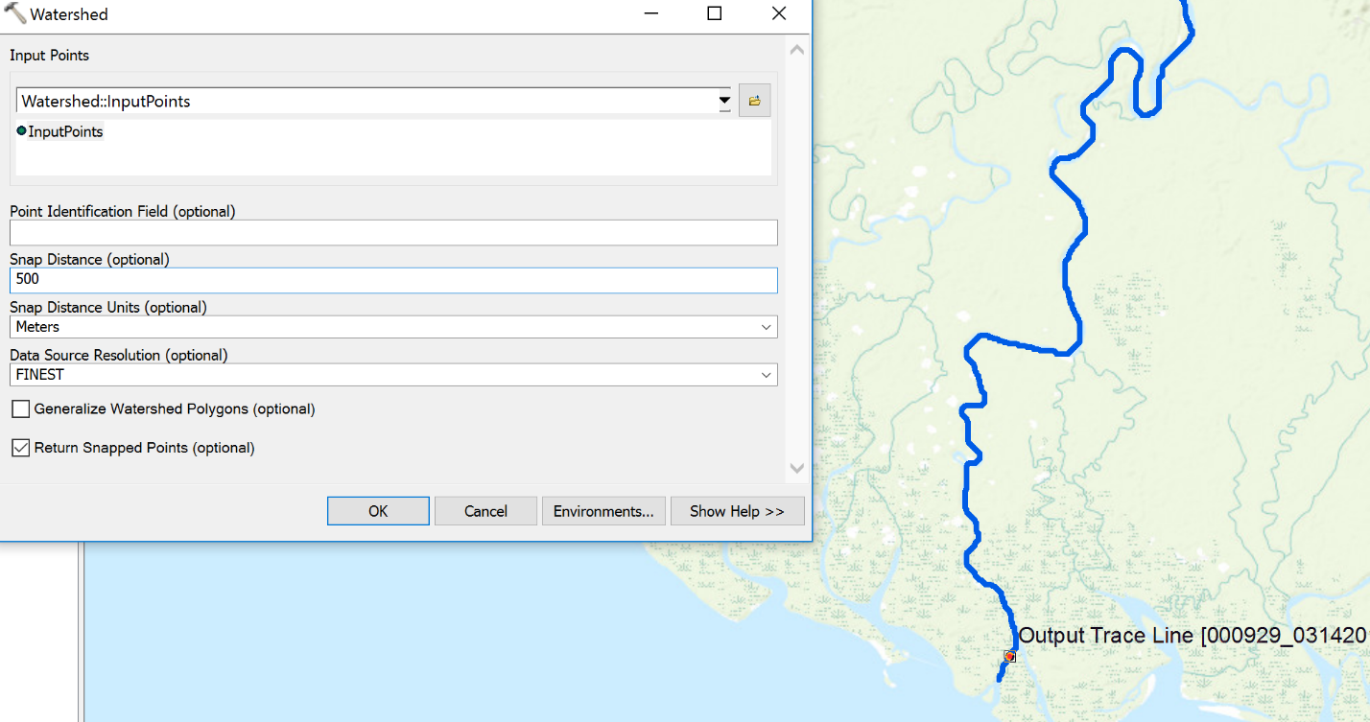
And you’ll get a new point in your map display and a drainage area polygon (after a bit of waiting)
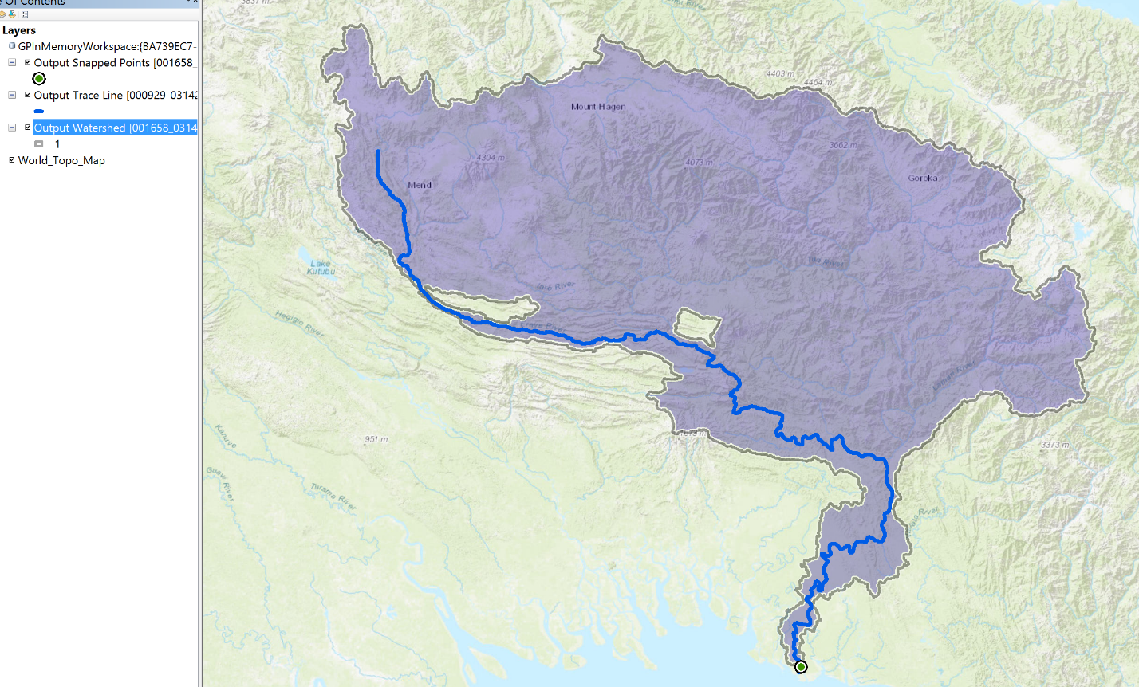
You’ll see a couple of holes in this drainage area, which are regions that those who developed the dataset considered to be areas of internal drainage in the drainage basin.
Lets build a new geodatabase called NewGuinea with a feature dataset called Purari and use the GCS_WGS_1984 coordinate system.
Now let’s export the watershed boundary to a new feature class called Basin
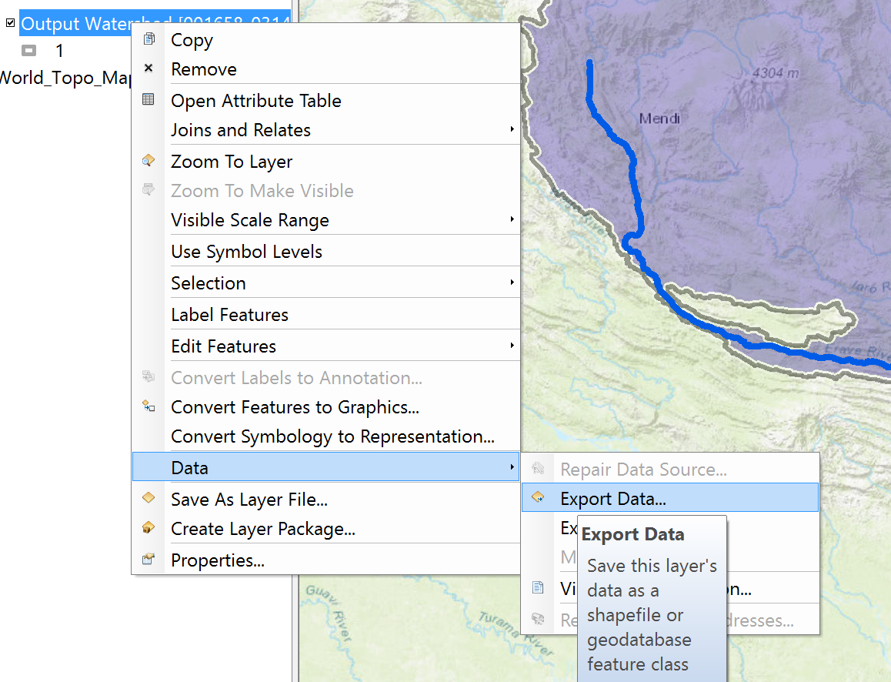
And similarly export the Trace Downstream line as a new feature class called River and you’ll find you’ve got a nice new geodatabase with two feature classes in it, Basin and River, that can serve as the Basemap for a study of the Purari river basin in Papua-New Guinea.
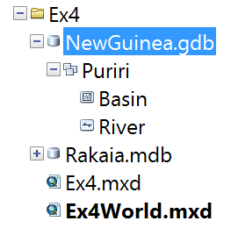
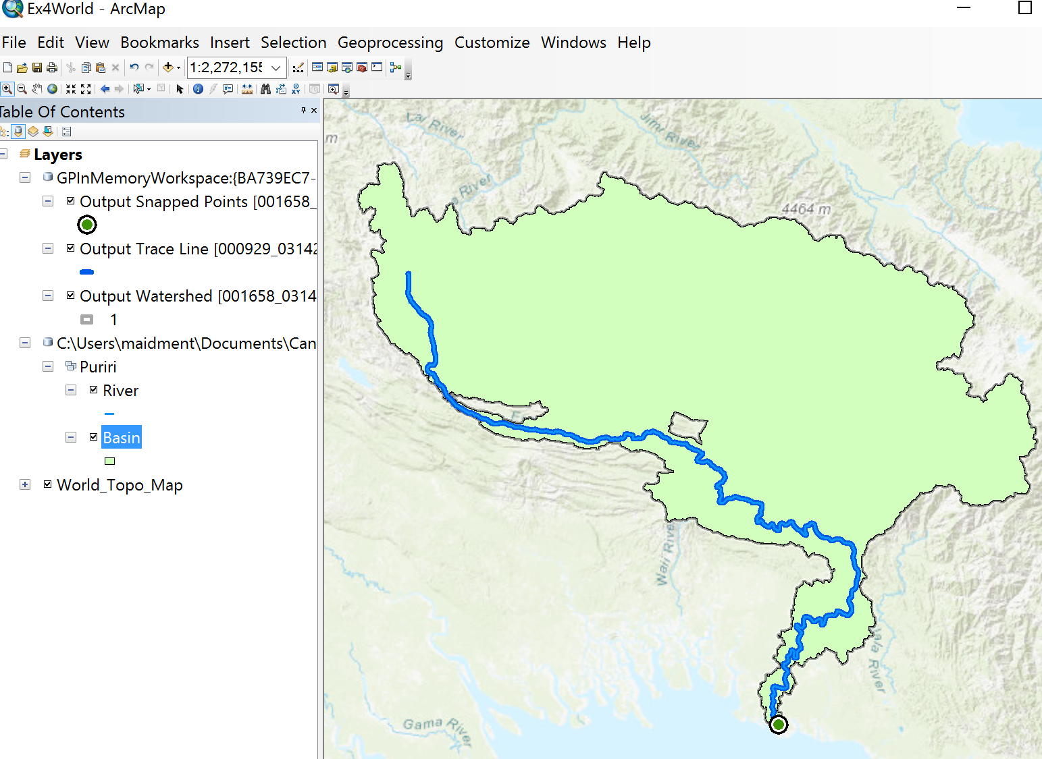
To be Turned In: A basemap of the Purari River basin in Papua-New Guinea.
Now that you’ve got the idea of how to create a new geodatabase and a basemap for a drainage area, I’d like you to create a comparable basemap for your Term Project study area, or if you are studying an abstract subject that doesn’t have a drainage area associated with it, create a base map for a study area in some region of New Zealand or the world that interests you.
To be turned in: A basemap of a drainage area of your term project or of another drainage area that interests you. The Geodatabase containing this basemap should be zipped up and submitted through Learn along with your pdf document that summarizes your response to the items requested in this exercise.
Summary of Items to be Turned In:
- A map of the riverlines in the Rakaia Catchment. How many RiverLines do we have in the map? What is their total length (Km)? What is their average length (Km)?
- A Basemap of the Rakaia River Catchment. What is the drainage area (Sq Km) of this catchment?
- A basemap of the Purari River basin in Papua-New Guinea.
- A basemap of a drainage area of your term project or of another drainage area that interests you. The Geodatabase containing this basemap should be zipped up and submitted through Learn along with your pdf document that summarizes your response to the items requested in this exercise.

