WATR404/604 Solution to Assignment 1
Prepared by David R. Maidment

Part 1
The web site Land Air Water Aotearoa https://www.lawa.org.nz/ presents comprehensive information about the water resources for regions of New Zealand. Choose one of these regions and prepare a narrative summary of the water quality in that region. Choose one swimming site within the region and prepare a narrative summary of water quality conditions at that site. The total length of the two narrative summaries together cannot exceed two pages. You can include pictures as part of your summary. Make a pdf document out of this summary.
(5 Points)
Solution to Part 1
Summary for Canterbury River Quality. Bacteria are in the second quartile (25% to 50%) compared to all regions of New Zealand and their trend is steady. Water clarity is in the third quartile (50% to 75%) and is steady or improving. Total Nitrogen is in the second quartile and is steady. Total Oxidised Nitrogen (NO₂ and NO₃) is in the second quartile and is improving. Ammoniacal Nitrogen (NH₃, NH₄) is in the fourth quartile (75% to 100%) the best level, and is steady. Dissolved reactive phosphorus and total phosphorus are in the third quartile and improving. Overall the state of Canterbury’s river quality is roughly in the mid-range for the country and is either steady or improving.
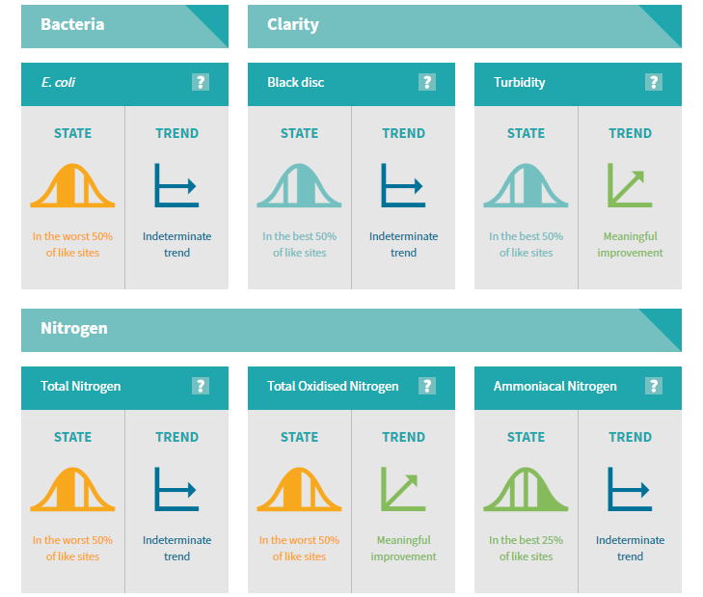
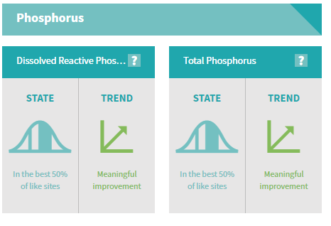

Can I swim here?
The Otaio River at Otaio Gorge in South Canterbury has an overall bacterial risk in the caution range. While the weekly result looks good. The interpretation of these results is given below. This particular location has had stock removed from the drainage area above so it is curious that the long term water quality is impaired. This location is in the Blue Cliffs station that is being used as a case study in this class. There were a couple of measurements above the acceptable limits that resulted in the caution score for swimming at this location.
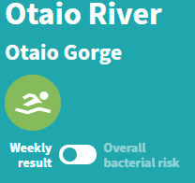
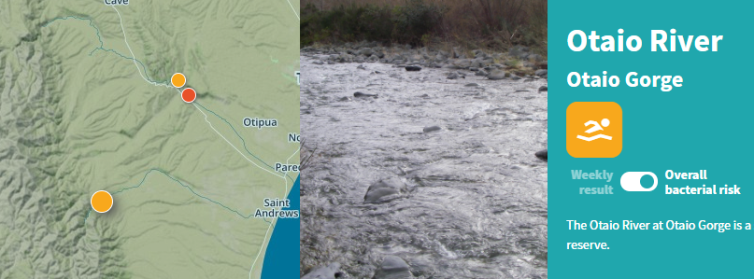
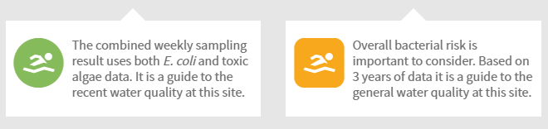
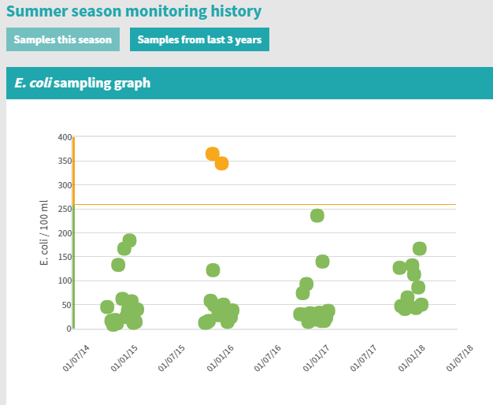

Part 2 Mangatainoka Catchment Characteristics

A screen capture of a map of the Mangatainoke Catchment, showing the SubManagement Zones, river network, water level sites and a background map.
(2 Points)
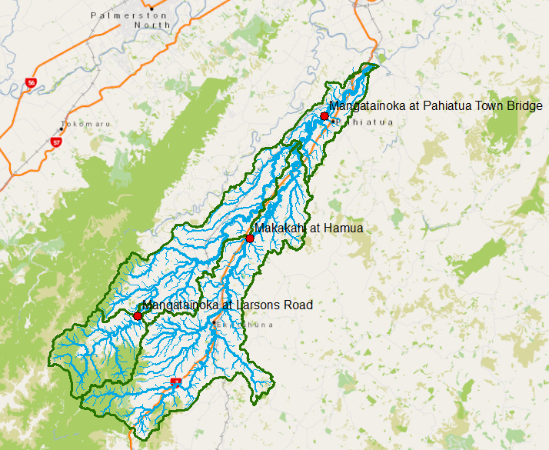
(2) How many river reaches are there in the Mangatainoka Catchment? What is their total length (Km) and average length (Km). How many SubmanagementZones are there in the catchment? What is their total area (Km²) and average area (Km²)?
(3 Points)
There are 958 reaches in the Mangatainoka Catchment. The Total Length (Sum) is obtained by doing statistics on the Shape_Leng field (whose values are in meters) and is 725.4 Km. The average length is similarly calculated to be 0.757 Km.
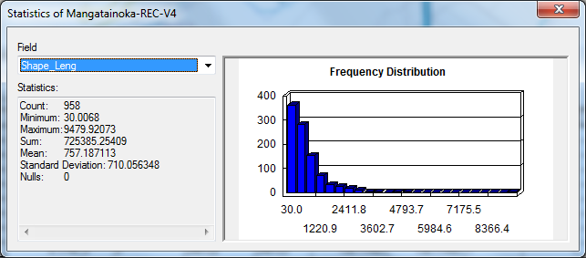
There are 4 Submanagement Zones. Statistics computed on the Hectares attribute show that the Total area is 43215 Ha = 432.15 Km². The average area = 10803 Ha = 108.03 Km².
