CE 374K Hydrology
Spring 2012
Homework #5
Mar 22, 2012
1. Problem #8.2.2
2. Problem #8.4.4
3. Make a 1-page summary of the lecture on “Texas Megadrought” by Dr Robert Mace, which will be presented on Tuesday March 27.
4. Four HEC-HMS models of Brushy Creek have been prepared by Dr Dean Djokic of ESRI (with some help from me):
- Brushy Creek during Tropical Storm Hermine with no flood control reservoirs. UBCHermine.zip
- Brushy Creek during Tropical Storm Hermine with flood control reservoirs. TSHermineModelRES.zip
- Brushy Creek during a 100-year flood using an SCS design storm with no flood control reservoirs UBCNN.zip
- Brushy Creek during a 100-year flood using an SCS design storm with reservoirs. UBCCNRes100yr.zip
Note that the Design Storm is for a 24-hour duration or one day, while the Tropical Storm Hermine model is for 7-9 September for 3 days, although most of the rain occurs in a shorter period.
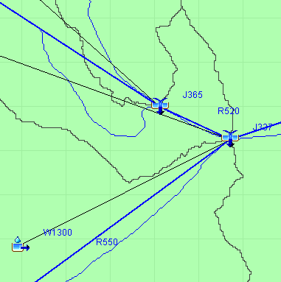
Walsh Drive and the flooded houses we saw are located at Junction 337. The inflow to this point is a combination of the North Branch of Brushy Creek (Reach 520) and the South Branch with the discharge from Dam 7 (Reach 550). The watershed draining directly to Junction 337 is W1300.
Please answer the following questions.
a. During Tropical Storm Hermine, what was the peak discharge (cfs) that occurred at Walsh Dr? What proportion of the runoff came from the North Branch and the South Branch of Brushy Creek? Were the peak flows coincident from both branches? (Show a graph to discuss this).
b. If the flood control reservoirs did not exist, what would have been the peak discharge at Walsh Dr?
c. During a 100-year flood, what is the peak discharge (cfs) at Walsh Dr?
d. Please fill in the values in the following table:
Brushy Creek | Peak Discharge (cfs)
 | Hermine | Hermine with Dams | 100-year | 100-year with dams
J337
R520
R550
W1300 | Storm Precipitation and Losses (in)
 | Hermine | 100-year
Total Precip
Loss
Excess Precip

e. Comment on the results you obtained. Which alternative (Hermine vs 100 year) has the larger amount of rainfall? Which has the larger peak discharge? These results are a little contrasting with one another. Explain why this occurs.
This homework is due in on Thurs Mar 29

