HWK SET #8 Assigned the week of Mar 20 Due Mar 28

Problem #1 Use HEC-RAS to determine the 100 yr flood (Q = 3000 cfs) Water Surface Profile on Lost Creek. Channel Manning n = 0.035. Overbank Manning n = 0.045. The cross sections were taken at 500 ft intervals. Assume normal depth at the most U/S and D/S sections. Report cross section plots for xs1, xs5, and xs7. Also report a longitudinal profile and an oblique view for the entire reach. Survey notes for cross sections 1 – 12 are provided on the following page.

Problem #2 As seen in the results of Problem #1, flooding occurs at cross sections 5 6 and 7. Propose a bank-fill solution to prevent flooding. Modify the necessary cross sections and re-run HEC-RAS to demonstrate the effectiveness of your plan. Determine the amount of fill material required in cubic yds.

Problem#3 As seen in the results of Problem #1, flooding occurs at cross sections 5 6 and 7. Propose a dredging solution to prevent flooding. Modify the necessary cross sections and re-run HEC-RAS to demonstrate the effectiveness of your plan. Determine the amount of material that must be removed in cubic yds.

Project: Lost Creek Cross Sections Survey Client: UT Austin Dept. of CAEE
Date: March 20, 2016 8:30am - 4:45pm Weather: Sunny, 65 deg F, Wind 10 - 15 mph NE
Party Chief: JFB PhD PE Crew: SMB, MMB, MDB

LOST CREEK SURVEY 03/20/2012 - CROSS SECTION DATA
XSECT1 | 0 |  | XSECT2 | 500 |  | XSECT3 | 1000 |  | XSECT4 | 1500
STA | ELEV |  | STA | ELEV |  | STA | ELEV |  | STA | ELEV
0 | 1767.0 |  | 0 | 1774.1 |  | 0 | 1779.0 |  | 0 | 1789.3
209 | 1765.5 | LB | 172 | 1770.1 | LB | 210 | 1777.7 | LB | 210 | 1785.5 | LB
222 | 1763.5 |  | 222 | 1765.8 |  | 222 | 1775.3 |  | 222 | 1781.5
245 | 1762.0 |  | 245 | 1762.9 |  | 245 | 1774.4 |  | 245 | 1780.0
255 | 1759.1 |  | 255 | 1761.4 |  | 259 | 1771.6 |  | 259 | 1777.4
267 | 1758.1 |  | 267 | 1760.0 |  | 267 | 1771.7 |  | 267 | 1777.4
277 | 1753.1 |  | 276 | 1759.9 |  | 276 | 1773.5 |  | 276 | 1778.1
286 | 1753.1 |  | 286 | 1760.5 |  | 286 | 1774.0 |  | 283 | 1779.5
291 | 1757.9 |  | 321 | 1772.0 |  | 296 | 1777.2 |  | 292 | 1783.4
312 | 1764.0 | RB | 330 | 1773.2 | RB | 312 | 1778.5 | RB | 314 | 1785.6 | RB
500 | 1768.0 |  | 500 | 1775.3 |  | 500 | 1779.5 |  | 500 | 1789.4
XSECT5 | 2000 |  | XSECT6 | 2500 |  | XSECT7 | 3000 |  | XSECT8 | 3500
STA | ELEV |  | STA | ELEV |  | STA | ELEV |  | STA | ELEV
0 | 1795.0 |  | 0 | 1798.1 |  | 0 | 1799.3 |  | 0 | 1803.0
208 | 1794.0 | LB | 200 | 1796.8 | LB | 183 | 1798.2 | LB | 181 | 1801.8 | LB
222 | 1793.0 |  | 222 | 1795.1 |  | 222 | 1792.4 |  | 222 | 1799.8
245 | 1788.1 |  | 245 | 1794.9 |  | 245 | 1791.8 |  | 245 | 1796.4
255 | 1788.0 |  | 254.8 | 1790.1 |  | 255 | 1791.1 |  | 255 | 1794.1
267 | 1789.5 |  | 262.96 | 1789.4 |  | 267 | 1792.0 |  | 267 | 1793.5
276 | 1793.0 |  | 270.63 | 1792.1 |  | 276 | 1795.0 |  | 273 | 1793.5
285 | 1793.2 |  | 286 | 1794.5 |  | 284 | 1796.2 |  | 286 | 1795.0
293 | 1793.3 |  | 292 | 1795.7 |  | 292 | 1798.1 |  | 292 | 1800.0
317 | 1794.4 | RB | 312 | 1797.2 | RB | 301 | 1799.1 | RB | 305 | 1801.5 | RB
500 | 1795.1 |  | 500 | 1798.0 |  | 500 | 1800.0 |  | 500 | 1803.4
XSECT9 | 4000 |  | XSECT10 | 4500 |  | XSECT11 | 5000 |  | XSECT12 | 5500
STA | ELEV |  | STA | ELEV |  | STA | ELEV |  | STA | ELEV
0 | 1813.6 |  | 0 | 1814.8 |  | 0 | 1818.9 |  | 0 | 1821.4
164 | 1813.2 | LB | 191 | 1812.4 | LB | 196 | 1817.1 | LB | 210 | 1818.2 | LB
223 | 1809.6 |  | 222 | 1810.8 |  | 222 | 1814.2 |  | 222 | 1813.9
240 | 1802.6 |  | 241 | 1809.3 |  | 243 | 1813.5 |  | 245 | 1812.0
255 | 1802.4 |  | 255 | 1800.7 |  | 253 | 1810.5 |  | 256 | 1810.3
267 | 1798.9 |  | 267 | 1800.3 |  | 267 | 1810.4 |  | 267 | 1810.0
276 | 1796.8 |  | 276 | 1804.1 |  | 276 | 1812.2 |  | 276 | 1812.3
286 | 1799.0 |  | 286 | 1806.8 |  | 286 | 1813.9 |  | 286 | 1812.6
292 | 1805.0 |  | 292 | 1810.5 |  | 292 | 1815.9 |  | 292 | 1814.7
318 | 1812.0 | RB | 313 | 1812.4 | RB | 312 | 1817.9 | RB | 360 | 1819.5 | RB
500 | 1813.4 |  | 500 | 1814.6 |  | 500 | 1818.5 |  | 500 | 1821.2

HEC-RAS Graphic User Interface Notes:

- To begin a new HEC-RAS Project:

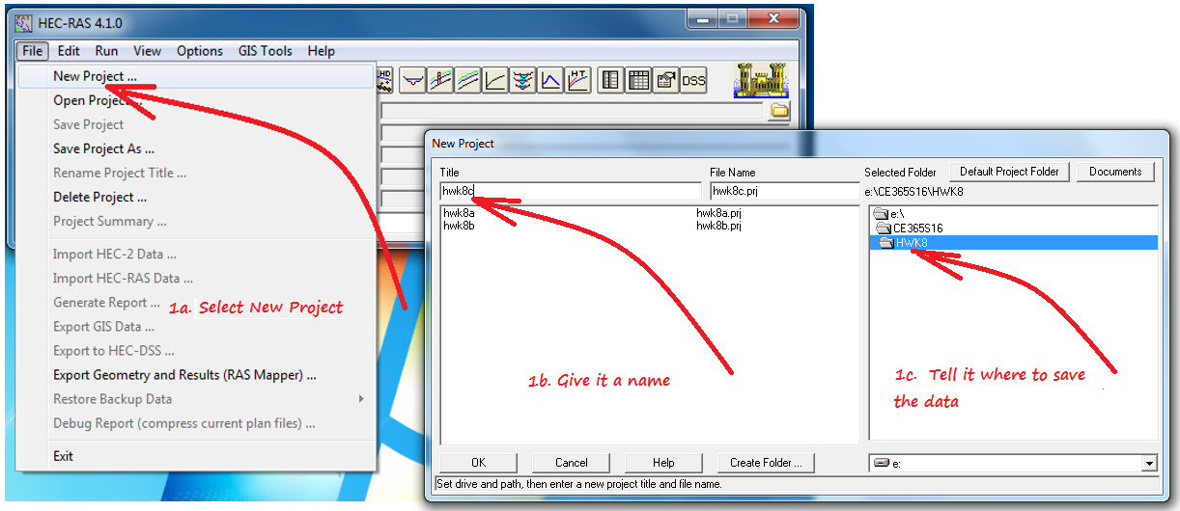

- To enter a river reach in the plan view drawing area:

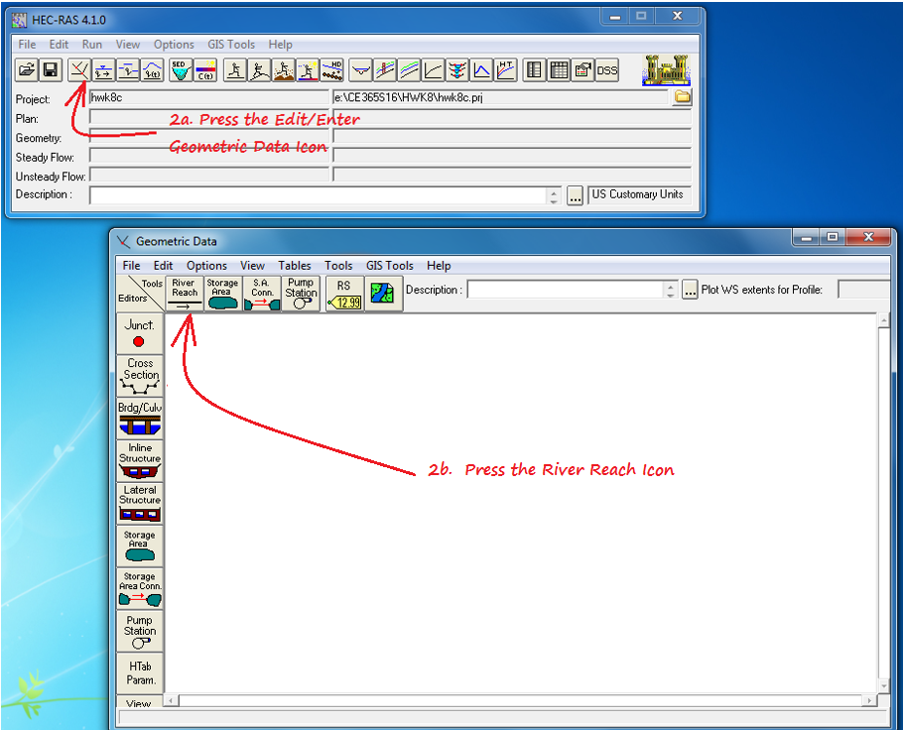

- To draw a plan view of your river reach, left click, left click, left click … double left click to terminate, then give it a river name and a reach name.

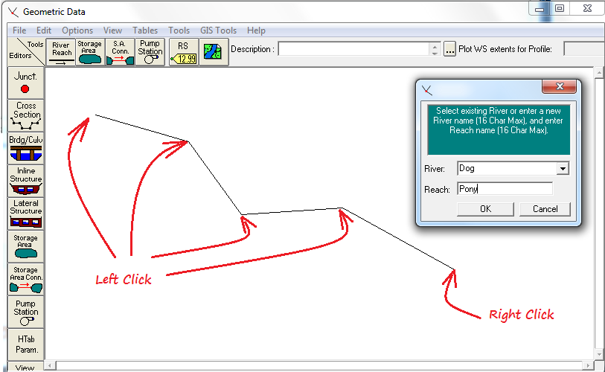

- Press the Cross Sections Icon on the Left Side Menu, select Options from the top menu, and select Add a New Cross Section.
Enter a new River Station Number for the new cross section. (Station numbers increase going upstream. The number is not used in calculations. It is only used to establish sequence from downstream to upstream. The River Station Number is usually in some distance unit such as river miles or reach-feet from the most downstream station.)

Add cross section Left Overbank D/S Distance, Channel D/S Distance, and Right Overbank D/S Distance (Note: at the most D/S cross section leave these fields blank.). Add Manning n values for LOB, Channel, and ROB. Declare the Left Bank Station and the Right Bank Station. Accept the default values for the Expansion and Contraction Coefficients.

Add your cross section Station – Elevation Data to the table and press Apply Data. Check the drawing that appears. Edit the data table if necessary.

Add all cross sections in the project and save and name the geometric data file. Its name will appear in the Main Menu and will be saved in the same directory as all other files associated with the project. (Note: Copy/Paste will work in the Cross Section Coords table, but you have to ‘select the paste space’.)

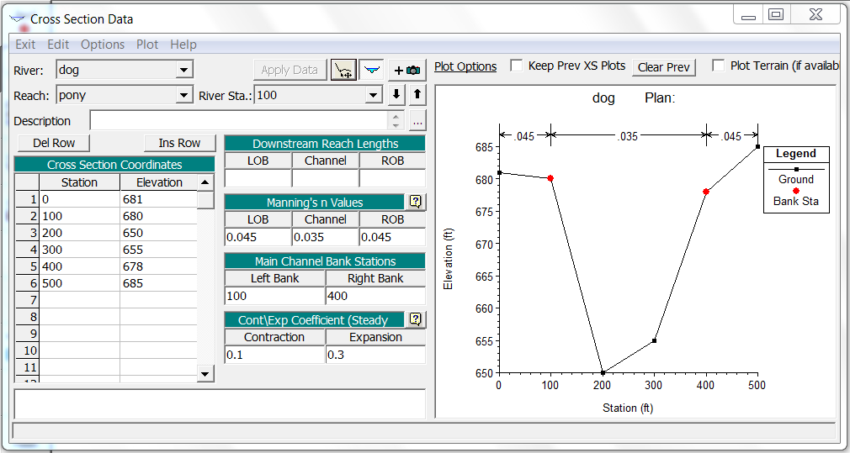

- To establish a flow rate (or a set of flow rates) to analyze, click the View/Edit Steady Flow Data Icon on the Main Menu.

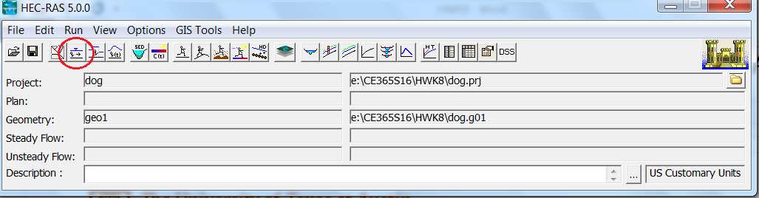

- Enter the Hydraulic Flow Regime of interest.

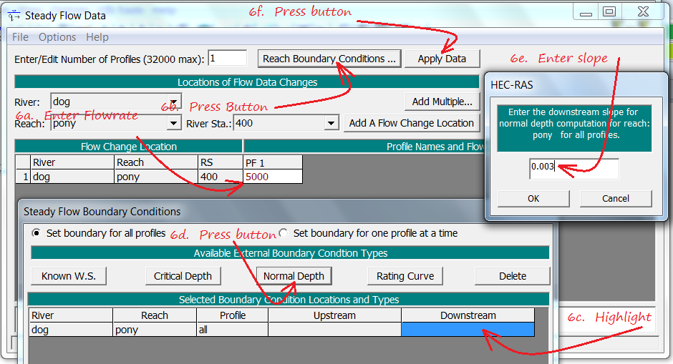

- Run a Steady Flow Analysis by Left Clicking the Dumb Little Guy running a steady pace on flat ground.

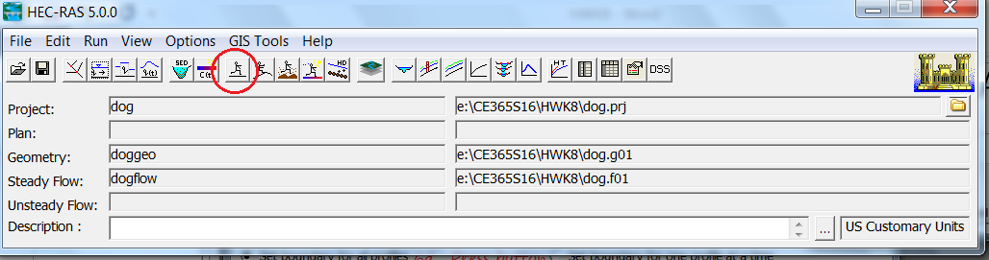

- Watch the blood pressure meters… Correct any errors… Re-run if necessary.

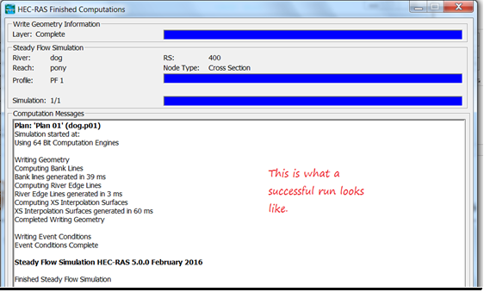

- Explore these buttons to see Water Surface Profiles in Cross Section Views, Longitudinal Profiles, Oblique and Plan Views. In Ver. 5.0 of the program, they even have a Fly Around and Look at Everything Mode.

