Climate Change Effects on Residence Times
in Texas Bays: 1975-1999

Laura Chu
UT Marine Science Institute
CE 394K – Surface Water Term Project
Spring 2005

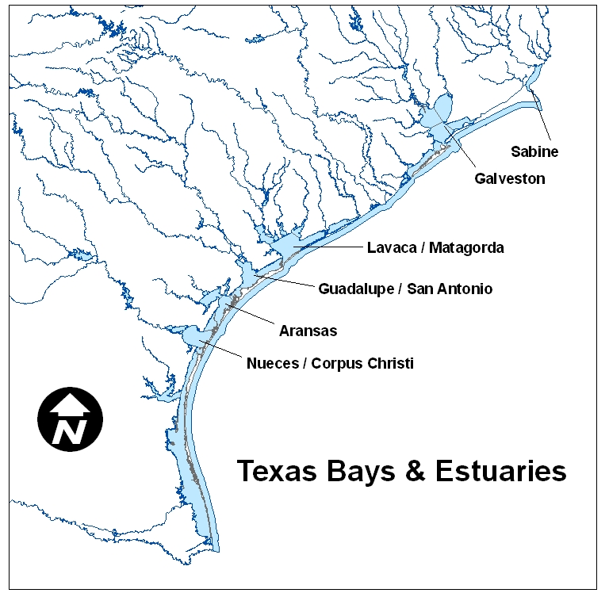

Introduction

Freshwater inflows are important determinants of ecosystem health and species abundance in Texas bays and estuaries. The rate at which freshwater enters the bay and how that rate may change and can greatly affect the productivity of the bay due to salinity tolerances of keystone species (Powell and Green, 1991). Residence times are an important parameter to describing abiotic conditions in a bay. Residence time is the amount of time it takes for a volume of water to move through a given volume, in this case a bay (Solis and Powell, 1998). Residence time may also be referred to at turnover time and flushing rate (Dyer, 1997). Therefore, residence times are a function of water inputs and outflows of the bay with respect to a bay’s volume.

Previous surveys of biological literature assume residence values to be constant for each of the bays (Armstrong 1982; Longley, 1995; Solis and Powell, 1998). Figures in Armstrong (1982) and Longley (1995) also show a gradient of residence times along the Texas coast where residence times increase with decreasing latitude. Solis and Powell (1998) compare the Texas values to those from bays and estuaries around the Gulf of Mexico to demonstrate that in the Gulf residence times increase based on proximity to the equator and in the westerly direction. Therefore, it is not surprising that the largest residence times were for Corpus Christi Bay and Laguna Madre (Solis and Powell, 1998). While these previous studies offer a good basis of comparison between bays, they do not take into account how seasonal changes may shift the residence times and the differences in water balance factors for each watershed system.

Based on stream flow data and lectures from this class, using one number to estimate residence times is poor estimation of residence times in Texas bays (Marcy Litvak, San Marcos Lecture, 2005). It is unclear if these residence times are calculated to take into account the vertical water fluxes: evaporation and precipitation. These fluxes account for a large amount of water movement and increase sharply at lower latitudes (David Maidment, personal communication). It is possible that the relative relationships in residence times will change if evaporation is incorporated into the equation. Given the hydrography of the bays along the Texas coast, shallow and broad, evaporation has the potential to account for a large portion of the water flux, and may sharply increase residence times, especially at lower latitudes.

Much discussion in recent years has been devoted to the possibility of climate change and what implications this may have for the Texas coast. Changes in climate are also reflected in changes in residence times. El Niño and La Niña events affect climate patterns by changing the precipitation patterns. El Niño years bring increased precipitation while La Niña years are characterized by drier than average conditions respectively to Texas (Barnet, 2002). These changes in precipitation patterns translate into changes in inflow regimes to the bays. This translates into changes in the rate of evaporation (David Maidment, Surface Water NARR lecture). The effects of both long and short term climactic trends can be visualized using residence time values.

In order to determine how changes in water balance parameters affect residence time in Texas bays, this study seeks to calculate the residence times in Texas bays in monthly time steps with respect to water balance model data. Information from these calculations will be used to show the effects of climate change on the Texas coast. Changes in residence times illustrate changing abiotic conditions that have both short and long term consequences on both bay and oceanic ecosystems.

Methods

Data
The inflow data are from the Texas Water Development Board’s water balance model. This model incorporates both horizontal and vertical water fluxes and flows. The inputs are freshwater inflows which include both estimates for gaged and ungaged inflows, evaporation and precipitation values in order to determine the water balance of each bay (Texas Water Development Board, 2004a). Figure 1 shows the direction of the fluxes and flows in the water balance model of a bay. Water balance model data covered dates from 1941 through 1999 for most bays. Aransas water balance data were only available through 1996. According to Quezner (1998), the inflow calculations for this model are good estimates of freshwater inflows and are comparable to other estimates and gaged flows.

Salinity data from the Texas Parks and Wildlife was sampled monthly on a 1 minute grid. The data were resampled using both Excel and LabView to find average monthly salinity values for each bay from November 1975 through present. Data were unavailable for some years in selected bays, most notably for several years in Lavaca bay. Dates where salinity data are not available were not included in the averaged estimates of residence times.

The volume of water in each bay was assumed constant to simplify calculations. Values are from the Center for Research in Water Resources (George Ward, personal communication). Tidal variation in Texas bays is not often large, on the order of a few feet and is strongly affected by wind (Longley, 1995). Because of the highly variable nature of wind direction and strength, the effect of wind on tides is not easily captured in a simple model and will be left out of this study. Therefore, it is assumed that the average tidal variation over the month is minimally significant compared to the total bay volume.

The El Niño Southern Oscillation Index (SOI) values were given by the Australian Bureau of Meteorology using the Troup method (Bureau of Meteorology, 2005). The values given the relative strength of El Niño and La Niña on a monthly scale based on the relative mean sea level pressure. The values are centered on a normal year value of zero. Values for El Niño are negative and La Niña values are positive. The higher the absolute value of the value, the stronger the event. For the analysis, SOI values with an absolute value over 15 were used to denote an El Niño or La Niña event. The SOI values were separated by season in an attempt to correct for any seasonal patterns in residence times. These values are given in table 1.

 | Winter | Spring | Summer | Fall
El Nino | -30.6 | -28.5 | -24.1 | -21.4
El Nino | 1/1983 | 3/1998 | 6/1997 | 9/1982
La Nina | 19.5 | 18.5 | 16.3 | 20.1
La Nina | 12/1975 | 4/1999 | 5/1978 | 9/1988
Normal | 0.1 | -0.5 | 0.2 | 0.2
Normal | 12/1983 | 4/1990 | 6/1976 | 9/1985
Table 1: SOI values and months used for this study

Calculations
Residence times were calculated using the freshwater fraction method. This method uses salinity and freshwater inflow rates to calculate residence time.

Freshwater fraction: 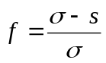

Residence Time = 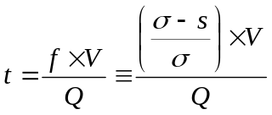

The above equations, f = the freshwater fraction, that is calculated based σ, the salinity of the incoming marine water and s, the salinity of the bay. The value for σ was estimated to be a constant 35ppt.

Residence time, t, was calculated based on the freshwater fraction (f), the volume of the bay (V) and the freshwater inputs (Q). In this study, bay volumes were assumed constant. In this study, residence times were calculated using two different values for Q. In the first case Q represents freshwater inflows only while in the second case, Q is equal to the freshwater balance: inflows minus evaporation plus precipitation. Residence time values for both Qs will be compared to show the latitudinal effects of evaporation.

Data Analysis
The data were analyzed in Excel primarily by using the average function and summary statistics operations. Negative residence time values do not appear and are not included in the averages.
Originally, I intended to animate the changes in residence times spatially in GIS using the tracking analyst. However, due to the large time scale and smaller time steps, this would have produced a file with 300 frames, too large to practically do much with, and may not give the most helpful results, especially because the data were highly variable. As the data are highly variable, creating graphs to illustrate the major trends and differences between the estuaries allowed the data to be represented in a variety of ways in the most efficient manner.

Results & Discussion

Inputs, freshwater inflows and precipitation, and outputs, evaporation and exchange with the Gulf of Mexico, to each of the bays are expressed in the following diagram (figure 1).

Bay
Freshwater
Inflow
Rainfall
Evaporation
Flow out
to Gulf
Figure 1: Fluxes & Flows of Water in Texas Bays

While freshwater inflow is the dominant input for all the bays, the relative size of the outflows varies over a north-south gradient where the role of evaporation increases as latitude decreases. The pie charts show outflow composition for two estuaries to demonstrate the relative differences in strength of evaporation in outflows in the representative bays (figure 2).

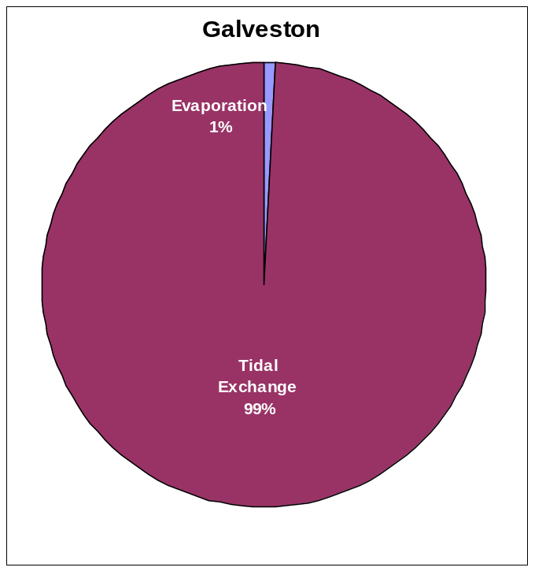

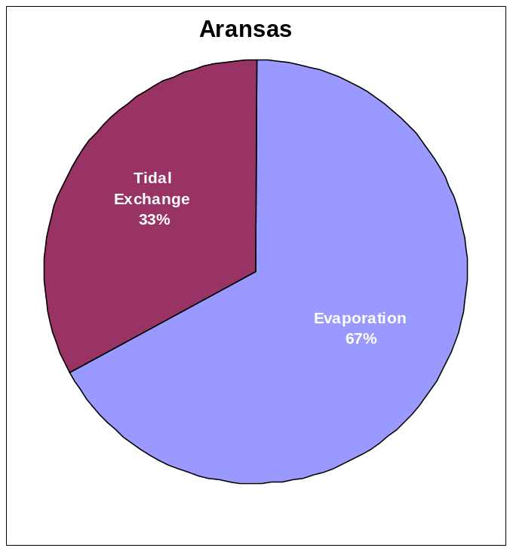
Figure 2: Comparison of Outflows in Galveston Bay (North) vs. Aransas Bay (South).

The increasing influence of evaporation as a flux is reflected in the residence time values. Calculations of the values based solely on the inflows show a gradient of residence times up and down the coast very similar to that found in the literature (figure 3).

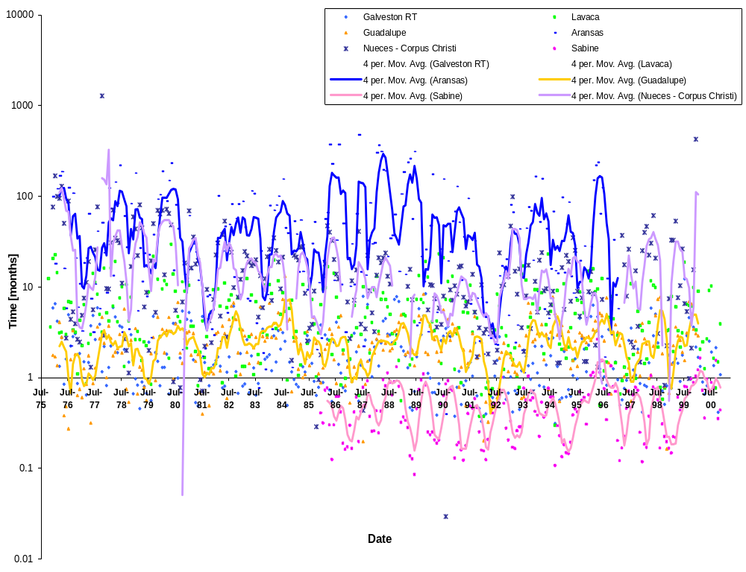
Figure 3: Residence Times calculated from inflows

However, when the residence times were calculated using water balance values instead of pure freshwater inflow estimates, the relative position of the residence times in the bays was completely the opposite (figure 4).

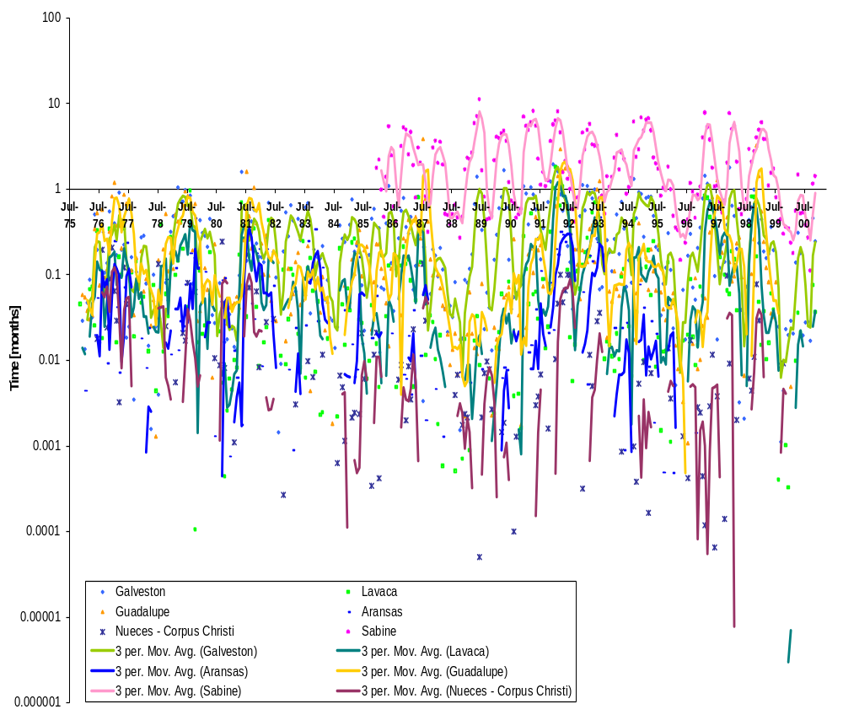
Figure 4: Residence times calculated from water balance values (includes vertical water fluxes)

Evaporation greatly reduced the residence time values for the southern bays. This is probably a more accurate description of water movement in the bays because the short residence times due to evaporation better explain the large number of hypersaline values observed. As seen in the NARR exercises, latent heat (evaporation) increases are correlated with lower latitudes. Hypersaline values (negative residence times) are not shown in the above figure in order to use a logarithmic scale which more easily shows the comparisons between bays.

The figures 3 and 4 above also demonstrate the highly variable nature of residence times. Most of this variation may be attributed to variability of freshwater inflows. This is reflected in the changes in residence times when calculated from just inflows throughout the year (figure 5). While there are no consistent seasonal patterns for all the estuaries, there appear to be differences in seasonal patterns at each end of the Texas coast. The northern and southern estuaries exhibit different seasonal patterns with the mid latitude bays showing patterns intermediate of the north and south patterns.

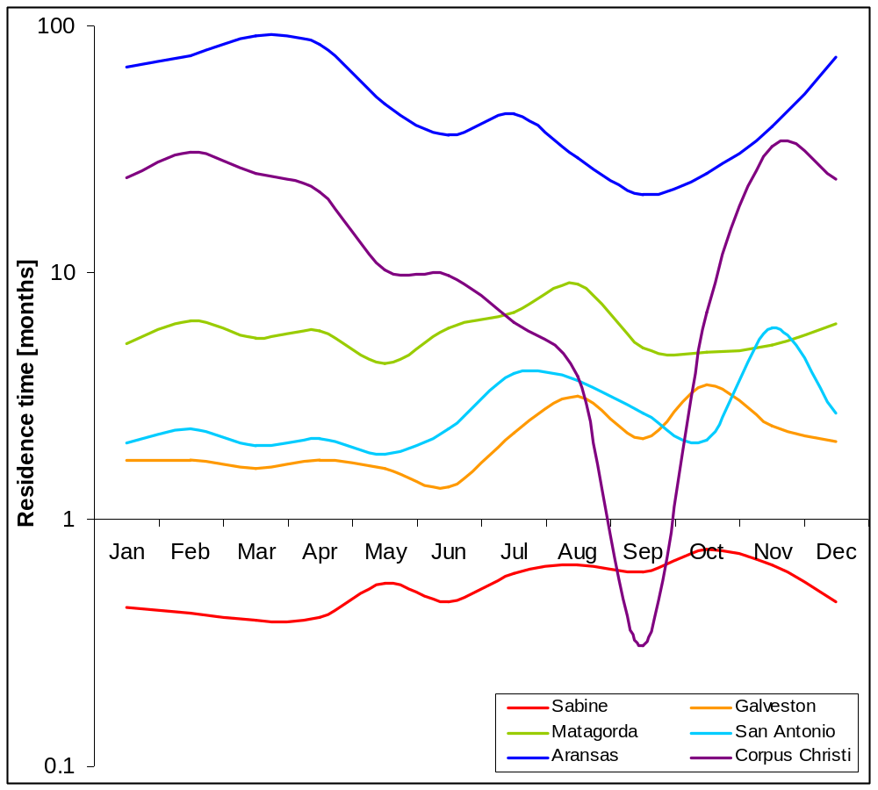
Figure 5: Average Seasonal Differences in Residence Times calculated from inflows only

When average monthly residence times were calculated using the water balance (figure 6), a slight seasonal pattern was observed for all bays.
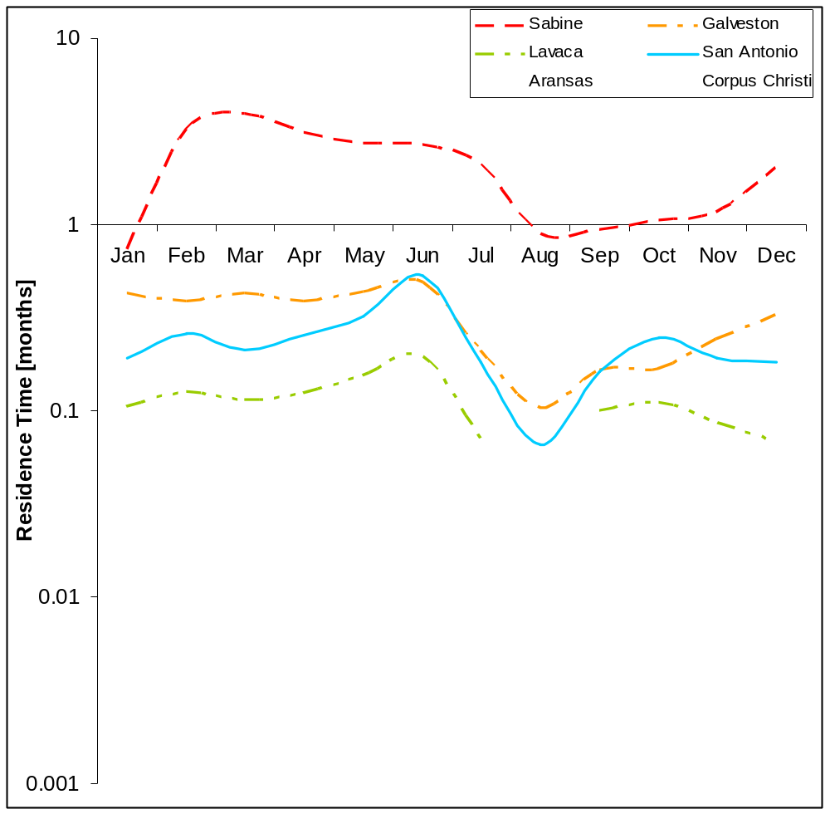
Figure 6: Average Seasonal Differences in Residence Times calculated from water balance values

While the scale of the pattern varied by bay, residence times were typically the highest in June and lowest in the early fall for most estuaries. Residence times decrease in the later summer months, possibly due to a combination of reduced inflows and evaporation. In some bays, these months overlap with periods of hypersalinity, where the evaporation rate exceeds the freshwater inflow and precipitation inputs.

As with both the above graphs, one may notice that the residence times for San Antonio Bay do not follow the north-south pattern as well as the other bays. Since the residence time is a function of the size of inflows and evaporation relative to the size of the bay, it is possible that due to certain characteristics of the watershed, such as baseflow due to the Edwards Aquifer springs, that the inflow regime is different for this bay than the others along the coast.

While there is a lot of year to year variation, trends over the 25 year study period indicate no long term trends toward a change in residence times for any of the bays studied. Regression lines for residence times return R values all under 0.1 for each of the bays. Analyzing the same TXWDB data, Applebaum et al., (submitted) found that freshwater inflows into Corpus Christi decreased during the time period from 1941 to 1999. Perhaps, a time scale of 25 years may not be sufficiently long to show long term trends.

Residence times are useful values used to measure climate change because they incorporate both changes in salinity and inflow to give a numeric indicator that may be tied to biological processes. Potential long term changes in climate can be shown in the short term through El Niño and La Niña events. These changes in Pacific Ocean temperature affect precipitation patterns in North America. In Texas, El Niño events create wetter than normal conditions, while La Niña is tied to drier than normal climate. Physical environmental changes resulting from these short term climate changes may be shown using residence times.

It was hypothesized that El Niño would decrease the residence times in the bays and La Niña conditions would be correlated with longer residence times compared to the normal values. The data show that this trend was not consistently observed. In only a few instances, for winter and summer in figure 7 and fall in figure 8 did the hypothesized pattern occurred.

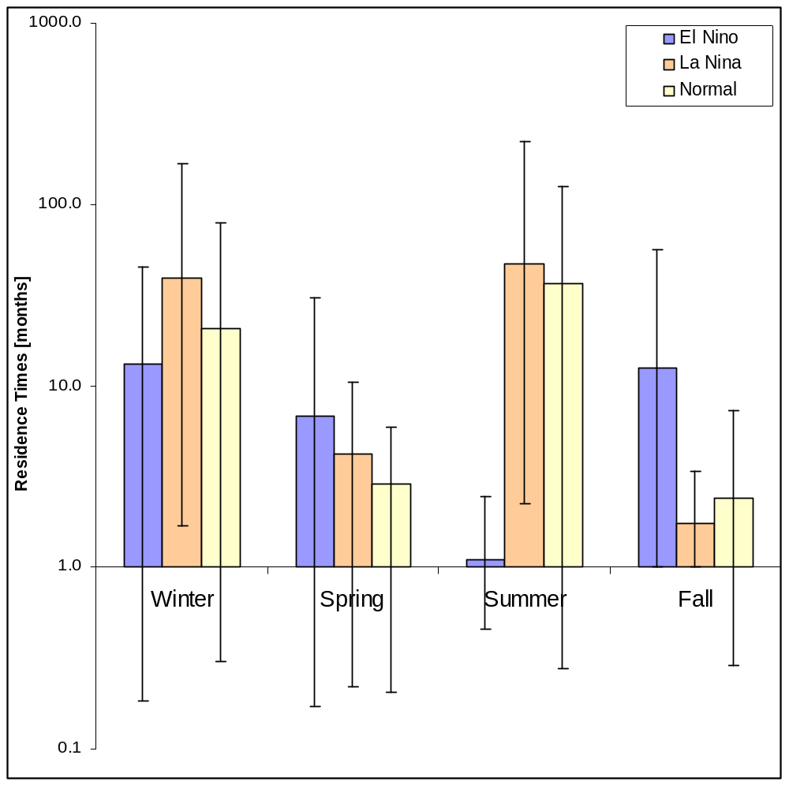
Figure 7: Effects of El Niño and La Niña on Residence Times calculated from inflows only

Both figures 7 and 8 show no consistent pattern in residence times by season or relative to each type of climate oscillation. Adding evaporation values seemed to reverse the relationships observed when comparing the effect of El Niño on residence times using just inflow data to compute residence times.

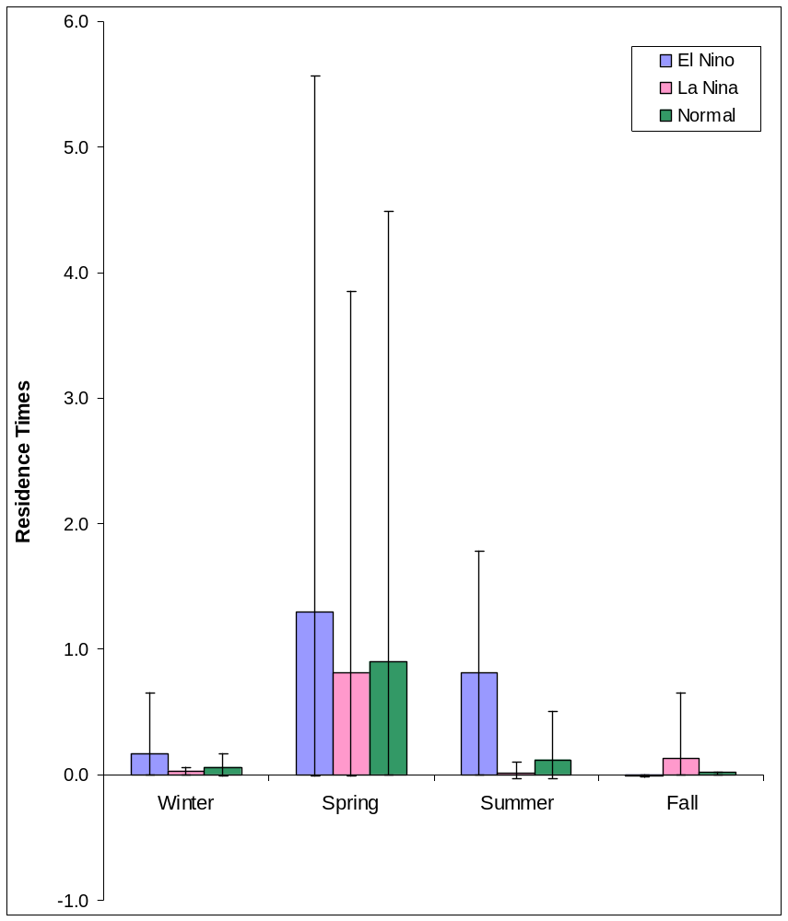
Figure 8: Effects of El Niño and La Niña on Residence Times calculated from water balance data

Further, there is no shift of the observed north-south gradient of residence times observed when comparing El Niño conditions to normal conditions. This suggests that any seasonal patterns, as observed in figure 8, are more dominant than changes due to El Niño or La Niña.
Implications & Future Work

This study relied a number of assumptions in order simplify calculations of residence times. Among these assumptions those with the largest impact are the assumptions of a well mixed estuary, a constant bay volume, and accurate evaporation and precipitation values. The hydrography assumption can not be corrected easily as the hydrography for each bay differs greatly. However, studies of flows in Corpus Christi Bay and other bays with small inlets for tidal exchange will help to show how the water in the bay circulates on a two dimensional scale (Furnas, 2004; Texas Water Development Board, 2004b). The bay volume assumption could be rectified by determining the average tidal difference over the month. Though these corrections may or may not address the effect of wind which is also a strong determinant of water level differences, especially in shallow bays with small tidal differences. Vertical water balances, from the Texas Water Development Board model, precipitation and evaporation, may be compared with NEXRAD and NARR values respectively to check the accuracy of values in the model.

Additionally, the present study did not include values for Laguna Madre due to lack of data for the entire bay. Residence times in the literature showed Laguna Madre as a bay with one of the longest residence times in the Gulf of Mexico system (Longley, 1995; Solis and Powell, 1998). Yet, Laguna Madre is hypersaline during many of the summer months. Since the data in the literature are an average, it is unclear how, if at all, negative residence time values were incorporated into the average. Also, adding in the evaporation calculations to Laguna Madre would increase the longitudinal scope of the study and may give a more accurate understanding of how residence times vary with latitude.

Residence times in southern estuaries tend to decline in the summer month coinciding with seasonal hypoxia in those bays (Ritter and Montagna, 1999; Applebaum et al., submitted). Another topic to examine is how residence times are correlated, if at all to incidences of hypoxia.

Also more data on tidal changes it would be helpful to compare the residence times calculated by the freshwater fraction model to output from the tidal prism method.
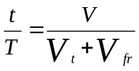
This method, equation shown above, uses differences in tidal levels to calculate residence times (Officer, 1976). Here, the residence time, t, is a function of changes in the bay volume due to tides and T, the tidal period.

Residence times may also have policy implications. Determining minimum inflows in Texas is a contentious issue. Studies by the various Texas state agencies have suggested the use of biological parameters to determine minimum inflows into bays (Powell et al., 2002; Powell and Green, 1992). As residence time values, using the freshwater fraction method, are a function of both freshwater inflows and salinity, an important parameter for many key species, it is possible that residence times could be used as an easily measured indicator to determine minimum inflows.

Further, there are possibilities to use residence times as an indicator of climate change. However, as shown in the results section, residence times may not be a sensitive enough indicator to detect trends in changing inflows or salinities on short time scales.

Acknowledgements
Dale Crockett - Texas Water Development Board
Dr. Mark Fisher - Texas Parks and Wildlife Department, Rockport Marine Lab
Dr. Paul Montagna - UTMSI
Jayson Ryckman
Dr. George Ward – UT Center for Research in Water Resources

Literature Cited

Applebaum, S.A., P.A. Montagna, C. Ritter. Submitted to Environmental Monitoring and Assessment, 2004. Status and Trends of Dissolved Oxygen in Corpus Christi Bay, Texas, U.S.A.

Armstrong, N.E. 1982. Responses of Texas Estuaries to Freshwater Inflows. In: Kennedy V.S. eds. Estuarine Comparisons. pp. 103-113.

Barnet, M. 2002. Moisture Outlook Good; El Niño to reappear. Texas Agriculture. Retrieved April 26, 2005 from the World Wide Web: http://www.txfb.org/TexasAgriculture/2002/041902/041902elnino.htm

Bureau of Meteorology. 2005. S.O.I. Archives. Retrieved April 10, 2005 from the World Wide Web: http://www.bom.gov.au/climate/current/soihtm1.shtml

Dyer, K.R. 1997. Estuaries: A physical introduction. 2nd ed. New York, New York. John Wiley and Sons Ltd. pp. 165-171.

Furnas, J. 2004. Exploring Hydrodynamic Modeling of Texas Bays with focus on Corpus Christi Bay & Lavaca Bay. CRWR Online Report 04-03. Retrieved April 10, 2005 from the World Wide Web: http://www.crwr.utexas.edu/online.shtml

Longley, W.L. 1995. Estuaries. In: North G.R., J. Schmandt, J. Clarkson. eds. The Impact of Global Warming on Texas. pp. 88-118.

Officer, C. B. 1976. Physical Oceanography of Estuaries (and Associated Coastal Waters). New York, New York. John , Wiley and Sons Ltd. pp. 157, 378.

Powell, G.L., J. Matsumoto, and D.A. Brock. 2002. Methods for Determining Minimum Freshwater Inflow Needs of Texas Bays and Estuaries. Estuaries. 25(6B): 1262-1274.

Powell, G.L. and A.W. Green. 1992. Freshwater Inflows to Texas Bays and Estuaries: Ecological Relationships and Methods for Determination of Needs. Draft. Texas Water Development Board and Texas Parks and Wildlife Department

Quenzer, A.M., 1998. A GIS Assessment of the Total Loads and Water Quality in the Corpus Christi Bay System. CRWR Online Report 98-1. Retrieved April 10, 2005 from the World Wide Web: http://www.crwr.utexas.edu/online.shtml

Ritter, C. and P. A. Montagna. 1999. Seasonal Hypoxia and models of benthic response in a Texas Bay. Estuaries. 22: 7-20.

Solis, R.S. and G.L. Powell. 1998. Hydrography, Mixing Characteristics, and Residence Times of Gulf of Mexico Estuaries. In: Bianchi, T.S., J.R. Pennock, R.Y. Twilley. eds. Biogeochemistry of Texas Estuaries. pp. 29-61.

Texas Water Development Board. 2004a. Coastal Hydrology. Retrieved February 3, 2005 from the World Wide Web: http://hyper20.twdb.state.tx.us/data/bays_estuaries/hydrologypage.html

Texas Water Development Board. 2004b. Estuarine Hydrographic Surveys. Retrieved April 10, 2005 from the World Wide Web: http://hyper20.twdb.state.tx.us/data/bays_estuaries/surveypage.html

