Base Flow Separation

Prepared by Lauren Schneider, CE 394K, Spring 2005

In order to determine the contribution from overland flow in a watershed to the streams in the watershed, it is necessary to separate out the base flow from stream gage data. Historically, base flow separation was computed by hand by hydrologists, but it is not likely that any two hydrologists will calculate the same base flow for a particular area. This resulted in a need for a set of procedures to ensure that base flows were calculated similarly. A FORTRAN program called Base Flow Index (BFI) was developed using the Institute of Hydrology procedures that were developed in 1980 (Wahl and Wahl, 1995). The base-flow index is the total volume of base flow divided by the total volume of runoff for a period (Wahl and Wahl, 1995). The base-flow index can be compared from year to year obtain an understanding of overall base flow for the area of interest.

Using BFI

BFI can be downloaded from the following site:

http://www.usbr.gov/pmts/hydraulics_lab/twahl/bfi/

Just click on “Download BFI” and then click “bfi-dosw.exe.” The site above also gives valuable links to information about BFI. Next is a procedure for using BFI with an explanation of the results. There are some limitations to the software that will be explained later.
After the program has been downloaded, start the program, and you will see the following user interface.

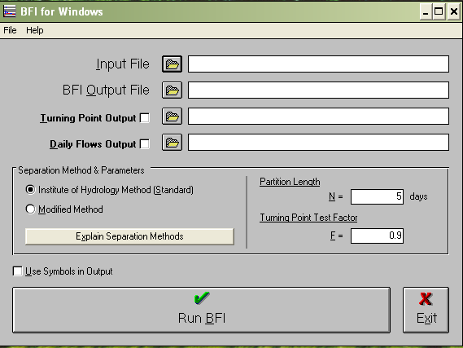

The “Input File” will come directly from the USGS stream gage data that you can download at http://nwis.waterdata.usgs.gov/usa/nwis/discharge. Choose your method of site identification and click submit. I have checked “site number”

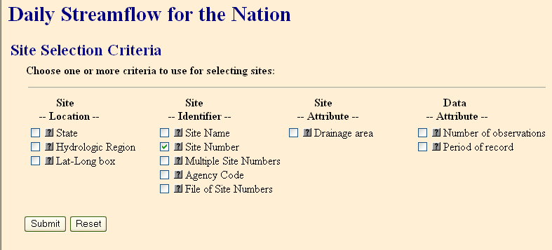

Input the site number 08171000 for this exercise and click submit. Leave everything else the same. The site should be “Blanco River and Wimberley.” Choose to download all available years as “Tab-separated data”. To download all data you do not need to specify any dates. Save the data as the site number (or any other recognizable name) and in place that you can locate it later.

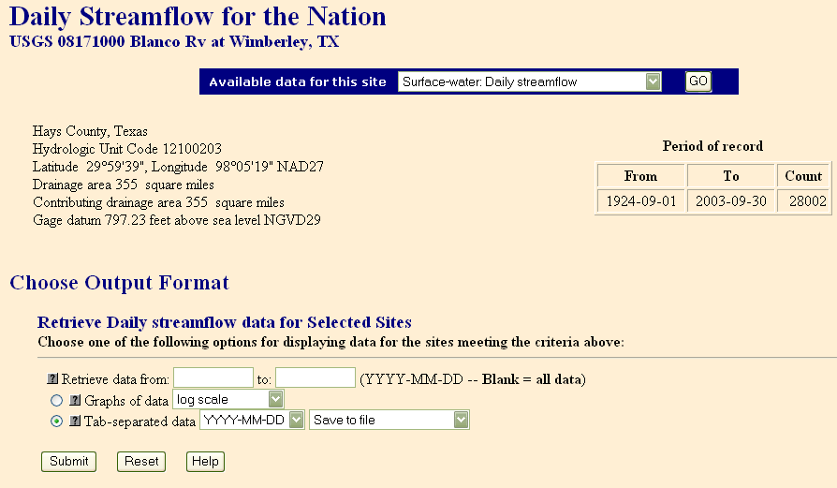

Return to the BFI interface and browse for the USGS gage data that you just downloaded for the input file. Be sure to show “all files” or you will not see the gage data file. Next, be sure to click the check box for “Daily Flows Output.”
The only other parameters are “N” (number of days) and “F” (turning point factor). N refers to the number of days over which a minimum flow is determined. It is the connection of these minimum points that determines the base flow (please see Wahl and Wahl paper on the BFI website for more information about this). Although the procedure developed by the Institute of Hydrology uses 5-day minimums, after 3 days, BFI usually does not vary much. If it is necessary to determine which N to use, make a table of BFI vs. N to determine the critical value of N. The follow graph shows an example for the Blanco at Wimberley gage data.

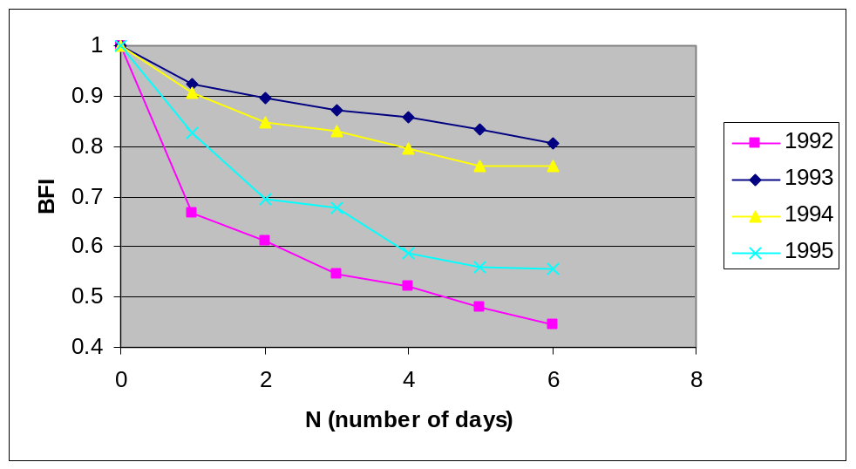

The predicted base flow decreases with an increase in number of days because more peak flows are excluded as the number of days increases. The 1995 data shows that N should be at least 4 and BFI does not change much after that point. Before making this graph I was told that 3 days was appropriate, but I believe it might be better to use 4 or 5 days since I was told that the program is known for overestimating base flow. I still need to read the literature concerning this point. In general, I was told that N=3 is an appropriate value and the output data for the example is based on that value. The value of F is said to be insensitive so this can remain as a default value of 0.9. Below is what the interface should now look like.

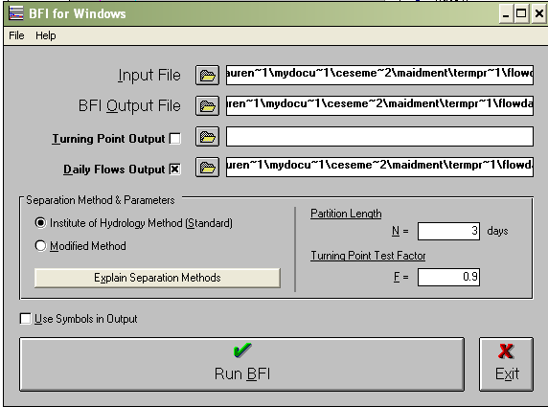

Click “Run BFI” and then exit the program. You cannot do anything until you exit the program. There should be two output files located in the same folder as the input file and with the same name but different types (one is the BFI file and the other is the Q file). The BFI file is shown below.

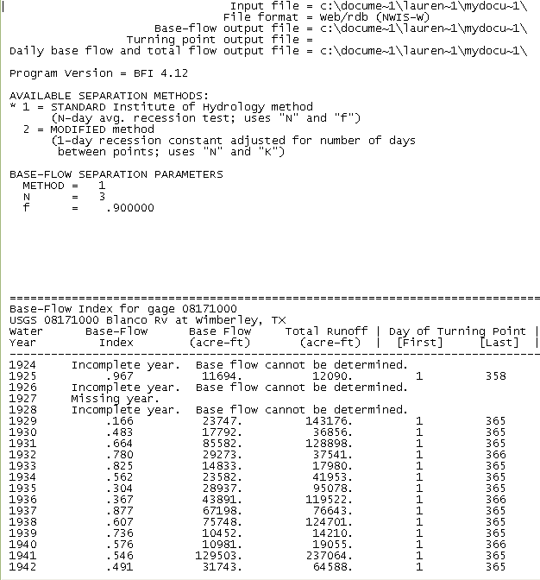
…
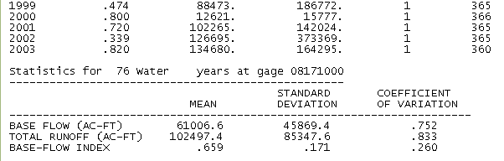

The data includes the base-flow index, total base flow for the year in acre-ft, the total runoff for the year in acre-ft, and some statistical data at the bottom. The base-flow index cannot be computed for a year that has missing data. Again the base-flow index is the ratio of the total base flow to the total runoff.
It is important to note that the watershed delineated for the Blanco River and Wimberley gage does not have an upstream gage so this data is complete as shown. *IMPORTANT* For an analysis of any watershed that has gages upstream of the gage of interest, the upstream gage data must be subtracted from the downstream gage data. This can be done by running the program for all gages involved, copying the data into a spreadsheet, subtracting the upstream gage total base flow from the downstream gage total base flow, subtracting the upstream gage total runoff from the downstream gage total runoff, and recalculating the base-flow index using these differences.
The Q (flow) file shows the daily base flow and total flow values in cfs. Data that is missing shows up as -99.00. This data can be used to graph the total flow and base flow trends over one or more years. Total base flow is only accurate for time periods longer than a day since the program uses daily data. Calculating total base flow for a month or more would be acceptable, although it is probably best to calculate over a year or more. Daily runoff would be calculated by subtracting the total base flow from the total flow for each day. Below is a graph of the base flow separation for the watershed of the Blanco River and Wimberley station in 1995 for N=3. This was created using the Q data file.
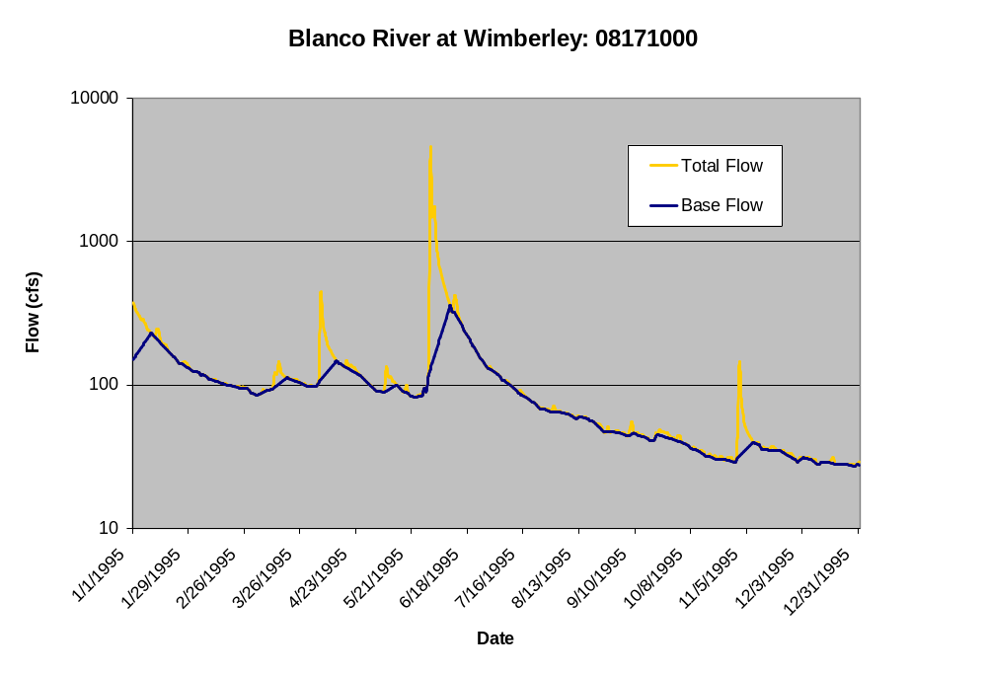
For watersheds that do not have upstream gages, the base flow data might have some problems. For example, after subtracting the upstream data from the downstream data for a particular watershed, the base flow came out to be greater than the total flow. I am not sure at this time how to deal with this data.

References:
J. Andrew Tachovsky, P.E., Research Scientist Associate. Bureau of Economic Geology.

Wahl, K. L., and Wahl, T. L., 1995, Determining the Flow of Comal Springs at New Braunfels, Texas, Texas Water '95, American Society of Civil Engineers, August 16-17, 1995, San Antonio, Texas, pp. 77-86.

