CE 394K/CEE6440 GIS in Water Resources Fall 2018
Final Exam
There are four questions on this exam. Do all four. For each of the first two questions, prepare a 2-page typed essay (2 pages x 2 essays = 4 pages total). For questions 3 and 4 use ArcGIS (and Excel/Word) to prepare the map and answers requested. Combine solutions together in the order of the questions in a single PDF document, and submit through the class Canvas website, by 11:59 PM on Friday, December 14.
This is a take-home exam. You are honor bound not to discuss this exam with your colleagues in the class. Your answers should be the result of your work and thought alone. Be assured that if essentially the same idea appears in answers from more than one person, it is fairly easy to recognize that when the grading is being done. If that happens, it is not clear from whom the idea originated and who is just using somebody else’s knowledge. So, keep your ideas to yourself!
Questions 1 and 2 require you to read and synthesize information from term projects by other students in the class. The term papers that you choose to describe in answering Questions 1 and 2 should be mutually exclusive, that is, if you focus on particular term papers in answering one of the questions, don’t focus on the same papers when answering the other question. The term projects can be found at:
Texas: http://www.caee.utexas.edu/prof/maidment/giswr2018/TermProjectGroups2018.htm
All projects via Hydroshare: http://hydrology.usu.edu/dtarb/giswr/2018/students.html
You are encouraged to look at term projects from all locations in preparing your answers since this will give you a greater body of information to speak from.
What we are looking for in grading your answers to this question is:
- Knowledge of the facts. Make sure you lay out the facts of what has actually been done before you start offering opinions about what could have or should have been done. Make sure you discuss what was actually done in the term papers not just about the general subject itself.
- Thoughtful evaluation. How do you evaluate the advantages and limitations of the principles, methods and data that have been used? How does the knowledge you’ve learned in this class relate to the world around us? I am looking for a sense of reflection here, of seeing you set individual situations and facts in a larger context in an intelligent way.
- Effective use of Maps. Identify specific maps from these projects that you think are effective and explain why they are effective.
In your answers, you must refer specifically to work presented in term papers prepared in this course this semester. In other words, I am not looking here just for a general statement about your opinions in the field but rather a deduction based on the term papers presented in this class of what has been done and how you judge the effectiveness of that.

Questions

1. Compare and contrast two papers dealing with the same theme

Choose two term papers that deal with the same or similar themes or topics. Neither of these papers should be your own term paper. The papers that you choose may be from any of the participating universities. Briefly summarize the contents of the papers (the problem examined, the method of analysis, the results achieved). Compare and contrast the approaches to the problem that the two papers took. Which technical approach do you think was more effective? Why? Which paper does a more effective job of communicating its results? Why? Suppose you were undertaking a study of this same subject. Having studied these two papers, what have you learned about how to go about your investigation effectively? What would you do differently from what the authors of these papers did? It may be helpful to prepare a table that summarizes the key characteristics of your two papers.

2. Write an assessment of the utility of GIS in a particular subject area

Student term papers on a range of topics have been presented. Select four papers that fall within a similar subject area and present a critique of how effective GIS is in its application in this subject area. What is the scope of the subject area? How has GIS been used? What types of problems have been solved effectively? What limitations exist that have yet to be overcome in the application of GIS in this area? You are encouraged to look at and use papers from both Utah and Texas where they address similar subject areas. It may be helpful to prepare a table that summarizes the key characteristics of your four papers.

3. Austin Population
The figure below shows two feature classes, one being the extent of the 1:24,000 Austin East topographic map and the other being Census blocks from the 2010 census of the United States. The blocks shown are those within 5 Km of the Austin East map extent. The data are projected into UTM coordinates in a geodatabase and ArcGIS project that can be obtained at: http://www.caee.utexas.edu/prof/maidment/giswr2018/austin/austin.zip
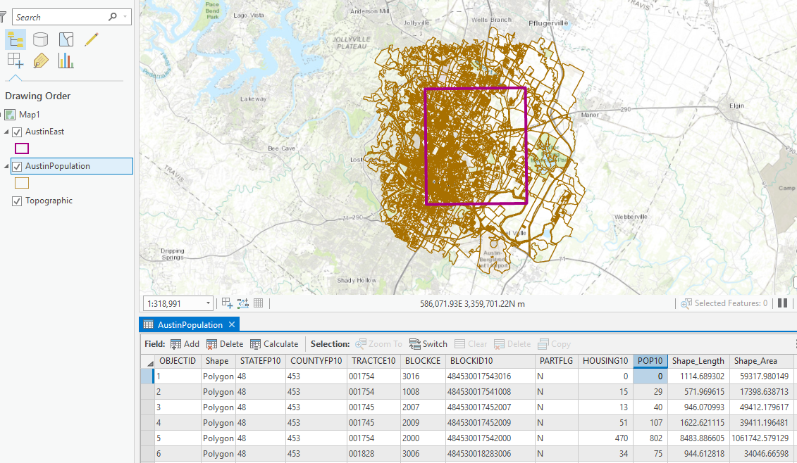
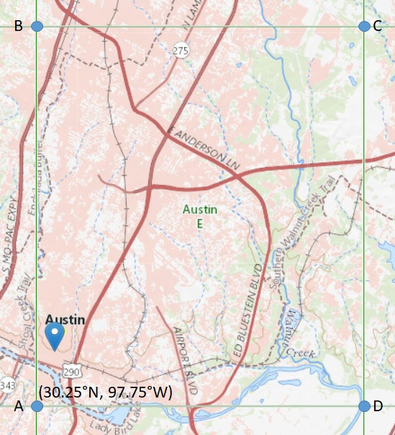
The following figure shows additional detail on the extent of the 1:24,000 Austin East topographic map which covers 7.5’ x 7.5’ (7.5 minute x 7.5 minute) of latitude and longitude.
- The location of point A in the lower left corner of the map is shown. What are the (latitude, longitude) coordinates of the points B, C, D shown in the map in decimal degrees? Complete the table.
Point | Location (Latitude, Longitude)
A | (30.25°N, 97.75°W)
B
C
D

- If the radius of the earth is 6371 Km, determine the lengths AB, BC, CD, and DA in Km. Complete the table.
Line | Length (Km)
AB
BC
CD
DA

- Determine the area ABCD (Km²).

- Compare the area for the Austin East map extent that you obtained above with the value given in the ArcGIS geodatabase.

- The attribute Pop10 in the AustinPopulation feature class gives the population in each census block. Make a map and layout that shows the population distribution across this area of Austin.

- Find the census block with the highest population. What is this population? What is located in this block that makes this so?

- Calculate the population density in persons/hectare (1 hectare = 10,000 m²). Make a map and layout that shows the population density across this area of Austin. Discuss the differences between population distribution (e) and population density maps. Indicate which better depicts the spatial pattern of population and why.

- Calculate the population living in 2010 within the extent of the Austin East map. Round off your final answer to an integer value. Show your working and explain how you dealt with census blocks lying across the boundary of the Austin East map extent.

Show and explain the work done in performing each calculation. Don’t just state the result.

4. Waller Creek
Waller Creek is the Creek that drains the area of Austin containing UT Austin. The figure below shows Waller Creek streams as mapped by NHD.
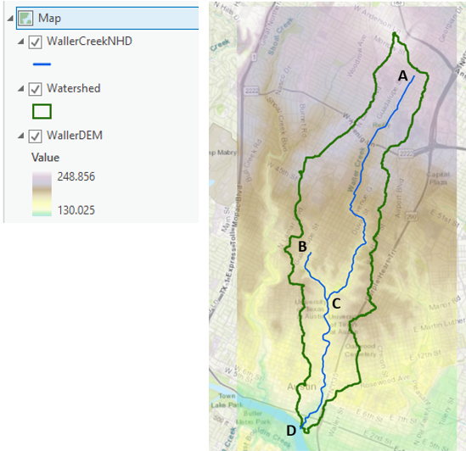
The file austin.zip provided for problem 3 includes a 10 m digital elevation model (DEM) for this area obtained from the National Map (WallerDEM) and the NHD streams within the Waller Creek Watershed, both projected into UTM coordinates.
- Obtain the Waller Creek Watershed upstream of the point (D on the map) where it drains into the Colorado River and determine its drainage area (Km²). You may use any watershed delineation method you know or have learned in this class.

- Prepare a map of the Waller Creek Watershed (as a polygon) and the NHD stream network within Waller Creek Watershed. Depict the topography within this watershed in a nice way. Present this map as a layout with appropriate title, legend and scale.

- Determine the length (Km) of each of the NHD stream sections AC, BC and CD.

- Calculate the slope of each of the NHD stream sections AC, BC, and CD.

- Calculate the average slope of the topographic surface within Waller Creek Watershed.

Show and explain the work done in performing each calculation. Don’t just state the results.

