**Freshwater Distribution and Water Quality in the Federated States of Micronesia**

By Rachel Weinheimer

**Introduction**

The Federated States of Micronesia (FSM) is made up of a chain of over 600 islands spanning one million square miles in the Pacific Ocean. Although it is an independent country, the FSM is considered “freely associated” with the United States. Through a Compact of Free Association, the U.S. provides economic assistance to the FSM and visa-less migration rights to its citizens in exchange for exclusive military control of the FSM’s territory. Because of the Compact, the U.S. government is legally obligated to respond to disaster declarations in the FSM. Though the Compact is designed to address acute disasters, a gradual trend of water degradation throughout the islands remains unaddressed. Insufficient access to clean water is a direct contributor to disease and illness and indirectly effects migration patterns, development, education, and the distribution of aid from international donors.

My term paper will focus on the amount of water available and the quality of that water. Though previous studies have addressed these issues separately, the data have not been combined an analyzed in a country-wide survey. Additionally, factors contributing to water degradation vary throughout the country. The high volcanic islands in the east can receive as much as 300 inches of rainfall a year, while the sandy islands in the west receive considerably less. Despite the substantial amount of rain the islands to the east receive, the quality of water is extremely low due to the location of piggeries along streams and rivers. Other islands face different issues, mainly salinization of groundwater.

Water availability directly impacts the number of people these small islands can support. Whereas island populations were previously limited by resources available on the islands, Micronesians have begun migrating to the U.S. (especially Guam and Hawaii) when resources become scarce. Both Guam and Hawaii have received additional funds from the U.S. Government to help manage the impact of Micronesians, who face high rates of obesity, diabetes and other health-related issues. Increasingly, aid organizations are called to respond to islanders’ dependence on water catchment systems and in extreme situations provide islands with reverse osmosis machines to provide drinking water.

In my term paper, I’d like to analyze both the availability and quality of freshwater on Micronesia’s four primary islands – Kosrae, Pohnpei, Weno, and Yap. I plan to address the following questions:

* How much freshwater is available for consumption?
* Is the quality of the water fit for human consumption?
* What are some possible solutions to increase water quality?
* How does water availability in the FSM relate to migration patterns?
* What are some of the potential implications for aid organizations?

**Design Aspects of Maps Depicting the FSM**

The largest island in the FSM (Pohnpei) is only 14 miles in diameter. Although this class does not necessarily emphasize aspects of map design, I’d like my maps to depict the enormity of my study area (one million square miles) to emphasize the vulnerability and remoteness of these islands. Most people will not be familiar with the FSM, so I’ve been experimenting with ways to quickly visually orient my audience. I’ve utilized graphic design software (Adobe Photoshop and Illustrator) to produce the following basemaps:

**Map of Study Area**

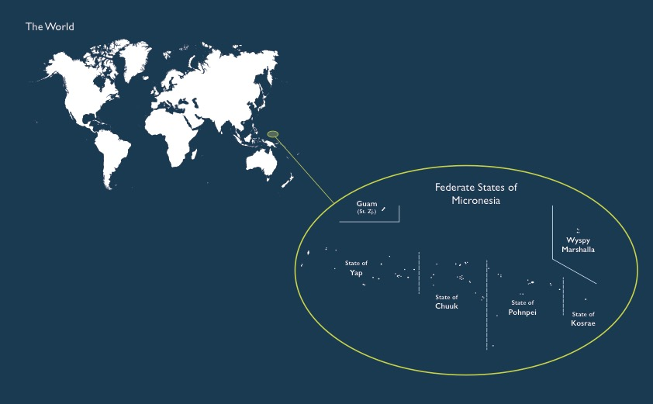

**Size Comparison of Compact Area to US**



**Update on Technical Aspects**

I have located streamflow records, watershed delineations, precipitation data, and soil type surveys for my study islands (mainly from the Department of Interior and university-affiliated researchers). Unfortunately, many of these records do not exist in easily-exportable formats, so I am creating Excel tables to import onto most of my maps. The island of Pohnpei (FSM’s most-populated island and the seat of the FSM and US governments) has the most-recent and most-comprehensive datasets. I’ve also located a report utilizing LiDAR data for Pohnpei, but have not been able to locate the data itself. This is not critical for my report, but I’d like to have it.

One aspect I hadn’t anticipated is the wide fluctuation of weather data according to El Niño/ La Niña seasons. The effects of the El Niño and La Niña weather pattern are seen in rainfall distribution, typhoon distribution, and changes in the sea level. Micronesia’s islands are impacted significantly by this weather pattern, which contributes to drought and flooding, which in turn effects islands’ freshwater reserves and ability to produce staple crops such as taro. The effects of this weather pattern (both drought and flooding conditions as well as typhoons) have previously triggered the US Presidential Disaster Declaration, which is the mechanism used to ‘activate’ emergency aid to the FSM. Because I am also investigating the relationship between water availability and impact to aid agencies, this will be important to consider as I move forward with my research.

I have had difficulty obtaining migration data relating to Micronesians relocating to the U.S. Because I have previously lived and worked in the country, I know that the government of the FSM keeps detailed census records relating to migration. However, I have written to them requesting the data (twice) and have not received a response. I can possibly request this data from the U.S. Census Bureau, but I am considering cutting this aspect from my report.