Piner, Rachel
GIS in Water Resources
October 24, 2017

Severe Flooding in the Onion Creek Watershed and Floodplain Housing Buyouts

Onion Creek Watershed: Map of Land Use
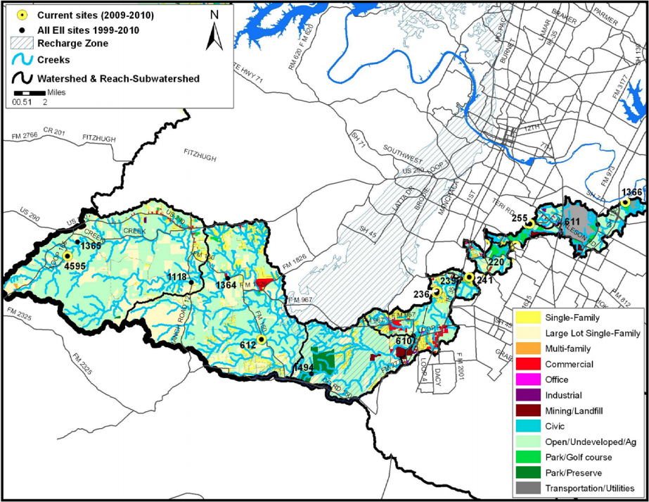
My main objective for this term project is to investigate the effects of large flood events (25, 100, 500, 1000 year storms) on the Onion Creek Watershed, and how particular neighborhoods are affected. I also want to investigate the relationship between homes at a higher risk of flooding and the socioeconomic status of the families that live in those homes. More than often, poorer citizens buy homes that lay in the floodplain because they are much cheaper, and then suffer the immense consequences after large flood events such as the Halloween floods of 2013 and the Memorial Day floods of 2015 occur. Additionally, I want to learn more about the Lower Onion Creek Housing Buyout program from the City of Austin, and learn about their progress, future buyouts, and goals with the properties once the buyouts are completed. Lastly, I want to look at the floodplain mapping available for as far back as it goes—to see how the floodplains have changed over the years as the earth has experienced additional warming due to climate change.
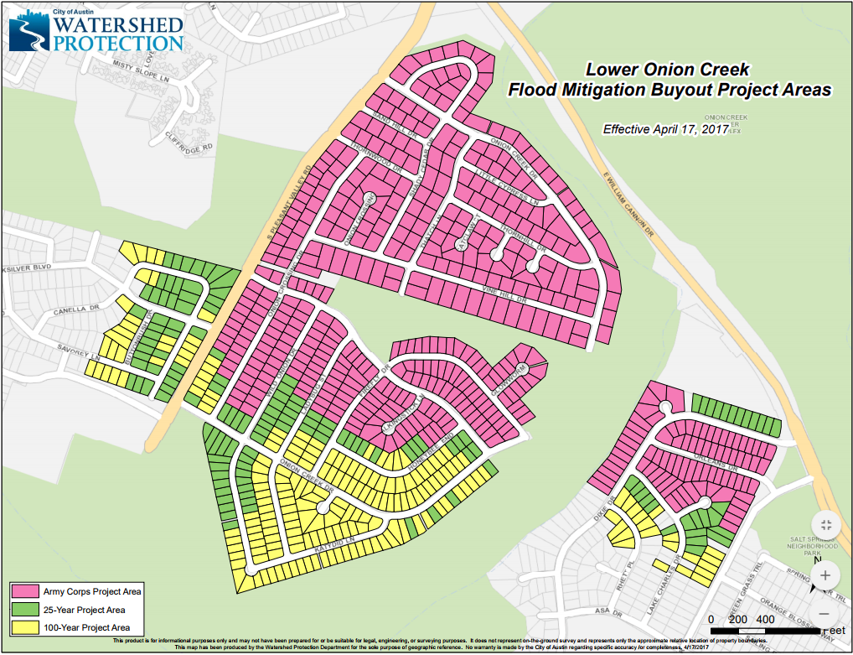
Figure 1: The Corps Project Buyouts in Lower Onion Creek

The area of main concern for my project is the Lower Onion Creek area, which is a large neighborhood southeast of the intersection of William Cannon Drive and South Pleasant Valley Drive. This neighborhood is the main focus for the Onion Creek Corps Project, where the Army Corps of Engineers is working with the City of Austin Watershed Protection Department to buy out homes in dangerous floodplains, and who face imminent potential damage to their homes from larger-scale storm events. This project received authorization from the U.S. Congress in 2007, and received federal funds by March 2014, and then completed the buyouts by May 2017. All 483 successfully purchased homes and plots of land from this project can be seen in Figure 1, as highlighted in pink. Furthermore, after the Corps Project properties were all successfully acquired, the City of Austin worked to buyout the remaining vulnerable homes, which are the homes in the 25-year and 100-year project areas (green and yellow highlighted homes in Figure 1, respectively). The highest priority homes for buyout were the remaining homes in the 25-year floodplain that were not purchased in the Corps project. This could be because of the slight difference in the floodplain mapping between the City of Austin and FEMA, the latter of which is used by the U.S. Army Corps of Engineers. The most recent update states that 133 out of 137 homes have been bought in the 25-year project area, and 187 out of 203 properties have been purchased in the 100-year floodplain project area.

The housing program began in 1999, and picked up much more speed after the 2013 Halloween floods that devastated many homes and families. This widespread flood expedited many of the buyouts in the Corps areas, as well as the City of Austin buyout areas. As seen in Figure 2, many of these horribly damaged homes now are owned by the City.
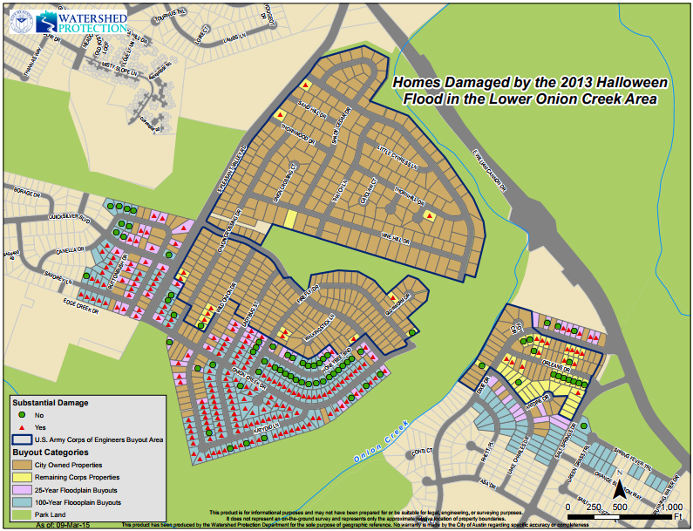
Figure 2: Homes Damaged by the 2013 Halloween Flood in Lower Onion Creek

As illustrated in Figure 3, this neighborhood is entirely in the 100-year floodplain, as shown in blue. If it is in the 100-year floodplain, it’s intuitive to note that the region is also in the 25-year floodplain. The orange area surrounding the blue region is the 500-year flood plain. For the 100-year flood plain homes, this means that these homes have a 1% chance of immense flooding (from a 100-year storm) every year. For the 500-year flood plain, these homes have a 0.2% chance of immense flooding (from a 500-year storm) every year. The homes in the 25-year and 100-year floodplain would suffer immensely from a 500 year storm as well since they are much lower in elevation. The larger the storm, the more catastrophe will result. The main goal of the Onion Creek Corps Project was to buyout the extremely vulnerable homes laying in the 25-year flood plain that would suffer greatly from any flood including and exceeding a 25-year flood (which has a 4% chance of occurring each year). All the homes highlighted pink and green in Figure 1 lie in the 25-year floodplain.
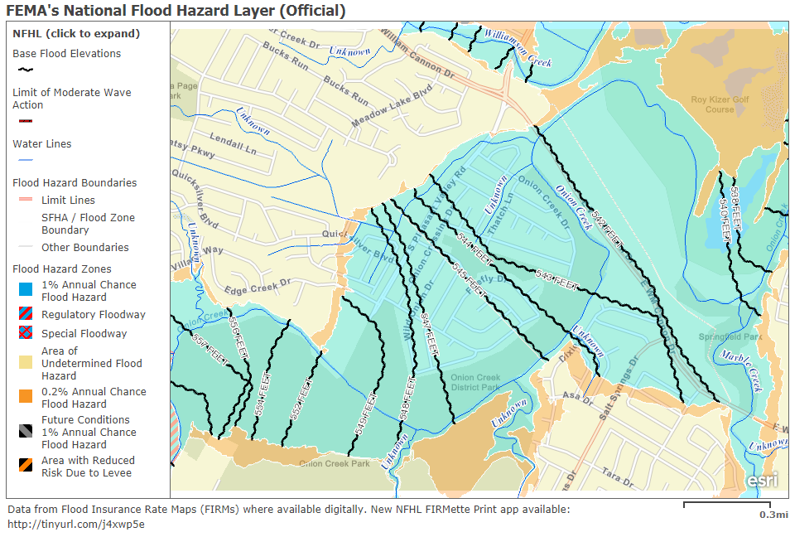
Figure 3: FEMA’s National Flood Hazard Layer in Lower Onion Creek

Now that all 483 properties have been purchased in the U.S. Army Corps project area, “the project team is currently focused on design of the recreational features and restoration of the natural area,” which will help alleviate flooding throughout Onion Creek. These 483 properties are now all owned by the City of Austin. They now consist of 290 acres of open space after the homes were demolished, 190 of which will be restored to a natural habitat that will properly convey water and improve the effluent water quality to the creek. The other 100 remaining acres are currently being designed by the U.S. Army Corps of Engineers, solely for recreational use in the future.

Recently, the City of Austin has now taken interest in 2 additional neighborhoods that also lie in the 100-year floodplain within the Onion Creek Watershed, and have the potential to suffer significant damage when a storm event of that magnitude occurs. The first is the Pinehurst Neighborhood near the Onion Creek Country club, where 116 homes are currently at risk (as of May 2017). Right next to the Pinehurst neighborhood is the Wild Dunes neighborhood, which currently has 23 homes currently at risk in the 100-year floodplain. These homes have potential flooding up to 3.7 feet inside the structure, as indicated in Figure 4. The City of Austin, working in conjunction with Halff Associates, is currently undergoing negotiations regarding the solution to this issue. They are currently considering a similar approach to the Lower Onion Creek region and doing voluntary buyouts, which would cost around $100 million. Other than that option, they are also considering constructing regional detention ponds to divert flow from the creek and prevent flooding in the neighborhoods, clearing channels in order to increase capacity of flow, or doing a combination of the 3 listed alternatives, in addition to the construction of a Pinehurst Flood Protection Wall to protect the most vulnerable homes in the Pinehurst neighborhood. All of these potential solutions are using the updated floodplain maps created by the City of Austin Watershed Protection Department in February 2017. The new FEMA floodplain maps will be published and effective in Fall of 2018, where the floodplain changes could differ again from what the City of Austin published this February.

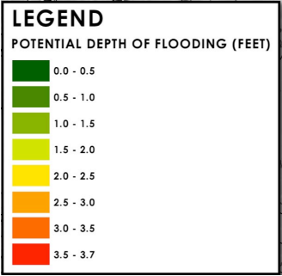
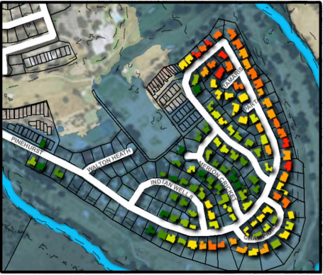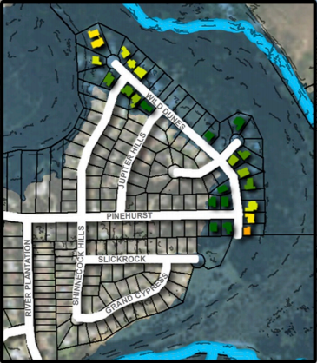
Figure 4: Existing Condition 100-year Flood Risk (left: Pinehurst Neighborhood, right: Wild Dunes Neighborhood)

I have completed a lot of investigation regarding the past, present, and future progress of the City of Austin’s housing buyout program in the Onion Creek watershed. The additional work I need to complete for the final presentation of my project includes the socioeconomic analysis of these neighborhoods, using any data I can find online, particularly from city-data.com, which seems to have very accurate and trustworthy information regarding the average age, annual income, racial distribution, poverty level, unemployment rate, and median house or condominium value within the city of Austin. I have found preliminary information regarding Onion Creek, as seen in Figure 5. I will continue to do research about the relationship between the housing buyouts and the socioeconomic status of families in the buyout areas.
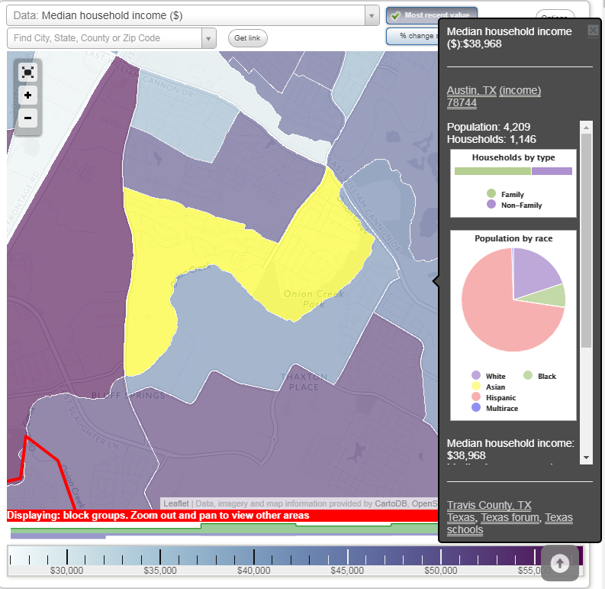
Figure 5: City-data.com Information on Lower Onion Creek Neighborhood

Additionally, I plan to use tools in GIS to delineate watersheds and floodplains in order to see how the City of Austin created their floodplain maps, and to understand the general flow of water in this watershed.

