GIS in Water Resources

Fall 2013

Homework #1

1. Map Projection Parameters

The map below shows Texas and a grid of world latitude and longitude from ArcGIS Online.

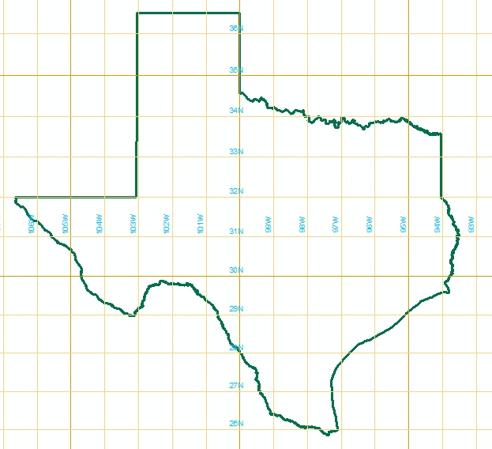

Here are the parameters of the State Plane Coordinate system of Texas, Central Zone:
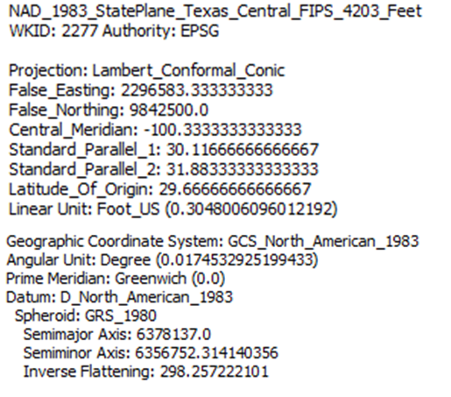

(a) What earth datum is used in this coordinate system?

(b) What map projection is used in this coordinate system?

(c) Sketch on the map the standard parallels, the central meridian and the latitude of origin of this projection.

(d) For this projection, what are the coordinates of the origin (φ_{o}, λ_{o}) (in units of degrees minutes and seconds) and the corresponding (X_{o}, Y_{o}) (in units of feet?

2. Locations on the Earth

Using ArcGIS Explorer Online and zooming to Austin and Logan reveals the following designated locations for these universities. Convert these locations into decimal degrees. Find the great circle distance between Austin and Logan in km if the radius of an equivalent spherical earth is 6371.0 km. Elevations for these locations were determined using Google Earth. 1 ft = 0.3048 m. Compute the slope along the great circle distance and indicate the direction that water would flow along this path.

Elevation 693 ft | Elevation 4789 ft

3. Sizes of DEM Cells

The National Land Data Assimilation System is a dataset produced by NASA to describe the time variation of the land surface hydrology of the United States. Data from this system are produced using 1/8 ° cells. When applied, they are projected to a coordinate system in which the (X,Y) coordinates are in meters. A spherical earth that has the same volume and surface area as a reference ellipsoid has a radius of 6371.0 km. Calculate the corresponding distances AB and AC in kilometers, and the area ABCD in square kilometers, for this cell on a spherical earth at Austin and Logan.

