**GIS in Water Resources Exercise #3 Solution**

**Part 1.**

1.1 Hand Calculations

(i) The standard ESRI surface slope function



(ii) The 8 direction pour point model



Note that the steepest 8 direction pour point model slope in direction 64 is:



D8 slope = **0.10**

D8 flow direction = **16**

1.2. Verifying calculations using ArcGIS

The values at cell A of Slope = 15.4%, Aspect = 234.25 deg, PercDrop = 10% and FlowDir=16 correspond to the hand calculations.

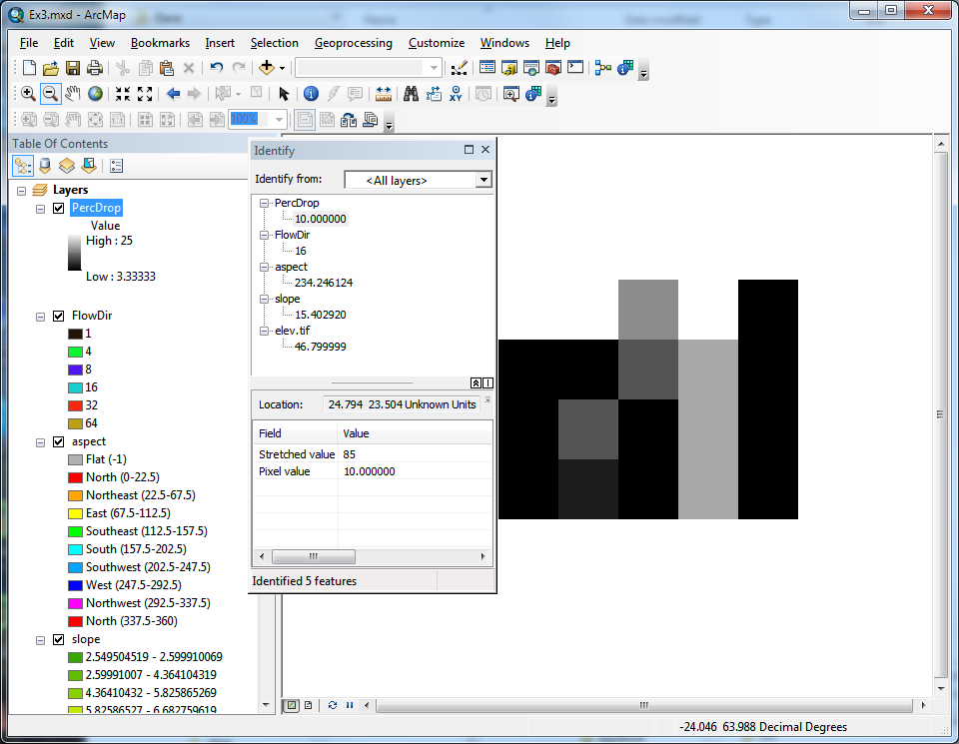

Other values are obtained similarly from identifying values in the ArcMap output.

Table of ArcGIS computed quantities

|  |  |  |
| --- | --- | --- |
| Cell | A | B |
| Slope | 15.403 | 11.159 |
| Aspect | 234.25 | 274.50 |
| Hydrologic Slope (Percentage drop) | 10% | 4.24% |
| Flow Direction | 16 | 32 |

Note that for the Cell B above ArcGIS (at least my version) reports 3.3%, so if students report 3.3% they should not be penalized. This appears to be a bug in ArcGIS, because based on the elevation values the percentage drop is 4.24%.

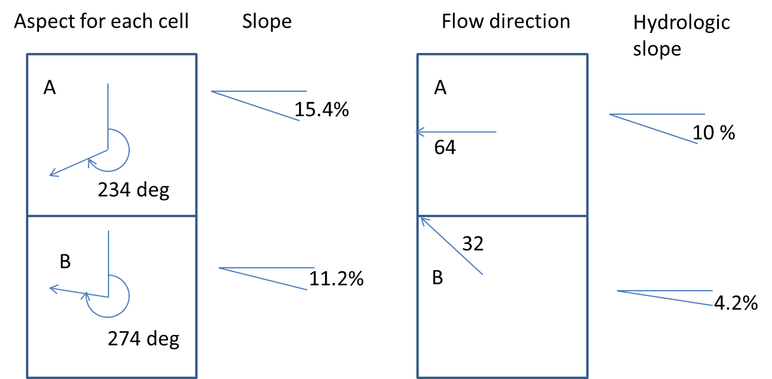

1.3 Model Builder model to do the above

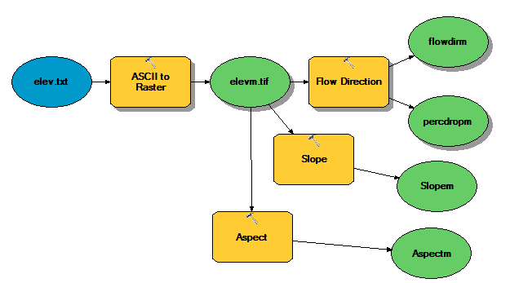

This tool is available on <http://www.neng.usu.edu/dtarb/giswr/2011/Ex3.tbx> if you want to download and look at it.

Table of data ranges from model output using the file demo.asc

|  |  |  |
| --- | --- | --- |
| Grid | Minimum | Maximum |
| Flow Direction | 1 | 128 |
| Hydrologic Slope (percentage drop) | 0.067% | 146.67% |
| Slope | 0 | 148.79% |
| Aspect (degrees from north) | -1 | 360 |

-1 for aspect is used to represent flat grid cells

**Part 2.**

**1. Loading the Data**

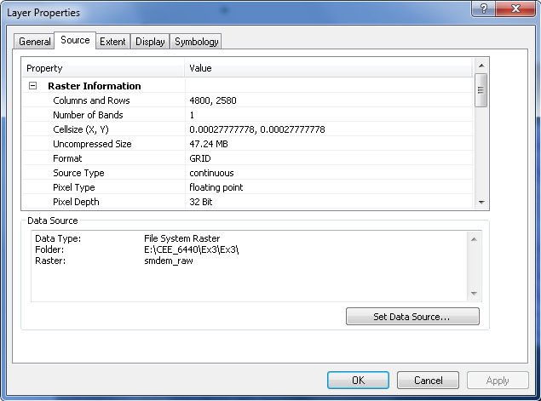

*The number of columns and rows are 4800 and 2580 respectively,*

*cell size in the N-S directions in m = , where in rad and Re (Earth radius)*

=**30.88 m**

*cell size in E-W direction must be adjusted for latitude.*

*cell size =  where, = longitude difference, use =29.82° (average of top and bottom latitudes) and = 0.0002778;*

*cell size E-W =* **26.8 m**

*Extent (in degrees) Top=30.1833o, Left = -98.7333o, Right = -97.4000o, Bottom = 29.4667o*

*Spatial reference information for the San Marcos elevation dataset DEM ‘smdem_raw’ is;*

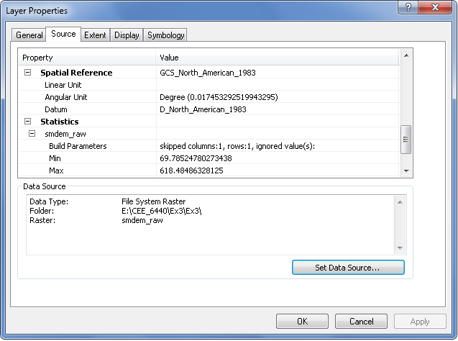

**2. Projecting the DEM**

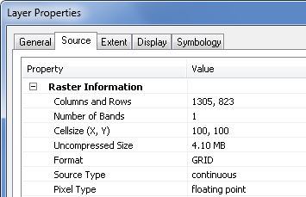

*1305 columns, 823 rows. The minimum and maximum elevations in the San Marcos elevation dataset DEM ‘smdem_raw’ as well as the projected one ‘smdem’ are shown below. The difference in min and max is due to interpolation to a coarse grid.*

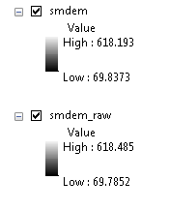

**3. Exploring the DEM**

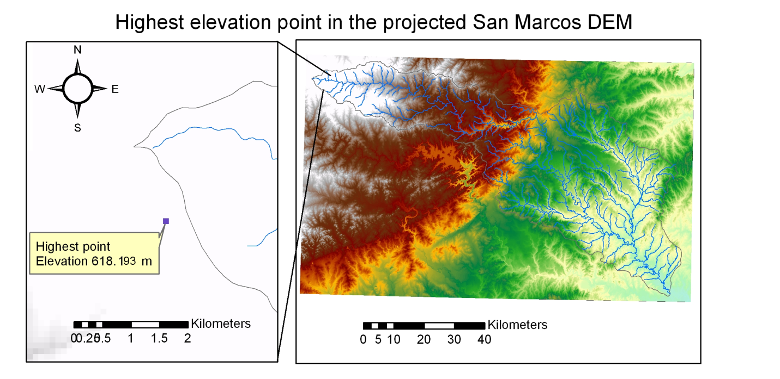

**4. Contours and Hillshade**

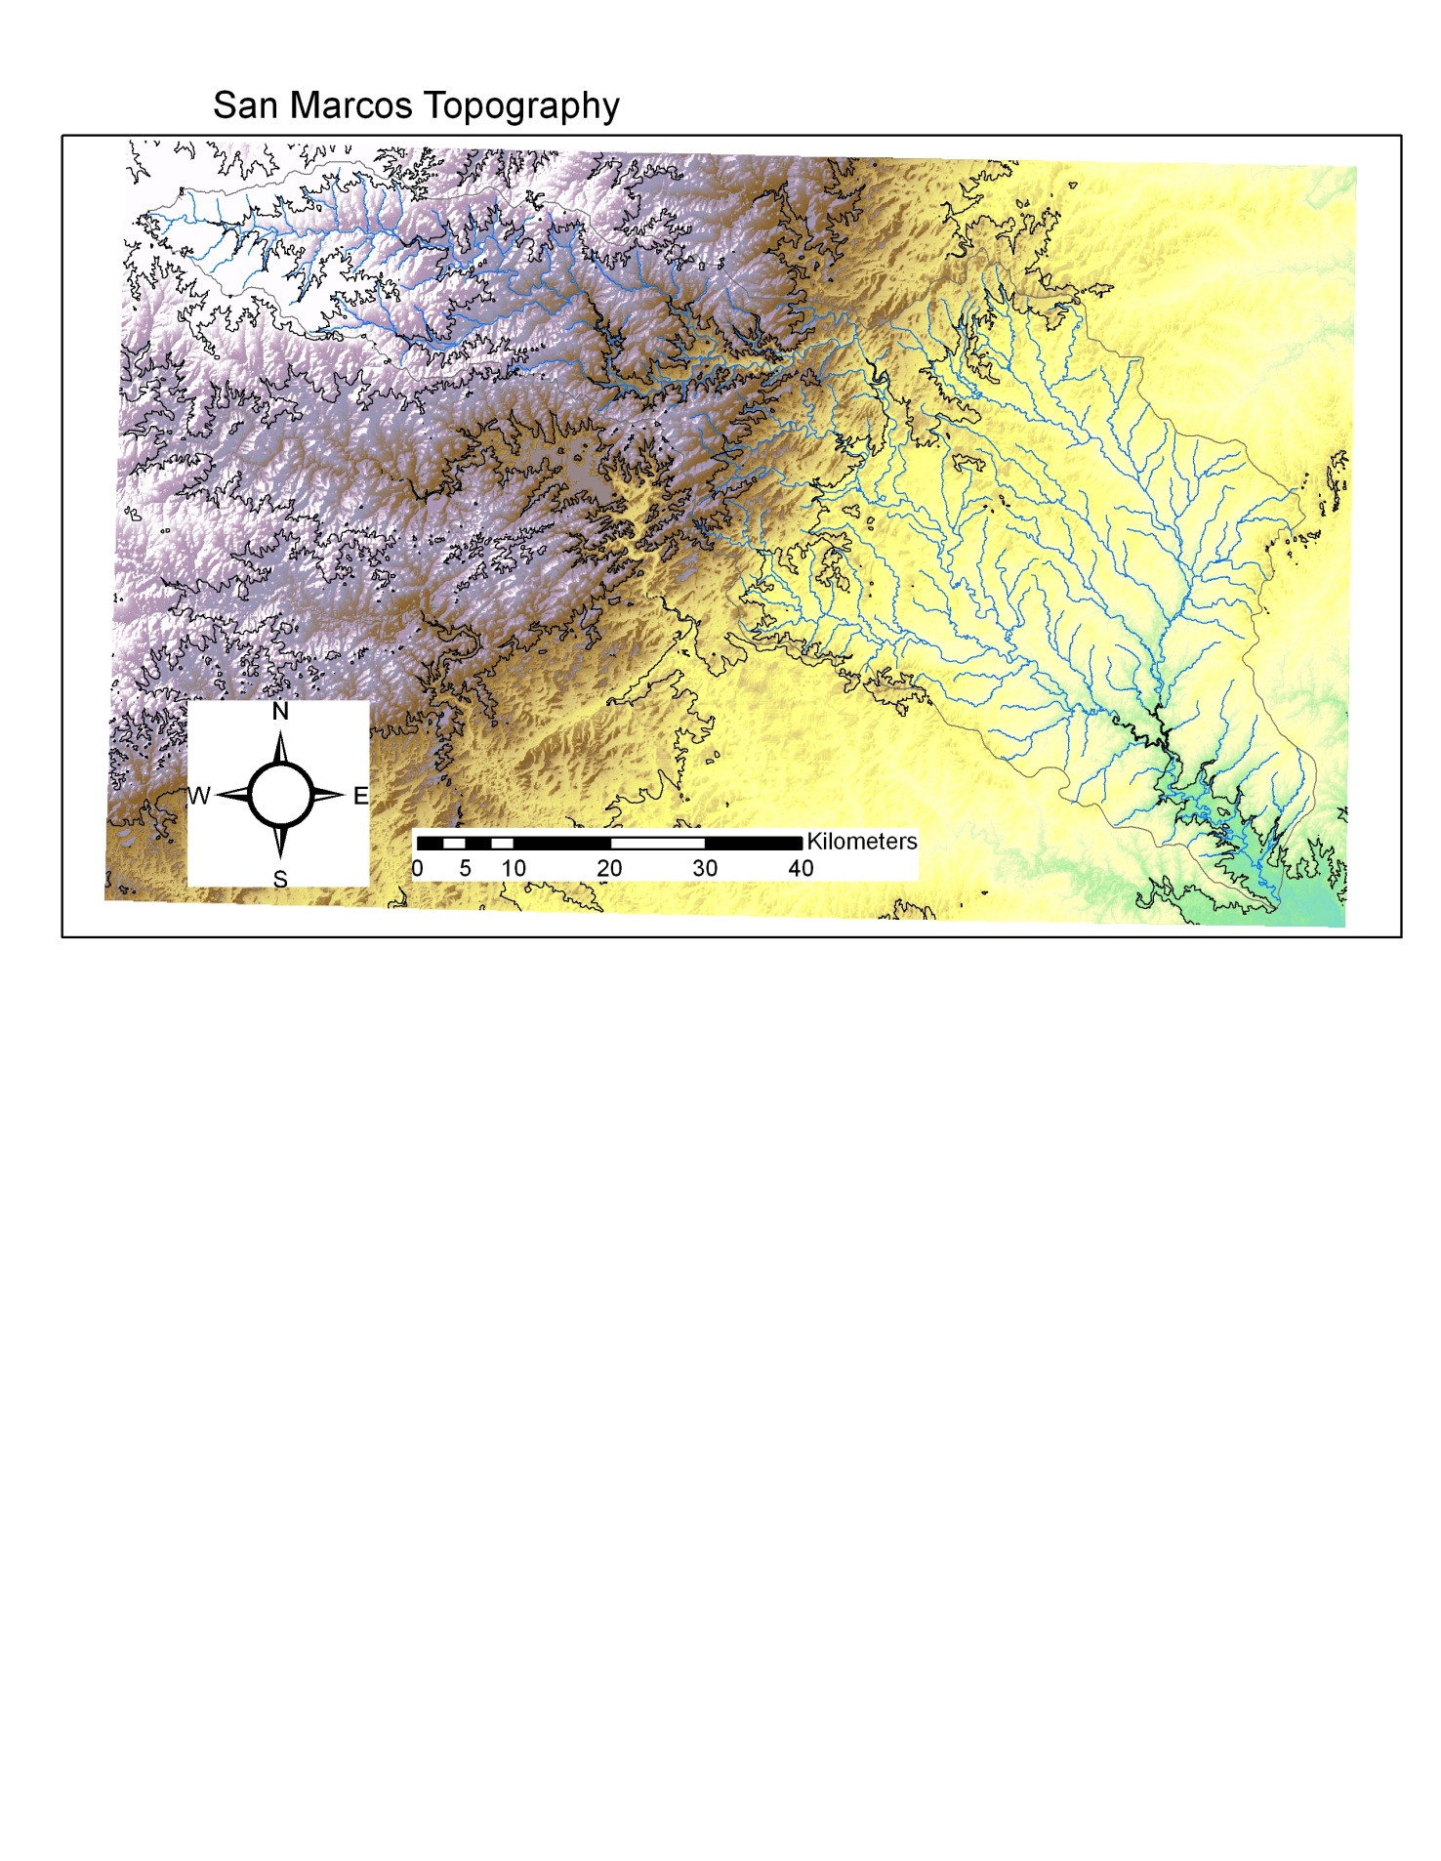

The layout above uses 100 m contours and the hillshade effect associated with the DEM to illustrate the San Marcos Topography.

**5. Zonal Average Calculation**

|  |  |  |  |
| --- | --- | --- | --- |
| HydroID | Name | Elevation range (m) | Elevation mean (m) |
| 330 | Plum Ck at Lockhart, TX | 136.727 | 189.915 |
| 331 | Blanco Rv at Wimberley, TX | 371.415 | 418.636 |
| 332 | Blanco Rv nr Kyle, TX | 207.755 | 288.644 |
| 333 | San Marcos Rv at San Marcos, TX | 214.879 | 265.926 |
| 334 | Plum Ck nr Lockhart, TX | 77.953 | 150.198 |
| 335 | Plum Ck nr Luling, TX | 113.106 | 152.989 |
| 336 | San Marcos Rv at Luling, TX | 308.916 | 183.518 |
| 337 | San Marcos Rv at Ottine, TX | 117.583 | 131.471 |
| 338 | San Marcos Subbasin | 112.168 | 115.347 |

The subwatershed with highest mean elevation is Blanco above Wimberley (Note the point with the highest elevation is near the upper end of this subwatershed). The largest elevation range is found in the Blanco above Wimberley subwatershed too.

**6. Calculation of Area Average Precipitation using Thiessen Polygons**

|  |  |  |
| --- | --- | --- |
| **HydroID** | **Name** | **Mean Precip (in) by Thiessen Polygons** |
| 330 | Plum Ck at Lockhart, TX | 36.37 |
| 331 | Blanco Rv at Wimberley, TX | 37.82 |
| 332 | Blanco Rv nr Kyle, TX | 40.48 |
| 333 | San Marcos Rv at San Marcos, TX | 40.48 |
| 334 | Plum Ck nr Lockhart, TX | 36.45 |
| 335 | Plum Ck nr Luling, TX | 36.56 |
| 336 | San Marcos Rv at Luling, TX | 37.59 |
| 337 | San Marcos Rv at Ottine, TX | 35.79 |
| 338 | San Marcos Subbasin | 34.49 |

The highest mean precipitation is found for the San Marcos River at San Marcos and Blanco River near Kyle watersheds. These are identical, because they are both in the same polygon.

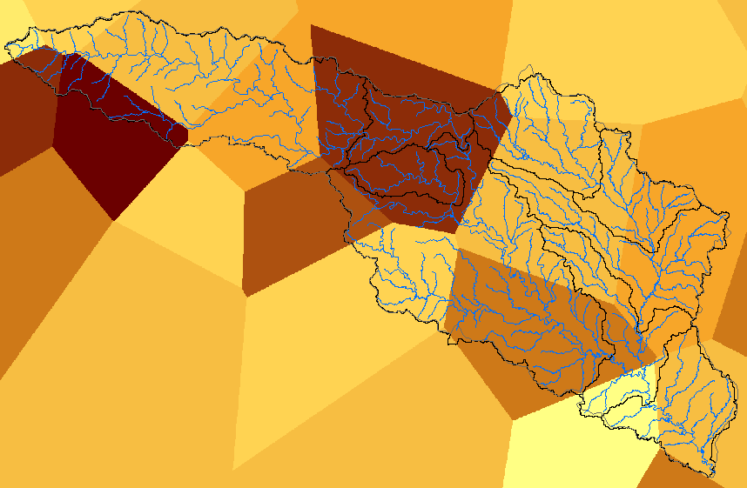

Two subwatersheds in the same polygon have identical estimated precipitation

To evaluate total watershed mean annual precipitation

Sum Shape Area = 3.528 x 109 m2

Sum APProd = 131.44 x 109 in m2

Dividing 131.44/3.528 = **37.26 in. This is the total watershed mean annual precipitation**

**7. Estimate basin average mean annual precipitation using Spatial Interpolation/Surface fitting**

|  |  |  |
| --- | --- | --- |
| **HydroID** | **Name** | **Mean Precip (in) by Tension Spline** |
| 330 | Plum Ck at Lockhart, TX | 36.22 |
| 331 | Blanco Rv at Wimberley, TX | 37.89 |
| 332 | Blanco Rv nr Kyle, TX | 39.79 |
| 333 | San Marcos Rv at San Marcos, TX | 39.66 |
| 334 | Plum Ck nr Lockhart, TX | 35.97 |
| 335 | Plum Ck nr Luling, TX | 36.74 |
| 336 | San Marcos Rv at Luling, TX | 37.99 |
| 337 | San Marcos Rv at Ottine, TX | 35.87 |
| 338 | San Marcos Subbasin | 34.52 |

Blanco Rv nr Kyle, TX has the highest mean precipitation estimated from Tension Spline Interpolation.

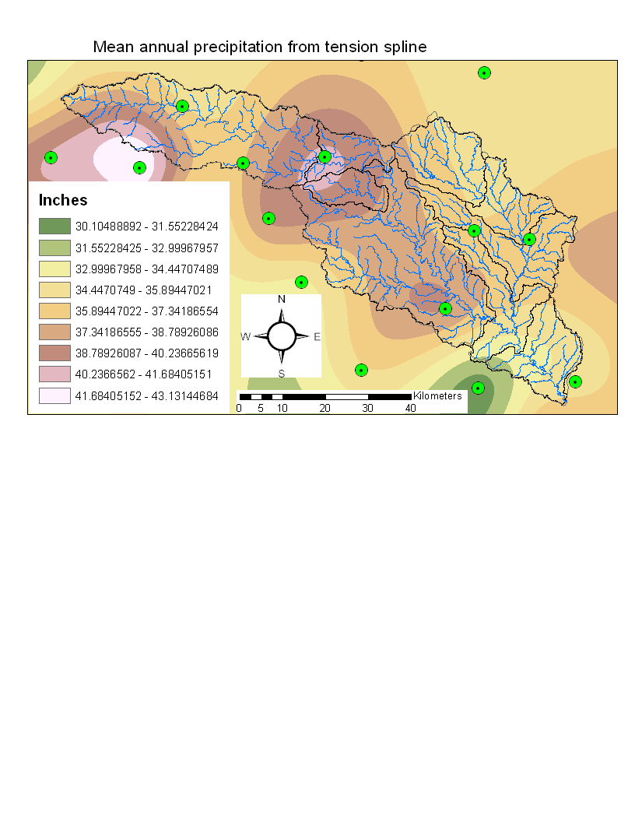

I also used Natural Neighbor Interpolation

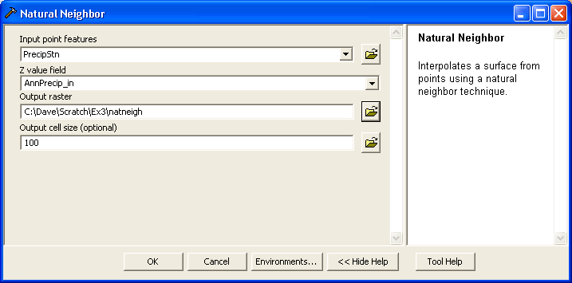

|  |  |  |
| --- | --- | --- |
| **HydroID** | **Name** | **Mean Precip (in) by Natual Neighbor method** |
| 330 | Plum Ck at Lockhart, TX | 36.56 |
| 331 | Blanco Rv at Wimberley, TX | 37.58 |
| 332 | Blanco Rv nr Kyle, TX | 39.24 |
| 333 | San Marcos Rv at San Marcos, TX | 38.70 |
| 334 | Plum Ck nr Lockhart, TX | 36.21 |
| 335 | Plum Ck nr Luling, TX | 36.79 |
| 336 | San Marcos Rv at Luling, TX | 37.26 |
| 337 | San Marcos Rv at Ottine, TX | 36.18 |
| 338 | San Marcos Subbasin | 35.07 |

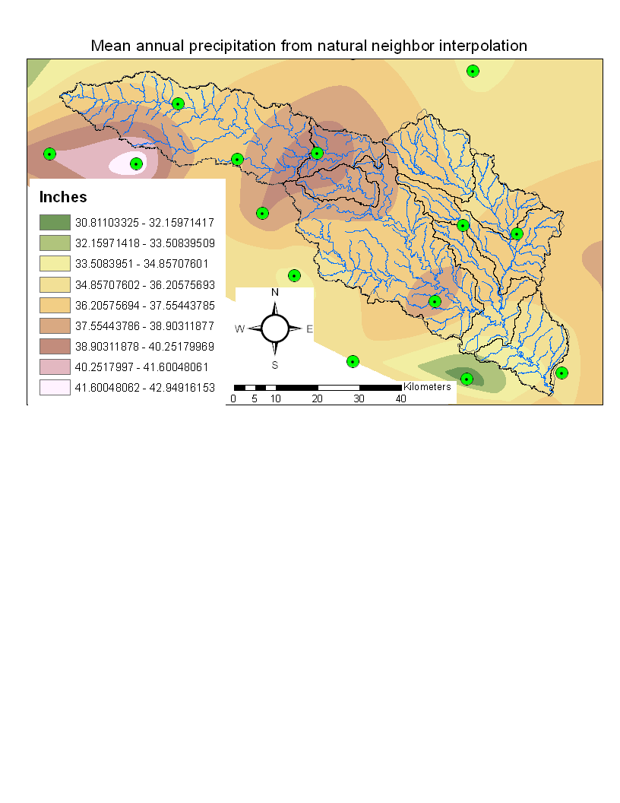

**8. Runoff Coefficients**

The following map shows stream gages at the outlet of each subwatershed

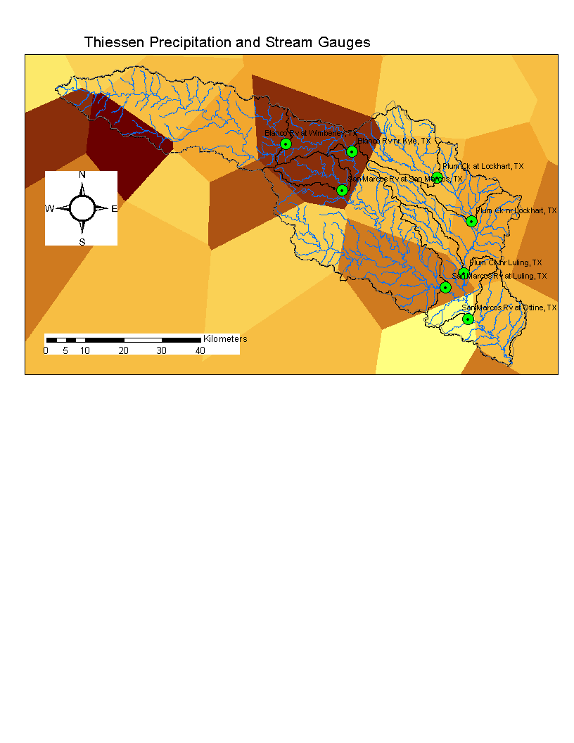

This indicates the following subwatersheds which comprise each watershed

|  |  |
| --- | --- |
| **Watershed** | **Subwatersheds** |
| Plum Ck at Lockhart, TX | Plum Ck at Lockhart, TX |
| Blanco Rv at Wimberley, TX | Blanco Rv at Wimberley, TX |
| Blanco Rv nr Kyle, TX | Blanco Rv nr Kyle, TX  Blanco Rv at Wimberley, TX |
| San Marcos Rv at San Marcos, TX | San Marcos Rv at San Marcos, TX |
| Plum Ck nr Lockhart, TX | Plum Ck nr Lockhart, TX  Plum Ck at Lockhart, TX |
| Plum Ck nr Luling, TX | Plum Ck nr Luling, TX  Plum Ck nr Lockhart, TX  Plum Ck at Lockhart, TX |
| San Marcos Rv at Luling, TX | Blanco Rv nr Kyle, TX  Blanco Rv at Wimberley, TX  San Marcos Rv at San Marcos, TX  San Marcos Rv at Luling, TX |
| San Marcos Rv at Ottine, TX | San Marcos Rv at Ottine, TX  Blanco Rv nr Kyle, TX  Blanco Rv at Wimberley, TX  San Marcos Rv at San Marcos, TX  San Marcos Rv at Luling, TX  Plum Ck nr Luling, TX  Plum Ck nr Lockhart, TX  Plum Ck at Lockhart, TX |

Runoff ratio calculations are in the following spreadsheet (embedded object so you can see calculations in electronic version)



In the top table Precip volume is Mean precip * Area divided by 12 x 0.30482 to obtain volume in ft3. In the bottom table Flow volume is obtained from flow in cfs by multiplying by 365.25*24*3600*3600. The subwatersheds that comprise each watershed are identified and precip volume obtained by summing these. Runoff ratio is then flow volume/precip volume.

The runoff ratio for the San Marcos river at San Marcos is anomalously high due to flow from springs that are fed by precipitation that recharges the Edwards Aquifer outside the watershed. This anomalous high flow attenuates downstream. Plum Creek at Lockhart is also in the vicinity of where the Edwards aquifer outcrops and has a slightly higher runoff ratio so likely gets some spring contributions too. Over all the other watersheds, runoff ratio is pretty consistent between 0.11 and 0.15, which seems about right for this region.