### ­­Introduction to ArcGIS Desktop

**Prepared by David R. Maidment**  
**Center for Research in Water Resources**   
**University of Texas at Austin**   
**September 2012**

### Table of Contents [Goals](#Goals) [Computer and Data Requirements](#Requirements) [Procedure](#Procedure) [1. Viewing Shapefiles in ArcMap](#Step1) [2. Viewing Shapefiles in ArcCatalog](#Step2) [3. Using Basemaps from ArcGIS Online](#Step3) [4. Accessing and querying attribute data](#Step4) [5. Selecting features from a feature class](#Step5) [6. Mapping annual evaporation](#Step6) [7. Making a chart](#Step7) [8. Making a map layout](#Step8) [9. Share in ArcGIS Online](#Step9)

### [Items to be turned in.](#TurnIn)

### Goals of the Exercise

This exercise introduces you to ArcMap and ArcCatalog. You use these applications to create a map of pan evaporation stations in Texas, and to draw a graph of monthly pan evaporation data measured at these stations. You use ArcCatalog to create a new personal geodatabase and import shapefiles to a feature dataset. The relationship between ArcGIS and MS Word and Excel is demonstrated so that you can create graphs in Excel, maps in ArcGIS and place the result in a Word file as a report for this homework. In this way, you link the spatial location of the observation sites, with the time variation of the water observations data at those sites.

### Computer and Data Requirements

To carry out this exercise, you need to have a computer, which runs ArcGIS Desktop version 10.1. You will also need and ESRI Global Account to enable you to login to ArcGIS Online. If you do not already have an ESRI Global Account, go to: <https://www.arcgis.com/home/createaccount.html> and create one.

You will be working with the following spatial datasets during this exercise:

1. A polygon shapefile of the counties of Texas, called **Counties**
2. A point shapefile of pan evaporation stations, called **Evap**
3. A polygon shapefile of the state of Texas, called **Texas**

These shapefiles consist of several files (e.g. **evap.dbf, evap.shp, evap.shx).** You can get them from this zip file: <http://www.ce.utexas.edu/prof/maidment/giswr2012/Ex1/Ex1Data.zip>

You need to establish a working folder to do the exercise on. This can be in c:\temp, your student directory, or on a memory stick attached to the machine you are working on. To establish a new account at the CE Information Technology Support and Services, go to <http://www.caee.utexas.edu/itss/> and select **LRC User Accounts.** If you don't yet have a regular Login account at the LRC, get a temporary guest login to do the exercise.

After you have downloaded the zip file **Ex1Data.zip** double click on the file and you should see the Winzip, Alladin Stuffit utility, or other zip utility to open the file on your computer (if it doesn’t open you’ll have to unzip this file on a computer that has a zip utility installed). Extract all files from the zip file to the working folder that you’ve set up to do this exercise. You should end up with a file list that looks something like this. You may see these data within a sequence of folder names, and if so, click on each folder down through the sequence until you locate the required files.

**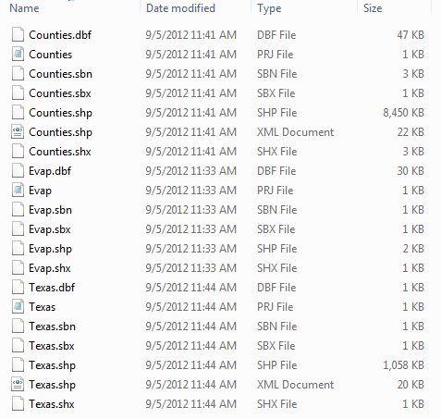**

### Procedure

*Please note that the following procedure is a general outline, which can be followed to complete this lesson. However, you are encouraged to experiment with the program and to be creative.*

#### 1. Viewing Shapefiles in ArcMap

A *shapefile* is a homogenous collection of simple features that do not contain topological information. A shapefile includes geometric features and their attributes. The attributes are contained in a dBase table, which allows for the joining with a feature based on the attribute key.

Open **ArcMap** and select the A **new empty map** option.

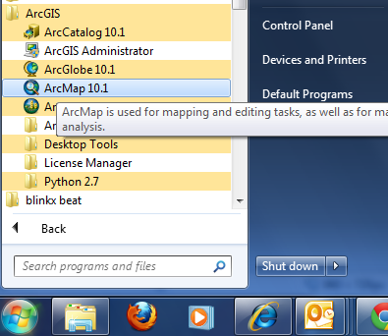

Use the Add Data button to add the data for this exercise to the ArcMap display.

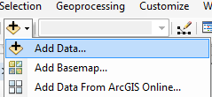

Navigate to the folder, which contains the data, and select all three files at once by using the shift key. Click the Add button to import the data. If you are using a network drive to obtain your files use the **Connect to folder** button to add the network drive to the ones that ArcMap is accessing so you can get to the files.

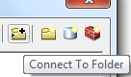

Click on each of the three shape files so that they are highlighted  
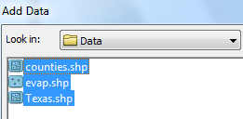

and add them to your ArcMap display.

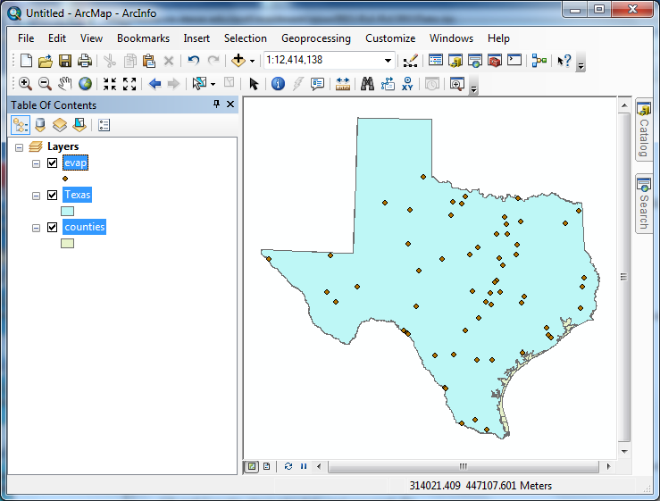

All the themes are highlighted and Texas lies above counties so you cannot see the counties theme. Click on the List by Drawing Order button in the Table of Contents page:

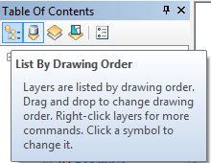

Click in the **Table of Contents** area below the feature class names so that three themes are no longer highlighted, then click on the counties theme and drag it up so that it is located above the Texas theme. You’ll then get a display showing the counties.

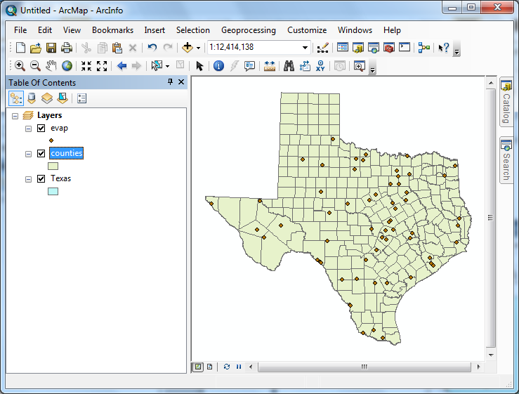

To change the appearance of a map display, you can access the **Symbology** menu just by double clicking on the Symbol



displayed in the ArcMap Layers, and you’ll get the **Symbol Selector** window

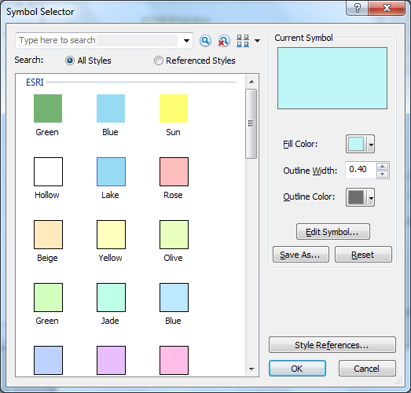

Click on the symbol color box, make your selections for the **Fill Color** and the **Outline Color**, and click OK, twice. You can show the outline of the State of Texas more distinctly by using the **No Color**

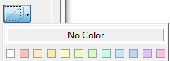

symbology for the Fill Color and then changing the Outline Color to Green and the **Outline Width** to 2.

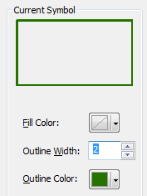

Drag the Texas layer above the Counties layer, and you’ll see that the Counties are not obscured as they were before and the State of Texas is highlighted with a nice Green outline! We are green in Texas!

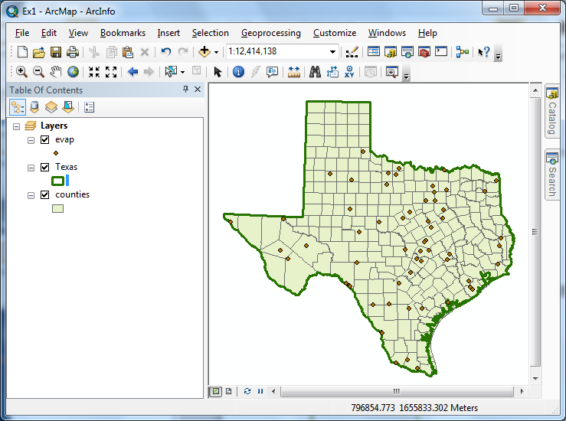

To Save this map display, use **File/Save** As in ArcMap and save the resulting file as **Ex1.mxd**.

Save your work in ArcMap by choosing **File/Save** and, after navigating to your working directory, naming the file **Ex1** (the file will be assigned the extension mxd). When you do this, the **Ex1.mxd** file contains the file location of the geodatabase and the symbology you’ve chosen for the map display. You can shut down Arc Map and then invoke Arc Map again and reload the same map display by clicking on Ex1.mxd. Note, however, that if in the mean time you’ve relocated your data, ArcMap will go back to where you had it at the time the map file was saved.

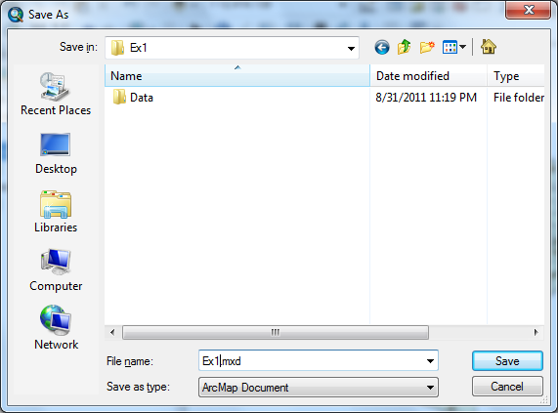

\_\_\_\_\_\_\_\_\_\_\_\_\_\_\_\_\_\_\_\_\_\_\_\_\_\_\_\_\_\_\_\_\_\_\_\_\_\_\_\_\_\_\_\_\_\_\_\_\_\_\_\_\_\_\_\_\_\_\_\_\_\_\_\_\_\_\_\_\_\_\_\_

#### Helpful Tip:

If you open your ArcMap Ex1.mxd file later from another location in your file system, you may see a red exclamation points beside your feature classes. If this happens, in ArcMap, right click on the feature class use **Data/RepairData Sources** to relocate the file location where the corresponding data are now stored and your map will display correctly again.

#### 2. Viewing Shapefiles in ArcCatalog

Open **ArcCatalog** by clicking on the Catalog tab on the right hand side of the map display

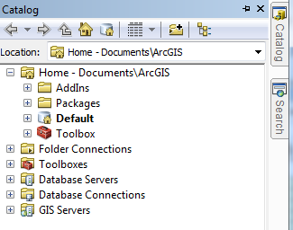

Click on the “Folder Connections” button and navigate to where your data are stored.

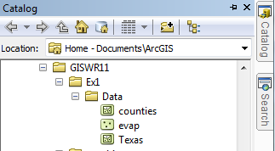

If you right click on a data layer, you can obtain an Item Description

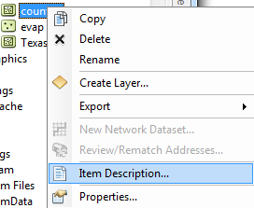

Select the **Preview** tab and then **Geography** to see a map of the feature class

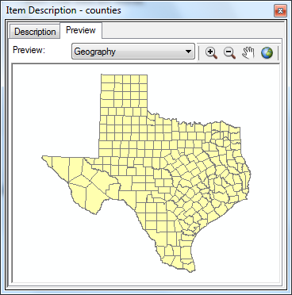

And then select the **Table** view

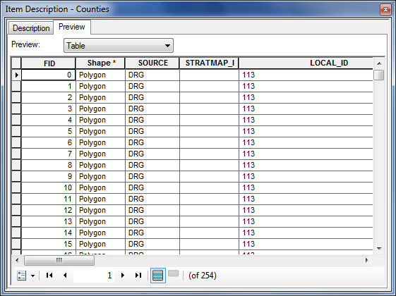

The attributes FID, Shape, Area and Perimeter are standard attributes for ArcGIS feature classes. The units of the area and perimeter are defined from the map units of the feature class.

If you right click on a feature class and then select **Properties**

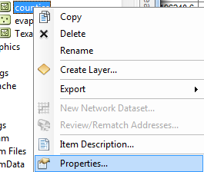

And select **XY Coordinate System** which shows you the parameters of the coordinate system of these data, **NAD83**, or the North American Datum of 1983. This provides a rather complicated set of parameters that we’ll learn more about later.

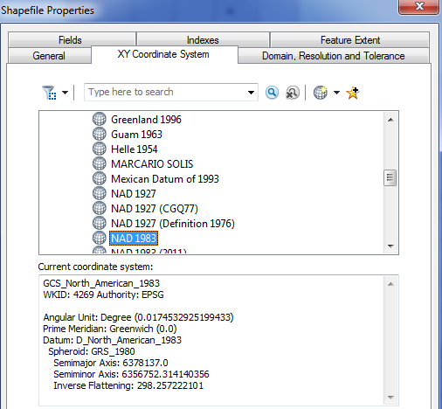

If you click on the **Fields** tab, you’ll see a formal definition of each attribute field with its **Field Name** and **Data Type**. In this case, **ObjectID** means a special data type that indexes each feature as an object in the GIS, **Geometry** means that the Shape field has geographical coordinates stored in it, and **Float** and **Double** mean decimal numbers in single or double precision, respectively. There are some other data types such as Short and Long integers, Text and Date types, that we’ll encounter later in the course.

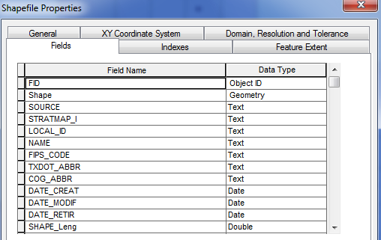

Click on the other two data layers**, Evap** and **Texas** to preview them also.

**3. Using Base Maps from ArcGIS Online**

Up to this point we have just used local GIS data in our display. Let’s instead using base maps from the ArcGIS Online. Use **Add Basemap**:

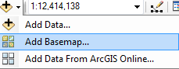

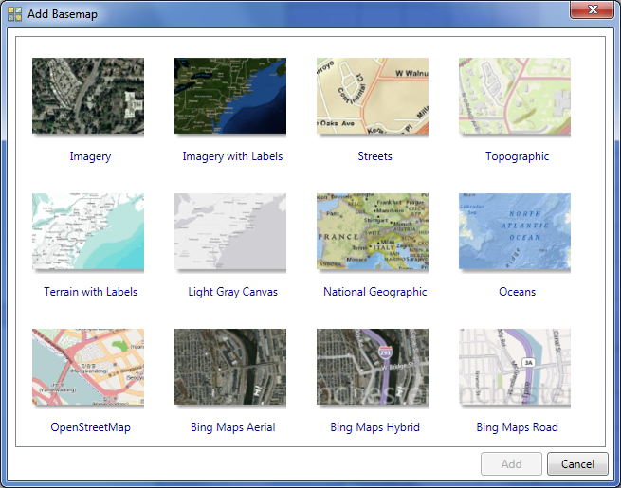

Click on “**Streets**”, in the bottom row of maps. You’ll see a background map appear behind your Texas display. Pretty cool!

If you get a message asking about Hardware Acceleration, say **Yes** to it.  
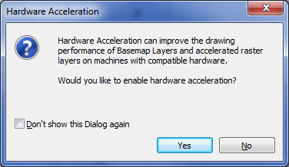

You should see a result like that shown below. If your BaseMap does not show up, use the **Refresh** tool  in the bottom left hand corner of the ArcMap display to redraw the map and the BaseMap should then show up.

To quickly get the map to center on Texas, right click on the Texas layer and select **Zoom to Layer**

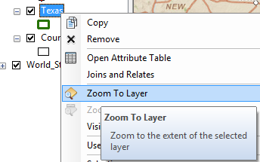

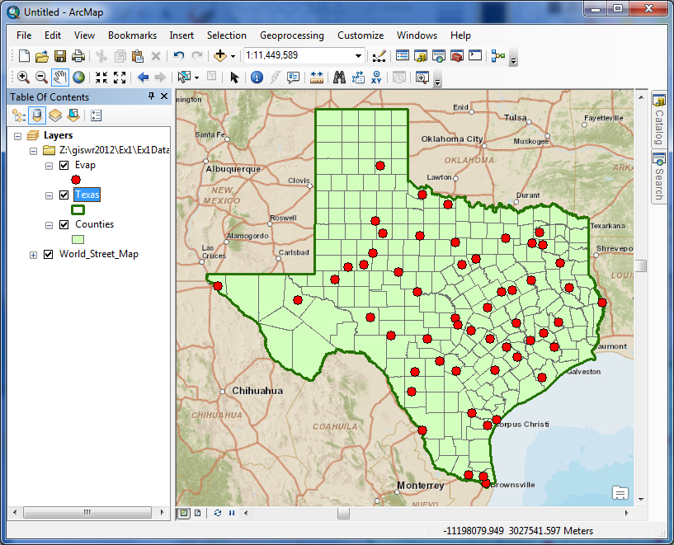

Click on the Counties theme and use the Symbol Selector to change the Fill Color to “No Color” so we can see through it to the background map, and the new display appears. Let’s examine Travis County.

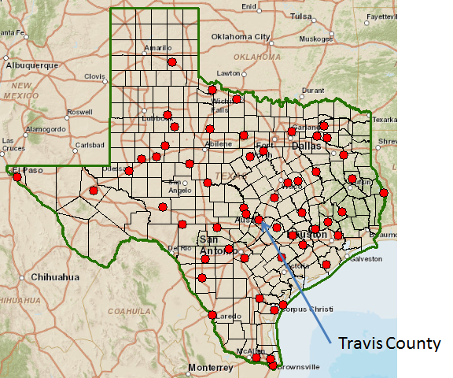

Use the Zoom in button to select a box around Travis County

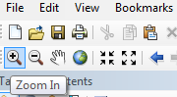

Click the counties layer to turn off the county boundaries since the background map already shows the county boundaries

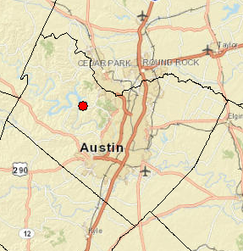

Zoom in to Travis County by Austin in the center of Texas, and let’s examine the evaporation site by Lake Travis to the Northwest of the city. Notice how more interesting information appears as you zoom in closer.

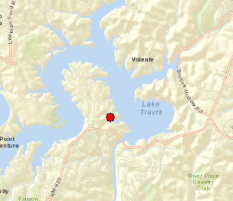

Lets label the sites with their names. Right click on the **Evap** theme and select **Properties** at the bottom of the display that appears.

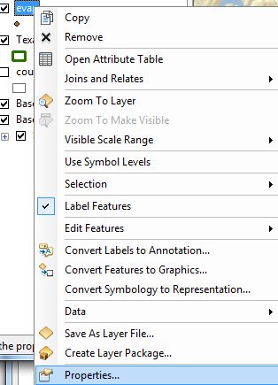

**Labels** tab and for the **Label Field,** select **Station,** and **16** point as the type size. Hit **Apply** and then **Ok**, to close this window.

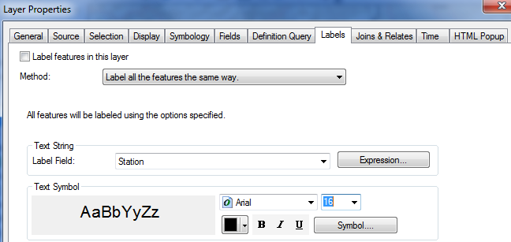

Now, right click on the Evap theme again and select **Label Features**, and you’ll see a nice label **Mansfield Dam** appear by the site next to Lake Travis.

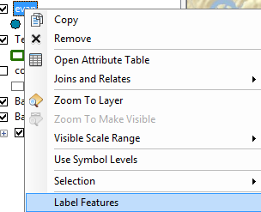

Click on the symbol for the Evap points and use the Symbol Selector to change the size of the points to 8 and the color to Red. Now we’ve got a nice map that shows the location of our observation site labeled with its name.

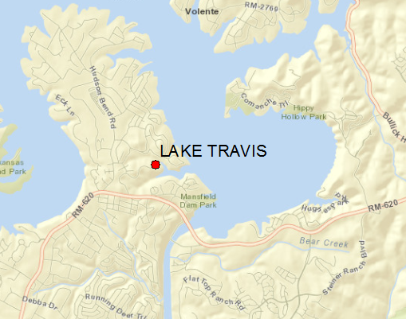

If you zoom in a bit closer, you can see just where the site is located near Lake Travis. Mansfield Dam is the dam that is at the downstream end of Lake Travis. You can even see the access roads you’d use to go to this site.

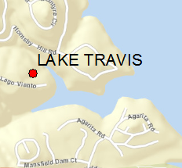

Now, lets look at some imagery for this location. Proceeding as you did before to get the Street map, use **Add BaseMap**, to add data for **Imagery** Turn off the Street Map so you can see the imagery.

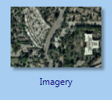

And now you’ll see the same information displayed against a background map of orthoimagery, and lets zoom in a bit to see more detail. For the **Evap** theme, I have used the **Properties/Label** to change the color of my site labels from black to blue to make them easier to see against the image background. This is really cool stuff! You can really get a sense of context about where this observation site is located.

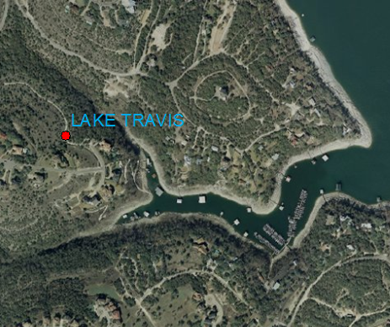

Use **File/Save As** to save this new map display as **Ex1.mxd** so that you can get it back later if you need it.

**4. Accessing and Querying Attribute Data**

Lets go back to the view we had earlier of Travis County. Use the Go Back to Previous Extent arrow

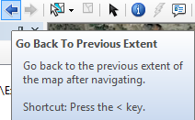

to step back through the views we have just been working on, and turn off the Image basemap so that you can see the Streets basemap again. Change the Label color for the evap sites back to Black.



Numerical and text information stored in the fields of the geodatabase tables are called **attributes**. To access attribute data of the feature classes at a specific location:

Click on the **Identify** tool

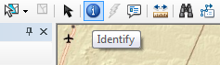

Highlight the feature class you are interested in the Table of Contents (Evap), and then click on the feature on the map you are interested in. In the **Identify** window that pops up you’ll see the attributes of that particular feature. In this instance, what you see is that the data for Lake, cover the range from 2003 to 2010, the latitude and longitude are 30.403 and -97.917, and the values from Jan through Dec are the mean monthly evaporation recorded at this location, in inches, whose annual total is an Annual of 69.36 inches.

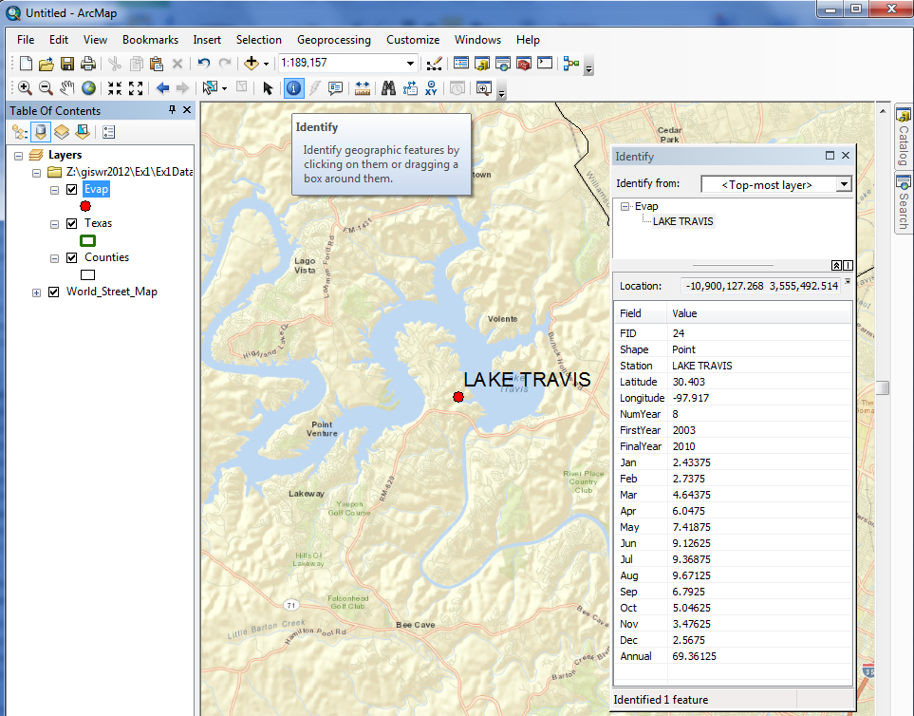

These are pan evaporation data recorded using an instrument like that shown below. The evaporation data were obtained from the Texas Water Development Board. Only data from 2001 onwards is used since the TWDB has quality control checked that information. Monthly evaporation is found by averaging the daily values of evaporation read from the pan, and multiplying by the number of days in the month. If a month has fewer than 20 daily values recorded, it is excluded from the dataset. Only years with valid monthly data for all 12 months are used in computing the mean monthly and mean annual pan evaporation data shown in the attribute table.

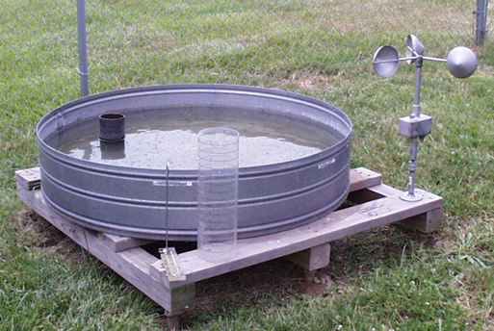

**Viewing an Attribute Table**

To access attribute data of an entire layer, in **ArcMap**: right click on the **Evap** layer name in the table of contents, and select **Open Attribute Table**:

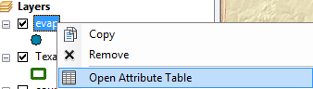

And if you scroll down the resulting **Table** and click on **FID 24** you’ll see the record that contains the attributes of the Lake Travis station that you identified earlier. Click on this to select it, and you’ll see the corresponding point selected in the map – this is a key idea of GIS – map features are described by records in attribute tables. 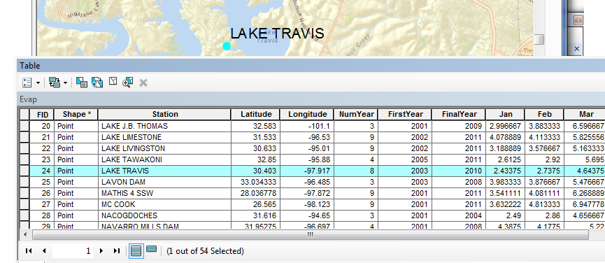

To Clear a Selected feature and select a new one, use: **Selection/Clear Selected Features** in the ArcMap toolbar:

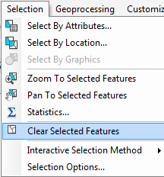

#### 5. Selecting features from a feature class

Selecting features from a feature class involves choosing a subset of all the features in the class for a specific purpose. Feature selection can be made from a map by identifying the geometric shape or from an attribute table by identifying the record. Regardless of how you select an object, both the shape in the map and the record in the attribute table will be selected. Make sure that the Evap theme is highlighted in the Table of Contents and then Click on the **Select Features by Rectangle** tool



If zoom back a little bit and drag a box over the three evaporation sites in the Highland Lakes reservoir system,

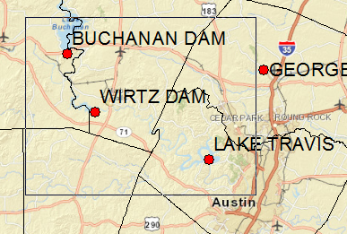

you’ll see both records highlighted on the map and in the attribute table. I’ve turned off the Counties layer and used **Show selected records** at the bottom of the Attribute Table to just show the three highlighted stations.

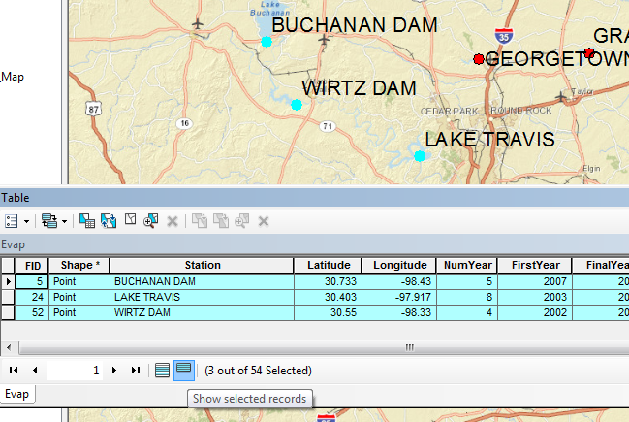

To clear your selection, choose **Selection/Clear Selected Features.**

**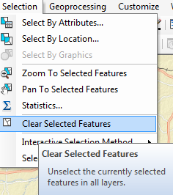**

Clicking on Show all records, then displays all the records in the attribute table again.

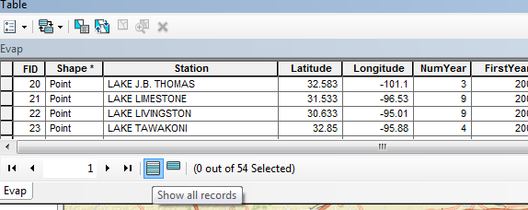

**6. Mapping Annual Evaporation**

Let’s suppose we want to map the values of annual evaporation recorded at the stations, rather than just symbolizing them by their location. Right click on the **Evap** layer and select **Properties/Symbology**

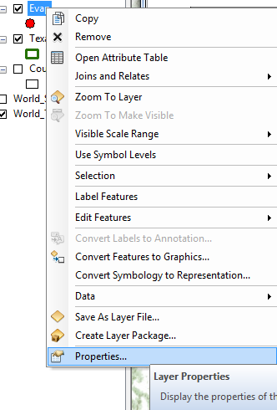

Show **Quantities/Graduated Symbols** with the **Value** field of **Annual**, and make the **Template** color blue.

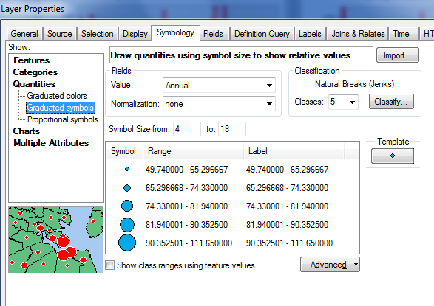

I have turned off all the other layers and added the **Topographic** base map to get the image below. Very cool!

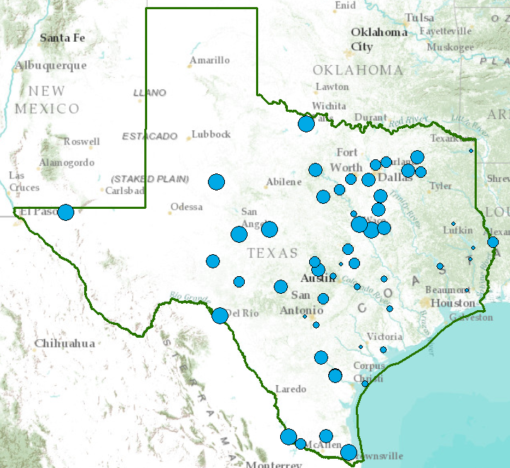

#### 7. Making a Chart

You can see from the map that there is some tendency for lower evaporation values near the coast and to the East and higher values to the West. Charts are useful because they allow you to visualize trends in data. Click on **Table** **Options**

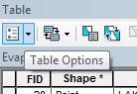

at the top left of the Table and select **Create Graph**.

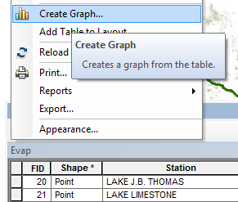

You will be making a Vertical bar chart (the default option). The next screen will allow you to indicate the data to be used in the graph. Here is a graph of the Annual Evaporation (**Annual**) of all the stations plotted against the Longitude of the station. You can see that there is a general trend of the evaporation increasing as you go from East to West in Texas. The color of the chart bars is blue, the same as the map points.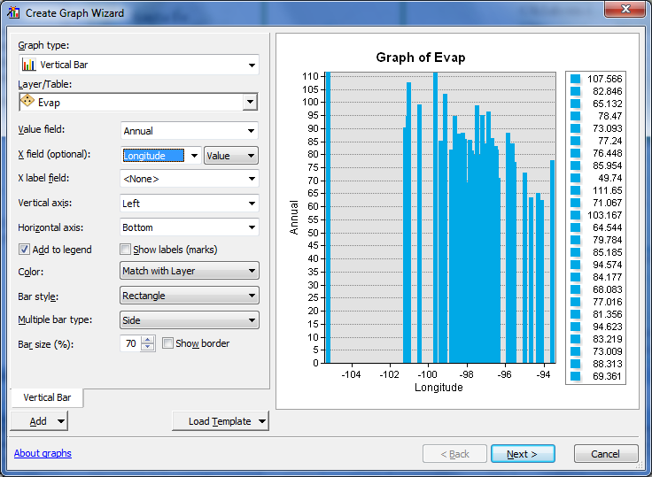

Click off “Add to Legend” to get rid of the legend on the right hand side.

Hit **Next** and edit the graph properties to make them nicer. Add a title **Evaporation and Longitude** and relabel the vertical axis **Evaporation (Inches)**

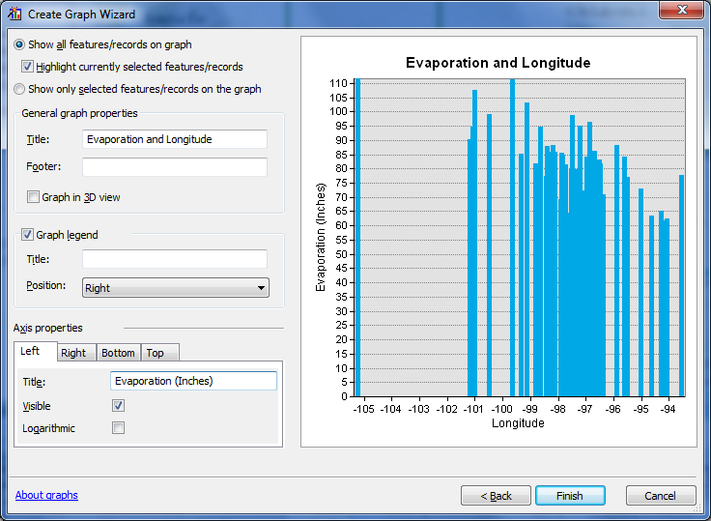

Click **Finish**, and you’ve created a graph linked to mapped features in ArcMap. If you create the same kind of graph for Evaporation and Latitude, you can see that there isn’t a tendency for evaporation to vary with latitude in Texas, as there is for variation of evaporation with longitude.

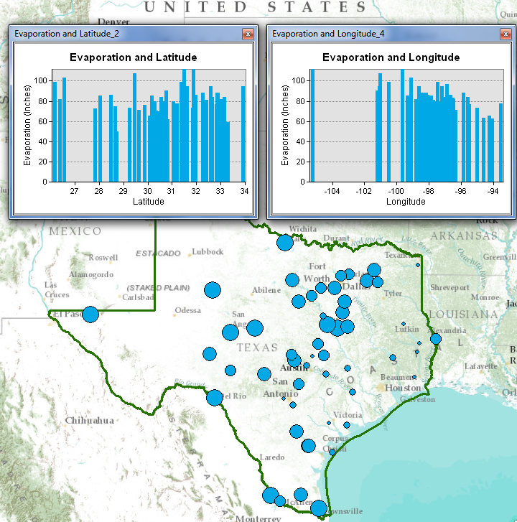

Save your ArcMap document **Ex1.mxd** so that you can retain this display.

**Graphing in Excel**

Another graphing option is to make a chart in Excel using the dBase tables given by the evaporation shapefile. Open the evaporation attributes table **Evap.dbf** as a table in **Excel**. Use **Files of Type: dBase files** in Excel to focus only on .dbf tables when you open the table.

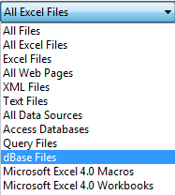

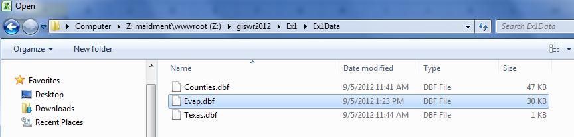

When you open the file, you’ll see that the Station name is very wide (254 characters). Right click on this column in Excel and select Column width of 30 characters to correct this.

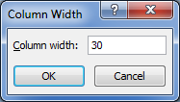

Select the stations you want to plot, copy their records to a new worksheet, delete the columns you don't need there, and then create a chart. Here is an example chart created this way.

#### 8. Creating a Map Layout

Now we are going to create a formal map of evaporation in Texas that includes the charts that we’ve created.

Change the format of the display window from **Data View** to **Layout View** by clicking on **View/Layout View**,



If your Layout doesn’t display properly in ArcMap, hit  at the bottom of the map display to refresh it.

Reduce the size of the data frame in the layout (i.e., rectangle where the spatial data is contained) -- to make room for the graph -- by clicking on the graph and moving its handlers. If you have a zoomed in view in Arc Map, you’ll get the same image in in the Layout. To move the location of your map, go back to the Data View and use the Pan tool

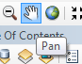   
to move your map around. When you switch back to the Layout View the new map location will be displayed.

I have turned off the Basemap to make the map easier to interpret.

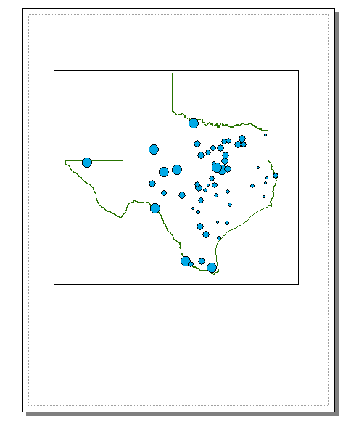

Keep saving your ArcMap document as you proceed through the map making steps so that if you mess up something you can get back the work you’ve already done.

To insert the ArcMap Chart into the Layout, right-click on the upper blue bar at the top of the Chart and select **Add to Layout**. Move and resize the graph as necessary. If you want to copy your graph from Excel, highlight the graph, and click on **Copy** in Excel, then **Paste** in ArcMap and your graph should appear in the map layout.

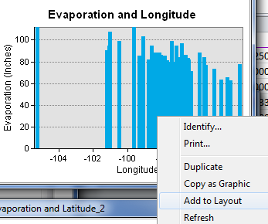

You can also insert a **North Arrow** and a **Scale Bar** by using the **Insert** menu in ArcMap.   
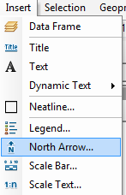

When you put up the scale bar you can select the distance units to be displayed. I have used miles.

You can add a **Title** or **Text** with the text tool ex1_45shown next to the line draw tool. The text displays in very small font sizes. Select and click on them, and use **Properties** to resize them.

Your map might look like this:

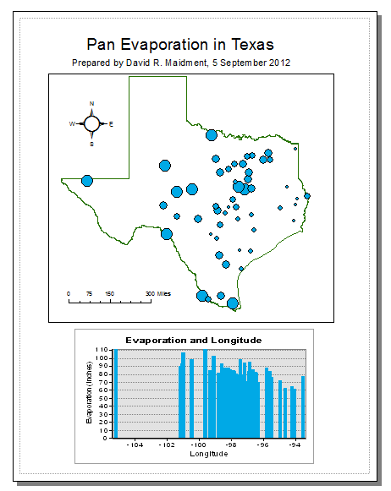

You can export your map from ArcGIS using **File/Export Map** from the ArcMap menu, and you can store this as **Ex1.emf** in your data file. Then you can add it to a Word document using **Insert/Picture/From File** and load this emf file, as shown below. Pretty cool!

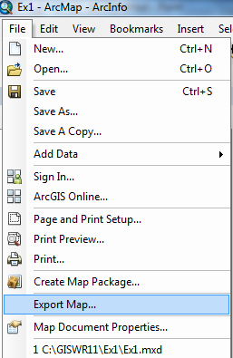

Then you can add it to a Word document using **Insert/Picture/From File** and load this emf file, as shown below. Pretty cool!

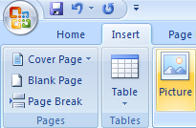



#### Helpful Tip:

A more general procedure is to simply copy the screen to the clipboard and crop out the part that you want, saving it to a file for later use. That is how all the images in this exercise were prepared. To copy any image, use the Snipping Tool in **All Programs/Accessories** on your Windows Desktop interface

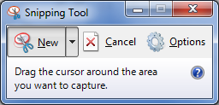

Drag the cursor around the area that you want to capture and you’ll see it copied into a new display, then use **Paste** to insert this snippet into a specific location in your document. If you only want to capture the active frame, press **Alt + Print Screen** and then Paste it to the new document.

This approach can also be used to add a map to a chart in Excel:

The manipulations just described transfer objects from one application to another.

*To be turned in: An ArcMap map layout in it showing a map of Texas with gages, coupled with a graph showing monthly evaporation data plotted from the gages. In the presentation of information on maps and charts it is important to include sufficient labeling detail so that the information can be clearly and unambiguously interpreted. You should include a scale bar to indicate distance, a north arrow to indicate direction and labels or legends with units wherever they are needed to interpret map or quantitative values.*

**9. Share in ArcGIS Online**

Sign in to your account in ArcGIS Online from ArcMap:

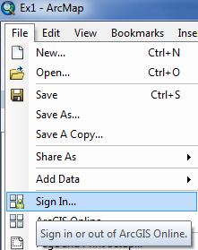

If the problem is that you get an 'invalid username/password' error when trying to log in from ArcGIS Desktop even though you can log in fine online, follow <https://www.arcgisonline.com/home/signup.html>  and following the signup steps. This authenticates your ESRI Global Account for use in ArcGIS Online and allocates you space to upload files into your “My Content” folder within ArcGIS Online.

Use **File/Map Document Properties** to fill out information about your map. It’s good to fill in as many of the fields possible so that your map is well documented. Use relative pathnames for the data and make a thumbnail so that your map can be summarized as a small image.

Close all your charts since they don’t seem to be preserved when you save the map package.

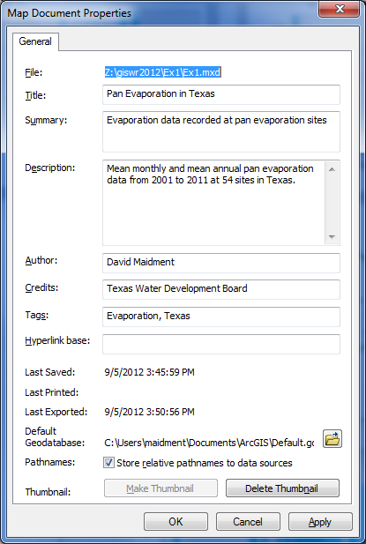

Share your information as a Map Package – this includes both the map and the data used to create it.

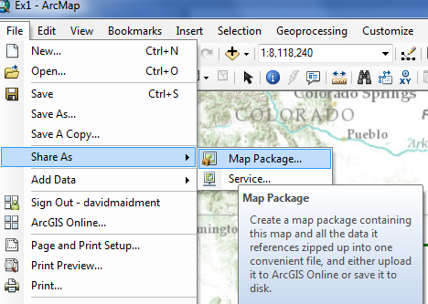

I have called my Map Package “Texas Evaporation”

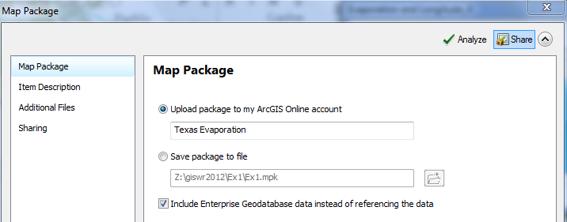

You’ll be asked to Save your map document again. Say Yes.

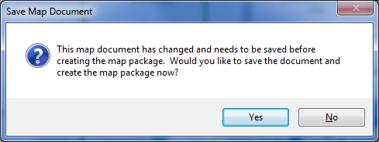

And after a little bit, your Map Package will be created.

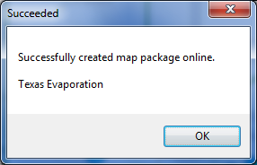

And if you go to <http://www.arcgis.com>, login with your ESRI Global Account username and password, and look under **My Content**, you’ll see that you now have a Map Package there.

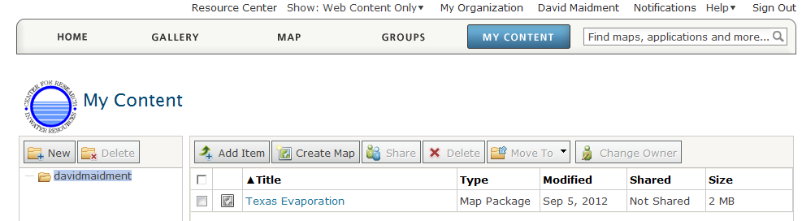

If you click on the Title “Texas Evaporation”, your package will open and you can see that its accessible in ArcGIS Version 10. You can also choose to Share your package publicly if you want to do so.

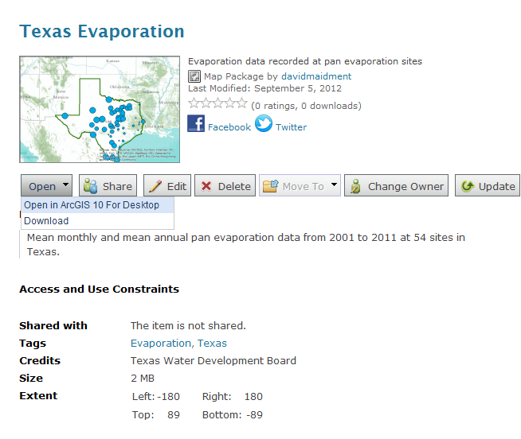

Close ArcGIS on your desktop, and choose **Open in ArcGIS 10 for Desktop** in the web browser, and here is your information again freshly displayed in ArcMap! Pretty cool! In this way, you can share your data and maps in a formatted form with your colleagues. Later we’ll show how to save map services that can be opened on the web without having ArcGIS Desktop locally available.

*To be turned in: A screen capture of your map package displayed in ArcGIS Online.*

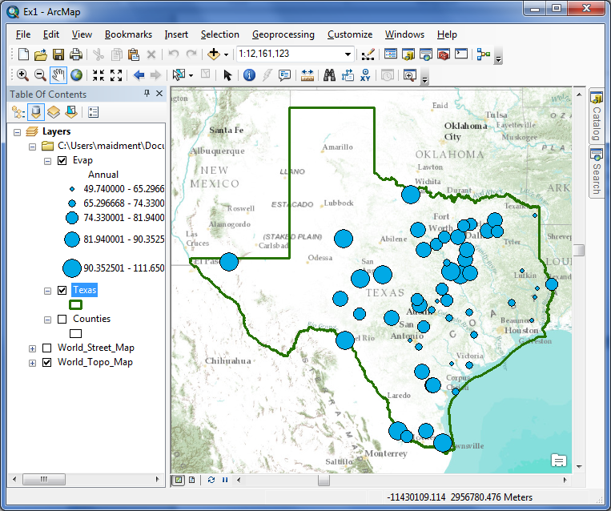

\_\_\_\_\_\_\_\_\_\_\_\_\_\_\_\_\_\_\_\_\_\_\_\_\_\_\_\_\_\_\_\_\_\_\_\_\_\_\_\_\_\_\_\_\_\_\_\_\_\_\_\_\_\_\_\_\_\_\_\_\_\_\_\_\_\_\_\_\_\_\_\_\_\_\_  
  
**Summary of Items to be Turned In:**

*(1) An ArcMap map layout in it showing a map of Texas with gages, coupled with a graph showing evaporation data plotted from the gages. In the presentation of information on maps and charts it is important to include sufficient labeling detail so that the information can be clearly and unambiguously interpreted. You should include a scale bar to indicate distance, a north arrow to indicate direction and labels or legends with units wherever they are needed to interpret map or quantitative values. Let’s see some nice cartography!!*

*(2) A screen capture of your map package displayed in ArcGIS Online.*

*The assignment is due in a week from the date it was assigned in class. Please print out your items to be turned in and bring them to class to turn in to the instructor.*