CE394K.3 GIS in Water Resources Fall 2012
Final Exam

There are three questions on this exam. Do all three. For each of the first two questions, prepare a 2-page typed essay (2 pages x 2 essays = 4 pages total). For the third question use ArcGIS (and Excel/Word) to prepare the map and answers requested. Staple solutions together in the order of the questions, and turn in the result to Dr Maidment in ECJ 8.610, by 5PM on Friday, December 14. If you want to turn in the exam early and Dr Maidment is not available, please give it to Crystal Murillo in ECJ 4.302. You are also welcome to email me your solution in Word or PDF format. If doing this please compile as a single document. This is a take-home exam. You are honor bound not to discuss this exam with your colleagues in the class. Your answers should be the result of your work and thought alone. Be assured that if essentially the same idea appears in answers from more than one person, it is fairly easy to recognize that when the grading is being done. If that happens, it is not clear from whom the idea originated and who is just using somebody else’s knowledge. So, keep your ideas to yourself!

Questions 1 and 2 require you to read and synthesize information from term projects by other students in the class. The term papers that you choose to describe in answering Questions 1 and 2 should be mutually exclusive, that is, if you focus on particular term papers in answering one of the questions, don’t focus on the same papers when answering the other question. The term projects can be found at:
- Texas: http://www.caee.utexas.edu/prof/maidment/giswr2012/TermProj/TermProjList1.htm and http://www.caee.utexas.edu/prof/maidment/giswr2012/TermProj/TermProjList2.htm
- Utah: http://www.neng.usu.edu/cee/faculty/dtarb/giswr/2012/students.html
- Nebraska: http://snr.unl.edu/airmak/giswr/2012/termproject/unl_termproject_list.htm

You are encouraged to look at term projects from all locations in preparing your answers since this will give you a greater body of information to speak from.

What we are looking for in grading your answers to this question is:
- Knowledge of the facts. Make sure you lay out the facts of what has actually been done before you start offering opinions about what could have or should have been done. Make sure you discuss what was actually done in the term papers not just about the general subject itself.
- Thoughtful evaluation. How do you evaluate the advantages and limitations of the principles, methods and data that have been used? How does the knowledge you’ve learned in this class relate to the world around us? I am looking for a sense of reflection here, of seeing you set individual situations and facts in a larger context in an intelligent way.
- Effective use of Maps. Identify specific maps from these projects that you think are effective and explain why they are effective.

In your answers, you must refer specifically to work presented in term papers prepared in this course. In other words, I am not looking here just for a general statement about your opinions in the field but rather a deduction based on the term papers presented in this class of what has been done and how you judge the effectiveness of that.

Questions

1. Compare and contrast two papers dealing with the same theme

Choose two term papers that deal with the same or similar themes or topics. Neither of these papers should be your own term paper. The papers that you choose may be from any of the three participating universities. Briefly summarize the contents of the papers (the problem examined, the method of analysis, the results achieved). Compare and contrast the approaches to the problem that the two papers took. Which technical approach do you think was more effective? Why? Which paper does a more effective job of communicating its results? Why? Suppose you were undertaking a study of this same subject. Having studied these two papers, what have you learned about how to go about your investigation effectively? What would you do differently from what the authors of these papers did?

2. Write an assessment of the utility of GIS in a particular application area

Student term papers on a range of topics have been presented. Select four papers that fall within a similar subject area and present a critique of how effective GIS is in its application in this subject area. What is the scope of the application area? How has GIS been used? What types of problems have been solved effectively? What limitations exist that have yet to be overcome in the application of GIS in this area? The papers that you select for this question may be from any of the three participating universities. You are encouraged to look at and use papers across all the universities, where they address similar subject areas.

3. Annual precipitation in Utah, Nebraska and Texas

It is sometimes said that Utah is the second driest state. For this question you should examine this statement using mean annual precipitation as given by PRISM data.

The data required is provided at http://www.caee.utexas.edu/prof/maidment/giswr2012/PRISM/PRISMData.zip. This zip file contains the following information

usprism | An ESRI grid file containing the mean annual precipitation 30-arcsec (800m) NORMALS from PRISM http://www.prism.oregonstate.edu/. The horizontal units are decimal degrees using the North American Datum of 1983 (according to http://www.prism.oregonstate.edu/docs/meta/ppt_30s_meta.htm). The units of precipitation are in mm x 100. This was downloaded from the PRISM web site then imported into ArcGIS using ASCII to raster and the appropriate spatial reference set using define projection.
States.shp | Shapefile giving the outline of US states

Following are latitude and longitude coordinates for each of our universities.

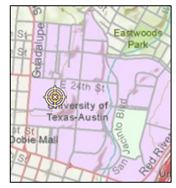 | 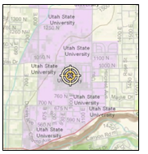 | 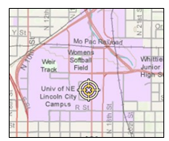
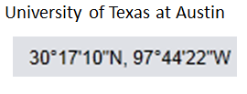 | 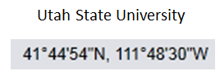 | 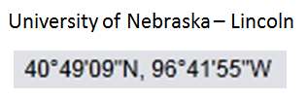

Questions (you should hand in answers to each of these questions including an explanation of what you did to get each answer)

- Determine and report the mean annual precipitation at each university in inches.

- Use your knowledge of GIS to determine the spatial average of mean annual precipitation for each state and report this in inches ranked from lowest to highest. Indicate where on the ranking each of the states (Utah, Texas and Nebraska) occurs. Note that area averaging is most meaningfully done in an equal area projection so for question 2 you should use the Continental US in the USA_Contiguous_Albers_Equal_Area_Conic_USGS_version projection in your calculations for the 48 contiguous states. You may omit Alaska and Hawaii from this analysis.

- Prepare a nice precipitation map for the state in which you are a student (Utah for the USU students, Texas for the UTA students and Nebraska for the UNL students). This should display the precipitation data clipped to the state boundary and be presented using contours and an attractive color scheme fully labeled and annotated with proper legend and scale. Use a projection appropriate for the display of geographic data for the state and give this on your map.

