CE 394K GIS in Water Resources Fall 2011
Final Exam

There are two questions on this exam. Do both questions. For the first question, prepare a 4-page typed theme paper. For the second question use ArcGIS (and Excel/Word) to prepare the map and answers requested. Prepare the result as a pdf file and email it to Dr Maidment by 5PM, on Friday Dec 9. This is a take-home exam. You are honor bound not to discuss this exam with your colleagues in the class. Your answers should be the result of your work and thought alone. Be assured that if essentially the same idea appears in answers from more than one person, it is fairly easy to recognize that when the grading is being done. If that happens, it is not clear from whom the idea originated and who is just using somebody else’s knowledge. So, keep your ideas to yourself!

Questions

1. Write an assessment of the utility of GIS in a particular topic theme

Student term papers on a range of topics have been presented. Select at least six papers that fall within one topic theme (GIS and Observations Data, Hydrologic Processes, International Water Resources, Regional Analysis, and Urban Systems). The term papers are indexed at: http://www.ce.utexas.edu/prof/maidment/giswr2011/docs/themes.htm.
You are encouraged to look at term projects from all participating universities in preparing your answers.

What is the scope of the topic theme? How has GIS been used? What types of problems have been solved effectively? What limitations exist that have yet to be overcome in the application of GIS in this area? In your answer, you must refer specifically to work presented in term papers prepared in this course. Present a short synopsis of each of the papers you have reviewed. In other words, I am not looking here just for a general statement about your opinions in the field but rather a deduction based on the term papers presented in this class of what has been done and how you judge the effectiveness of that. What we are looking for in grading your answers to this question is:
- Knowledge of the facts. Make sure you lay out the facts of what has actually been done before you start offering opinions about what could have or should have been done. Make sure you discuss what was actually done in the term papers not just about the general subject itself.
- Thoughtful evaluation. How do you evaluate the advantages and limitations of the principles, methods and data that have been used? How does the knowledge you’ve learned in this class relate to the world around us? I am looking for a sense of reflection here, of seeing you set individual situations and facts in a larger context in an intelligent way.
- Effective use of Maps. Select three maps from these projects that you think are effective and explain why they are effective.

2. Study of the Logan River Basin

Logan, Utah is located near the Logan River, and just upstream of town there is a large dam. Here is what the Logan River looks like in this area.
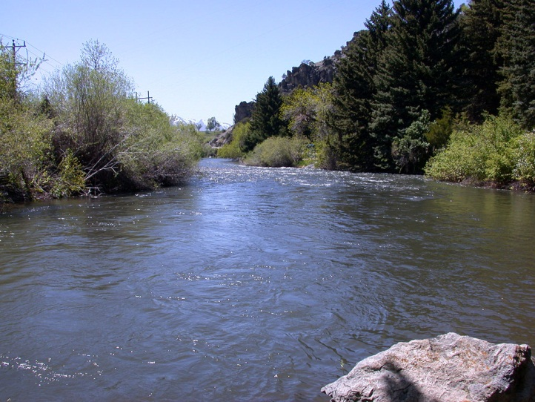

There is a USGS Gaging Station located above the dam, and the basin and its main streams are shown in the image below. The basin shown is one HUC8 Subbasin and overlaid on that are the HUC12 subwatersheds that lie within that basin.

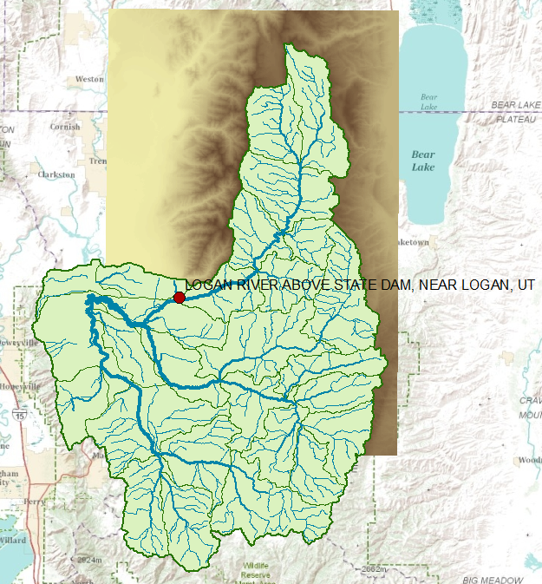

The dataset shown in this map can be obtained at: http://www.caee.utexas.edu/prof/maidment/giswr2011/utah/LoganBasin.zip This dataset contains the files listed below:

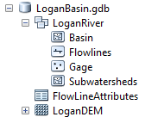

Questions

1. Prepare a nice map of the Logan River Basin with a North Arrow and Scale bar. Label the Logan River and the Blacksmith Fork River. Symbolize the flow lines so that they increase in size with the amount of the mean annual flow. Label the gage on the Logan River above State Dam.

2. How many HUC12 subwatersheds are there in this HUC8 basin? How many HUC12 subwatersheds contribute flow to the Logan River USGS gaging station above State Dam? Select these HUC12 subwatersheds and prepare a separate feature class for them called LoganWshed.

3. What is the average elevation within the LoganWshed? (the DEM has elevations in meters above NAVD88 datum). What are the highest and lowest elevations in this LoganRiverWshed? Prepare a table that reports the area (km²) and average elevation (m) for each HUC12 subwatershed in LoganWshed.

4. Process the LoganDEM using the standard ArcGIS Hydrology tools and delineate the watershed of the Logan River above the USGS gaging station above State Dam. What is the drainage area of this watershed (km²). How does this compare with the drainage area defined by the USGS for this gage? Prepare a nice map that shows the gage, its watershed and the streams that flow within this watershed. Highlight the stream segments in this map that comprise the Logan River.
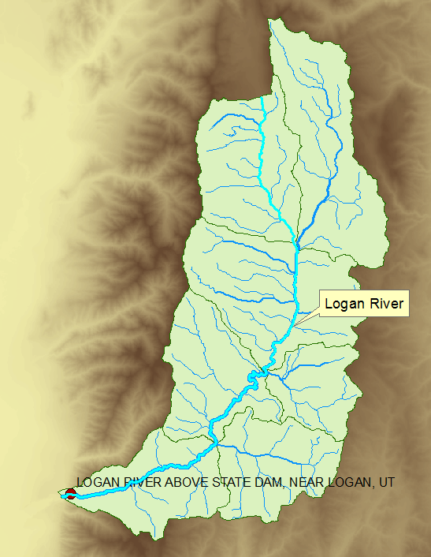

5. Determine the length of the Logan River shown in the above map (km). Determine the average slope of the river over this length (%).

