Computation of Slope
Prepared by David R. Maidment
GIS in Water Resources Class
University of Texas at Austin
September 2010
There are various ways in which slope can be computed depending on the nature of the information available and the method to be used.
A Line in a 3D space
The simplest way to think about slope is to consider two points in a three dimensional space and a line that connects them. Suppose there are two such points, A and B, and they have coordinates (x_{a}, y_{a}, z_{a},) and (x_{b}, y_{b}, z_{b},). If we connect them by a line drawn from A to B then the components of the vector AB are (Δx, Δy, Δz), where Δx = (x_{b}- x_{a}), Δy = (y_{b}- y_{a}), Δz = (z_{b}- z_{a}). The vector AB can also be thought of as having two components, a rise, which represents the vertical difference, Δz, between the two points, and a run, $\sqrt{{Δ∆x}^{2}+{Δ∆y}^{2}}$, which represents the horizontal distance between them. With these definitions, the slope of the line AB is given by
$Slope=\frac{Rise}{Run}$ (1)
In addition, the azimuth of the line AB, or its orientation angle measured clockwise from North, is given by
$Azimuth=\frac{180}{π}\tan^{-1}\frac{∆x}{∆y}$ (2)
Example
The location of two survey benchmarks on 24th St on the University of Texas campus is shown in Figure 1, and a Figure 2 shows a photograph of Benchmark B which is located on a bridge over Waller Creek. These benchmarks serve as reference points for the location of campus facilities. The coordinates of these two benchmarks with all dimensions in feet are given by
Benchmark | Easting | Northing | Elevation
A | 819470.95 | 235256.11 | 555.42
B | 820462.32 | 235187.15 | 524.06
Determine the length, slope and azimuth of the line AB.
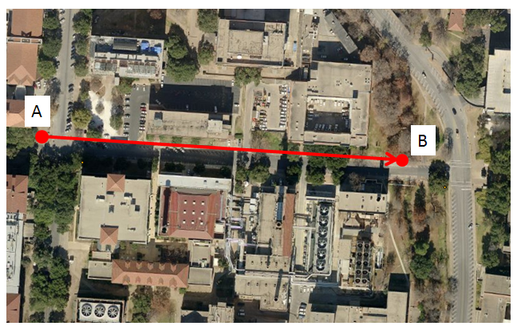
Figure 1. Survey benchmarks on the University of Texas campus
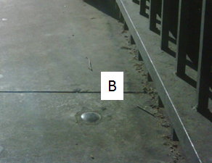
Figure 2. Location of Survey Benchmark 2

Solution
In the coordinate values, the Easting is x, Northing is y, and Elevation is z, so the x-component of the vector AB is given by Δx = 820462.32 - 819470.95 = 991.37, and similar computations for Δy and Δz produce the following values in feet:
 | Δx | Δy | Δz
AB | 991.37 | -68.96 | -31.36

Notice that while Δx is positive meaning that B is East of A, Δy is negative meaning that B is slightly South of A, and Δz is also negative because B is below A, and in fact water flows down 24th St from A to B as it drains towards Waller Creek on our campus.
The Length of the line AB is given by
$$Length= \sqrt{{∆x}^{2}{+∆y}^{2}+{∆z}^{2}}$$
$$= \sqrt{{991.37}^{2}{+(-68.96)}^{2}+{(-31.36)}^{2}}$$
$$= 994.26 ft$$
For the line AB, the rise = -31.36 ft, and the run = $\sqrt{{Δ991.37}^{2}+{Δ(-68.96)}^{2}}$ = 993.77 ft, and substituting these quantities into Eq. (1),
$$Slope=\frac{-31.36}{993.77}$$
$$or, Slope = -0.0316$$
This means that the average downhill slope of 24th St as water drains along it towards Waller Creek is a little more than 3%. Another way of expressing the slope is as an angle in degrees, called the zenith, which may be computed as
$$Zenith = \frac{180}{π}\tan^{-1}\left(-0.0316\right)$$
$$or, Zenith = -1.807°$$
Similarly, by substituting into Eq. (2), the azimuth of line AB is given by
$$Azimuth=\frac{180}{π}\tan^{-1}\frac{∆x}{∆y}$$
However, the computation of the azimuth is a more complicated mathematically than for the zenith because the zenith angle is limited to the range -90$°$to 90$°$the while the azimuth angle has the range 0$°$ to 360$°$, within which the tangent function goes through several changes in sign. One way to do this to use the ATAN2 function, which is defined in Excel as follows: “ATAN2(x_num,y_num) returns the arctangent, or inverse tangent, of the specified x- and y-coordinates. The arctangent is the angle from the x-axis to a line containing the origin (0, 0) and a point with coordinates (x_num, y_num). The angle is given in radians between -pi and pi, excluding –pi”.
In this instance, we have $\frac{180}{π}atan2\left(∆x,∆y\right)= \frac{180}{π}atan2\left(991.37, -68.96\right)=$-3.98°, and since the azimuth is a clockwise angle measured positively from North or y-axis, the azimuth is given by
$$Azimuth = 93.98°$$
So, in summary, there several ways that we can think about the definition of the line AB:
- A vector that originates at point A, and has components in the (x,y,z) Cartesian coordinate space of (991.37, -68.96, -31.36).
- A vector of length 994.26 ft that originates at A, which is rotated 93.98$°$ from North in the horizontal plane, and then – 1.81$°$ in the vertical plane to reach the point B. The values (994.26, 93.98, -1.81) are its coordinates in a Spherical coordinate space.
- A vector drawn in the azimuth direction of 93.98$°$ that has a horizontal component or run of 991.37 ft and a vertical component or rise of -31.36 ft.
In all these instances, it takes three pieces of information to define the line that originates at point A and ends at point B in a 3D space, in the first instance three length values, in the second instance one length value and two angles, and in the third instance two length values and one angle. These are all valid ways of thinking about how vectors are defined in a 3D space, but the third one is the most useful for defining the slope of the line.
A Function in a 2D Space
Suppose we have a 2D space (x,y) where x and y are coordinates in the horizontal plane, and we have some arbitrary function F defined over this plane. The value of F could represent any scalar quantity, such as annual precipitation or air temperature. If we wish to define the gradient of this function at a particular location (x,y), we would use the nomenclature:
$$∇F(x,y)=\left(\frac{∂F}{∂x},\frac{∂F}{∂y}\right)$$
where $∂F/∂x$ represents the partial derivative of the function in the x-direction, $∂F/∂y$ represents the partial derivative of the function in the y-direction, each evaluated at the point (x,y). In this case, the magnitude of the gradient is given by:
$$\left|∇F\left(x,y\right)\right|=\sqrt{{\left(\frac{∂F}{∂x}\right)}^{2}{+\left(\frac{∂F}{∂y}\right)}^{2}}$$
And the direction of the gradient is given by
$$Direction\left[∇F\left(x,y\right)\right]=atan2\left(\frac{∂F}{∂x} , \frac{∂F}{∂y} \right)$$

Land Surface Slope
Land surface elevation is a function defined on a 2D coordinate space, that is, at any location (x,y) on the land portion of the earth’s surface, there is a corresponding elevation value, let’s call it S, which represents the vertical height of the land surface above the geoid surface at that location. Hence we can define the gradient, or slope of the land surface by
$$Land Surface Slope=∇S(x,y)=\left(\frac{∂S}{∂x},\frac{∂S}{∂y}\right)$$
However, now the special character of the land surface makes itself felt – the surface S is actually represented by the elevation Z, so the land surface slope is a 2D vector:
$$Land Surface Slope=∇Z(x,y)=\left(\frac{∂Z}{∂x},\frac{∂Z}{∂y}\right)$$
where the value of Z is capitalized to distinguish the land surface elevation from any quantity defined by a z-coordinate. The magnitude of the land surface slope is given by
$$\left|Slope\right|=\sqrt{{\left(\frac{∂Z}{∂x}\right)}^{2}{+\left(\frac{∂Z}{∂y}\right)}^{2}}$$
To make this computation meaningful, Z needs to be defined in the same length units as x and y, and the result is a dimensionless quantity that represents the slope with positive being upwards. When multiplied by 100, this becomes the percent rise value arising from the slope function in the ArcGIS software. A computation corresponding to that for the zenith angle described earlier gives the slope angle in degrees in the ArcGIS Slope function.
In physical geography, the orientation of the land surface is defined by its aspect, which is analogous to the azimuth used in land surveying. For example, we might describe mountainside as having a Westerly aspect if the ridge at its crest lies in the North-South direction, and the land sloping down from that on one side, faces towards the West (and correspondingly an Easterly aspect on the other side of the ridge). By analogy with the azimuth, the aspect is defined in the ArcGIS slope function as:
$$Aspect= atan2\left(\frac{∂Z}{∂x} , \frac{∂Z}{∂y} \right)$$
with an interpretation of the values that arise from the atan2 function depending on what quadrant of the (x,y) plane the slope vector lies within. The computation of the partial derivatives in the Slope function uses a second order finite difference method to approximate calculating the gradient of a truly differentiable continuous surface using the elevation values in a mesh of DEM grid cells of discrete size.
Hydrologic Slope
To define slope in hydrology, we are interested in the slope of steepest descent, rather than steepest ascent, so that we can define the pathway of water flowing downhill. This means that slope is considered a positive quantity if pointing downhill. The D8 flow direction is a special case, because although it is being defined on a continuously gridded elevation surface, only 8 discrete flow directions are possible, and so effectively, the D8 Slope is computed as
$$D8 Slope= \frac{Drop}{Run}$$
Where drop refers to the difference in elevation between the “from cell” and the “to cell”, with downwards considered positive, and the run is equal to the cell size for flow along the coordinate directions, and equal to $\sqrt{2}$ x cell size for flow in the diagonal directions. So, in effect, the D8 flow direction is a slope computation on a set of eight 3D lines like the lines connecting the survey benchmarks in the example described above, where the one giving the maximum downward slope is selected as the direction of steepest descent and its corresponding value (1, 2, 4,…., 64, 128) is encoded in the flow direction grid.

