Batch Processing in ArcGIS
By Lindsay Olinde
GIS in Water Resources Class
University of Texas at Austin
17 November 2010

Batch processing: How to apply a GIS tool many times without using model builder.
- I recommend doing the operation once as you would without batch to confirm the files you want to use are in the correct order- otherwise when you RUN the batch file, it may hang up. So confirming first could save time waiting for a error function.
- In ArcGIS, locate tool in toolbox or search. If you use search, instead of clicking the link, follow the path (looks similar to a file path) shown under the link to locate the tool in the toolbox.
- Right click on the tool then click batch.

- Load the files you want to use in each row. You can edit the table one cell at a time, copy cells, or double click on the far left cell to get the typical toolbox dialog. If your output files are of similar name and in the same folder, for example “Watershed_01”, once you set the first output cell, you can copy it to the other rows, just editing the last part so “Watershed_02”, “Watershed_03”, etc. This is takes less them that rebrowsing and fully renaming each output raster.
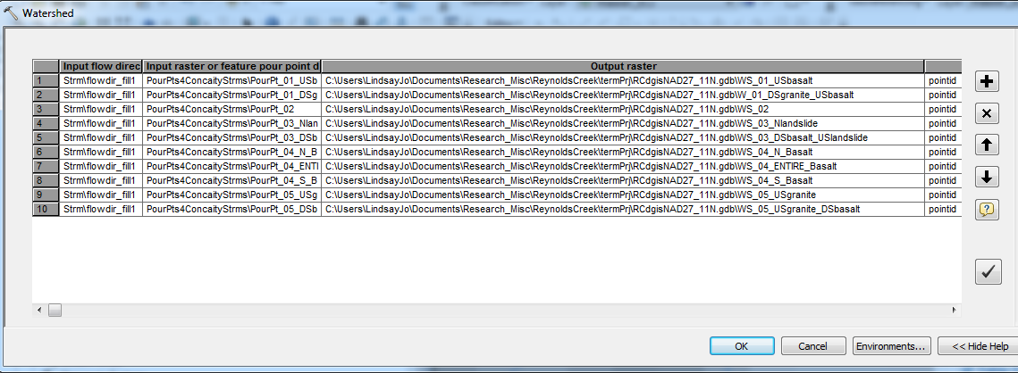
- When all rows are loaded press “ok” and let it run. It may take a little while to complete depending on how many functions you’re doing but still saves time instead of having to do each one.
- When completed, all output files will be loaded into the table of contents.

