The Relationship Between Geology and Soil
Development in Austin, Texas
Rob Forkner

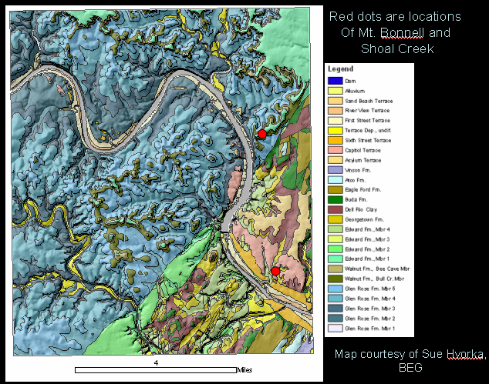

This project is an attempt to integrate geologic mapping, soil mapping, precipitation measurements and DEM surface analysis to determine whether certain rocks in the Austin are either more or less prone to weathering into soil. The Mt. Bonnell fault serves as a reference point, as it juxtaposes rocks with different amount of clay next to one another. The red dots on the map show the localities chosen to photograph for illustrative purposes (Mt. Bonnell being the northern point, Shoal creek being the southern point).

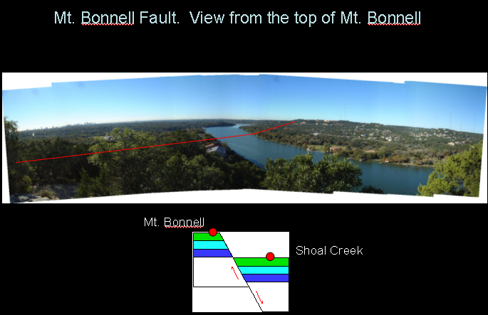

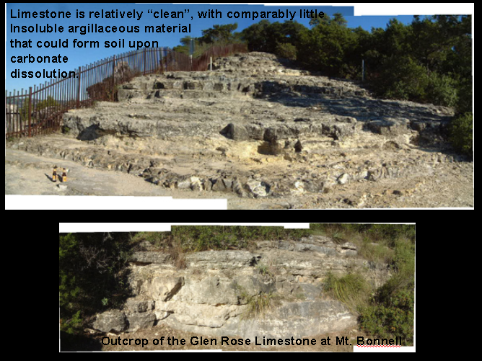
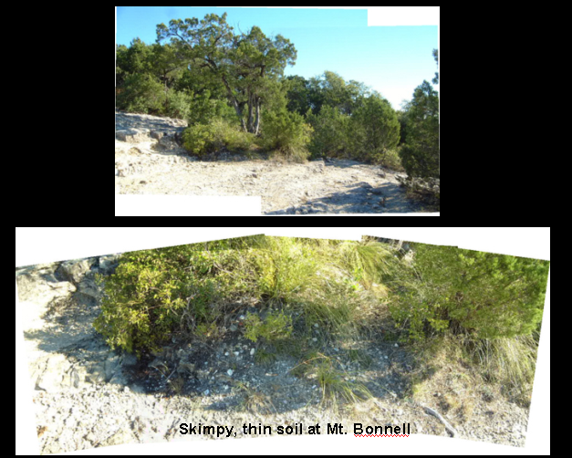
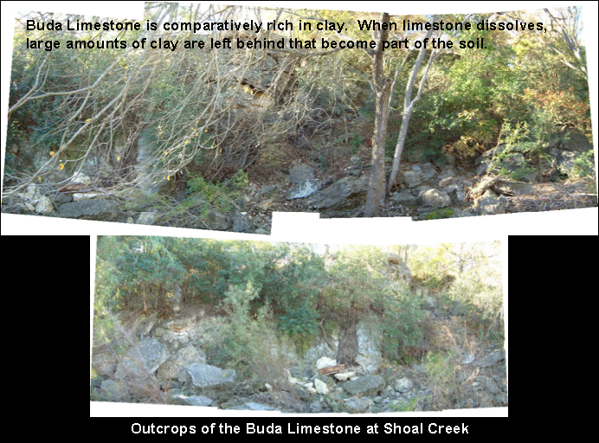
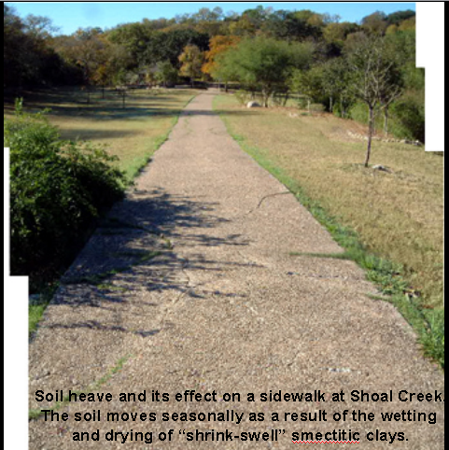

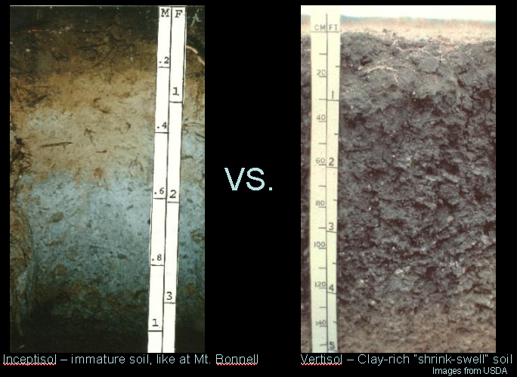

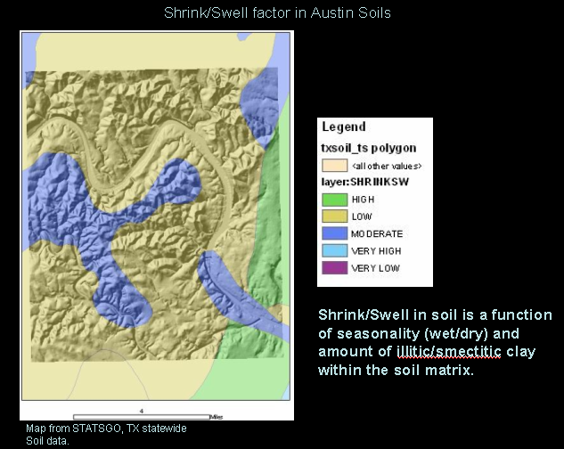

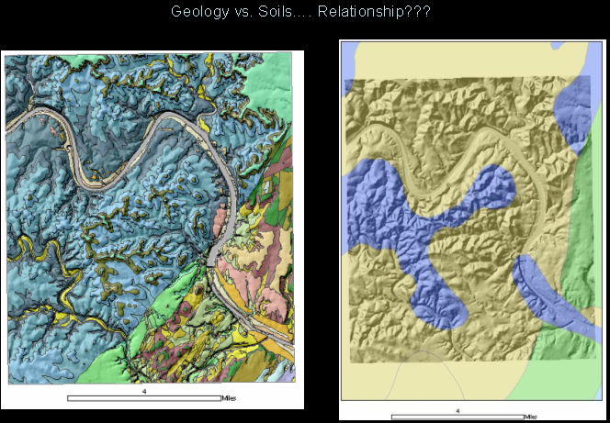

How can we use spatial analysis to determine a more quantitative relationship between soils and bedrock?

- Rasterize data so that spatial analyst can work with it.
- Reclassify data into groups of similar erodability
- Add raster layers to determine combined erodability.

All of this is done using the Arc Spatial Analyst tool.



