Best Management of Operational Practices
For
Glen Canyon Dam

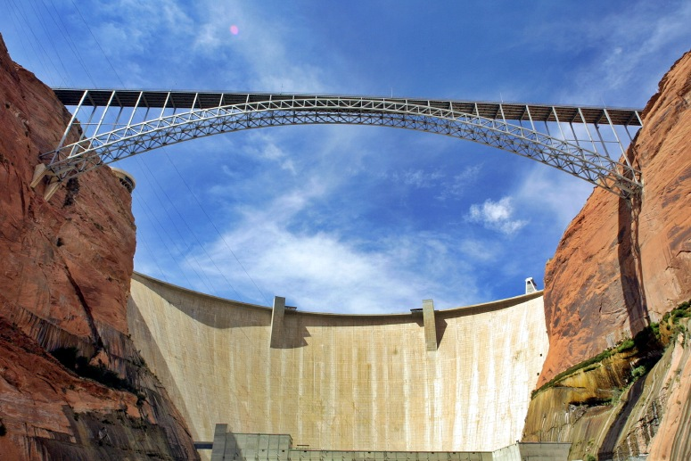

by
Charlotte Amato

CE394K
Dr. David Maidment
December 2003
Table of Contents

Project Introduction 3
Introduction to the Glen Canyon Dam 4
Effects of Altered Flows 5
Sediment 6
Temperature Error! Bookmark not defined.
Flora and Fauna 12
Mitigation 13
Conclusions 16
Bibliography 17
Appendix 1: Procedure for Creating Really Use Maps……………………………….....18

Project Introduction

The original proposal to create a GIS model of the entire Colorado River to monitor the River’s health and determine best management practices was an overly ambitious goal that reached far beyond the available time for a term project. The project scope has been narrowed to a segment of the Colorado River directly downstream of the Glen Canyon Dam. The objective has also been slimmed down to comparisons of pre and post impounded water quality and flow data and the correlation to the general health of the eco system, particularly the effects of on native fish species.
The dam is located at the head of the Grand Canyon in northern Arizona and as such it is a hotspot in the political and environmental fervor that surrounds ecological preservation and river impoundment in general. The task is immensely difficult to balance and manage ever-growing human water and power demands while minimizing the effects on natural resources. In an effort to protect the incredible resources of the Grand Canyon System and the Colorado River, studies by various institutions and agencies aim to determine the dam’s ability to meet these demands as well as to examine the dam’s effects upstream and downstream on resources and ecosystems in order to develop best management practices. The intention of this exercise is to examine the downstream effects of Glen Canyon Dam through the use of mapping several monitoring sites using GIS. Throughout the report several GIS maps appear, detailed instructions to create these maps and information on the data sources used to create them are in a separate document that may be viewed through the above hyperlink.

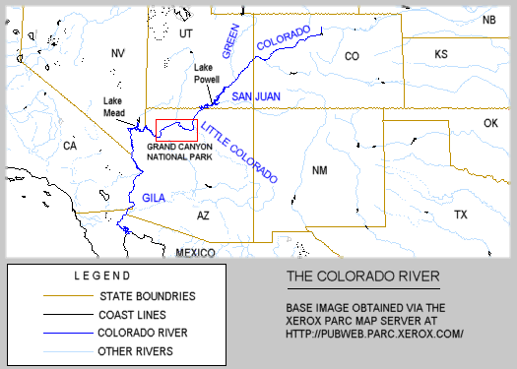
Glen Canyon Region

Figure 1: Vicinity Map Source: http://www.kaibab.org/misc/gc_coriv.htm

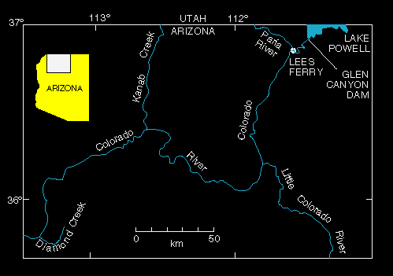
Figure 2: Colorado River System Below Glen Canyon Dam
Source: http://walrus.wr.usgs.gov/grandcan/map.html

Introduction to the Glen Canyon Dam

The Colorado River receives water from seven Western states (Wyoming, Colorado, Utah, New Mexico, Arizona, Nevada and California). In an effort to end debates of water rights and to allocate the water fairly, these seven states formed the Colorado River Compact in 1922. The Compact divided the states into upper and lower basins, with Lee’s Ferry, Arizona arbitrarily selected as the dividing point. During the 1950’s amidst growing demands on the river and concern that the Colorado River could not provide the required water each basin demanded the U.S. Bureau of Reclamation proposed the Colorado River Storage Project (CRSP). The CRSP proposed several dams be built including ones in Echo Park, Split Mountain and Glen Canyon with the idea that the dams would store water so that in draught years the upper basin would be able to meet their water delivery commitment. There are currently 7 dams on the main Colorado River.

Glen Canyon Dam was proposed so that exactly 7.5 million acre feet of water would flow downstream to the lower basin. A group of Bureau of Reclamation engineers and geologists selected the location of the Glen Canyon Dam project upstream from Lee’s Ferry at the head of the Grand Canyon based on several criteria:
- The area forming the basin could contain an immense amount of water
- The canyon walls and bedrock foundation were strong and stable enough to safely support the high dam
- A large source of good rock and sand was available for the dam construction at nearby Wahweap Creek

After years of environmental protests headed by the Sierra Club an agreement was reached to allow the Glen Canyon project if the Echo Park and Split Mountain projects were withdrawn because, at the time, the goal of the environmental movement was to protect popular scenic recreational destinations and Glen Canyon was so remote it was not among the sites fought for. An oversight of the environmental movement and the Bureau was that nearly all of the thought and debate focused on the areas which would be flooded by the dam’s lakes and very little was considered or known of the incredibly altering effects that a dam’s impoundment can have the ecosystems downstream.

Congress passed the bill authorizing the CRSP in early 1956 and construction on Glen Canyon Damn project began October 15, 1956 and was completed in 1963. Turbines and generators were installed from 1963 to 1966 and the dam was dedicated by Ladybird Johnson on September 22, 1966. The Glen Canyon Dam houses Lake Powell which began to fill in 1963 and took until 1980 too fill. Lake Powell stretches from the Glen Canyon Dam in Arizona up the Colorado River through Utah, past the San Juan confluence to Hite for a total of 186 miles. Including the numerous flooded canyons, Lake Powell has more than 2,000 miles of shoreline.

Effects of Altered Flows

Three USGS gage stations were chosen to obtain information for and to then draw comparisons for each of the gage between pre and post-impoundment conditions.

- 09379910: gage is located directly downstream of Glen Canyon Dam
- 09380000: gage is located at Lee’s Ferry, AZ (16 miles DS of Dam)
- 09402500: gage is located in Grand Canyon, near Grand Canyon, AZ.

The base map is constructed from two HUC watershed drainage area coverages and River Reach files from USGS. Gage station location and data is also from USGS. (click here for detailed construction information)

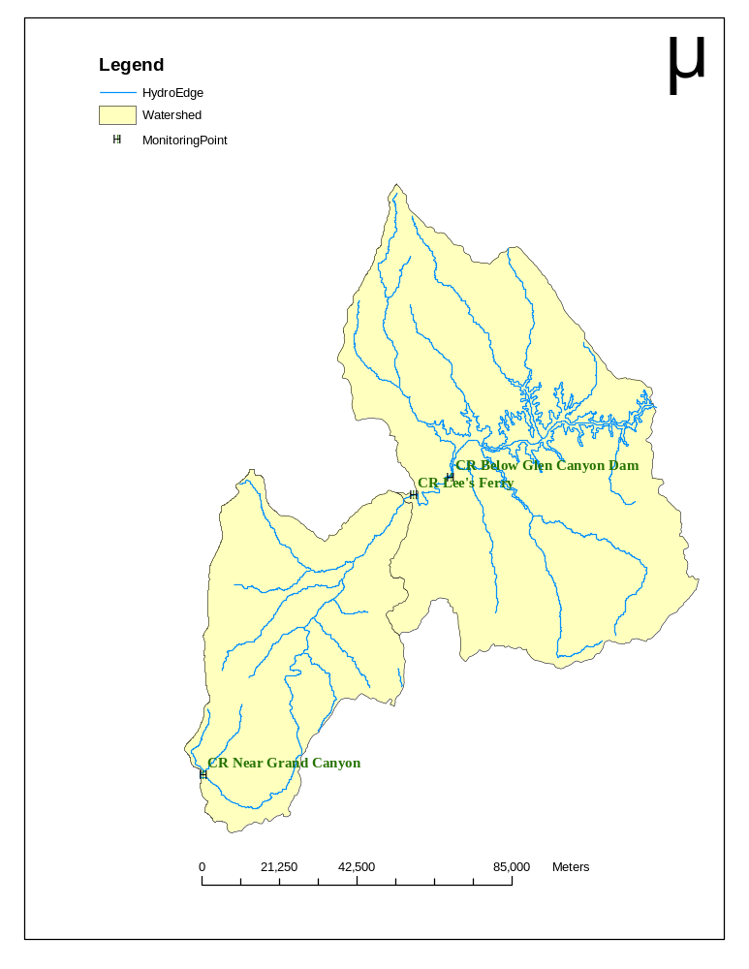

Sediment

Glen Canyon Dam is estimated to block 95% of the 275,000 ton sediment daily average that once flowed through the Grande Canyon. Sediment blockage is the source of several environmental concerns:
- The degradation of riparian habitat
- Aggradation upstream of Lake Powell
- Sedimentation of Lake Powell
- Accumulation of toxic materials in the sediment

The Colorado River is historically a very seasonal river which is not surprising considering its headwaters are in Rocky Mountain National Park and the river drops some 2,000 feet before entering the high desert of the Canyon Lands. Every year in late spring, floods often in excess of 100,000 cfs from the mountain runoff scoured the main river channel and deposited massive amounts of nutrient-laden sediment and replenished the aquatic habitat beaches throughout the river. Without these beaches breeding ground for many species, now endangered is lost. During the summer, fall, and winter flows were often less than 3,000 cfs and the water warmed to an average 80 degrees Fahrenheit. Aside from affecting the season flows the dam has also increased fluctuations in daily flows. Below is a statistical summary table of these fluctuations:

Table 1: Flow Statistics Source: http://walrus.wr.usgs.gov/grandcan/watereffects.html
Statistical Summary
 | Pre-Dam |  |  | Post-Dam
 | Flows |  | % | Flows |  | %
Mean Daily Flows | >30,000 |  | 18% | > 30,000 |  | 3%
Daily Fluctuation |  |  |  | 12-16,000 cfs
Spring Flows | >100,000 cfs
Summer- Winter Flows | < 3,000cfs
Low Flows | < 5,000 cfs |  | 16% | < 5,000 cfs |  | 10%
Temp yF | 40-80 |  |  | 46

Real-Time data download into excel and prepared as a .dbf attribute table for the monitoring points.

Figure 3 is a graph of the peak flow data downloaded from USGS real-time data (see instructions for more detail). The grey lines perpendicular to the axis represent the construction period of the dam. As expected the dramatic rate is very noticeable. Figure 4 is a graph of the annual high and low flow values. These values were obtained by averaging the monthly mean flows downloaded form USGS real-time data. Aside from the reduction in high flows the decrease in fluctuations is also of considerable notice.
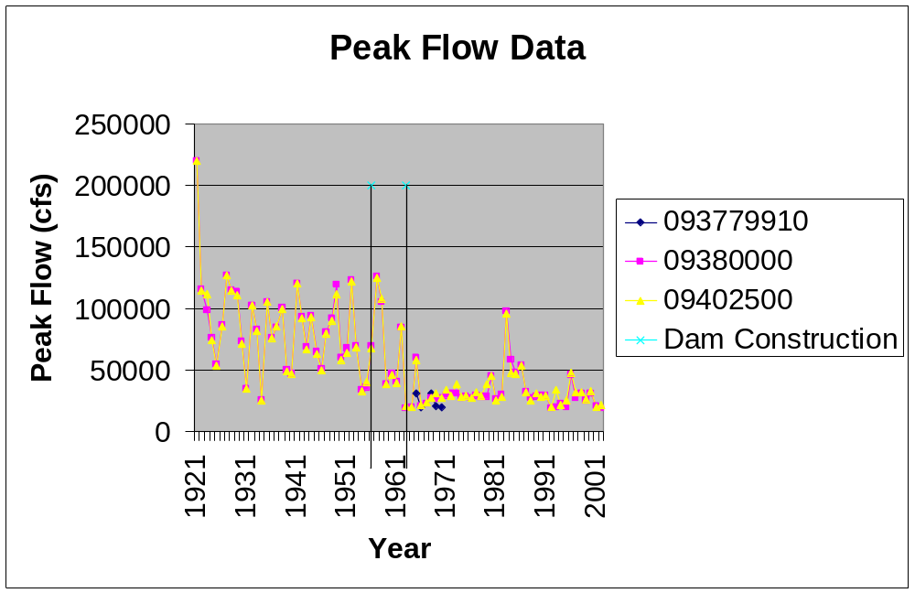
Figure 3 Flows Based on USGS water data

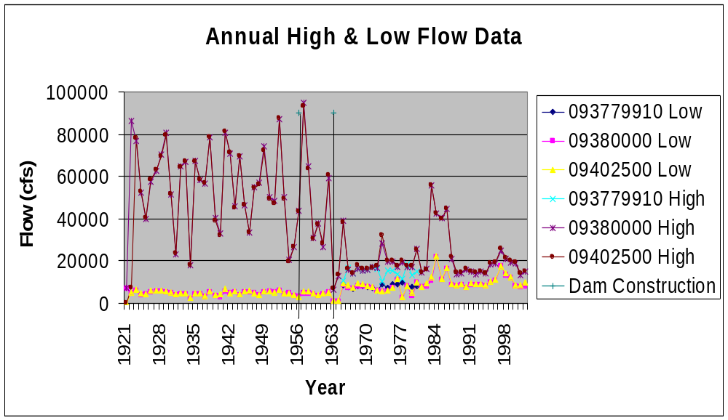
Figure 4 Flows based on monthly mean USGS water data

Figure 5 and 6 display this graphically even more clearly. Values for figure five were determined by averaging the monthly mean values for pre and post-impoundment of both downstream gage stations, 09380000 and 09402500. 1963 is used as the divisive year for the averages because it is the year the dam was completed and Lake Powel began to fill. In figure 6 only two months, January and June, were graphed so as to avoid clutter on the map. January and June were selected to represent one winter, low flow month, and one summer, high flow month. The Pre-impounded set of bar charts appears on the left for both gages. 1963 is used as the divisive year for the chart because it is the year the dam was completed and Lake Powel began to fill.

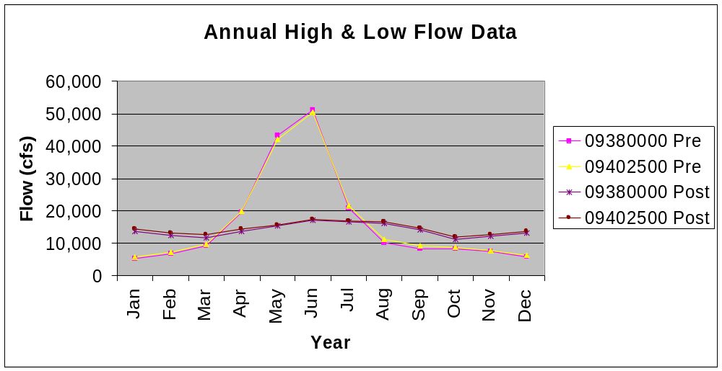
Figure 5 Pre and Post Dam Monthly Mean
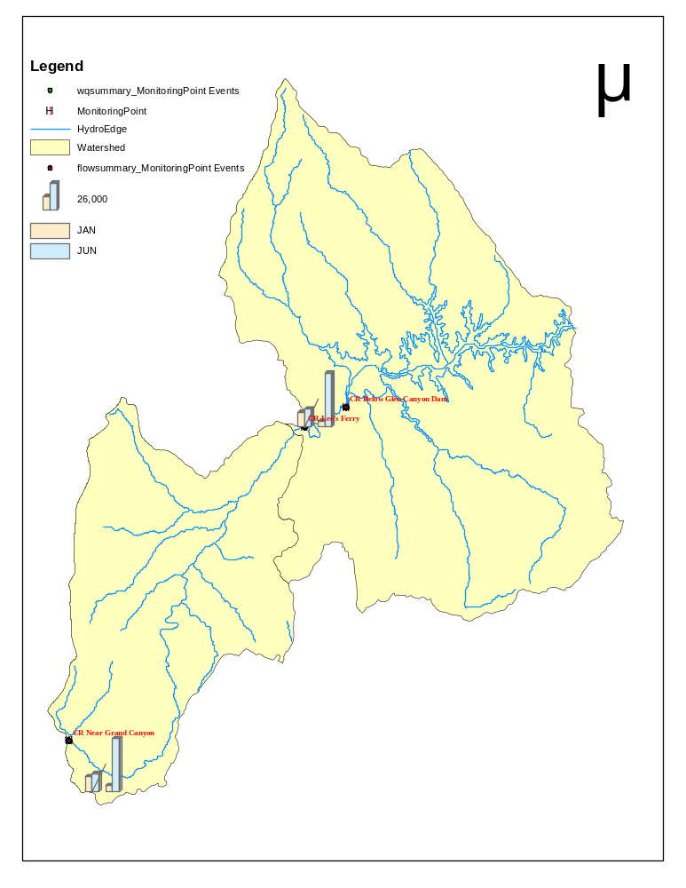
Figure 6 Pre and Post Dam Monthly Mean

The Colorado River transports nearly as much sediment as it does water, this sediment is filling Lake Powel and aggrading many more miles of the Colorado River and its many tributaries upstream where the river flow slows as it approaches the lake, burying. An estimate 2.2 million acre-feet of Lake Powell’s Storage capacity has already been lost to sedimentation. Although such extreme sedimentation to the extent that would decommission Glen Canyon Dam is not estimated to occur within the next 100 years it is clear that some mitigation needs to occur so that the dam may continue to operate efficiently and replenish beaches.

Water Quality
The Glen Canyon Dan has also had a negative effect on the season temperature fluctuations of the Colorado River. Pre-dam the temperatures ranged from 35in the winter to 85 degrees Fahrenheit in the late summer. Because of power generation water is released from the bottom of the dam and consequently average 42 degrees Fahrenheit year round. Native fish species are unable to spawn in the cold water, but non-native species such as the Rainbow Trout, which was introduced by man, thrive under these conditions, increasing competition and predation of native species. The segmented table blow is the USGS real-time gage data cropped down to a few indicators that had substantial data for pre and post impoundment for the two downstream gages. The Excel graph, Figure 7, was used to display most of the data rather than mapping the cylinders in GIS (as above for flow data) so that all the data could be displayed simultaneously.
Table 2 Water quality data
USGSID | LongDD | LatDD | Color, Water, filtered Pt-Co | hardness, water, unfiltered mg/L as CaCO3 | Calcium, water, filtered mg/L | Sodium, water, filtered mg/L
09380000 | -111.5875 | 36.8647 | 12.44 | 388.54 | 99.16 | 109.74
09380000 | -111.5875 | 36.8647 | 4.18 | 275.66 | 68.17 | 69.39
09402500 | -112.0856 | 36.1014 | 12.53 | 410.09 | 105.83 | 136.02
09402500 | -112.0856 | 36.1014 | 3.92 | 278.70 | 71.98 | 89.16

Chloride, water, filtered mg/L | Sulfate, water, filtered mg/L | Silica, water, filtered mg/L | Iron water, filered ug/L | Residue on evaporation at 180degC, water, filtered mg/L | Suspended Sediment Sieve Di% <.062mm
76.85 | 338.26 | 14.88 | 193.82 | 829.59 | 80.85
47.80 | 219.61 | 8.48 | 13.34 | 541.08 | 55.68
117.65 | 342.74 | 14.60 | 121.47 | 882.57 | 80.93
76.45 | 227.94 | 9.21 | 41.20 | 607.40 | 53.50

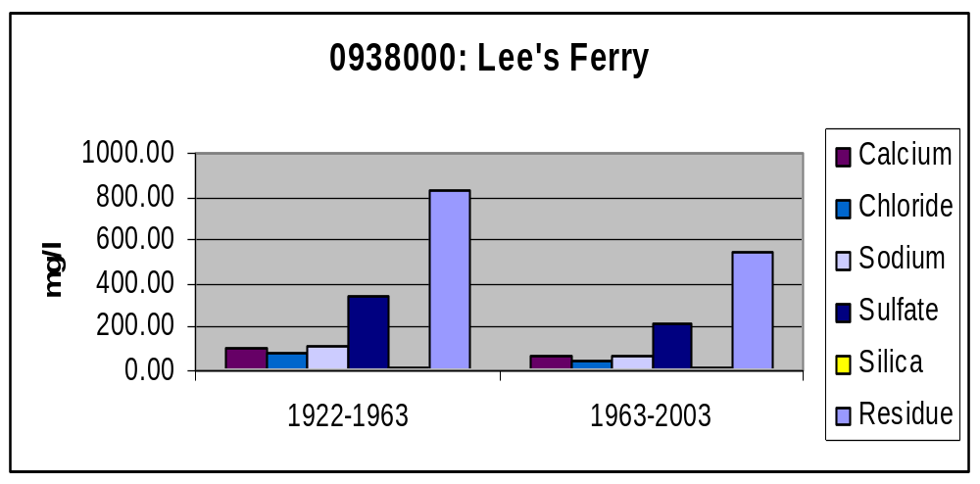
Figure 7 Water quality data pre and post dam

Flora and Fauna

The unnaturally cold temperature and lack of sediment beaches is primary reason for the extinction of the Southwest River Otter, the Colorado Pikeminnow, and the Bonytail Chub.Several other species are listed as endangered such as the Humpback Chub, Flannedlmouth Sucker and the Razorback Sucker. The dam control waters have also straightened the main channel of the river resulting in the loss of most in-stream spawning sites, and many back water areas have been filled with sediment. Several groups such as USBR and Colorado State University are currently studying the effect of water surface elevation on these habitat areas. GIS can be used to provide input data for hydraulically modeling water surface elevations and to visualize the output effects on the habitat.
Today,
- three native species--the Colorado squawfish, bonytail chub, and roundtail chub--have disappeared from the Grand Canyon,
- two native species--the humpback chub and razorback sucker--are listed as endangered,
- one native species--the flannelmouth sucker--is a candidate for listing under the Endangered Species Act, and
- two native species--the bluehead sucker and speckled dace--remain relatively common in tributaries and certain sections of the river.

After much web surfing I was still unable to obtain the coverage data for these species, however ,U.S. Fish and Wildlife does employ GIS methods to do just that..

Mitigation

The U.S. Congress passed the Grand Canyon Protection Act of 1992 in response to concern about the degrading ecosystems of the Grand Canyon. The act requires all damages to the Canyon to be mitigated and all dam operations to become secondary to the health of the Grand Canyon ecosystem.
Spurred by the 1992 Act in the spring of 1996 an artificial "flood" was released from the dam to mimic the high flows seen in spring runoff. After one week of high water release (45,000cfs) , new beaches and backwater habitats were formed to provide safety for the endangered fish and plants. The flood was a success in the short term of about a year before the beaches were eroded away and demonstrated even more so the need for more frequent flooding similar to historically annual cycle to maintain the sand bars. A similar flood was releases in 2000 (31,000cfs). There are currently more studies and floods planned for habitat monitoring.
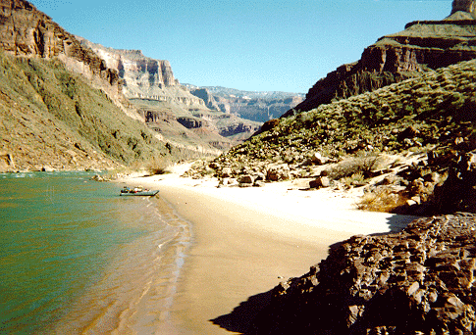
Figure 8- Pre 1996 flood Source: USBR
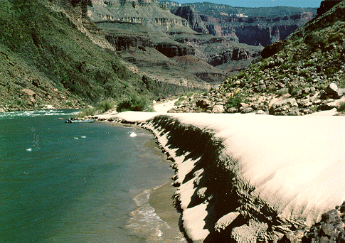
Figure 9- Post 1996 flood Source: USBR
Many studies are underway to predict predict what the river will do to sediment at different flow rates. Although not done for the 1996 Glen Canyon Dam flood, before and after the 2000 flood, orthoquad images were collected to monitor changes in channel geometry and sediment deposits. The Grand Canyon Monitoring and Research Center has these digital orthoquads, among many other GIS goodies, on their FTP site. The orthos below capture Lee’s Ferry in which the deposition and water clarity is greatly increased after the flow.
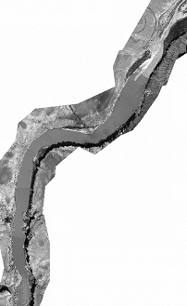
Figure 10 August 2000

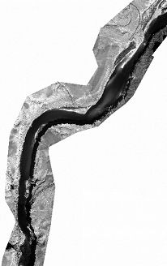
Figure 11 September 2000

These orthoquads can be digitized in GIS by creating polygons around the increased sediment areas and backwater areas to correlative quantitative increase in sand bar and backwater areas. This quantitative data is useful to compare to species data maps for the same and consecutive year to examine the effects of on reproduction.

Conclusions

I am merely restating what one would expect to be the effects of impoundment. What makes the pursuit of reiterating and explaining these things through GIS important is that it is such a user friendly resources management tool. The ability to graphically view data points such as water quality and flow monitoring data simultaneously with coverages of species habitat and vitality makes the coordination of data so much faster.

There are numerous limitations of this report that lend to a vast amount of future work that is largely already underway by several agencies. The rudimentary statistical handling of data for this report most likely does not portray complete accuracy. Above and beyond that is the ability to combine and coordinate much more sophisticated data discussed previously such as:
- DEM and bathymetry models to predict and map back water condition based on released flows.
- Aerial and satellite imagery to map sediment deposition and back water conditions
- Species covereages that more detailed in relaying actual species counts and not just inhabited areas.

Bibliography

- Grand Canyon Explorer. Bob Ribokas. 1994-2000.
www.kaibab.org/misc/gc_coriv.htm

- Glen Canyon Institute. 2003. www.glencanyon.org

- U.S Fish and Wildlife Services. http://www.fws.gov/

- Grand Canyon Monitoring and Research Center
www.gcmrc.gov

- Canyon Country Online, LLC. Copyright Shelly James. 1995-2003. LLC
www.canyon-country.com

- Desert USA. Digital West Media Inc.1996-2003. www.desertusa.com

- U.S. Bureau of Reclamation. Glen Canyon Environmental Studies. www.usbr.gov

- Grande Canyon Trust. 2001-2003. http://www.grandcanyontrust.org/pdfs/colorivgcanfactsheet.pdf

- National Academic Press. http://www.nap.edu/books/0309065798/html/157.html

- Seamless Coverage. USGS. 2003. http://seamless.usgs.gov/

- Visualizing the Impact of Control on the Lower Colorado River. Jeffrey D. Rieker, Kevin Fagot, John W. Labadie, PhD. http://gis.esri.com/library/userconf/proc02/pap0712/p0712.htm

Glen Canyon Institute www.glencanyon.org
Glen Canyon Institute www.glencanyon.org, Grand Canyon Explorer www.kaibab.org/misc/gc_coriv.htm
USGS. http://walrus.wr.usgs.gov/grandcan/fisheffects.html Appendix 1: Procedure For Creating Useful Maps For Best Management of Operational Practices For Glen Canyon Dam 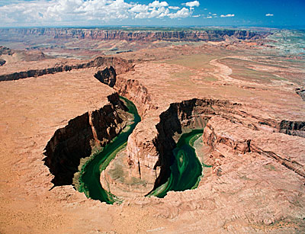 by Charlotte Amato CE394K Dr. David Maidment December 2003 Table of Contents Creating a Base Map 19 Creating a Geodatabase 22 Importing Data into the Geodatabase 24 Narrowing the Map the Area of Interest 26 Introducing Gages to the Map 33 Choosing Gage Stations 33 Transform Monitoring Points into Feature Class 35 Real Time and Historical Water Quality Data 38 General River Features Error! Bookmark not defined. Digital Elevation Models Error! Bookmark not defined. Creating a Base Map The Glen Canyon Damn and Lake Powell fall within the HUC region 14, the majority of the Grand Canyon is with HUC region 15. Data from both of these regions will be required to draw comparisons and form a simple base map. - Standard base map data may be obtained from the USGS. Download the Hydrologic Cataloging Unit coverage and the enhanced River Reach Coverage over the internet from the USGS ftp site: ftp://water.usgs.gov/pub/dsdl/. The HUC files contain drainage areas and are in scale 1:250,000. The Rf1 files contain data on the rivers. - These files are in are stored in Arc/Info interchange file format, as indicated by the .e00 extension. In order to make these files compatible with ArcMap they need to be converted using ArcToolbox Conversion Tools/Import to Coverage/  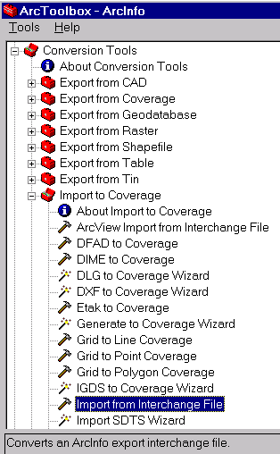 Import from Interchange File save all files as coverage and name: - huc14_250k.e00 huc14reg250k - huc15_250k.e00 huc15reg250k - rf1_14.e00 as rf1reg14 - rf1_15.e00 as rf1reg15 - Open ArcMap and the four reg files. The huc 14 and 15 and rf1 14 an 15 can be merged using the GeoProcessing Wizard to eliminate repetitive data and will make the data easier manage and manipulate later. - Open the GeoProcessing Wizard, which is located under the Tools menu. - Select merge the layers. 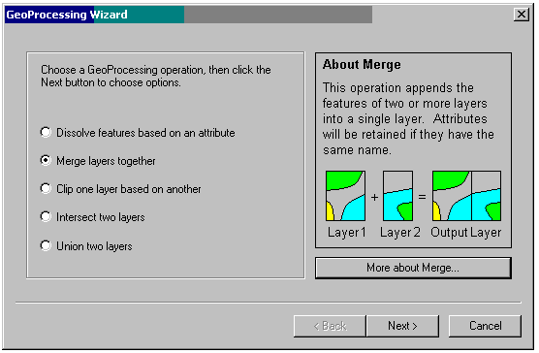 - Select both huc14reg250k and huc15reg250k merge and save as Allhuc. - Select both rf1reg14 and rf1reg15 merge and save as Allrf1. - Save the map as Map1.mdx. The resulting map will look something like the following: 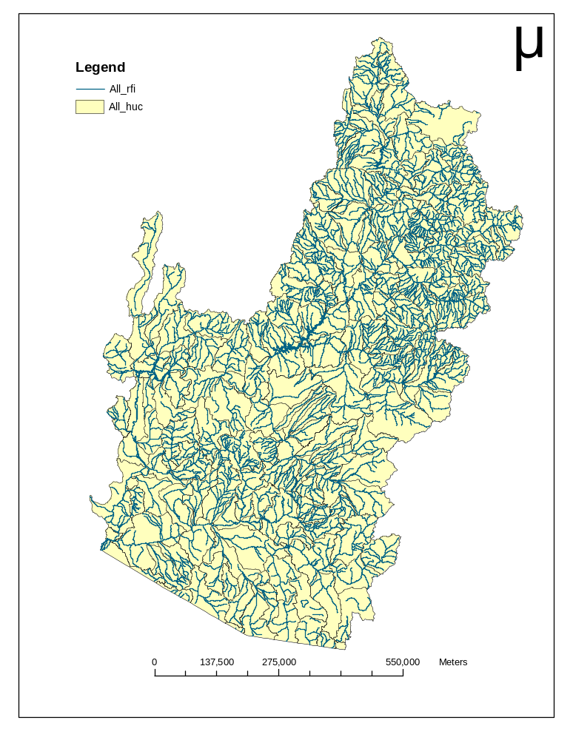 Creating a Geodatabase The next step is to create a Geodatabase so that a variety of data types can be used and relationships formed between them. Close are ArcMap and open ArcCatalog. - Right click on your data storage folder and select create new personal geodatabase. Save geodatabase as Map1.mdb. - Right click on the geodatabase and select create a new feature dataset. Name the feature dataset Basemap. 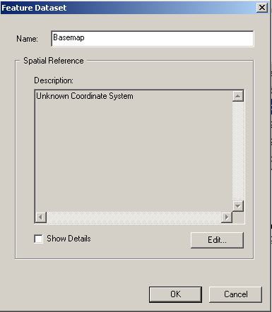 - Select Edit to set the projection and map extent. Select the Import option and navigate to the allrf1 file. The X/Y domain can also be adjusted to the extent values obtained from the Map1.mdx. This will adjust the map projection to values that are reasonable and relevant to the project. 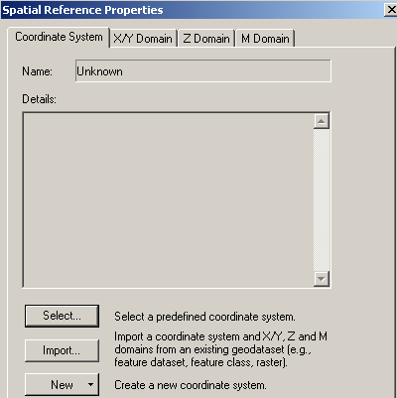 Importing Data into the Geodatabase The geodatabase is now ready to have data imported. The geodatabase will adopt the spatial reference of the first imported feature class so it is logical to import the HUC drainage areas first because they have the largest extents. - To import the two created shapefiles, allhuc and allrf1: - Right click on the feature dataset, Basemap, select the Import option. - Select the Shapefile to Geodatabase option. - Navigate to the allhuc and then repeat the process for the allrf1. Projecting the Geodatabase Often it is more useful to represent data in geographic coordinates rather than the Albers projection that the data downloaded from USGS is usually in. To project the Geodabase in geographic coordinates create a new data set as before. - Right click on the geodatabase, Map1.mdb and select create a new feature dataset. Name the feature dataset BasemapGeo. - As before select Edit to set the projection and map extent setting the coordinate system. This time choose the Select option and browse for the North American Datum 1927 geographic coordinate system. 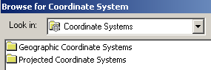 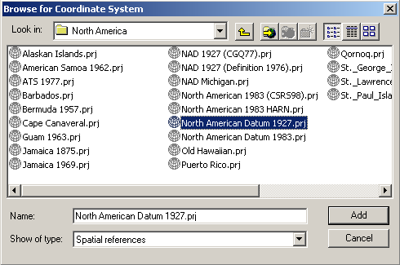 - The feature classes previously created in the Basemap can be exported to the BasemapGeo by: - Right click on the feature class All_huc and select Export - Select the Geodatabase to Geodatabase option - Select the Map1.mdb as the output Geodatabase - Select BasemapGeo as the new feature dataset - Enter All_huc_geo as the new feature class - Repeat this for All_rf1 and name the feature class All_rf1_geo. Now both geodatabases are contain the same feature datasets. - Add the BasemapGeo to ArcMap and Save as Map1Geo.mdx. The map should look something like the following:  Narrowing the Map the Area of Interest The basemaps just created cover a large region to crop the maps to an area that is of greater interest. - First add the names of the HUCs to identify watersheds of interest more readily. - The HUC names are stored in .dbf file that contains the names of all of the HUC in the nation. To link the HUC name from the table hucname.dbf use the Add Data button to add the table to Map1.dbx. - Right click on the All_Huc and select the Joins and Relates option. - Then Select the Join... option. What you are doing here is associating corresponding records in the two tables using HUC as the key field values that they have in common. 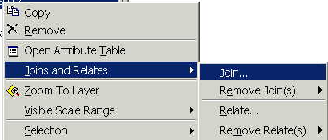 - For question 1 Select the attribute HUC. - For question 2, browse for the hucname.dbf table. - For question 3 select the HUC common attribute. 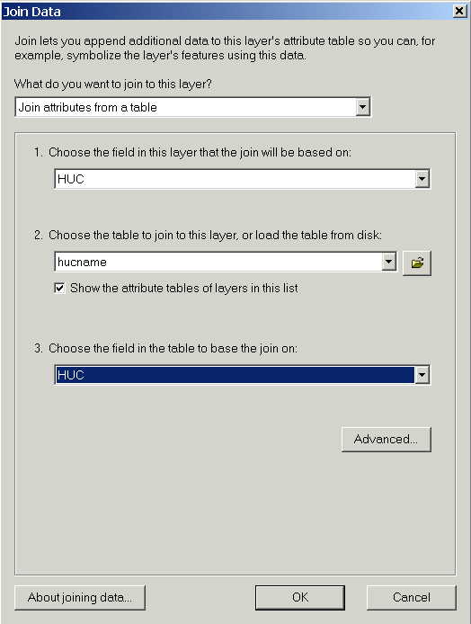 - The watershed names are now an attribute of the All_huc map layer. 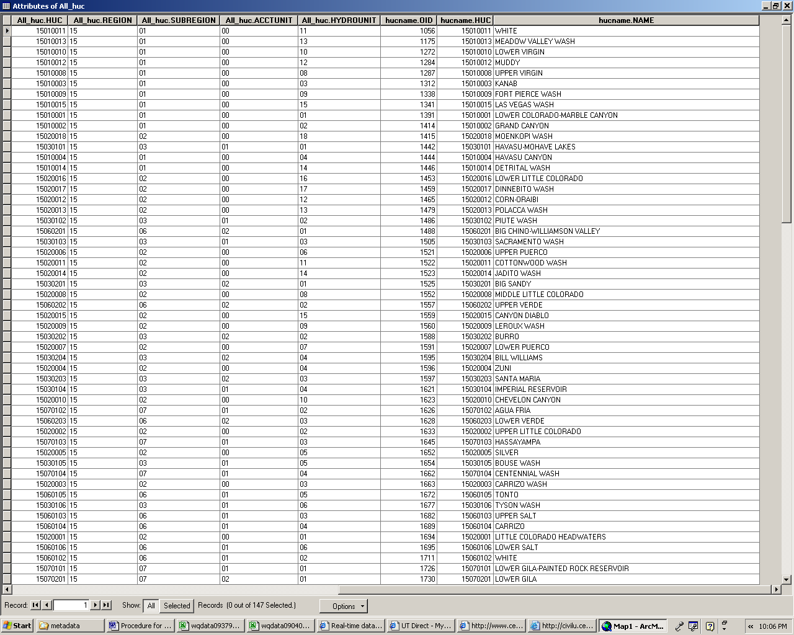 - The map can now be cropped to an area of specific interest. To covert only the watersheds of interest to a new map layer: - Select the Lower Colorado –Marble Canyon and Lower Lake Powell watersheds. - Right click on the All_Huc select the Data option. - Select the Export Data option. - Save the new feature class to the Personal Geodatabase feature class: Basemap. - Name feature class Watershed. - Save as file type Personal Geodatabase feature classes. 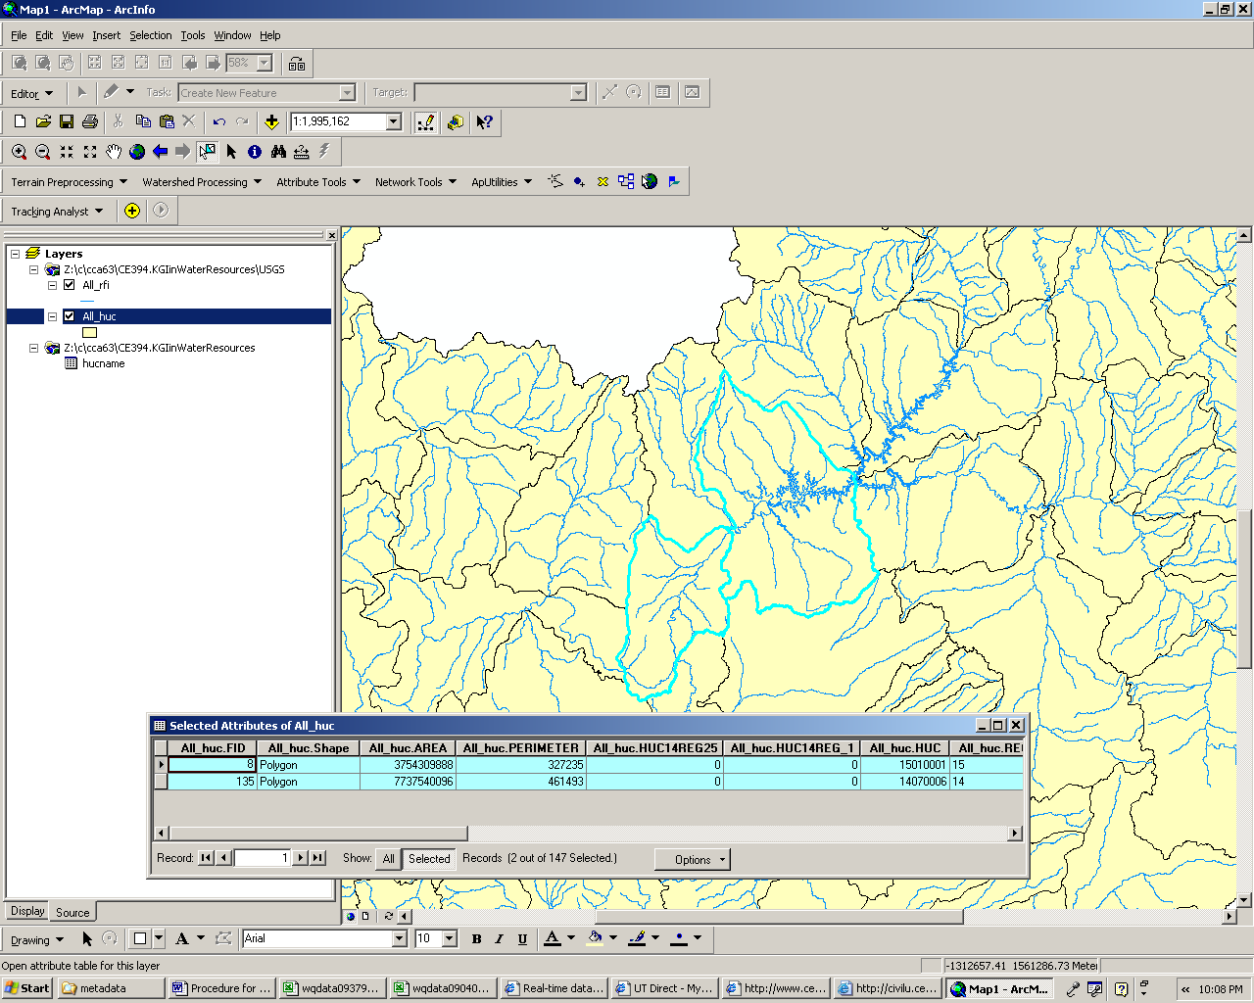 - The same procedure can be followed to add the names of the river reaches using the file rf1name.dbf. - For question 1 Select the attribute RR. - For question 2, browse for the rf1name.dbf table. - For question 3 select the RR common attribute. - The river reach names are now an attribute of the All_rf1 map layer. 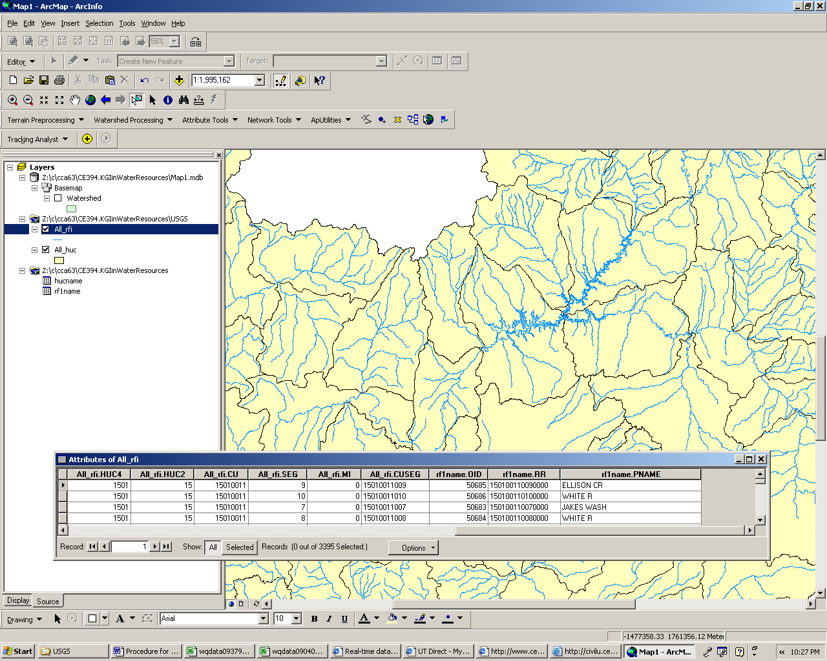 - To crop the All_rf1 river reach layer to only the reaches of interest a similar procedure may be followed as performed with the watersheds. - Open the All_rf1 attribute table. - Select Options. - Click Select By Attribute. - Choose “Create a new Selection” method - Select all_rf1.huc8 field - Set this field equal to 14070006 - Right click on the All_rf1 layer and select Data - Select Data Export - Save the new feature class in the Personal Geodatabase Basemap as Hydroedge1 - Repeat steps a-i except set all_rf1.huc8 equal to 15010001 and save and hydroedge2. - Now use the GeoProcessing Wizard to merge Hydroedge1 and Hydroedge2 into one layer called Hydroedge. The resulting map include only the watershed and associated river reaches that Glen Canyon Dam and the area directly downstream are located in. 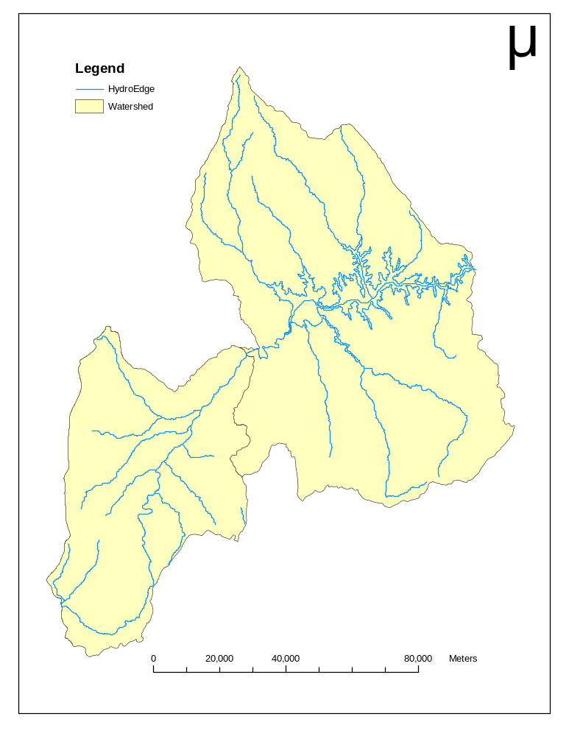 Introducing Gages to the Map Choosing Gage Stations The next step is to add monitoring points so that data can joined to the feature class and mapped. Monitoring point data is available from several sources, here USGS water data was used. Three gages were chosen to map: - 09379910: gage is located directly downstream of Glen Canyon Dam Coconino County, Arizona Hydrologic Unit Code 14070006 Latitude 36°55'18", Longitude 111°28'58" NAD27 Drainage area 111,700. square miles Gage datum 3,100. feet above sea level NGVD29Location of the site in Arizona. Site map. 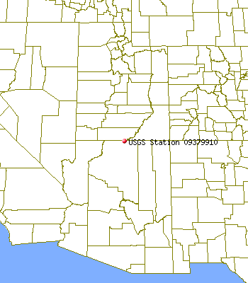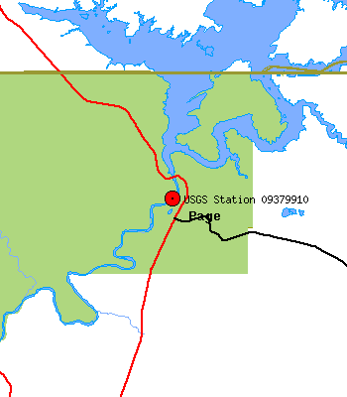 - 09380000: gage is located at Lee’s Ferry, AZ Coconino County, Arizona Hydrologic Unit Code 14070006 Latitude 36°51'53", Longitude 111°35'15" NAD27 Drainage area 111,800 square miles Gage datum 3,106.16 feet above sea level NGVD29Location of the site in Arizona. Site map. 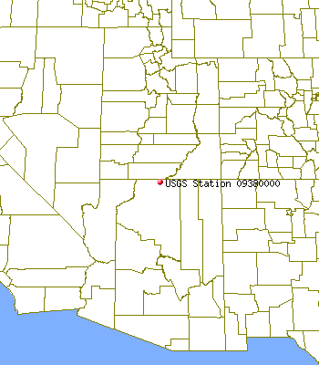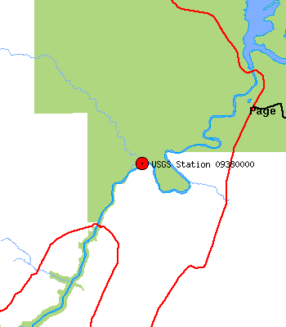 - 09402500: gage is located in Grand Canyon, near Grand Canyon, AZ. Coconino County, Arizona Hydrologic Unit Code 15010001 Latitude 36°06'05", Longitude 112°05'08" NAD27 Drainage area 141,600 square miles Contributing drainage area 137,641 square miles Gage datum 2,418.70 feet above sea level NGVD29Location of the site in Arizona. Site map. 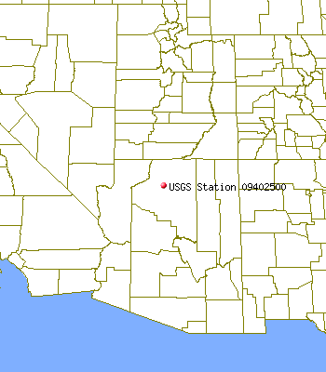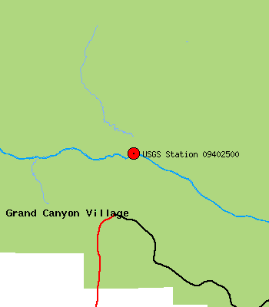 Transform Monitoring Points into Feature Class - The first step in creating a feature class is to create an excel table of the pertinent ID information. Below is the table created saved as GageIDTable.dbf so that it is compatible with ArcMap. GageNoLongdegLongminLongsecLongDDLatdegLatminLatsecLatDDUSGSIDNameHUC11112858-111.482836551836.921709379910CR Below Glen Canyon Dam1407000621113515-111.587536515336.864709380000CR Lee's Ferry14070006311258-112.0856366536.101409402500CR Near Grand Canyon15010001 - Open the BasemapGeo in ArcMap. Add GageIDTable.dbf and right click. Select Display XY Data ..... Complete the dialogue box as follows: - X Field: LongDD - Y Field: LatDD - Select Edit to set the projection. - Select Geographic Coordinate System and North American Datum of 1927, as before in the BasemapGeo. Click OK. - The gage table is now transformed to an Event. - So that the gages are functional in Basemap.mdx which is in Albers Projection the Event Layer GageIDTable need to be converted to a feature class and then exported to Basemap.mdx. - Right Click on the GageIDTable Event and select Data and then Export... - Export to BasemapGeo as a Personal Geodatabase Feature Class and name the file MonitoringPoint_Geo. - Close ArcMap and Open ArcCatalog. Right click on the feature class Monitoringpoint_Geo and as before choose the option Export Geodatabase to Geodatabase to export the feature class MonitoringPoint_Geo to the feature dataset Basemap and save as MonitoringPoint. - Open Map1 and add the MonitoringPoint as a layer. The gages should now be visible in their correct locations. - The gages can be labeled by right clicking on the layer and selecting Properties. Then select the Lables tab and check the Label Features in this Layer then choose the desired field, here Name was used. Real Time and Historical Water Quality Data Now that a base map is complete data tables of flow patterns and water quality data need to be joined to the gage stations so that trends and effects may be found and used as a factor in determining best management practices. Real-time Gage data was obtained from USGS. Three gages were chosen to compare data over time. For the time being only the gage names and locations are important to create a feature class of the monitoring points and display them on the base map. For each gage station water quality data and flow data was downloaded and copied to excel. Generally for gages 09380000 and 09402500 data, although intermittent is available from 1921 to present. Gage 09379910 is available from 1965, two years after the dam was complete. The tables were then modified and trimmed down so that they were manageable. The following flow data was chosen to compare pre and post-impounded river flows: - Monthly mean flow - Annual low flow based on monthly mean - Annual high flow based on monthly mean - Annual peak flow There were very few water quality attributes and good indicators that data for both pre and post-impoundment years. Mostly like this is due to increasing technology and environmental awareness. The following water quality attributes were organized into five year averages from 1921 to the present and the five averages were then averaged for pre-impoundment years (before 1963, the year the dam was completed) and post-impoundment years. - Color of Water, filtered Pt-Co - Specific conductance, water unfiltered uS/cm - pH of Water, unfiltered, field, std - hardness of water, unfiltered mg/L as CaCO3 - Magnesium, water, filtered mg/L - Sodium, water, filtered mg/L - Potassium, water, filtered mg/L - Chloride, water, filtered mg/L - Sulfate, water, filtered mg/L - Fluoride, water, filtered mg/L - Silica, water, filtered mg/L - Iron water, filtered mg/L - Alkalinity, water, filtered, incremental titration ug/L - Residue on evaporation at 180degC, water, filtered mg/L as CaCO3 - Suspended sediment as %of Natural Water. <.002mm - Suspended sediment as %of Natural Water. <.004mm - Suspended sediment as %of Natural Water. <.008mm - Suspended sediment as %of Natural Water <.016mm - Suspended Sediment Sieve Di% <.062mm - Suspended Sediment Sieve Di% <.125mm - Suspended Sediment Sieve Di% <.25mm - Suspended Sediment Sieve Di% <.5mm The water quality attributes below were desired for comparison between pre and post- impoundment, however, the data was sparse or there was no pre-impoundment data to draw comparisons between. As such the following data were cropped from the tables imported into ArcMap and discarded: - Alkalinity - Phosphorus - Nitrate - COD - Turbidity - Dissolved Oxygen - Dissolved Oxygen as percentage of saturation - Suspended Sediment Concentration Temperature data was also not available for pre-impoundment conditions either. This was particularly disappointing because it has such a profound effect on the aquatic life and their ability to live and procreate. These created table can be linked to the monitoring points by: - Save the flow summary and water quality summary tables in excel as DBF4 (dbaseIV) - Add the tables to the map in the .dbf format - Right click on each table, select Joins and Relates - Then select Join and use the USGSID to base the join upon Now that the data is added to the map it can be visually displayed in graphic format by manipulating the Symbologly found under Properties.

