Hydrologic Modeling Using Arc Hydro

CE 394K GIS in Water Resources
University of Texas at Austin
Fall 2002

Prepared by: David Maidment, Tim Whiteaker, Venkatesh Merwade, Hema Gopalan, and Oscar Robayo

This exercise is composed of two parts: Hydrograph Routing in Arc Hydro, and Model Connections with Arc Hydro. Each part is an exercise in itself but they all share a common focus on the potential interaction and connectivity between Arc Hydro and external water resources datasets, libraries, and models.

Two sets of data folders are needed for this exercise:
ExRouting.zip for Part 1
ExXMLWRAP.zip for Part 2

Part 1: Hydrograph routing using the Muskingum method

Prepared by: Venkatesh Merwade and David Maidment

Introduction
This section demonstrates how ArcHydro can be used to perform hydrologic calculations using a Dynamic Link Library (DLL). We are going to use LibHydro.dll, a DLL compiled by the US Army Corps of Engineers (USACE). LibHydro is a collection of several subroutines written in Fortran. All the subroutines in the LibHydro perform some sort of hydrologic calculations, however we are going to use only the Muskingum channel routing subroutine to route an inflow hydrograph from one monitoring station to another monitoring station located downstream. If you have not studied Muskingum routing before, please consult a Hydrology book to understand the process and its parameters, namely K and X.

Data Requirements
This section requires the data files located on ExRouting.zip, which contains an ArcHydro geodatabase with one featureclass called MonitoringPoints, and one time series table called ts_Q_15min. The data folder for this part of the exercise can be downloaded from Prometheus or from the web site http://www.ce.utexas.edu/prof/MAIDMENT/giswr2002/modeling/exrouting.zip

Preparing data for Muskingum Analysis
(1) Add the MonitoringPoints layer to the map from the ArcHydro geodatabase. The MonitoringPoints layer contains all the USGS gauging stations for the Guadalupe basin. The two monitoring stations that will be used for Muskingum routing are located in upper Guadalupe basin and are shown below.

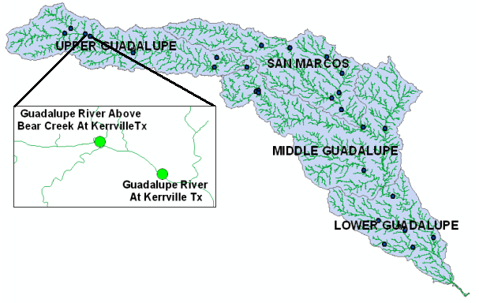

To be turned in: What are the USGS station-IDs of these two monitoring stations: Guadalupe River above Bear Creek at Kerrville and Guadalupe at Kerrville? What is the distance between these two monitoring stations?
(2) Add the time series tables, ts_Q_15min to the map. Open the table by right clicking on it as shown below.

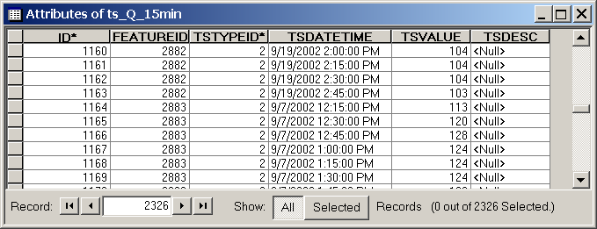

This time series table contains real time streamflow data in cfs recorded from 9/7/2002 12:15 PM to 9/8/2002 8:45 AM at 15 minutes interval. There are 2326 records, 1163 for the Bear Creek and 1163 for the Kerrville monitoring station respectively. All the data in this time series table have a FeatureID = 2882 correspond to Bear Creek at Kerrville and the data that have a FeatureID = 2883 correspond to Guadalupe at Kerrville. Look at the HydroID of these monitoring points in the MonitoringPoints feature class.
To be turned in: Briefly describe how is the time series table related to spatial features?
All the data in this timeseries table have a TSTypeID = 2 and it classifies the data as recorded streamflow data. You will see later, after routing the flow, that a TSTypeID = 3 will be assigned to all the modeled streamflow data.
After the timeseries table is added to the map, you are ready to route the flow using the LibHydro DLL.

The Muskingum Routing interface
(1) Although the interface does not require an edit session, it is recommended to do all the calculations in an edit mode. That way if you wish, you can exit the edit session without saving your edits to the time series table. Go ahead and click on the editor (Select EditoràStart Editing) and select the geodatabase that contains the ts_Q_15min table as the target for editing.
(2) Copy the LibHydro.dll into “c:\temp” directory. Since this program uses LibHydro to route the flow, it is important to make sure that the DLL is stored in “c:\temp” otherwise the program will not work.
(3) Also there is one more DLL. Muskingum.dll, in the ExRouting.zip folder. Add the Muskingum.DLL to ArcMap by clicking on the Tools menu and then selecting Customize… > Add from file... Browse to your data folder where the Muskingum dll is located and after it loads drag it on the ArcMap toolbar. You will see a command button called Muskingum Routing as shown below.

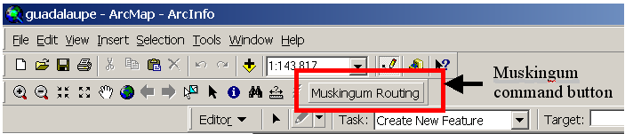

(4) Click on the Muskingum Routing command button to have a look a the Muskingum routing interface as shown below:
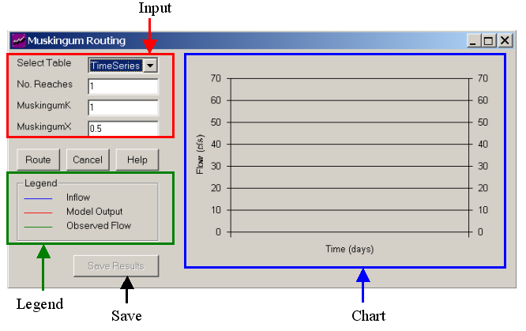

The Muskingum routing interface has two main components, input and output. The output is displayed as a chart on the interface itself. The user has to specify the input time series table, number of reaches, the K value, and the X value. X is dimensionless and K is in hours and a time interval of 15 minutes only is used to route the flow. The program reads the inflow and the observed outflow using the FeatureID from the time series table. For example, in the present case, all the inflow data have a FeatureID = 2882 and the observed flow data have a FeatureID = 2883. However, the program uses only the inflow data and the input parameters to route the flow. Observed outflow is used only to graph the data on the chart so that user can change the input parameters and try to match the modeled flow with the observed flow.
Please note that the Save Results button will be inactive at the beginning because there are no model results to save, but once the user routes some flow this button becomes active and the user can then save the output. The output is saved in the same time series table that contains the input data. The model output results will have same FeatureID as the downstream monitoring station, 2883 in this case. However the model output will have a different TSTypeID of 3, to differentiate it from the observed flow for the same monitoring station. Every time the Save Results button is clicked, the program replaces all the old modeled data with the new modeled data.
The legend on the interface helps user to identify different data that appear in the chart.

2.5. Routing the flow
(1) If you have canceled the interface, click on the Muskingum routing command button to activate the interface.

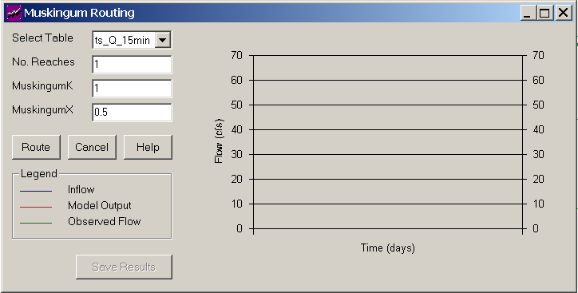
Click on the Select Table combo box to select the ts_Q_15min Table. For the first trial, let the program use default parameters for the number of reaches, K, and X. Click on the Route button and the interface creates a graph as shown below.
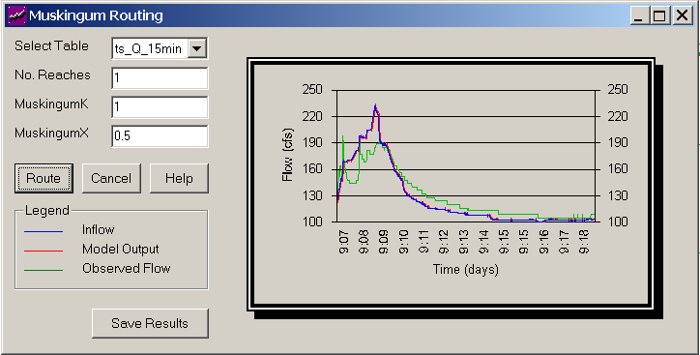
Also note that the Save Results button is now activated! Before saving the results we should make sure that our model output is satisfactory.
(2) Since the model output is the same as the input, change K to 5 and click the Route button. The output is shown below:

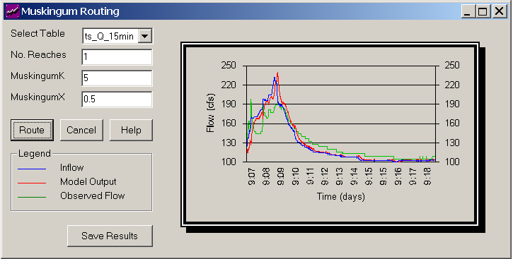

You can see that the change in K has only shifted the outflow hydrograph without any storage effect because a value of 0.5 for the Muskingum X does not have impose any storage effect (Note: maximum value for X is 0.5).
(3) Change the X value to 0.25 keeping K = 5 and click the Route button to get the output as shown below.
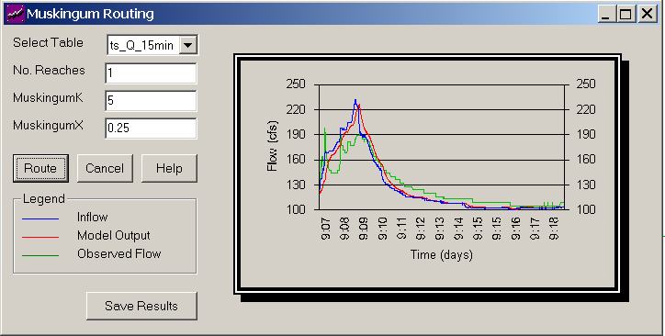

You can see that the peak of the model output has reduced a little bit. Also change the number of reaches and see how it affects the model output.
(4) Play with these parameters and save the results that you think are close enough to the observed outflow hydrograph. The results with K=24 and X = 0.10 for a single reach are shown below.

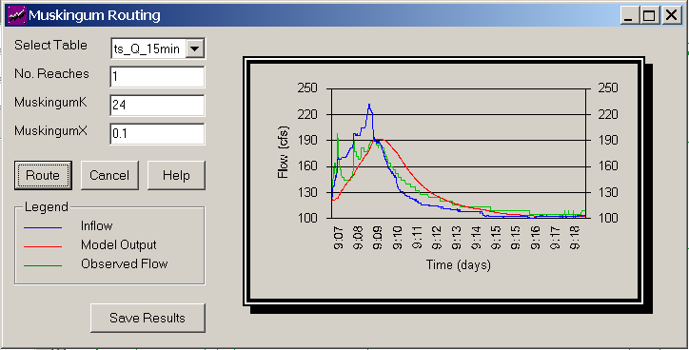

To be turned in: Make a screen capture of the Muskingum Routing window showing the effect on the hydrograph from using small vs. large values of X and give a brief comment.
To be turned in: Make a screen capture of the Muskingum Routing window showing the effect on the hydrograph from using small vs. large values of K and give a brief comment.
To be turned in: Make a screen capture of the Muskingum Routing window showing the effect on the hydrograph from using small vs. large values of Number of Reaches and give a brief comment.
To be turned in: Make a screen capture of the Muskingum Routing window showing your best match at the end of your calibration process.
To be turned in: Comment on how this hydrologic process might help on flood control management operations.

Saving the Results
If you are satisfied with the resulting hydrograph, click on the Save Results button to save the model output. It takes few seconds to save the data. Look at the progress bar at the bottom-left corner of the screen to see if the process is fast or slow. After the data is saved, a message box as shown below will appear.
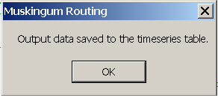
Click OK and then click Cancel to unload the Muskingum routing interface. Save your edits and close the edit session by clicking on Editor…> Stop Editing. If you stop editing without saving the edits, the model output will not be saved in the time series table.
Open the ts_Q_15min table by right clicking on it as shown below.
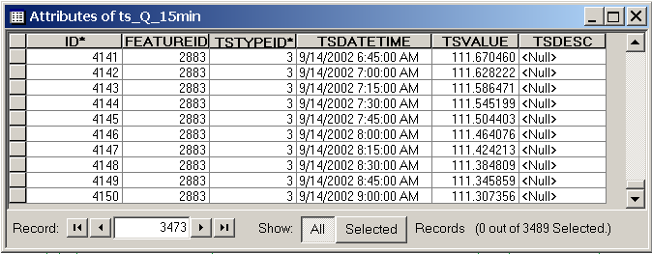
You can see that the time series table now contains 3489 records. The model output results have same FeatureID as the downstream monitoring station, Guadalupe at Kerrville. The TSTypeID = 3 distinguishes the model output from the observed flow.

Part 2: Model Connections with Arc Hydro

Prepared by: Hema Gopalan, Oscar Robayo, and David Maidment

Introduction
Model connections to Arc Hydro represent one of the main goals for the next phase of Data Model development. The issue of data exchange between diverse utilities is becoming a paramount topic as needs for integral simulations emerge. By using XML and Visual Basic you can prepare input files for any Water Resources Model that take GIS related parameters as input.
The Water Rights analysis package (WRAP) was developed by Dr.Ralph Wurbs at Texas A&M. As defined by Dr.Wurbs, “WRAP simulates management of the water resources of a river basin under a priority based water allocation system, such as the Texas Water rights system”. The WRAP model facilitates assessment of hydrologic/institutional water availability/reliability for existing and proposed water rights.”
It is being used for water rights reliability assessments in all Texas river basins with the exception of the Rio Grande basin. Several versions of WRAP have been produced and for this exercise we will be using the July 2001 version.
WRAP is a set of Fortran programs. The main simulation program WRAP-SIM performs the river/reservoir/use system water allocation simulation computations. WRAP-HYD facilitates developing the hydrology-related portion of the WRAP-SIM input. The TABLES program is a post-processor, which organizes and summarizes the WRAP-SIM results to user-friendly tables.

Purpose
This exercise will familiarize you with the water availability modeling using the Water Rights Analysis Package. By the end of this exercise you will be able to:
- Use XML and VB capabilities to extract spatial parameters from a GIS geodatabase to update existing input files for the WRAP model
- Perform a basic water Availability simulation using WRAP-SIM
- Use the TABLES post-processor to format the WRAP-SIM output
- Do a sensitivity analysis on the data and compare the output

Data Requirements
The data files needed for this exercise are contained in the ExXMLWRAP.zip data folder which can be downloaded from Prometheus or from the web site http://www.ce.utexas.edu/prof/MAIDMENT/giswr2002/modeling/ExXMLWRAP.zip This data folder contains the following file structure:
- ControlXML.xml, Configuration XML file with selected GIS parameters to be retrieved.
- Smarcos_old.DAT, existing input DAT file for the WRAP-SIM program of the WRAP model.
- Smarcos_old.DIS, existing input DIS file for the WRAP-SIM program of the WRAP model.
- ExportXML1.dll, a dll for ArcGIS data exchange.
- Test.dll, a dll for ArcGIS data exchange.
- Msxml, XML parser installation setup.
- XML2WRAPEXE, VB application to transfer data from XML to WRAP structures.
- WinWRAP, the windows WRAP application
- SIM.exe, the simulation program for WRAP
- TAB.exe, the output table generation program for WRAP
- HYD.exe, the hydrologic simulation program for WRAP
- Readme_WRAP, General Information on WRAP file structures
- DRY folder
      - Smarcos_Dry.mdb, ArcGIS geodatabase containing basemaps for the San Marcos Basin.
      - SanMarcos_Dry.DIS, an empty file in which to place the updated DIS file.
      - SanMarcos_Dry.DAT, an empty file in which to place the updated DAT file.
      - SanMarcos_Dry.eva, input file containing the evaporation data for WRAP-SIM
      - SanMarcos_Dry.inf, input file containing naturalized streamflow for WRAP-SIM
      - TABDRY.Dat, input file for WRAP-TAB
- WET folder
      - Smarcos_Wet.mdb, ArcGIS geodatabase containing basemaps for the San Marcos Basin.
      - SanMarcos_Wet.DIS, an empty file in which to place the updated DIS file.
      - SanMarcos_Wet.DAT, an empty file in which to place the updated DAT file.
      - SanMarcos_Wet.eva, input file containing the evaporation data for WRAP-SIM
      - SanMarcos_Wet.inf, input file containing naturalized streamflow for WRAP-SIM
      - TABWet.dat, input file for WRAP-TAB

WRAP Input Files with GIS-related parameters
The standard default input files for WRAP-SIM, the simulation component of WRAP, are as follows.
- root.DAT basic file containing all input data, except the voluminous hydrology related data contained in the following files
- root.DIS flow distribution FD and watershed parameter WP records for transferring flows from the IN records to other control point locations
- root.INF inflow IN records with naturalized streamflows
- root.EVA evaporation EV records with net evaporation-precipitation rates
The root name corresponds to the common input file name for a given project. The input files in WRAP that might be updated with GIS information are root.DAT and root.DIS. These two files have the following FORTRAN structure:
Root.DAT: (other fields not shown) | Root.DIS:
  Field | Value | Description
  1 | CP | Record identifier
  2 | AN | Control point identifier [cp = 1,NCPTS]
  3 | AN | Identifier of next downstream control point.
   | blank,OUT | Basin outlet. There is no control point downstream.
  Field | Value | Description
  1 | WP | Record identifier
  2 | AN | Control point identifier
  3 | + | Drainage area
  4 | + | Curve number
  5 | + | Mean precipitation
  6 | + | Multiplier to convert drainage area to square miles
All the bold items on these two files might come from a centrally maintained geodatabase that feeds information to a variety of Water Resources Models. Next you will learn how to extract those parameters and make them accessible to other applications.

Generate the Control XML
XML stands for Extended Markup Language and even though it is quite similar to HTML it describes the data instead of formatting the data for display on a web page. In short, all levels of data have tags that describe the data by means of a nested tree structure in which every sub node (child level) belongs to a node (parent level).
Control XML is a configuration file in which you can specify the data you want to retrieve from a GIS geodatabase (in this case parameters relevant to the WRAP model) and the structure in which these parameters will be organized. The file must have xml syntax and use some predefined keywords.
You need to have a Control XML file defining the parameters to retrieve. For this exercise the Control XML has already been created for you. Open the file ControlXml.xml by double clicking on it. The Internet Explorer will open the file. Take a look at its structure and try to recognize the parameters contained in it and the GIS layer from which they will be extracted.
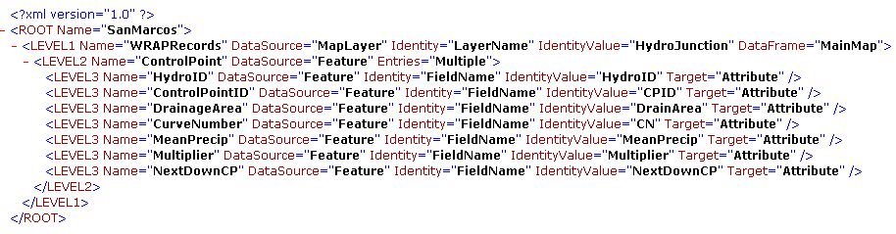
The first line contains a tag defining the XML version being used. This line should always exist independently of the project. The next tag defines the name of the project, SanMarcos in this example.
The next line defines the first level of data (Level1) as a GIS layer inside an ArcMap document. In this case the layer that contains a group of WRAP parameters under the name WRAPRecords that come from a MapLayer in GIS identified by its LayerName, HydroJunction. This Layer must exist in the Data Frame of ArcMap that also has a generic name of MainMap.
The second nested level of data (Level2) corresponds to Multiple Features inside the previously defined GIS Layer. The name for this group of features is ControlPoint to be consistent with the WRAP structure, which defines a series of Control Points representing diversions, gages, return flows, etc.
The third nested level of data (Level3) corresponds to each of the attributes describing the features within the ControlPoint feature class. Each attribute has a given name, the source of it, the type of identifier, and the name of the identifier, which must coincide with the names in the attribute table of the layer containing the data. At the end, the Target is set to Attribute to make it an attribute of its parent class (ControlPoint) and get all the features in the same line for better output readability. This is the highest internal data level in the structure and can have a simple closing tag />.
After all the Features are defined, it is necessary to close each level of data using the closing tags </LEVEL2>, </LEVEL1>, and </ROOT>. The Control XML file can be edited in any text editor like notepad. After you finish your Control XML you can open it in Internet Explorer to make sure the XML syntax is OK.

Installing MSXML
You should already have the Microsoft XML Parser (msxml.exe) installed on your computer. In case you do not, the msxml setup file is also included in the data folder for this exercise.
By installing this, all applications on your computer can access the necessary libraries to manipulate and parse XML documents.

Opening the Geodatabase
For this part of the exercise we will be using the SanMarcos_dry geodatabase provided to you in the DRY folder. The HydroJunction feature class has five control points on the San Marcos basin as shown below. CP-2 and CP-5 are stream gages, CP-1 and CP-4 are Diversion points and CP-3 is a return flow point. The Drainage Area, Curve Number, and Mean Precipitation values for each control point are given in the attribute table.
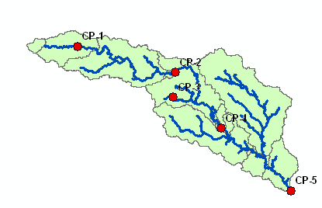
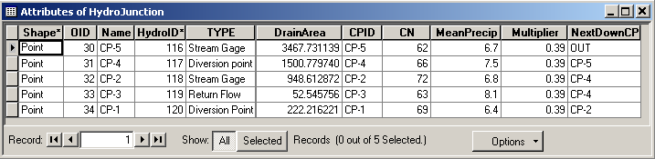

Making GIS references to Libraries
In ArcMap, open the geodatabase SanMarcos.mdb and save your ArcMap document as Xml2Wrap.mxd
Also in ArcMap, make reference to the XML library by doing: Tools > Macros > Visual Basic Editor > Tools > References > Microsoft XML, v3.0
Again in ArcMap, make reference to the FileSystemObject Library by doing: Tools > Macros > Visual Basic Editor > Tools > References > Microsoft Scripting Runtime
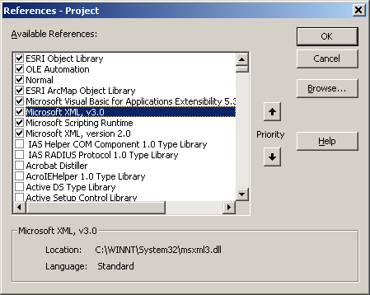

Registering XML DLLs to GIS Software
ESRI has developed tools to read and execute a Control XML from inside ArcMap. You need to register two XML dlls on your computer.
- ExportXML1.dll
- Test.dll
One simple option to register DLLs for ArcGIS is to run the Register_in_menu.reg file. Search for the Register_in_menu.reg file normally located in C:\arcgis\arcexe82\ArcObjects Developer Kit\Utilities and double click on it. By doing this, your right click menu will allow you to automatically register and unregister dlls for ArcGIS. You may need to have administrator privileges to run the Register. See your network administrator for help if you cannot run the register. If you don’t find the required file in the Utilities folder, go to the arcexe82\bin folder and use the RegCat or Register applications to perform this function.
Right click on each of the above dlls (ExportXML1.dll and Test.dll), select register, and click OK
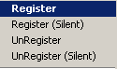

Adding The “Export to XML” Tool to ArcMap
In ArcMap select Tools > Customize > Commands > Add from File > test.dll > Open.
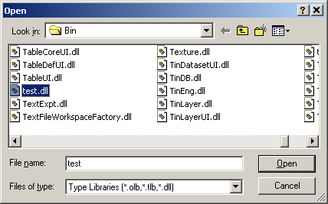
On the Customize window, load the Tool “Export To XML” by clicking on the DataExchange Category and adding Export to XML as the new command button. Drag Export to XML to the gray toolbar area and place it adjacent to an existing command icon.
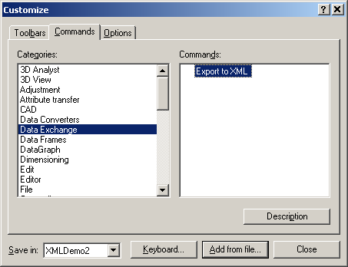

Running the Export to XML Tool
Make sure the feature class HydroJunction is open in your ArcMap document.
Click on the Export To XML tool:
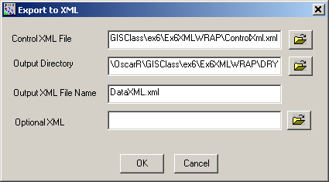
Browse to your data folder and select your Control XML file. Browse to your output directory (just click on your Dry data folder). Give a name to your Output XML file (DataXML or similar). Leave the Optional XML field blank. Click OK to execute the export to XML function.

Checking the Output Data
Check the output data by opening your Output XML File to review the retrieved parameters and look at the consistency between this file and your initial Control XML. By having the parameters in a Data XML file any application may now access them for its own modeling purposes.
Here is the first part of this file:
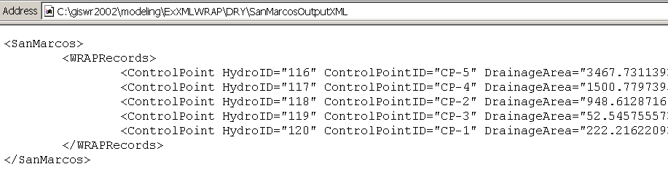
Here is the rest of this file:
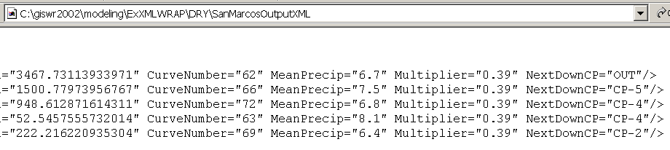
Notice how the attribute values of the HydroJunction feature class now exist as an XML text file that can be interpreted by an external program. Pretty cool!

Generating WRAP Input Files Through a VB Application
The WRAP modeling package consists of a series of Fortran programs. The input for these programs must follow a very rigid structure or data format that is hard to manually maintain. You will use a Visual Basic application to readily generate the updated input files according to the WRAP Fortran structure. Once we have the updated parameters available from a Data XML file we can retrieve them using a user-defined application. For this example we will use the XML2WRAP application specifically designed to read the DataXML file and prepare new WRAP input files based on updated information.
In this exercise we will be working with two hydrologic conditions representing two different periods of time (1993,1994 and 1995 being the “wet” condition and 1996, 1997 and 1998 being the “dry” condition). We will first work with the Dry conditions and you will have to repeat the same process for the wet conditions.
Run the VB application XML2WRAPEXE provided with this exercise to update the WRAP Input Files (SanMarcos_old.DIS and SanMarcos_old.DAT) with the most current GIS Info. This application takes advantage of the DOM (Document Object Model) to manipulate the XML Output file and retrieve all the necessary field values containing relevant parameters for WRAP. Now your new WRAP input files are created which include the GIS spatial information.
The Input fields for this application are:
- Data.XML Input File: The output XML file obtained after running the “Export to XML” tool from ArcMap.
- SanMarcos_Old.DIS File: The existing DIS file that wants to be updated with GIS based information.
- SanMarcos_Old.DAT File: The existing DAT file that wants to be updated with GIS based information.
- SanMarcos_Dry.DIS File: The Output DIS file after updating with GIS based information.
- SanMarcos_Dry.DAT File: The Output DAT file after updating with GIS based information.
Note: To select the input files with the right extension (.DIS or .DAT) for this application, you must select the detailed list of the files while browsing to locate them.
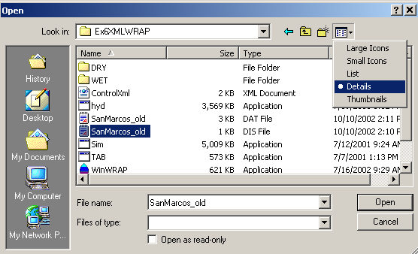
Once you have entered all the input fields, press the “Generate WRAP Input Files” button and check the output.
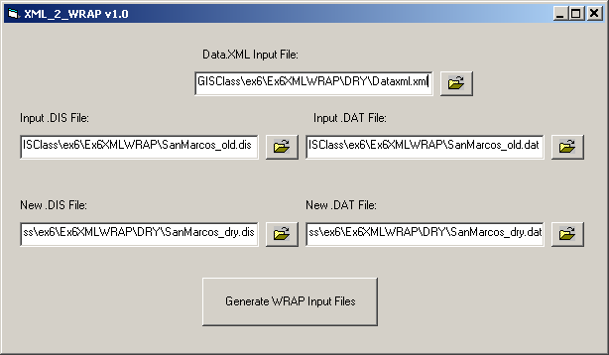

In this example no Control Points were added or removed. If the XML2WRAP application gives a report showing added or removed Control Points you must make the corresponding changes on all the input files including .INF, EVA, .DIS, and. DAT.
Now you will have to run the same process for the Wet conditions using the Geodatabase and the required data is in the WET folder. Open the attribute table for the HydroJunction feature class and compare the data with the dry condition. What differences do you see (the values for annual precipitation are different).

Running WRAP
Open the input files: SanMarcos_dry.dat, SanMarcos_dry.dis, SanMarcos_dry.eva, and SanMarcos_dry.inf in WordPad and take a look at their content. The format for each record is detailed in a separate word document called Readme_WRAP. The file also has some basic definitions, which you might like to go through. Now you are ready to run the WRAP model.
Open the WinWRAP application and select the WRAP-SIM application from the WRAP menu.
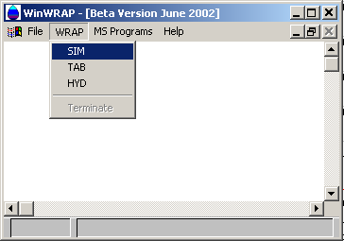
Type in the name of the input files (root name) along with the path.

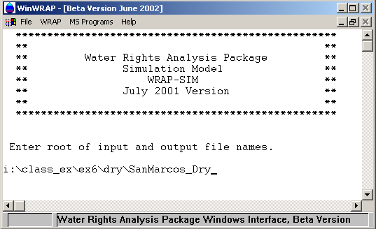
On running the program the output should look like this:
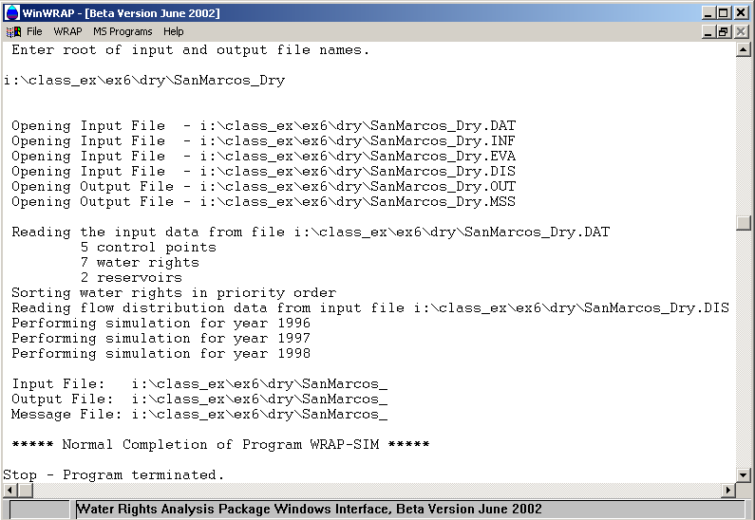
If you look into your folder you can see that the program has created two files, message file Sanmarcos_Dry.mss and output file Sanmarcos_dry.out.
The message file has the input trace messages and reproduction of input records to track which input records were successfully read (a log file). It also has error messages if any noting missing or erroneous input records.
The output file provides data for a water right for a given period (month). The records for all of the water rights are grouped together for a given period. Each regular water right output record contains, from left to right, year and month, diversion shortage, target diversion amount, net evaporation-precipitation volume, end-of-period reservoir storage, the streamflow depletion the water right made during the month, the streamflow available to the right before the streamflow depletion, all water that was released from secondary reservoirs to meet the diversion and/or refill storage, and the three identifiers from the WR input record.
The TABLES processor is used to convert this output file to a more readable format. There is a file called TABDRY.dat in your DRY folder that is the input file for the TABLES program. You need not bother with the format for this input file. Run the TAB from the WRAP menu in the WRAP application. Enter the input file name with the path, use the default root for the output file name and enter the input file ‘SanMarcos_dry’ we used earlier for the WRAP-SIM. The run should look something like this:

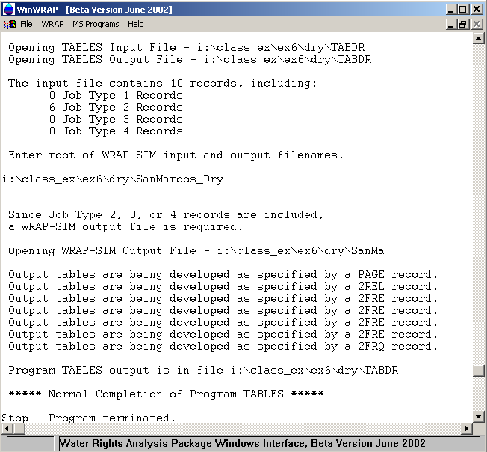

Now open the TABDRY.out file:
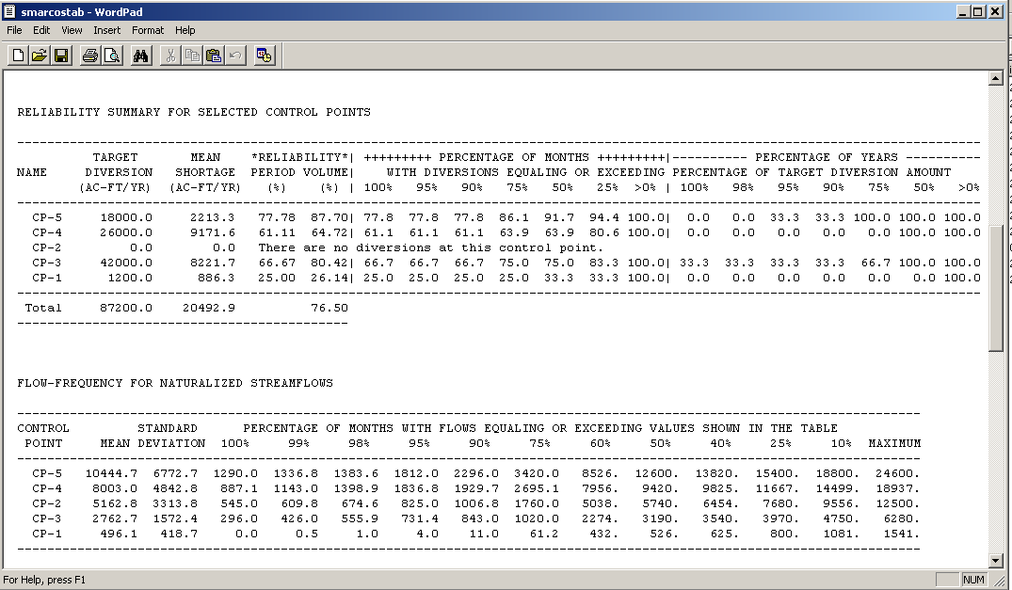
The results of this simulation are typically viewed from the perspective of the frequency, probability, percent-of-time, or reliability of meeting water supply, instream flow, hydropower, and/or reservoir storage requirements. The first table shows the reliability summary for the control points. CP-5 has a target diversion of 18000 Ac-Ft/Yr and the mean shortage for the 3 years of simulation has been calculated as 2213.3 Ac-Ft/Yr by the WRAP model. The period reliability is the percentage of the months in the simulation for which the specified target is fully met without shortage and the volume reliability is the percentage of the total demand that is actually supplied. Thus for CP-5, for 77.78% of the time of simulation (a 3 years period), the water demand target was fulfilled and 87.7% of the total demand was met. Also for 77.8% of the total number of months the diversion was greater or equal to the target diversion. Similarly for 91.7% of total months the diversion was greater than or equal to 50% of the target diversion.
Open the SanMarcos_Wet.inf and SanMArcos_Wet.eva files. Notice the difference between the Files for the wet and dry periods. Now, run the WRAP simulation for the WET conditions following the same steps as above. Obtain the output table after running the TABLES and compare the results.
To be turned in: A screen capture of the final output table of the wet condition showing the reliability summary for all the control points. What is the percent difference in the mean shortage for the two conditions? What happens to the period and volume reliability in the wet condition (compare it to the dry condition)? How many years does diversion amount exceed or equal 98%, 90%, 75% and 50% of the target diversion for CP-4 and CP-3 for both wet and dry conditions?
To be turned in: Make a layout that depicts the basin, river network, and control points (CPs) and place tags on each CP with brief comments describing the conditions found for the wet and dry periods.
Congratulations!! You are now done with this modeling exercise.

