Homework 4 Solution CE374K Hydrology Spring 2013
Prepared by Gonzalo E. Espinoza
#1. Flood Frequency Analysis Exercise
(1) Assume the design discharge is 30,000 cfs and determine the return period of this annual maximum discharge in the period 1900 to 1940, and in the period 1941-2010. What was the annual probability, p, of having a flood discharge of at least 30,000 cfs flowing through Austin in the Colorado River before 1940? After 1940?

Years with annual maximum discharge equaling or exceeding 30,000 cfs (1900-1940)

Exceedence Interval |  | Recurrence Interval (years)
1900 | 1902 | 2
1902 | 1903 | 1
1903 | 1904 | 1
1904 | 1905 | 1
1905 | 1906 | 1
1906 | 1908 | 2
1908 | 1909 | 1
1909 | 1913 | 4
1913 | 1914 | 1
1914 | 1915 | 1
1915 | 1916 | 1
1916 | 1918 | 2
1918 | 1919 | 1
1919 | 1920 | 1
1920 | 1921 | 1
1921 | 1922 | 1
1922 | 1923 | 1
1923 | 1924 | 1
1924 | 1925 | 1
1925 | 1926 | 1
1926 | 1927 | 1
1927 | 1928 | 1
1928 | 1929 | 1
1929 | 1930 | 1
1930 | 1931 | 1
1931 | 1932 | 1
1932 | 1933 | 1
1933 | 1934 | 1
1934 | 1935 | 1
1935 | 1936 | 1
1936 | 1937 | 1
1937 | 1938 | 1
1938 | 1940 | 2
Average |  | 1.21

$$T=1.21years$$

$$P\left(X>x_{T}\right)=\frac{1}{T}$$
$$P\left(X>x_{T}\right)=\frac{1}{1.21}$$
$$P\left(X>x_{T}\right)=0.83$$

Years with annual maximum discharge equaling or exceeding 30,000 cfs (1941-2010)

Exceedence Interval |  | Recurrence Interval (years)
1941 | 1957 | 16
1957 | 1958 | 1
1958 | 1960 | 2
1960 | 1961 | 1
1961 | 1975 | 14
1975 | 1977 | 2
1977 | 1987 | 10
1987 | 1992 | 5
1992 | 1997 | 5
1997 | 1999 | 2
1999 | 2002 | 3
2002 | 2005 | 3
2005 | 2010 | 5
Average |  | 5.31

$$T=5.31years$$

$$P\left(X>x_{T}\right)=\frac{1}{T}$$
$$P\left(X>x_{T}\right)=\frac{1}{5.31}$$
$$P\left(X>x_{T}\right)=0.19$$

(2) A plot of the flood discharges for the annual peak flows of the Colorado River at Austin including all the data and the historical flood.

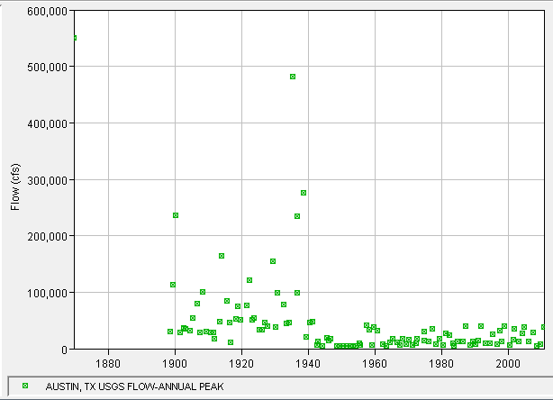

(3) A plot and a table of results for the frequency analysis for the Colorado River at Austin for the period 1900 to 1940.

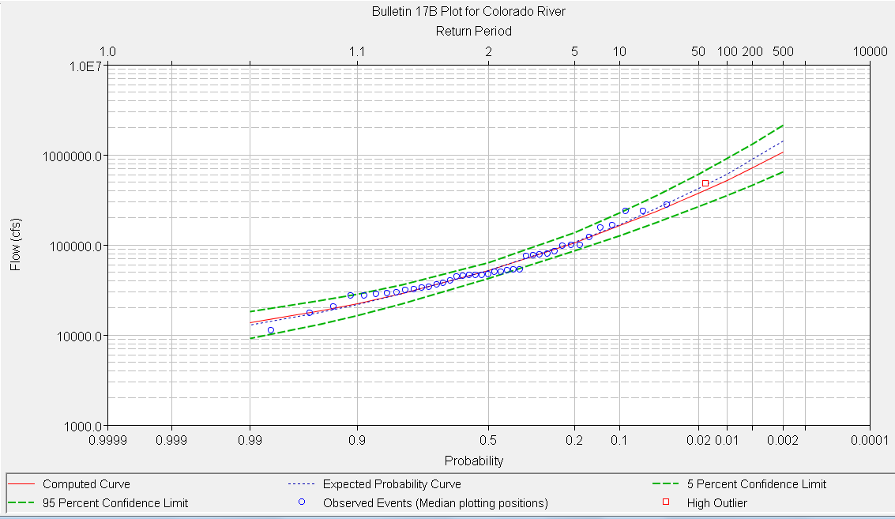

Computed Curve | Expected Probability | Percent Chance Exceedance | Confidence Limits
 |  |  | 0.05 | 0.95
Flow (cfs) |  |  | Flow (cfs)
1,066,182.40 | 1,428,381.40 | 0.2 | 2,141,525.60 | 651,738.60
716,499.60 | 885,877.70 | 0.5 | 1,322,901.40 | 463,397.80
523,817.00 | 613,816.60 | 1 | 906,087.30 | 353,765.40
377,632.30 | 423,193.50 | 2 | 611,165.30 | 266,414.00
237,958.70 | 254,000.80 | 5 | 352,078.00 | 177,787.40
162,453.60 | 168,950.20 | 10 | 224,569.80 | 126,485.00
105,994.10 | 108,007.90 | 20 | 137,399.40 | 85,413.70
51,931.20 | 51,931.20 | 50 | 63,653.20 | 42,101.10
28,923.50 | 28,596.00 | 80 | 36,010.70 | 22,158.10
22,338.40 | 21,906.10 | 90 | 28,379.90 | 16,470.30
18,468.40 | 17,940.70 | 95 | 23,895.70 | 13,193.50
13,624.10 | 12,982.40 | 99 | 18,227.30 | 9,214.50

(4) A plot and a table of results for the frequency analysis for the Colorado River at Austin for the period 1941 to 2010. Using the “Computed Curve Flows” make a comparison of the 2, 5, 10, 50 and 100 year design discharges for the two periods. By what amount did the construction of the dams reduce the 100 year flood flow of the Colorado River at Austin? What are the 95% confidence limits on the 100 year flood discharge estimate for the “After Dams” condition?

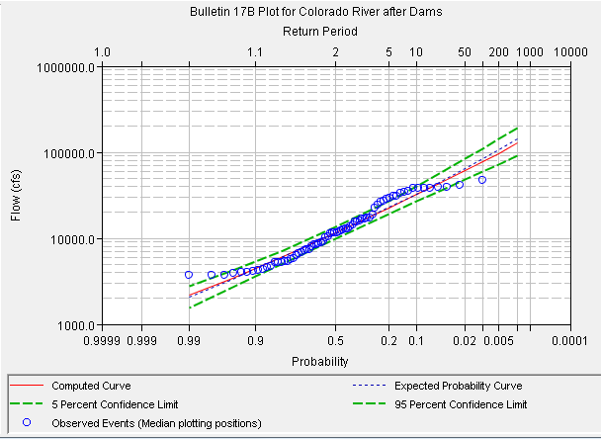
Computed Curve | Expected Probability | Percent Chance Exceedance | Confidence Limits
 |  |  | 0.05 | 0.95
Flow (cfs) |  |  | Flow (cfs)
127,143.80 | 141,741.30 | 0.2 | 193,368.70 | 91,919.20
97,256.90 | 105,519.80 | 0.5 | 142,135.30 | 72,391.40
78,196.30 | 83,293.10 | 1 | 110,703.40 | 59,562.20
61,802.30 | 64,776.30 | 2 | 84,618.60 | 48,218.80
43,684.70 | 44,962.80 | 5 | 57,068.30 | 35,229.80
32,288.30 | 32,873.90 | 10 | 40,624.90 | 26,711.30
22,558.70 | 22,766.80 | 20 | 27,320.90 | 19,111.70
11,619.50 | 11,619.50 | 50 | 13,539.10 | 9,963.90
6,161.40 | 6,111.10 | 80 | 7,277.30 | 5,081.70
4,473.30 | 4,405.10 | 90 | 5,396.30 | 3,566.30
3,454.10 | 3,372.00 | 95 | 4,256.40 | 2,668.10
2,156.70 | 2,054.40 | 99 | 2,779.30 | 1,563.30

Flow |  | Before/After Dams conditions  (%) | Percent Chance Exceedance | Return Period (years)
1900-1940 | 1941-2010
(cfs) | (cfs)
523,817 | 78,196 | 15% | 1 | 100
377,632 | 61,802 | 16% | 2 | 50
267,286 | 47,756 | 18% | 4 | 25
162,454 | 32,288 | 20% | 10 | 10
105,994 | 22,559 | 21% | 20 | 5
51,931 | 11,620 | 22% | 50 | 2

The 100-year flood flow is reduced by:
$$523,817-78,196$$
$$445,621cfs$$

5% Confidence Limit: $110,703cfs$
95% Confidence Limit: $59,562cfs$

2. Repeat the flood frequency analysis for the data from the Colorado River at Austin from 1900 to 1940 in HEC-SSP using a weighted skew in which the regional skew for Austin, Texas is -0.25 with a root mean square error of 0.3025.
 | Using Station Skew |  | Using Weighted Skew
Return Period (years) | 1900-1940 | 1941-2010 | 1900-1940 | 1941-2010
2 | 51,931 | 11,620 | 54,368 | 11,753
10 | 162,454 | 32,288 | 159,862 | 32,077
50 | 377,632 | 61,802 | 329,581 | 59,607
100 | 523,817 | 78,196 | 431,311 | 74,380

#3. 12.1.3 Calculate the probability that a 100-year flood will occur at a given site at least once during the next 5, 10, 50 and 100 years. What is the chance that a 100-year flood will not occur at this site during the next 100 years?
$$P\left(X≥x_{T}\right)=1-{\left(1-\frac{1}{T}\right)}^{N}$$
$$T=100yr$$
$$N=5, 10,50 and 100yr$$

$$N$$ | $$P\left(X≥x_{T}\right)$$
5 | 0.05
10 | 0.10
50 | 0.39
100 | 0.63

What is the chance that a 100-year flood will not occur at this site during the next 100 years?

$$P\left(X<x_{T}\right)=1-P\left(X≥x_{T}\right)$$

$$P\left(X<x_{T}\right)=1-0.63$$

$$P\left(X<x_{T}\right)=0.37$$

#4. 12.5.1 Perform a frequency analysis for the annual maximum discharge of Walnut Creek using the data given in Table 12.5.1, employing the log-Pearson Type III distribution without the U.S. Water Resources Council corrections for skewness and outliers. Compare your results with those given in Table 12.5.2 for the 2-, 5-, 10-, 25-,50- and 100-year events.

- Using Excel
Year | Flow (cfs) | y=log(x) | $${\left(y-\overline{y}\right)}^{2}$$ | $${\left(y-\overline{y}\right)}^{2}$$
1967 | 303 | 2.4814 | 1.3395 | -1.5502
1968 | 5,640 | 3.7513 | 0.0127 | 0.0014
1969 | 1,050 | 3.0212 | 0.3814 | -0.2356
1970 | 6,020 | 3.7796 | 0.0198 | 0.0028
1971 | 3,740 | 3.5729 | 0.0043 | -0.0003
1972 | 4,580 | 3.6609 | 0.0005 | 0.0000
1973 | 5,140 | 3.7110 | 0.0052 | 0.0004
1974 | 10,560 | 4.0237 | 0.1481 | 0.0570
1975 | 12,840 | 4.1086 | 0.2207 | 0.1037
1976 | 5,140 | 3.7110 | 0.0052 | 0.0004
1977 | 2,520 | 3.4014 | 0.0564 | -0.0134
1978 | 1,730 | 3.2380 | 0.1606 | -0.0644
1979 | 12,400 | 4.0934 | 0.2067 | 0.0940
1980 | 3,400 | 3.5315 | 0.0115 | -0.0012
1981 | 14,300 | 4.1553 | 0.2668 | 0.1378
1982 | 9,540 | 3.9795 | 0.1161 | 0.0396
Total |  | 58.2206 | 2.9555 | -1.4280

n= | 16 |  | Sy= | 0.4439
$\overline{y}$= | 3.6388 |  | Cs= | -1.2440

A | B | C | D
Return Period [yr] | Frequency factor ($K_{T}$) | $y_{t}$=log(Qt) | Qt [cfs]
2 | 0.202 | 3.7285 | 5,351
5 | 0.841 | 4.0121 | 10,282
10 | 1.076 | 4.1164 | 13,074
25 | 1.264 | 4.1999 | 15,844
50 | 1.355 | 4.2403 | 17,388
100 | 1.420 | 4.2691 | 18,583

Column B: Interpolating from Table 12.3.1
Column C: $y_{t}=\overline{y}+K_{T}S_{y}$
Column D: $Q_{t}={10}^{y_{t}}$

- Using HEC-SSP

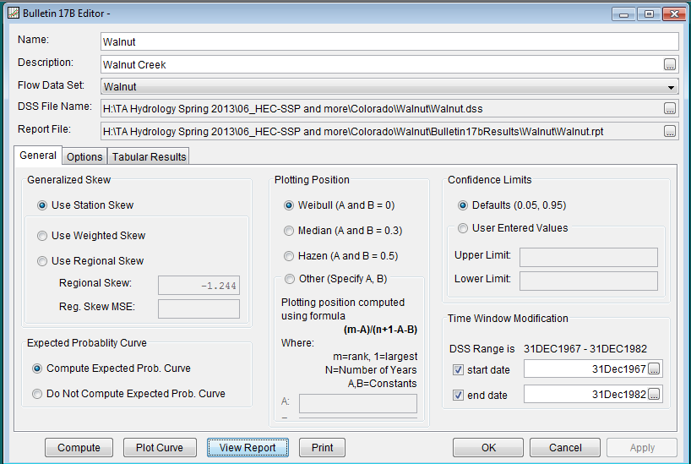
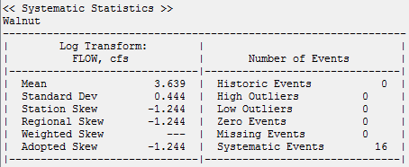
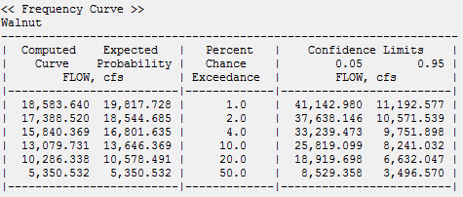

Return Period [yr] | Probability of Exceedance | Qt [cfs]
2 | 0.50 | 5,351
5 | 0.20 | 10,286
10 | 0.10 | 13,080
25 | 0.04 | 15,840
50 | 0.02 | 17,389
100 | 0.01 | 18,584

