CE 374K Hydrology Homework 1 Spring 2013
Question 1
The precipitation and streamflow for a heavy rainfall on January 8-9, 2013, on Shoal Creek at West 12thSt in Austin, Texas, are shown below. Calculate the time distribution of storage on the watershed assuming that the initial storage is 0. Compute the total depth of precipitation and the equivalent depth of streamflow which occurred during the period of the data given. How much storage (inches) remained in the watershed at the end of the period? What percent of the precipitation appeared as streamflow during this period? What was the maximum storage (inches)? Plot the time distribution of incremental precipitation, streamflow, change in storage, and cumulative storage. The watershed area is 12.3 mi².
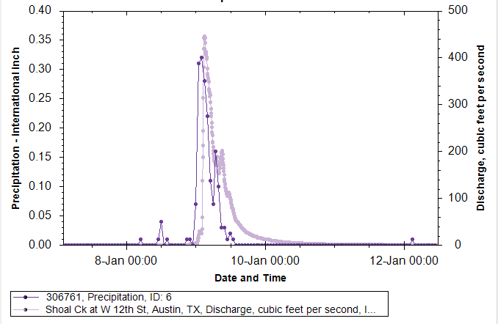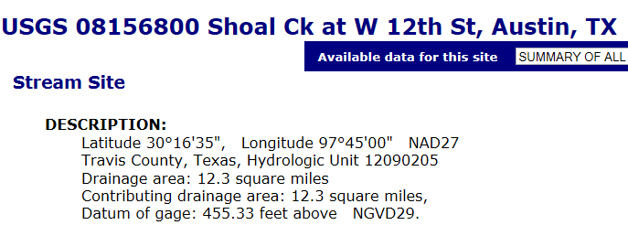
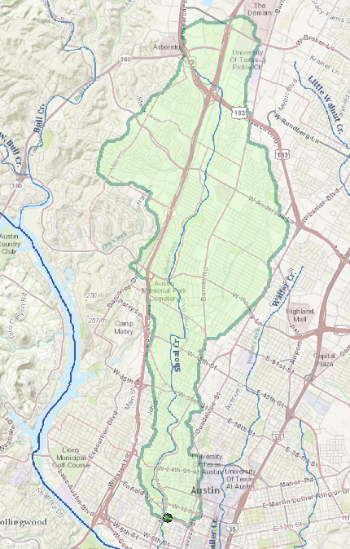
Watershed of Shoal Creek at West 12th St in Austin, Texas
LocalDateTime | Precipitation (inches) | Discharge (cfs)
1/8/2013 22:00 | 0.01 | 1.7
1/8/2013 23:00 | 0 | 3.4
1/9/2013 0:00 | 0.07 | 3.9
1/9/2013 1:00 | 0.31 | 22
1/9/2013 2:00 | 0.32 | 25
1/9/2013 3:00 | 0.28 | 439
1/9/2013 4:00 | 0.22 | 376
1/9/2013 5:00 | 0.11 | 320
1/9/2013 6:00 | 0.07 | 210
1/9/2013 7:00 | 0.16 | 181
1/9/2013 8:00 | 0.1 | 157
1/9/2013 9:00 | 0.03 | 199
1/9/2013 10:00 | 0.03 | 136
1/9/2013 11:00 | 0.01 | 105
1/9/2013 12:00 | 0.02 | 99
1/9/2013 13:00 | 0.01 | 76
1/9/2013 14:00 | 0 | 52
1/9/2013 15:00 | 0 | 45
1/9/2013 16:00 | 0 | 36
1/9/2013 17:00 | 0 | 31
1/9/2013 18:00 | 0 | 27
1/9/2013 19:00 | 0 | 23
1/9/2013 20:00 | 0 | 20
1/9/2013 21:00 | 0 | 18
1/9/2013 22:00 | 0 | 16
1/9/2013 23:00 | 0 | 14
1/10/2013 0:00 | 0 | 12
1/10/2013 1:00 | 0 | 12
1/10/2013 2:00 | 0 | 11
1/10/2013 3:00 | 0 | 9.6
1/10/2013 4:00 | 0 | 8.6
1/10/2013 5:00 | 0 | 7.7
1/10/2013 6:00 | 0 | 6.9
1/10/2013 7:00 | 0 | 6.2
1/10/2013 8:00 | 0 | 5.7
1/10/2013 9:00 | 0 | 5.3
1/10/2013 10:00 | 0 | 4.6
1/10/2013 11:00 | 0 | 4.6
1/10/2013 12:00 | 0 | 4.1

Question 2
Calculate the velocity and flow rate of a uniform flow 4 ft deep in a 200-ft-wide stream with approximately rectangular cross section, bed slope 1 percent, and Manning’s $n$ of 0.045. Check that the criterion for fully turbulent flow is satisfied.
Question 3.
Compute the flow of water (m³/s) through a 20m long conduit filled with fine sand with hydraulic conductivity of 0.01 cm/sec under a piezometric head difference of 0.2m between the ends of the conduit. The cross-sectional area of the conduit is 5.0 m².
Question 4.
The incoming radiation to a lake is 100 W/m². Compute the net radiation if the albedo is α = 0.06, the surface temperature is 20°C and the emissivity is 0.97.

