Adding Reservoirs and Reaches to the HEC-HMS Model
By David R. Maidment
CE 374K Hydrology
University of Texas at Austin
March 2012
Starting with the Subbasin element from the previous exercise, lets continue our construction of an HEC-HMS model.
Adding a Reach Element
Click on the Reach Creation Tool 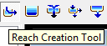 and on the basin model screen, drag a line between two points and create a new Reach element.

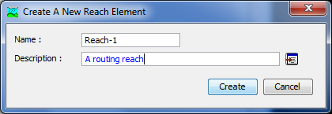
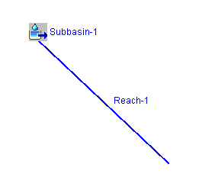
Now, let’s give the reach some parameters using the Muskingum-Cunge method:
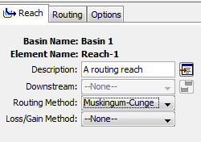
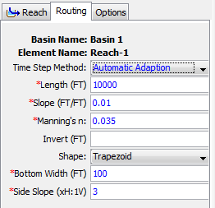
Let’s connect the Subbasin element to the Reach element downstream of it:
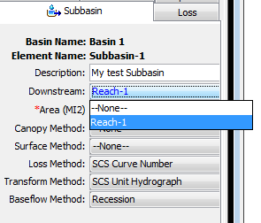
And let’s repeat the run we made before with the routing reach included.
And here is the computed result
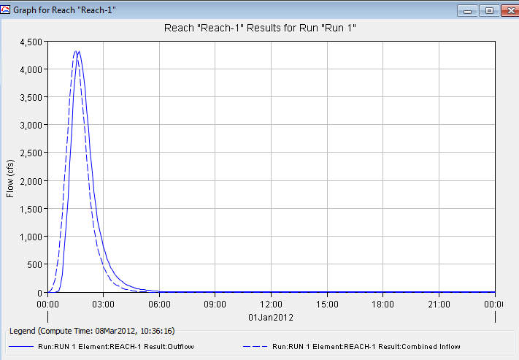
Adding a Reservoir Element
create a new Paired Data table
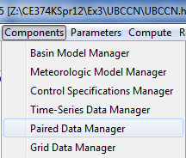
And I’ll call this the Dam-7, Storage-Discharge Function table
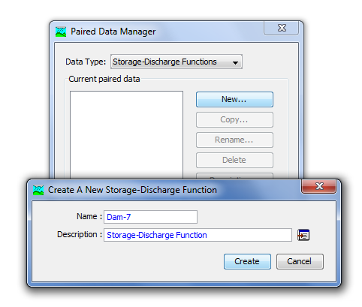
I will enter the data manually as the only other option is HEC-DSS and we don’t have the data stored there yet.
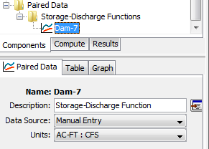
The data to be entered for Dam 7 were obtained from the Upper Brushy Creek Water Control and Improvement District, as follows:
Elevation | Storage | Total Discharge
805.00 | 0.0 | 0.0
807.00 | 109.2 | 94.6
809.00 | 238.1 | 98.9
811.00 | 385.6 | 102.8
813.00 | 561.8 | 106.6
815.00 | 772.8 | 110.3
817.00 | 1031.5 | 113.8
819.00 | 1307.0 | 117.2
821.00 | 1608.4 | 120.6
823.00 | 1967.2 | 123.8
825.00 | 2353.0 | 127.0
827.00 | 2775.9 | 130.1
829.00 | 3243.9 | 133.1
829.75 | 3430.9 | 387.2
830.50 | 3631.0 | 922.3
831.85 | 4002.9 | 2486.8
833.50 | 4501.4 | 5186.0
836.50 | 5510.8 | 14100.1
840.25 | 7008.9 | 81641.5
844.00 | 8692.7 | 201496.5

The resulting table appears as:
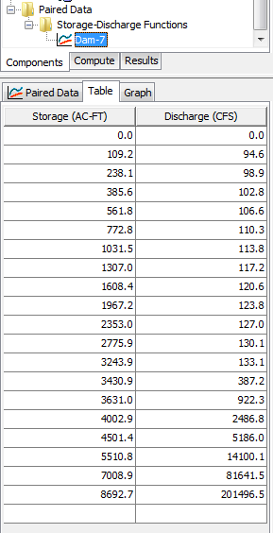
and the graph of the storage-discharge function is:
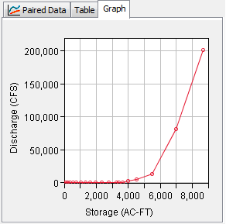
Now, we’ll create a new Reservoir element
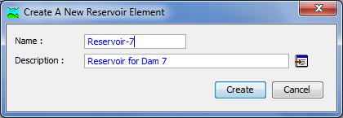
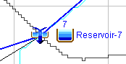
The options for Reservoir-7 are edited as shown below. The “Outflow Curve” method means that the relationship between storage and outflow is defined by a function, in this case, the Paired Data table just defined for Dam 7.

