Exercise 2 Solution
GIS in Water Resources
Fall 2012
Prepared by Gonzalo E. Espinoza
- A screen capture of the San Marcos basin with its HUC-10 and HUC-12 watersheds and subwatersheds.
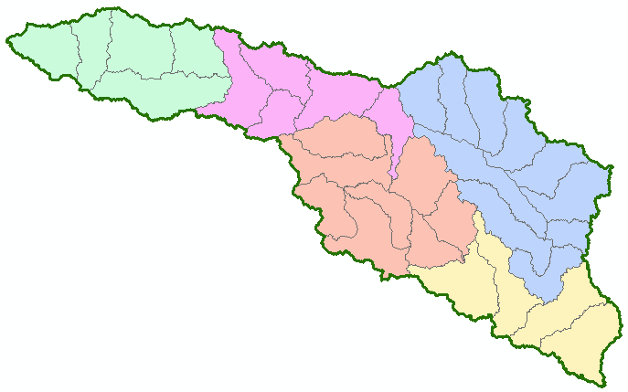
- What is the average available water storage (cm) in the San Marcos basin? If the area of the basin is 3520 square kilometers, what volume of water (km³) could potentially be stored in the top 1m of soil in the San Marcos basin if the soil were fully saturated with water?
Average Available Water Storage $=12.59cm$
Potential Storage:
$$V=A×h$$
$$V=\left(3,520\right)\left(12.59×{10}^{-5}\right)$$
$$V=0.44 km^{3}$$

- How many HUC12 subwatersheds are there in the San Marcos Basin? What is their average area in acres and in km²? What is the total area of this basin in km²? What is the ratio of the length of the streamlines to the area of the HUC12 subwatersheds (called the drainage density) in km⁻¹?
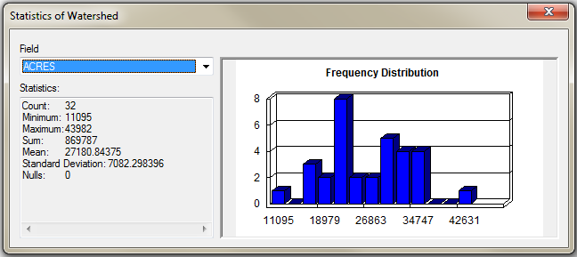
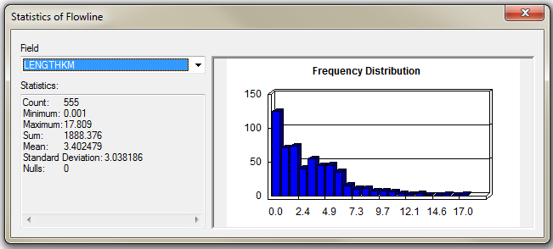
There are $32$HUC12 subwatersheds in the San Marcos Basin.
The average area is $27,181 acres$ or $\left(27,181×= 0.0040469 \right)=110km^{2}$
The total area of the basin is $\left(869,787×= 0.0040469 \right)=3,520km^{2}$
The drainage density is ${1,888}/{3,520=0.54 km^{-1}}$

- To be turned in: A map (a screen capture is ok) of the San Marcos Basin and streams. Add labels to show the San Marcos River, the Blanco River and Plum Creek.
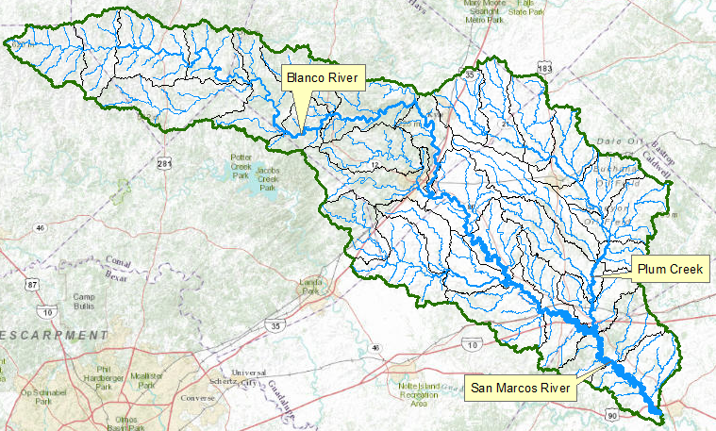

- A map showing the labeled streams and streamgages for the San Marcos Basin
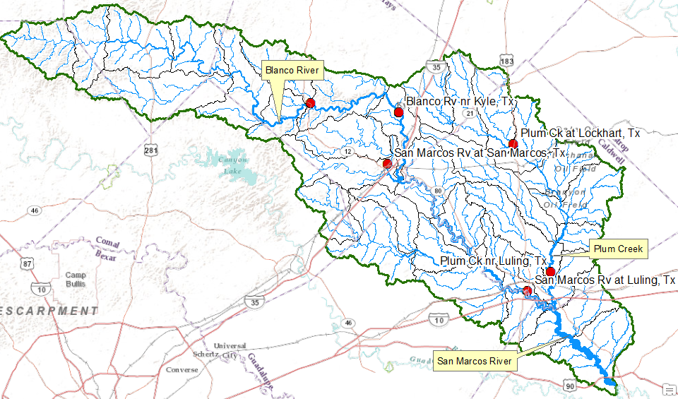

- A map showing the Edwards aquifer and the San Marcos basin
