Significant Digits
Prepared by David Maidment and David Tarboton
GIS in Water Resources, Fall 2011
In ArcGIS, the default number of significant digits for display of floating point numbers is six. Hence, when a floating point number is displayed in a map or legend, it appears that way:
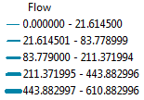
Or in the attribute table:
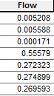
To change, this, open the Layer Properties in ArcMap and select the Fields tab. Select the attribute you want to change and the following image will appear:
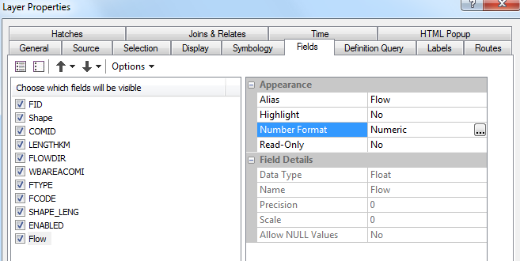
In this instance, the variable is Flow. Click on Number Format and you’ll see Numeric and an ellipsis box appear. Click on the ellipsis box, and you’ll see the number format with 6 decimal places.
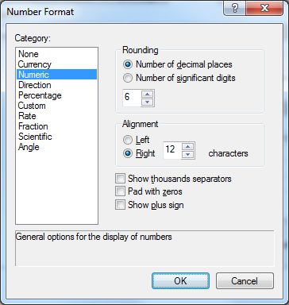

Reduce this number to a lesser number of decimal places, say 2 in this instance.
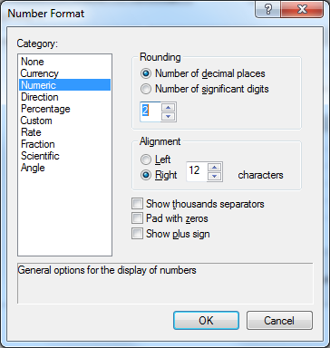
Now, when you open the attribute table, you see:
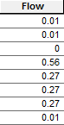
And if you resymbolize the map, the Range is defined in terms of the reduced number of decimal places.
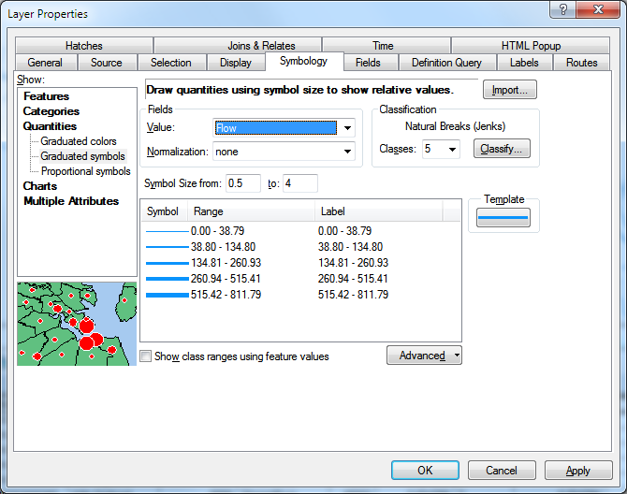
You can also click on the Label header and select Format Labels to adjust the label formats independent of the precision shown in the tables
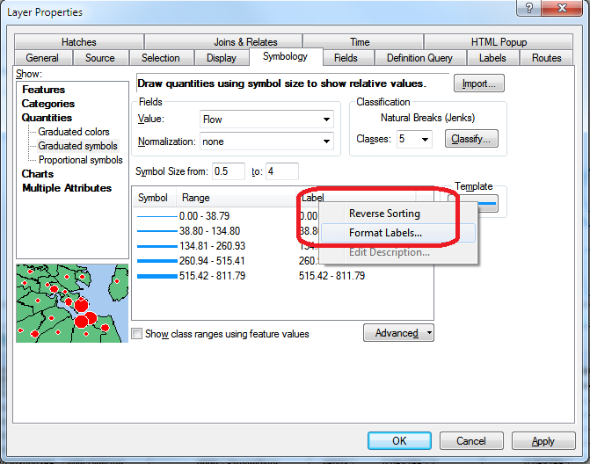
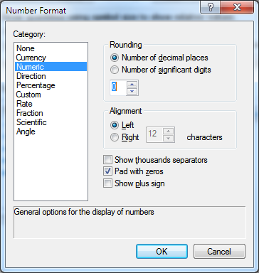
However the result may not always be what you want. For example below the Labels go to 0-39, 40-135, while the break is at 38.8, so 39 is really in the second group. Also you are left wondering where in the range numbers like 39.5 go.
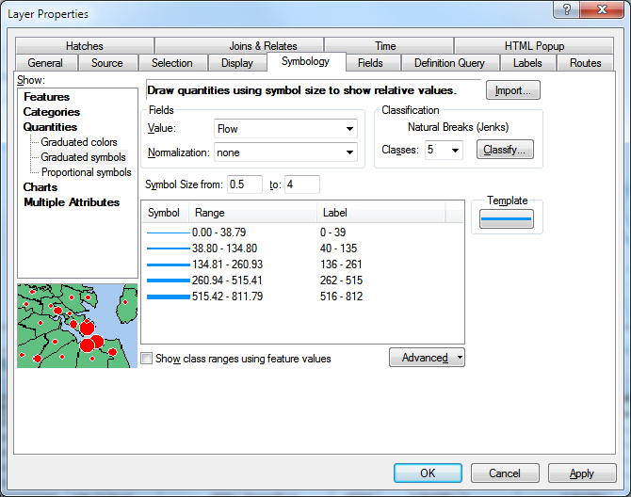
You can also manually edit the Label fields to make them say what you want, and even include text if you like. For example
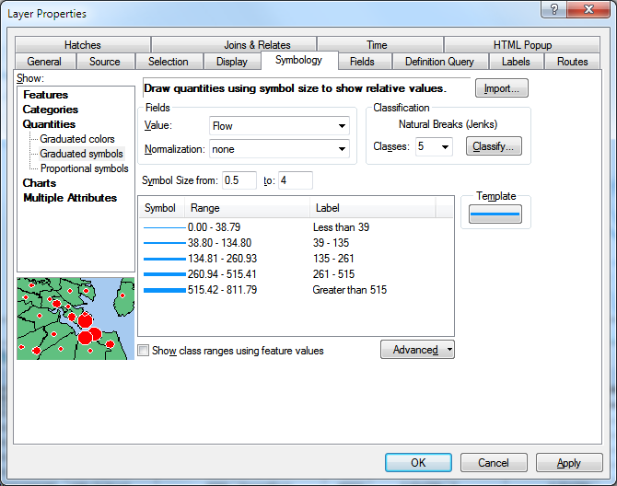

And then the Symbology is changed accordingly.
