Solution to NFIE-Geo Exercise
(1) Prepare a nice map showing the Travis County NFIE-Geo database.
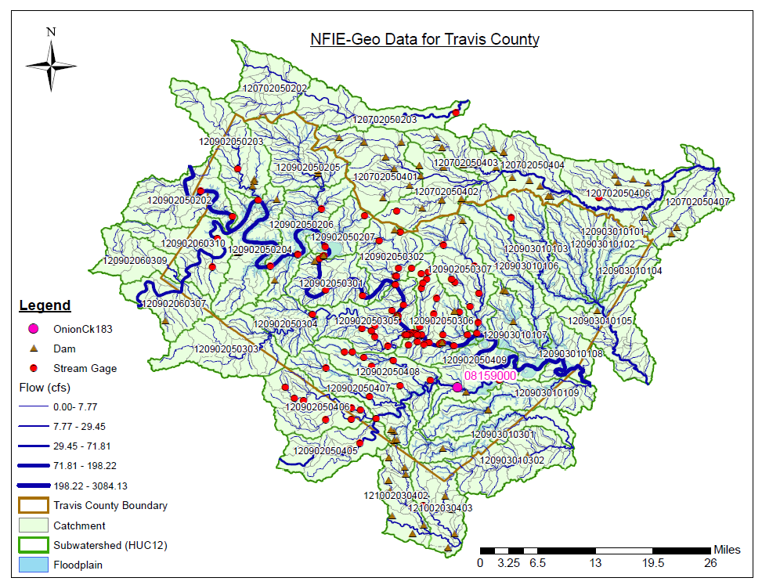
Map prepared by Cyndi Castro.
(2) How many Subwatersheds are in this database? 42
How many Catchments? 911
How many Flowlines? 917
How many catchments are there in a Subwatershed, on average? Average = 911/42 = 21.69, or 22 approximately.
(3) What is the average area (km²) of the Subwatersheds and of the Catchments? The map units are in feet so you’ll need to do some conversions here.
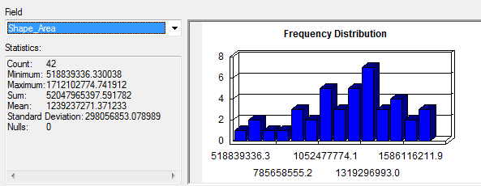
For the subwatersheds, the average area = 1,239,237,271 ft², and converting this to km² using 1 km² = 1.06739 x 10⁷ ft², the average area of the subwatersheds = 116.10 km².
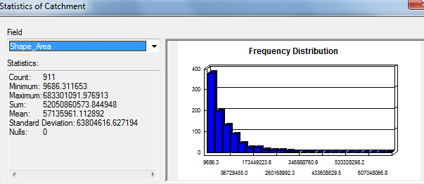
For the Catchments, the average area = 57,135,961 ft², and converting this to km² using 1 km² = 1.06739 x 10⁷ ft², the average area of the Catchments = 5.35 km².
(4) What is the average length of the MFlowlines (km)?
The LengthGeo attribute is the length of the flowlines in km as determined from the original NHDPlus dataset, and the following statistics table shows that the average value is 3.1 km. Another way to do this is from the shape_length attribute, which shows that the average length is 10158 ft, and converting this to km using 1 km = 3280.84 ft, the resulting average length is 3.1km, which is the same result as before.
