### Introduction to HEC-HMS on Waller Creek

#### CE 374K Surface Water Hydrology University of Texas at Austin - Spring, 2011

**Prepared by** **David R. Maidment and Gonzalo Espinoza**

### Table of Contents

* Goal of the Exercise
* Obtaining the Program and the Data
* Procedure
  + 1. Importing a Basin Model
  + 2. Editing a Basin Model
  + 3. Creating a Meteorologic Model
  + 4. Defining the Control Specifications
  + 5. Executing an HEC-HMS Model
  + 6. Viewing HMS Results
* Waller Creek diversion tunnel design discharge

### Goal of the Exercise

The intent of this exercise is to introduce you to the structure and some of the functions of the HEC-Hydrologic Modeling System (HEC-HMS), by simulating the runoff hydrographs resulting from a design storm on Waller Creek in Austin, Texas.

### Obtaining the Program and the Data

The HEC-HMS Version 3.5 program can be obtained from the Hydrologic Engineering Center at <http://www.hec.usace.army.mil/software/hec-hms/> A user's manual is also available at this location.  The program is loaded on computers in the LRC room ECJ 3.302. You may choose to do this homework on your own computer or in the LRC.

Here is a map of Waller Creek so you can see its relation to the University of Texas campus and to Cockrell Hall.

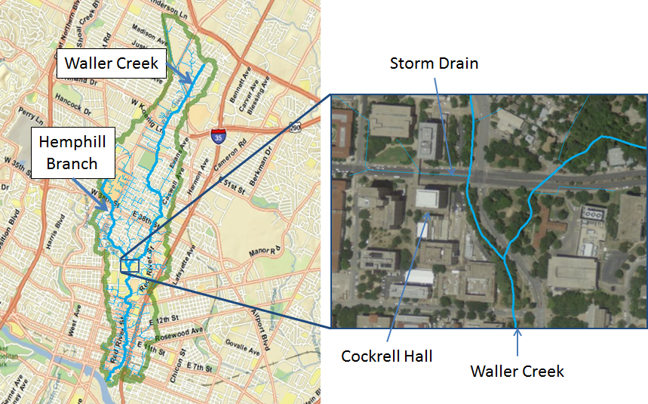

To run the HEC-HMS model for Waller Creek, a basin file is needed to specify the physical parameters of the watershed, and a map file to give the outline of the drainage areas and creeks.  These files can be downloaded from here <waller.zip> as a zip file.  Make a working directory on your computer and extract these files (**Waller_Ck.basin** and **hms.map**) into it.



### Procedure

You may start the HMS by clicking on the HEC-HMS icon

**Start/All Programs/HEC/HEC-HMS**

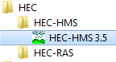

If you are using HEC-HMS on your own computer for the first time, you’ll have to agree to some conditions of use of the program. You have to scroll down through these conditions before you will be able to Accept them.

Once HEC-HMS opens, you’ll see the following screen:

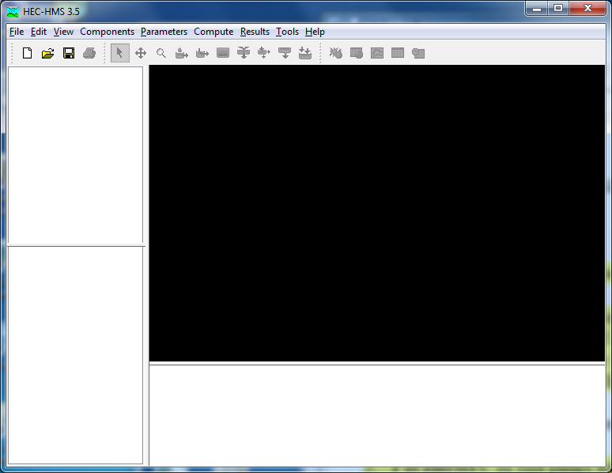

### 1. Importing a Basin Model

The first of the **Components** we will consider is the **Basin Model**. To create a hydrologic model of Waller Creek, we need to import the basin file that you just downloaded.  In HMS Project Window, use **File/New** to open a new project by entering the following data

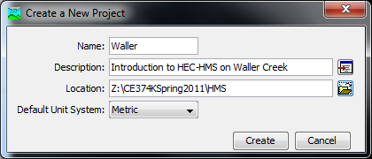

A **Project** in HMS refers to all of the data sets associated with a particular model. The **Description** bar underneath the **Project** name allows you to type a detailed name for the actual short **Project** name.

Notice that after creating the new project, a new folder called “waller” is created inside the location chosen, and the **Main Window** appears as:

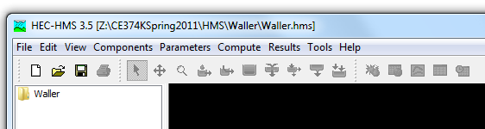

In the HMS Main Window, use **File/Import/Basin Model…** to import the basin model file **Waller_Ck.basin** from your working directory.

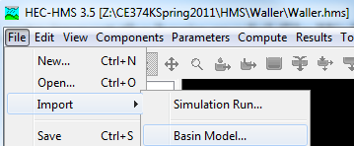

You'll see in the waller folder a **subfolder** called **Basin Models** in the **Data Panel** on the left hand side of the HMS model display, expand it and **select Waller_Ck**, the Basin window open up and some icons appear.

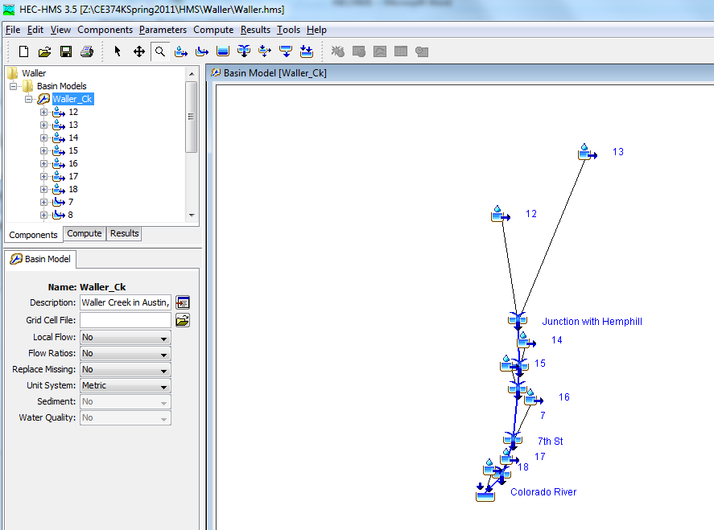

**Right click** in an empty area of the **Basin Model Window**, select **Background Layers**

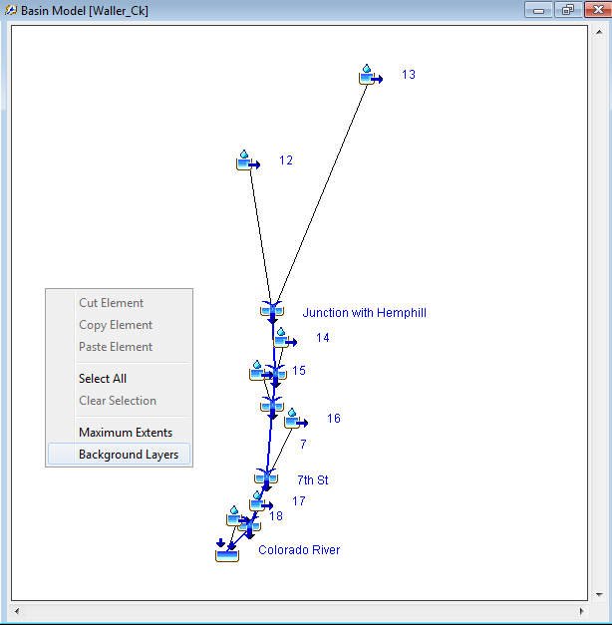

A new window will appear, click **Add...** change the *Files of type* option to **HMS Map File (*.map)** and select **Hms.map** from your working directory.

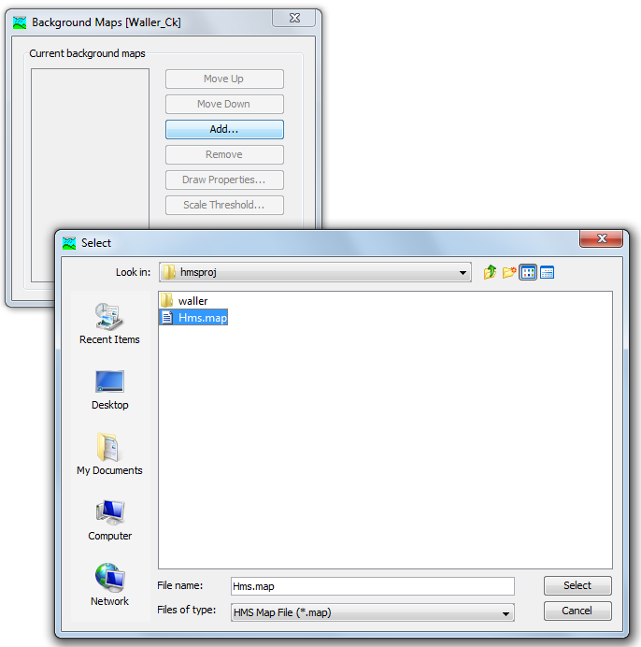

You should then see a schematic of Waller Creek showing the watershed and stream map and an overlay of the hydrologic elements in the **Basin Model Panel**

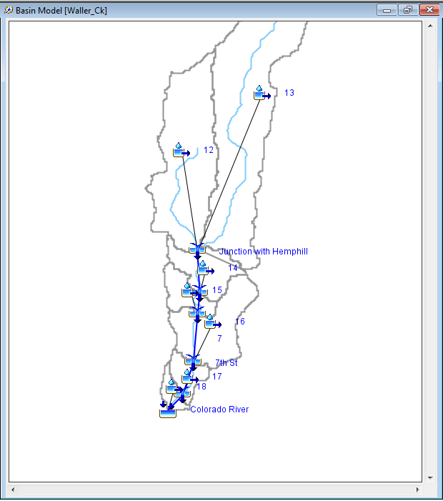

In the HMS menu there are displayed the seven hydrologic elements contained in HEC-HMS.

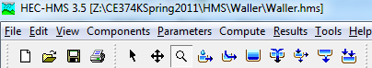

They are:

 **Subbasin** - rainfall-runoff computation on a watershed

 **River reach** - routing of flows from one end of a reach to the other

 **Reservoir** - routing of flows through a level-pool reservoir

 **Junction** - combination of flows from upstream reachs and subbasins

 **Diversion** - abstraction of flow from the stream

 **Source** - inflow of water from a stream crossing the boundary of the modeled region

 **Sink** - outflow of water in a stream crossing the boundary of the modeled region (basin outlet)

The model of Waller Creek shown above contains only 4 of these kinds of elements.  There are 18 hydrologic elements in the Waller Creek model, made up of 7 subbasins, 5 river reaches, 5 junctions, and 1 sink at the point where Waller Creek flows into the Colorado River.  Notice that when a stream flows through a watershed, the additional local runoff from the drainage area around the stream is not accounted for until the downstream end of the reach where its flow is combined at a junction with the flow coming from the upstream reach.  The junctions have been located at points where roads cross Waller Creek.

### 2. Editing a Basin Model

After first making sure that the  is depressed over the **Top Menu**, click on the icon which represents basin 12 in the **Basin Model** with the left mouse button (you also can select these basin under Waller_Ck in the **Data Panel**), as shown in the following figure.

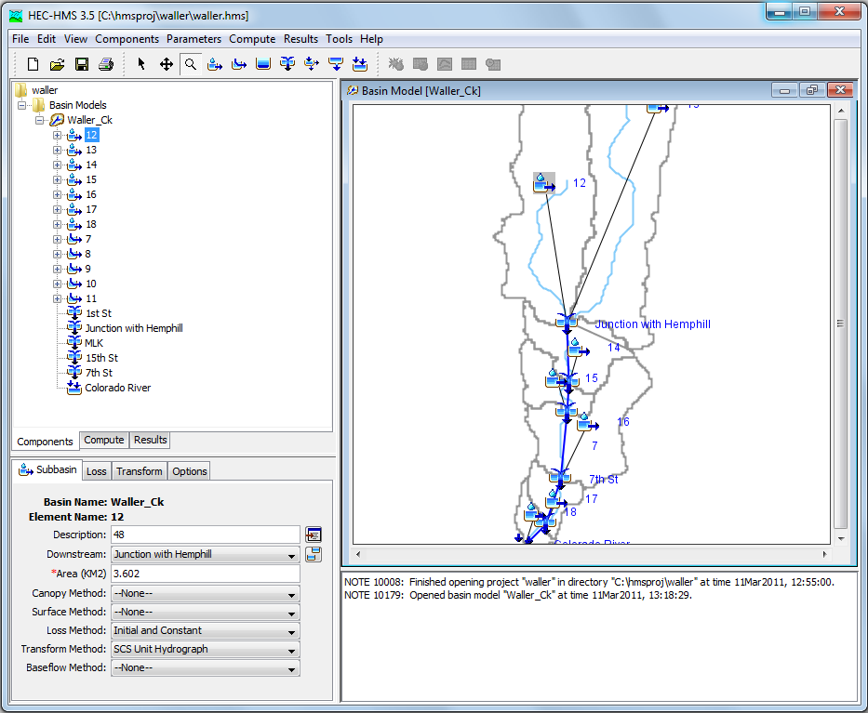

After this icon is highlighted, the **Parameters panel** show the information related to this Sub-basin. In the first tab (**Sub-basin Tab**) you will find the the area of sub-basin 12 (3.602 sq. km). Make a note of this value. Go ahead and look up the areas of the other sub-basins as well. HMS can work with a Basin file in either SI or English units.  In this case, the file is in SI units.

*To be turned in: a table showing the areas of the subbasins.  What is the total drainage area of Waller Creek (sq. km)?*

Returning to the HMS, focus your attention on the icons over the **Top Menu**. The  button allows you to select (highlight) items in the model. You may also use the  button to drag-and-drop hydrologic elements from the left-hand-side of the window or to move individual elements within the model. If you have a model element highlighted, you can view its properties in the **Parameters Panel** on the lower left hand side of the display. The  button allows you to move (or pan) the entire model display by holding down the left mouse button and moving the mouse. If you wish to zoom in or out, you may do so by depressing the  button, left click and hold to select a rectangle area in Basin Model to zoom in, to zoom out just right click in the window. Go ahead and experiment with these buttons to understand better how each works. I had some trouble making the Pan tool to work.

In the Top Menu under View we have the following options checked:

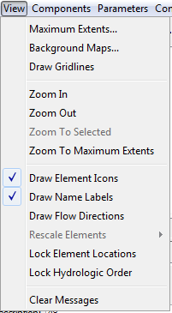

Click in **Draw Flow Direction** to check this option too, now the reaches will show the flow direction with the symbol . If you Uncheck the **Draw Element Icons** you will see only the text name of the hydrologic elements, in the next figure you can see this, in the left side the Draw Elements Icons is checked and in the right side is unchecked

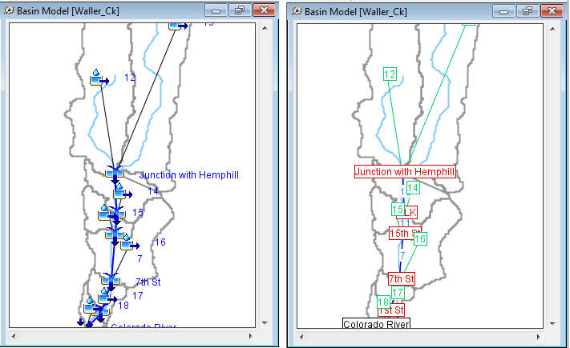.

As needed, you may **create** new hydrologic elements in the model area, to do this just click in one of the icons  and then click in an **empty space** in the **Basin Model Panel** (after doing this the program will ask for a name and description for the new element, give those and press create). Go ahead and try this, but make sure you keep the elements you add away from the elements currently in the model. Try taking a river reach and connecting a junction to each end. To do this, create one  and two  junctions. Hook up one end of the river reach to one junction by drag-and-drop the river reach end to the junction (use ). If you do it correctly drag-and-drop the junction in another part of the map and the river reach end will follow the movement to the new place because they are hooked. Repeat these steps appropriately to connect the stream to the other junction. To delete the elements you have added when you are finished, highlight all added elements (hold down the shift key to keep adding elements) and then right click in one of them and choose **Delete Elements**. If you want, take some time now to experiment with some of the other hydrologic elements.

As the calculation steps above suggest, the primary function of a surface-water model such as the HMS involves three sets of calculations--quantifying rainfall losses into the soil, converting excess rainfall to runoff, and routing. As part of creating a HMS model, the selection of the processes to be used for each calculation set is made in the **Parameters Option** in the **Top Menu.**

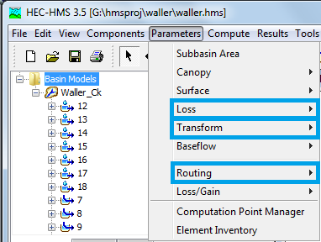

First **Select Parameters/Loss/Initial and Constant**, the **Initial and Constant** method is the only option available because is the method selected (if we want to change the method we can do it selecting Change Method… at the end of the list, and select one of the others methods listed)

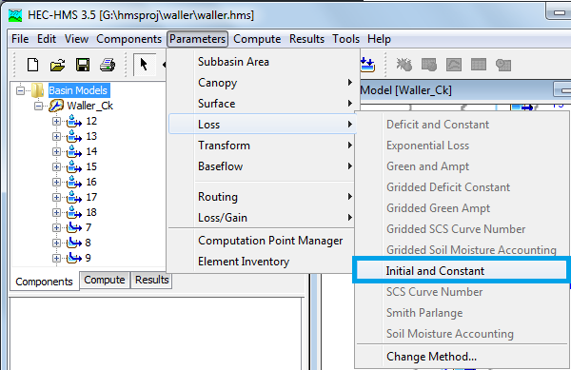

The following window should appear in the place of the **Basin Model Panel**.

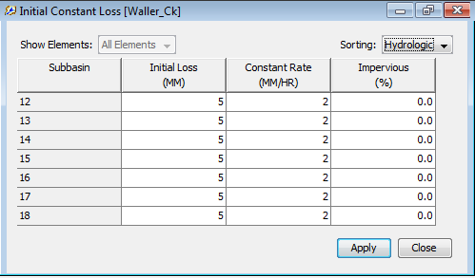

Note that the **Initial/Constant Loss Rate** parameters are entered is in this table. Each basin requires an **initial loss** quantity, a **constant loss rate**, and a **percent** **imperviousness**.   These values have been selected arbitrarily.  If the % impervious value differs from 0, that % of the land area is assumed to have no losses and the loss method is applied only to the remainder of the drainage area

After you have looked over the data, click **Close**. For future reference, while both **Close** and **Apply** transfer the data to the computer's short-term memory, they differ only in that **Close** closes the window while **Apply** keeps the window open.

Once you have closed the **Initial/Constant Loss** window, choose **Parameters/Transform/SCS**:

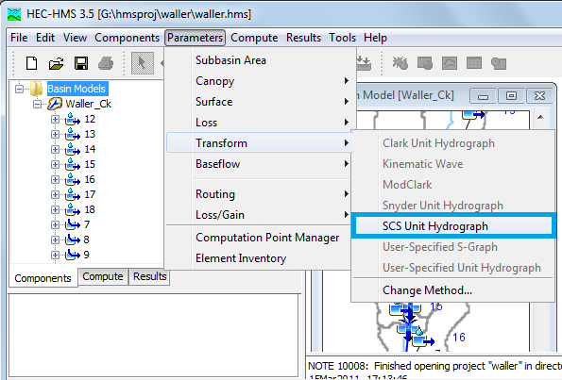

Similar to Parameters/Loss, in this section the only option available is SCS Unit hydrograph method (also if we want to change the method we can do it selecting Change Method… at the end of the list, and select one of the others methods listed), click in SCS Unit Hydrograph will display the following window.

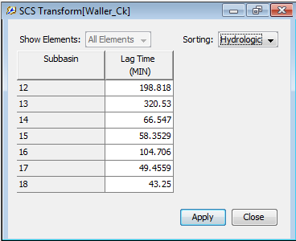

Note that the SCS unit hydrograph method requires only one parameter for each sub-basin--lag time between rainfall and runoff in the subbasin. HMS. At this point, go ahead and close this window.

The next step involves entering the parameters for the routing process. From **Parameters/** **Reach** / **Muskingum**.

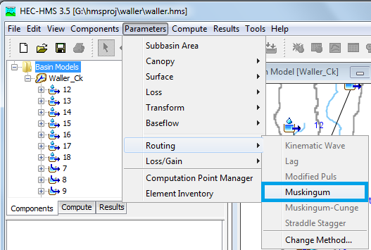

This should cause the following image to appear.  This simulation routes the water through the reaches by the Muskingum method in which K is the travel time of a flood wave passing through the reach, X is a measure of the degree of storage (X = 0 means a level-pool reservoir or maximum storage, X = 0.5 means a pure transmission reach in which there are no storage effects, and X ranges between 0 and 0.5).  The reach is divided into a number of subreaches if necessary to keep the computations numerically stable.

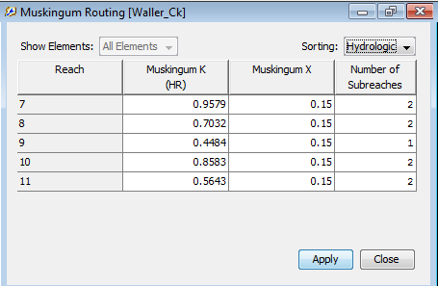

You do not have to go through the **Parameters menu** to edit element properties. Editing may also be accomplished by highlighting an element, and changing the options in the **Parameters Panel**.

In the **Parameters/Baseflow** option of the HMS, you supply if necessary, information such as **basin areas** and initial **base flows** in the system. In this model we are not allowing for any base flow

***To be turned in:*** *Select subwatershed 14 and reach 10 and describe in words what the parameter values are that are used to characterize these hydrologic features.*

**3. Creating a Precipitation Model**

Having established the physical aspects of the model, we will now address the rainfall data.  From a statistical study of extreme storm rainfall data recorded at gages, tables and maps have been prepared for the whole US which specify the storm precipitation depth to be expected as a function of the return period of the event and the duration of the rainfall.  A table of such values is shown below for Travis County, in which the City of Austin is located.  For example, for a 10 year return period event, we expect that in 15 min 1.47" of rainfall will fall, in 30 min 1.98", and so on, up to 4.81” in 12 hours) and 6.10” in 1 day.  These precipitation depths are the values which would be equaled or exceeded on average once in 10 years when considering a very long period of data.  As rainfall duration increases, the cumulative depth of rainfall increases but the average intensity over the duration decreases because severe rainfall cannot be sustained for very long. These data were taken from the City of Austin Drainage Criteria Manual:  
<http://www.amlegal.com/austin_nxt2/gateway.dll?f=templates&fn=default.htm&vid=amlegal:austin_drainage>

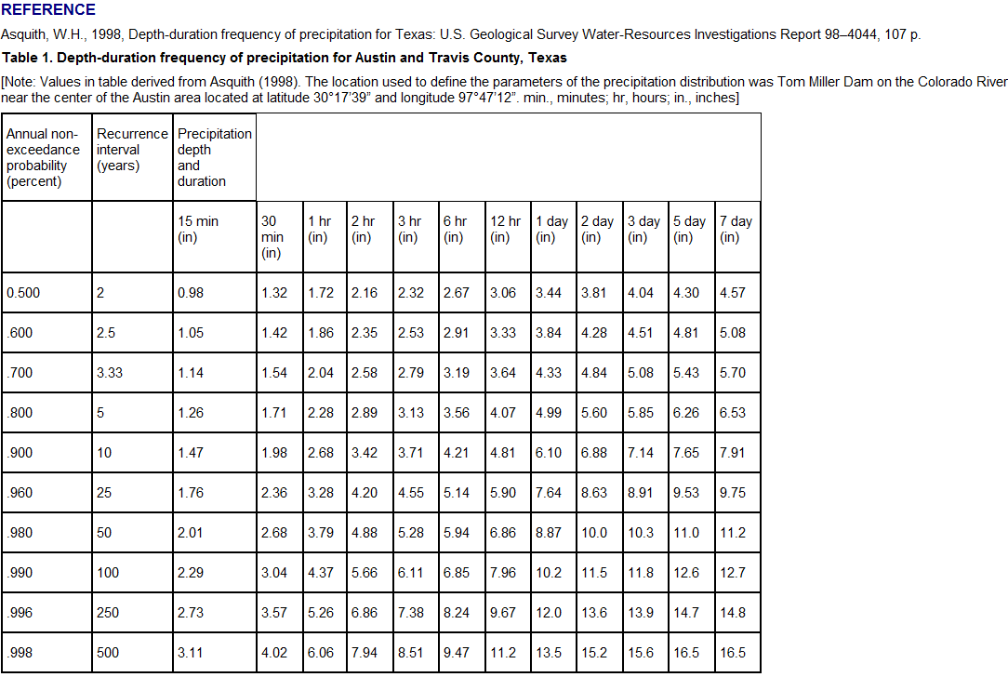

We are going to input the rainfall to HM. To create a design precipitation input file, go to the Project Window and select **Component/ Meteorologic Model Manager/New**.  A window like this appears in which you can describe the precipitation file you intend to create, in this case for a 10 year storm.

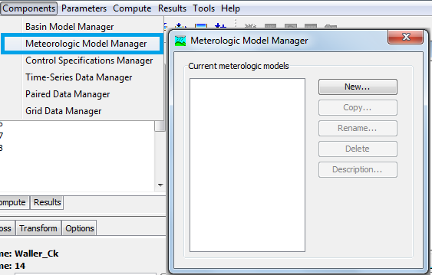

Write **Precip 1** as **name** and **10 year design storm** in **description**, then click **create**.

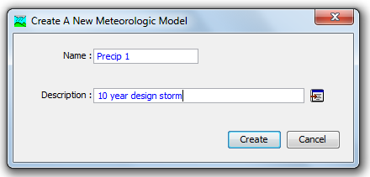

After clicking, create, close the Meteorologic Model Manager; in the Main Window, the **Data Panel** will display a **Metereologic Models Folder** which contains the **Precip 1** model created in the previous step, **select** this Model.

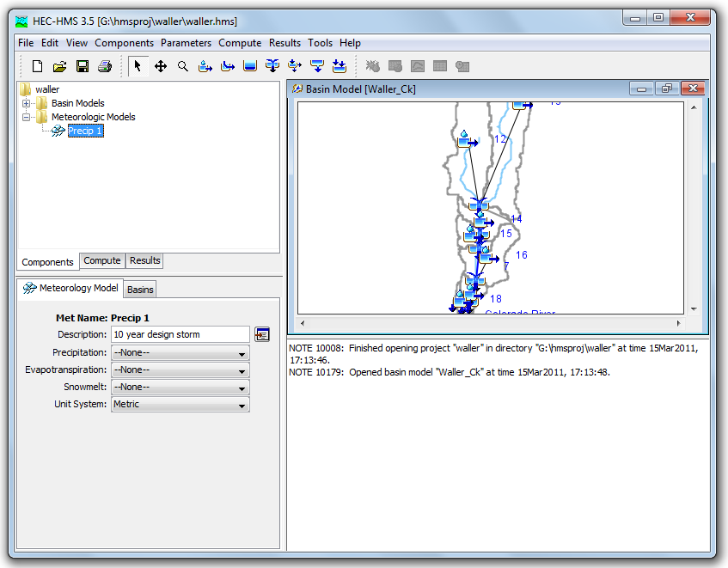

In the **Precipitation** combo box select **Frequency Storm**

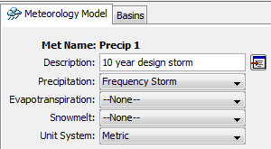

Select Basins tab and for the **Waller_Ck** Basin Model change the **Include Subbasins** options to **yes**.

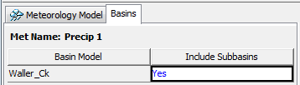

In the **Data Panel**, expand the options for **Precip 1** and select **Frequency Storm**

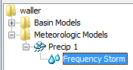

Now, in the **Parameters panel** fill in the values shown from the table above for a 10 year storm (10% chance of being equaled or exceeded in any year), as **input type** select **Annual Duration**, for **Intensity Duration** select 15 minutes, for **Storm Duration** select **1 Day** don’t forget to use the **correct precipitation units**! (The program will ask you for millimeters). Here are the data for the 10 year return period storm:

|  |  |  |  |  |  |  |  |  |
| --- | --- | --- | --- | --- | --- | --- | --- | --- |
| Duration | 15min | 30min | 1 hr | 2 hr | 3 hr | 6 hr | 12 hr | 1 day |
| Depth (inches) | 1.47 | 1.98 | 2.68 | 3.42 | 3.71 | 4.21 | 4.81 | 6.10 |
| Depth (mm) | 37.3 | 50.3 | 68.1 | 86.9 | 94.2 | 106.9 | 122.2 | 154.9 |

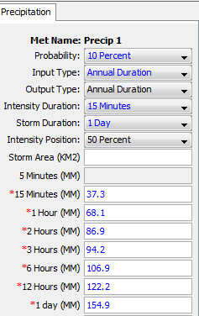

For each project, the HMS then creates an output Data Storage System DSS file which stores calculated data from all runs for a given project so that results from a previous run can be directly compared to results from a more current run.

***To be turned in:*** *a screen capture of the design precipitation input file*

**4. Defining the Control Specifications**

The final piece of the model setup involves establishing the model's time limits. Go back to the **Top Menu** and select **Parameters/Control Specifications Manager/New**.

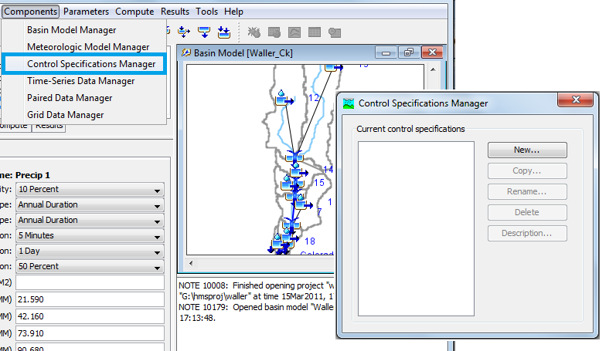

The following window will appear in which you can label the name and description.

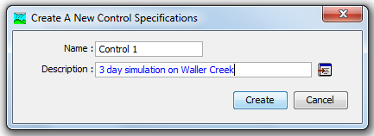

Click Create and close the Control Specifications Manager, in the **Data Panel**, expand the options for **Control Specifications** and select **Control 1**

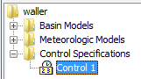

In the **Parameter Panel**, specify the duration of the simulation in date and time, and also the time interval of the calculations (10 minutes).  In this case, the duration is arbitrary, long enough to depict the runoff from a 1-day storm, but the 10 minute time interval is part of the Basin file model setup and should remain fixed for this Waller Creek model.

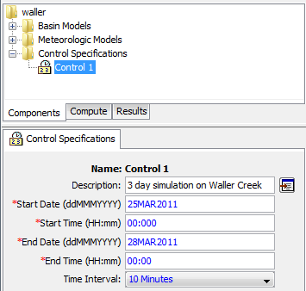

***To be turned in****: how many time intervals of computation will be performed?*

### 5. Executing an HMS Model

Finally, you have finished perusing the data involved in creating the Tenkiller model. In the **Top Menu** select **Compute/Create Simulation Run**.

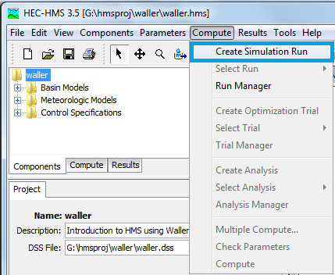

In the following four steps the simulation will be created, in the first step specify the Name of the Simulation **10 years Waller Creek** and **click next >**

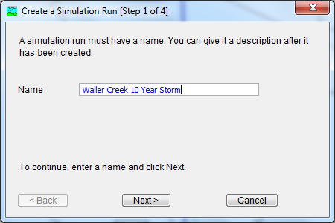

In the second step we select the Basin Model **Waller_Ck** (the only one that we have) and **click next >**

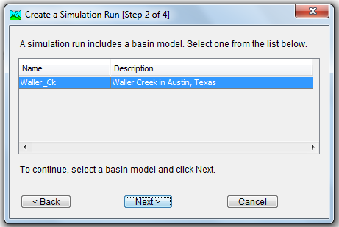

The third step corresponds to the **Meteorological model**, select **Precip 1** and press **next >**

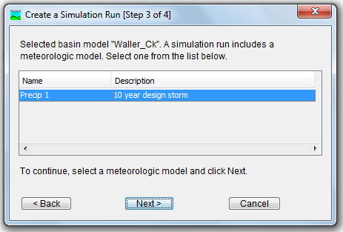

Finally, in the fourth step we select the **Control 1** of the **Control Specifications** and click **finish.**

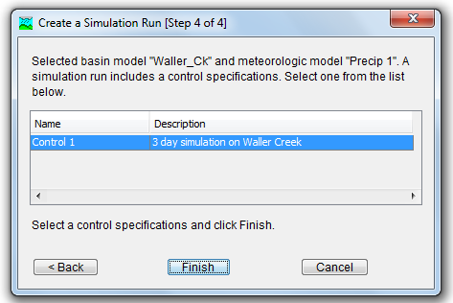

After completing the previous steps, the simulation is created (although we need to run it), you can see it in the **Data Panel**, in the **Compute tab**

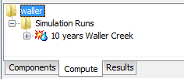

In the **Main Window**, select **Compute/Select Run** and you will see that **10 years Waller Creek** is checked; in the case of multiple simulations runs it is important to check (select) the one that we want.

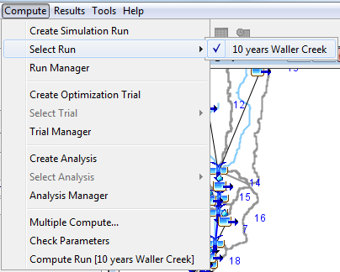

To run the model, go the **Top Menu** and **Compute/Compute Run [Waller Creek 10 Year Storm]**

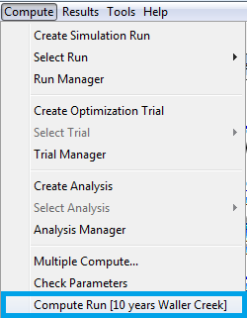

You should get a window that says the following:

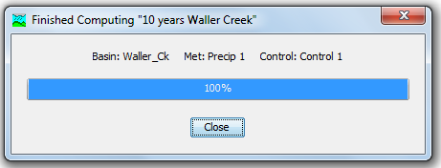

If you want to make runs with alternative model files, you

Create different simulations runs in the **Top Menu** select **Compute/Create Simulation Run** (and follow the four steps described previously), check the simulation in **Compute/Select Run** and **Compute/Compute Run [*Name of the new simulation*]**, the HMS allows the user to have multiple data sets available to include conveniently in different runs.

Choose **Compute / Run Manager**. You should see an image similar to this: which shows what files were used on this Run.

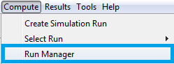

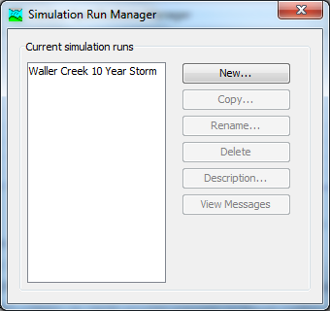

### 6. Viewing HMS Results

The HMS allows you to view results in tabular or graphical form. To view a global results table, in the **Top Menu** select **Results/Global Summary Table**.  I had trouble getting this to work properly.

You may view results for each element within the model. To do this, in the **Data Panel** Select **Results** expand **Waller Creek 10 Year Storm** and also the **Junction 15th St** and select **graph,** you should see the following:

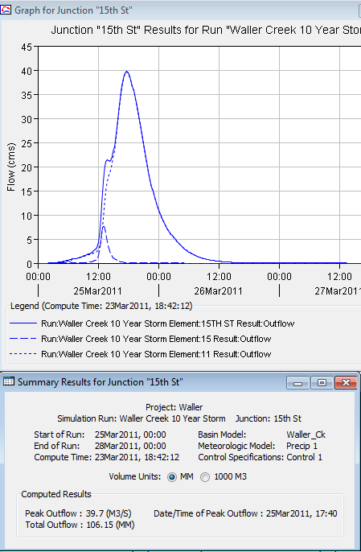

***To be turned in:*** *Make a table showing the peak discharge in cms at each of the six outlet points on Waller Creek (5 junctions and 1 sink)..  What is the drainage area above each of these points?  What is the peak discharge per unit of drainage area (cms/sq. km) for these points?*

### Waller Creek Diversion Design Study

The citizens of Austin approved a bond issue which authorized the City to borrow funds for the construction of a flood diversion tunnel for Waller Creek.  <http://www.ci.austin.tx.us/wallercreek/wctp_home.htm> At present, the 100 year flood plain for the creek covers many city blocks in downtown Austin.  The goal is to make this area safer from floods and also to encourage the development of a river walk area, perhaps similar to that in San Antonio.    Assume that you are the hydrologist whose job it is to determine the design discharge at the inlet point of this tunnel which is just on the downstream side of 15th Street.  At this point an overflow weir will divert a significant part of the flood discharge and convey it to Town Lake in a 22 to 26 ft diameter tunnel. A second inlet further downstream will divert more water into the tunnel.

Recompute the flows from the HMS model using the 100 year design storm instead of the 10 year design storm. How much water would have to be diverted at 15th street if the diversion tunnel is to reduce the peak flow at 15th during a 100 year storm to the level that it has now during a 10 year storm?

Recompute the flows from the HMS model using a 2-year, 5-year, 25-year, and 50-year storms. Make a plot showing the peak discharge to be expected from these events at 15th St as a function of the storm severity from 2-years to 100-year return periods.

***To be turned in:*** *A graph and a table showing the relationship between flood peak discharge and return period for Waller Creek at 15th St. Determine the flow diversion needed at 15th St to reduce the natural 100 year flow to the 10 year discharge level.*

**Summary of Items to be Turned In:**

1. *a table showing the areas of the subbasins.  What is the total drainage area of Waller Creek (sq. km)?*
2. *Select subwatershed 14 and reach 10 and describe in words what the parameter values are that are used to characterize these hydrologic features.*
3. *a screen capture of the design precipitation input file*
4. *how many time intervals of computation will be performed?*
5. *make a table showing the peak discharge in cms at each of the six outlet points on Waller Creek (5 junctions and 1 sink)..  What is the drainage area above each of these points?  What is the peak discharge per unit of drainage area (cms/sq. km) for these points?*
6. *a graph and a table showing the relationship between flood peak discharge and return period for Waller Creek at 15th St. Determine the flow diversion needed at 15th St to reduce the natural 100 year flow to the 10 year discharge level.*