CE 374K Hydrology Homework #3 Spring 2013
Question 1. Table 1 below shows the hourly heat balance in Austin as of 24 January 2013 from the National Land Data Assimilation System. Radiation and heat fluxes are positive upwards and negative downwards. Net Radiation = - (Shortwave + Longwave) is the radiant energy absorbed by the land surface. Balance = Net Radiation – Sensible – Latent + Ground is the energy remaining at the land surface after exchanges of sensible and latent heat fluxes with the overlying air, and ground heat flux with the underlying soil. The radiation and heat balance has an overall average of almost zero (-0.6 W/m²), as it should do.
 | Radiation Fluxes (W/m²) |  | Net Radiation | Heat Fluxes (W/m²) |  |  | Balance
 | Shortwave | Longwave | (W/m²) | Sensible | Latent | Ground | (W/m²)
12:00 AM | 0 | 50 | -50 | -4 | -5 | 40 | -1
1:00 AM | 0 | 50 | -50 | -4 | -6 | 39 | -1
2:00 AM | 0 | 50 | -50 | -4 | -6 | 37 | -3
3:00 AM | 0 | 48 | -48 | -4 | -6 | 36 | -2
4:00 AM | 0 | 48 | -48 | -4 | -6 | 35 | -3
5:00 AM | 0 | 47 | -47 | -4 | -6 | 34 | -3
6:00 AM | 0 | 46 | -46 | -4 | -6 | 33 | -3
7:00 AM | 0 | 44 | -44 | -4 | -6 | 30 | -4
8:00 AM | 0 | 42 | -42 | -5 | -6 | 17 | -14
9:00 AM | -17 | 46 | -29 | -2 | 2 | -59 | -88
10:00 AM | -121 | 63 | 58 | 17 | 24 | -110 | -93
11:00 AM | -235 | 83 | 152 | 66 | 63 | -115 | -92
12:00 PM | -340 | 96 | 244 | 112 | 85 | -127 | -80
1:00 PM | -416 | 93 | 323 | 134 | 102 | -125 | -38
2:00 PM | -452 | 91 | 361 | 122 | 113 | -114 | 12
3:00 PM | -445 | 96 | 349 | 72 | 116 | -102 | 59
4:00 PM | -391 | 102 | 289 | 23 | 98 | -76 | 92
5:00 PM | -296 | 99 | 197 | -16 | 57 | -46 | 110
6:00 PM | -173 | 87 | 86 | -8 | -5 | 17 | 116
7:00 PM | -42 | 72 | -30 | -5 | -3 | 51 | 29
8:00 PM | 0 | 60 | -60 | -5 | -4 | 47 | -4
9:00 PM | 0 | 56 | -56 | -5 | -5 | 47 | 1
10:00 PM | 0 | 58 | -58 | -5 | -6 | 46 | -1
11:00 PM | 0 | 57 | -57 | -5 | -6 | 42 | -4
12:00 AM | 0 | 54 | -54 | -5 | -7 | 42 | 0
Average | -117.12 | 65.52 | 51.6 | 18.12 | 22.84 | -11.24 | -0.6

Prepare two charts, one of the radiation fluxes (short-wave, long-wave, net) and one of the heat fluxes (sensible, latent, ground). What percentages of the net radiation become sensible heat flux, latent heat flux, and ground heat flux? Why are the average sensible and latent heat fluxes positive and the ground heat flux negative?
Question 2. The evaporation example presented in class is for average conditions over 24 hours on 24 January 2013, as shown at: http://www.caee.utexas.edu/prof/maidment/CE374KSpr13/Evaporation/EvaporationExample.pdf Go through the same computations for the conditions at 2PM on that day when the net radiation is 361 W/m², the climate conditions recorded at Bergstrom airport are air temperature 23°C, relative humidity 64%, and wind speed 1.5 m/s. Prepare a summary table comparing the values of the potential evaporation at 2PM computed by the energy balance method (E_{r}), the aerodynamic method (E_{a}) and the combination method (E_{o}) with those computed in the class example for daily average conditions.
Question 3. The potential evaporation on 24 January 2013 for daily average conditions is E_{o} = 1.73 mm/day. The daily average of the values of the latent heat flux is 22.84 W/m². Determine the corresponding value of the actual evaporation (mm/day) and find what percentage of the potential evaporation actually occurrs on this day. Comment on this percentage in light of the drought conditions currently prevailing.
Question 4. The particle size distribution of a soil sample is 25% sand, 65% silt and 10% clay. What soil texture does this sample represent?
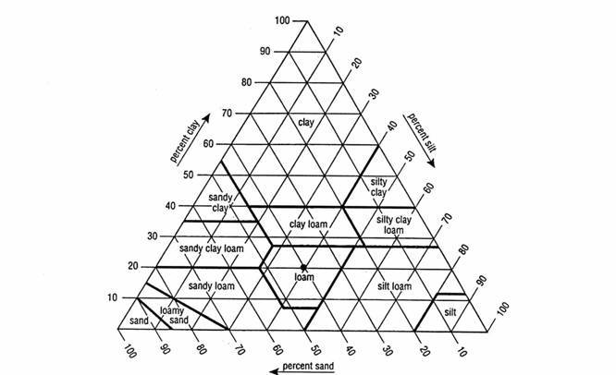
Question 5. Compute the infiltration rate (cm/hr) and the cumulative infiltration (cm) at hourly intervals from 0-5 hours for three soil textures: sand, silt loam and clay. Plot a graph showing the three infiltration rate (f) curves and the three cumulative infiltration (F) curves. In each case, assume that the initial effective saturation is 20% and that water is instantaneously ponded on the soil.
Question 6. Determine the ponding time for the same three soils if infiltration occurs under rainfall intensities of 1 cm/hr and 10 cm/hr. Prepare a table showing the resulting ponding times (including “No Ponding” if necessary). How quickly will surface runoff happen on these soils?

