3
HydroNetwork

The heart of the ArcGIS Hydro Data Model is the HydroNetwork. It is this network that allows us to connect together, in a systematic way, stream and shorelines, and establish a flow direction for the different elements of the network. Flow direction gives us the critical relationship of upstream and downstream, which is a fundamental query used in hydrologic modeling. A network is also a collection of linear features, and linear features have a referencing system, such as river mile, for recording observations.
In this chapter:
- Networks
- HydroNetworks
- HydroEdges and HydroJunctions
- HydroNetwork Tools
-. HydroEvents
- HydroNetwork Examples
Networks
Traditionally, networks have been used in GIS to describe transportation or utility systems. Networks are sets of lines, called edges, joined at points, called junctions, that form a framework layout for connecting different locations. In general, edges allow traveling in either one or both directions, and the difficulty of traveling through them is quantified by an impedance parameter. Street networks, for example, can be used to determine the fastest route to connect two points in a city at a certain time of the day. In such a case, accounting for the fact that some streets are one- and others two-way, or that some streets might experience heavy traffic at certain times of the day, is an essential part of the solution of the problem. It is possible that the optimum route is not the straight line or the shortest route, and that, instead, among the infinite number of alternative routes, the fastest is the one that balances distance and traffic, so that the travel time is minimized. Determining the fastest route can be a complex problem and advanced GIS tools can be necessary.
Most of the times, stream networks satisfy certain additional conditions that make them simpler than general GIS networks. Hydrography datasets, describing major rivers by their banks and lakes by their shorelines, constitute a truthful description of the landscape, but, until simplified, do not take full advantage of the user's knowledge of the overall flow patterns.
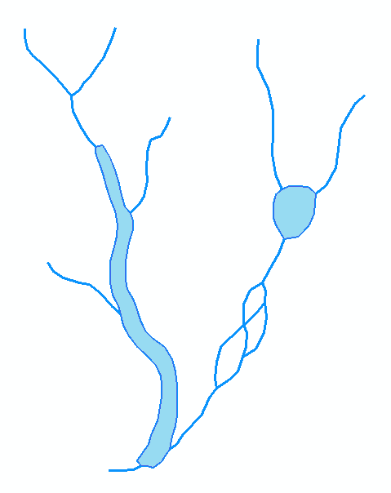
Hydrographic data of a stream network including double-line rivers, waterbodies and braided streams.
HydroNetworks
Once a stream network is processed into a set of flow lines and shorelines, a HydroNetwork can be generated. HydroNetworks are particular and simpler cases of networks, and represent systems that convey water through the landscape. The HydroNetwork components are HydroEdges and HydroJunctions. HydroEdges can be Flowlines (i.e., single-line streams, centerlines of double-line streams, and flow-paths within waterbodies) or Shorelines (i.e., banks of double-line streams and shorelines of waterbodies). If the double-line streams and waterbodies in the hydrography dataset do not have flow lines within them, they must be digitized or otherwise generated. HydroJunctions are points that stand for sources, sinks, stream junctions and other relevant user-defined locations. Among the HydroJunctions, sinks play a significant role in the analysis because each feature in the network is related to one, and only one, sink.
Because water can flow only through Flowline HydroEdges and not Shoreline HydroEdges, in the case of a lake, water flows through the flow lines within the lakes and not through the shorelines.
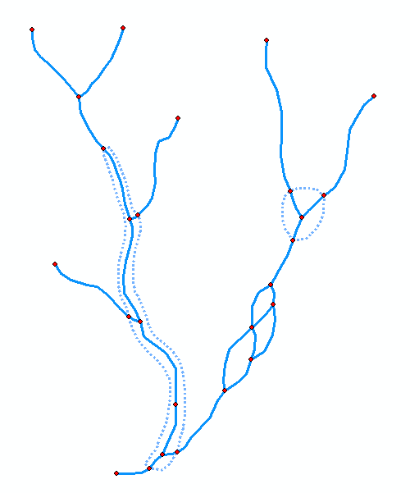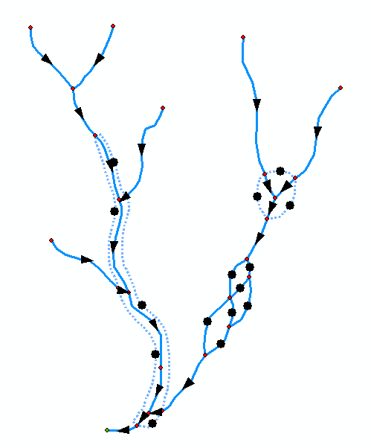
Left: HydroNetwork showing HydroEdges (Flowlines in solid lines and Shorelines in broken lines) and HydroJunctions. Right: HydroNetwork showing flow direction arrows. Note that flow direction is not defined for Shorelines (flow through them was disabled) and Flowlines of braided streams.
Network navigation is based on spatial relations between HydroEdges and HydroJunctions, and consists of identifying the network features located upstream and downstream of any feature. Navigation can be used to follow a water or pollutant particle as it flows downstream, or to identify the potential areas where a water or pollutant particle entered the system. HydroNetworks allow for NetworkTrace, which is the automatic upstream and downstream tracing using ArcGIS built-in functions. Upstream tracing allows the user to identify all HydroEdges and HydroJunctions that drain to a certain point. Downstream tracing, on the other hand, allows the user to identify all HydroEdges and HydroJunctions that constitute the flow path from a point to its corresponding sink.

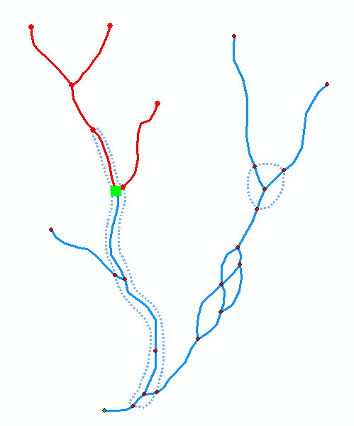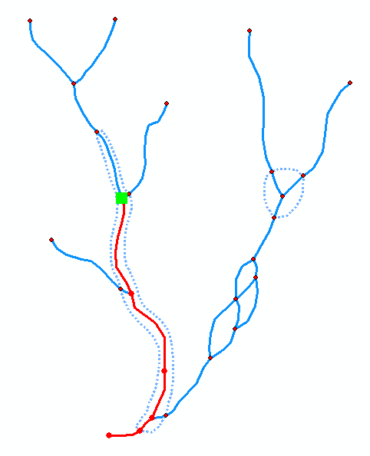
Upstream and downstream tracing from the HydroJunction flagged by a green square.
By combining upstream and downstream tracing, the flow path that connects two points of the HydroNetwork can also be identified.
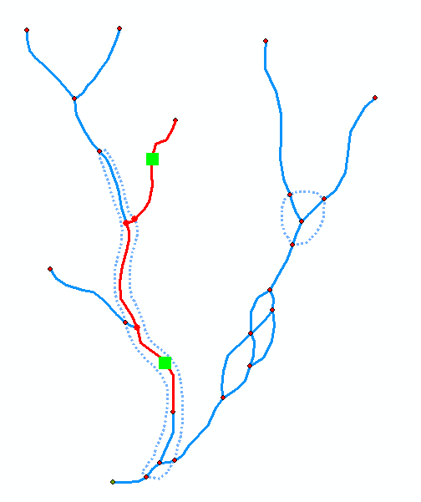
Flow path connecting the HydroEdges flagged by green squares. Note that the entire HydroEdges, and not just the part between the squares, are selected.
Tracing, however, is not possible through braided streams in which the flow direction is not resolved, and therefore there is a need to identify in advance the Flowlines that form loops.
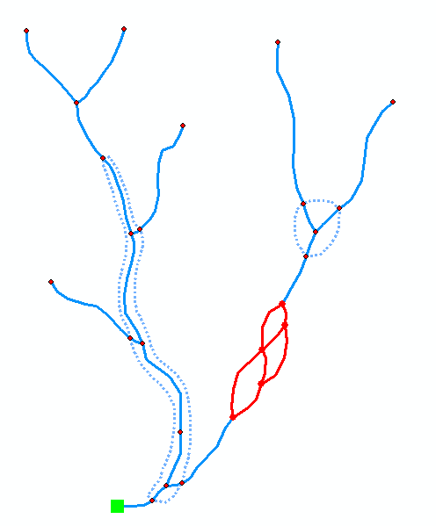
HydroNetwork loops.
For gravity-driven flow – such as that found in most surface water systems --, water flows always in the same downhill direction, which is determined by the topography. The consequences of applying this concept to networks are several, and it is worth discussing them. Since water flows always in the same downhill direction, it can be concluded that the elevation of the downstream end of an edge is less than that of its upstream end, and that, for each edge, there is one and only one downstream (i.e., ensuing) edge. Additionally, because the elevation decreases in the flow direction, it is also impossible to form loops or shortcuts in the network. Likewise, edges cannot intersect because that would imply that, at the intersection point, water would have two alternative paths to flow downstream. Thus, there is only one path from a point on the network to its corresponding system outlet, and, overall, the network has a dentritic shape. As well, note that not all points on a dentritic network can be connected through the network, and that, if two points can be connected, one is necessarily downstream of the other. Consequently, dentritic HydroNetworks have additional properties that simplify their analysis and allow the modeler to perform specific tasks that would not apply to standard networks. It seems natural to take advantage of these additional properties to better understand the hydrologic system represented by the network.
In flat areas, though, water does not necessarily flow always in the same direction. Braided streams and complex manmade channel systems are not uncommon in this type of terrain. In the case of braided streams, water flows always in the same direction in each branch, but it has more than one option to flow at the junctions. In the case of manmade channel systems, flow direction in the channels can change, and, again, water has more than one option to flow at the junctions. When including braided streams and manmade channel systems, the HydroNetwork does not have a dentritic shape.
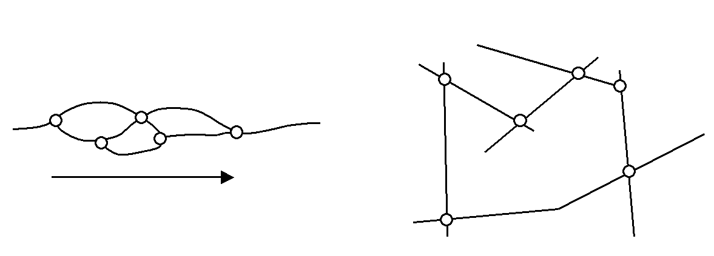
Left: Braided stream. Right: Manmade channel system.
To form a dentritic network, when braided streams or manmade channels are present, the flow through some Flowlines has to be disabled to force flow through other Flowlines. Selection of the Flowlines with disabled flow should be done manually.
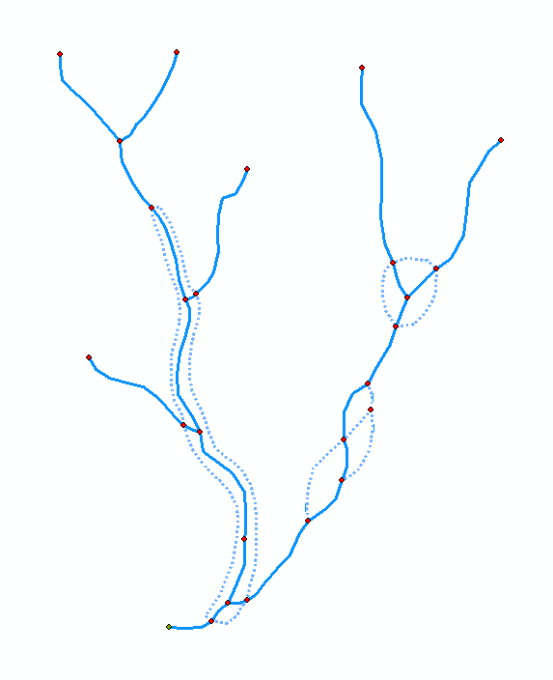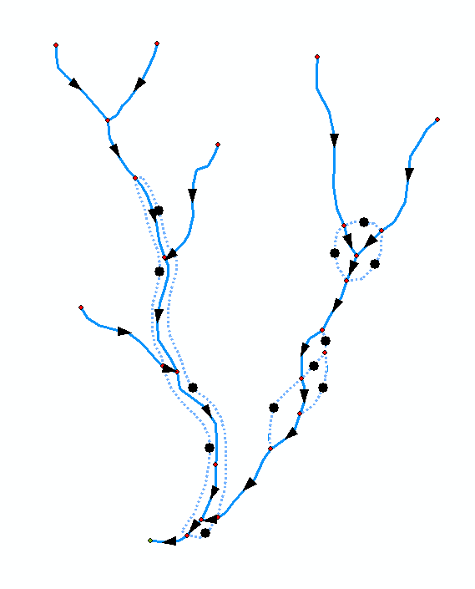
Left: By disabling specific Flowlines, a dentric HydroNetwork is produced. Right: Flow direction is defined in all enabled edges of a dentric HydroNetwork.
HydroEdges and HydroJunctions
HydroEdge is a Network Feature Class, which inherits from the ComplexEdgeFeature ESRI ArcObject class, and HydroJunction is a Network Feature Class, which inherits from the SimpleJunctionFeature ESRI ArcObject class. Junctions are the endpoints of HydroEdges, where other HydroEdges connect.
HydroEdges have the following attributes:
- HydroID: Is a unique numerical integer identifier for all features within a single Arc Hydro geodatabase.
- HydroCode: Is a unique text identifier for all features within a set of Arc Hydro geodatabases.
- ReachCode: Is a text identifier for a set or more edges (usually between stream confluences).
- Name: descriptive name of a stream or river.
- LengthKm: Is the length (in kilometers) of the edge.
- LengthDown: Is the length from the downstream end of the edge to the nearest downstream sink junction.
- FlowDir: Indicates the flow direction with respect to the direction in which the edge was digitized.
- FType: Is a descriptive classifier of edge types (e.g., natural channel, constructed channel, etc.).
- EdgeType: An edge can be either a Flowline or a Shoreline.
- Enabled: Enables or disables tracing over the edge. Disabled tracing is applied to shorelines and to streams with multiple channels in order to generate a dentritic network.
HydroJunctions have the following attributes:
- HydroID: Is a unique numerical integer identifier for all features within a single Arc Hydro geodatabase.
- HydroCode: Is a unique text identifier for all features within a set of Arc Hydro geodatabases.
- NextDownID: Is the HydroID of the next downstream junction.
- LengthDown: Is the length from the junction, on shortest path, to the nearest downstream sink junction.
- DrainArea: Is the total drainage area upstream of the junction.
- FType: Is a descriptor of the junction type: General, Dam, Bridge, Structure, MonitoringPoint, WaterWithdrawal, WaterDischarge or UserPoint.
- Enabled: Enables or disables tracing over the edge.
- AncillaryRole: Assigns one of three roles to the junction: None, Source or Sink
HydroNetwork Tools
A set of tools to operate on HydroNetwork is presented below. Although some of the tools can be applied to non-dentritic networks, it is advisable to simplify the network into a dentritic one before implementing tools.
HydroID
After having created HydroID fields of string type in selected feature classes, this tool populates them with a unique identifier across the geodatabase. The HydroID value is built by concatenating the feature class ID and the ObjectID (within the feature class) into a single string.
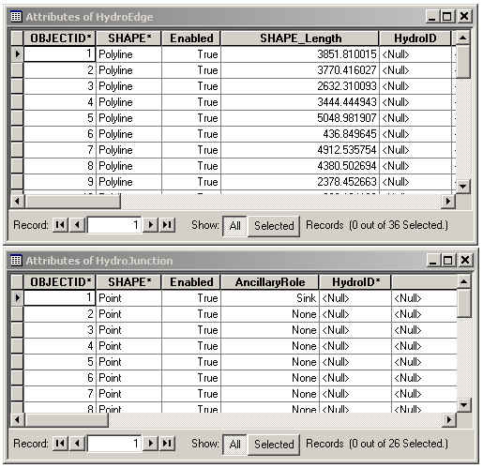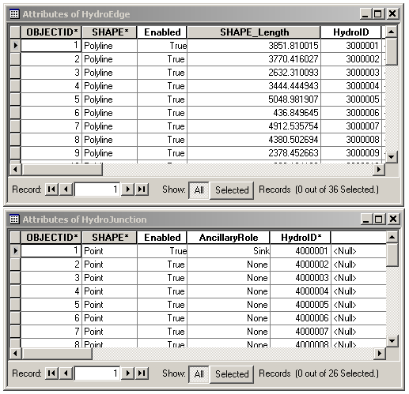
Attribute tables of HydroEdge and HydroJunction before and after populating the HydroID field.
HydroEdge Downstream Length
This tool populates the LengthDown field in the HydroEdge attribute table with downstream length values. Downstream length values are the length from the downstream node of a HydroEdge to the sink to which it flows. Unless a dentritic network is used, calculation of downstream lengths is ambiguous.
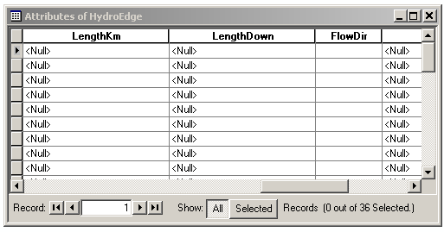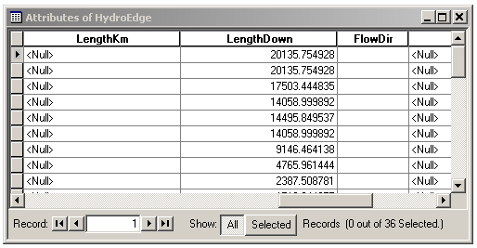
Attribute table of HydroEdge before and after populating the LengthDown field.
HydroJunction Downstream Length
This tool populates the LengthDown field in the HydroJunction attribute table with downstream length values. Downstream length values are the length from the HydroJunction to the sink to which it flows. Unless a dentritic network is used, calculation of downstream lengths is ambiguous.
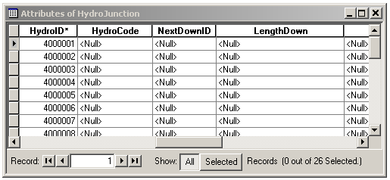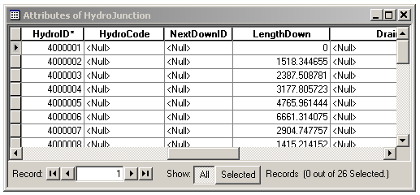
Attribute table of HydroJunction before and after populating the LengthDown field.
Flow Direction (store)
This tool populates the FlowDir field in the HydroEdge attribute table with a numeric code that relates the HydroEdge network flow direction to the digitization direction (i.e., 0 = network flow direction has not been determined yet, 1 = network flow direction coincides with digitization direction, 2 = network flow direction does not coincide with digitization direction, 3 = network flow direction cannot be determined).
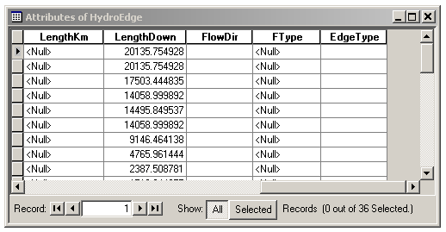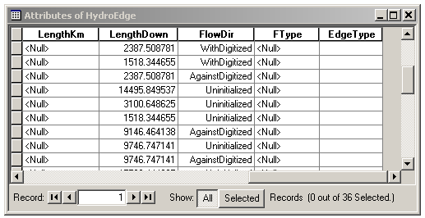
Attribute table of HydroEdge before and after populating the FlowDir field.
Flow Direction (assign/modify)
This tool assigns or modifies network flow direction to the HydroEdges based on stored flow direction values.
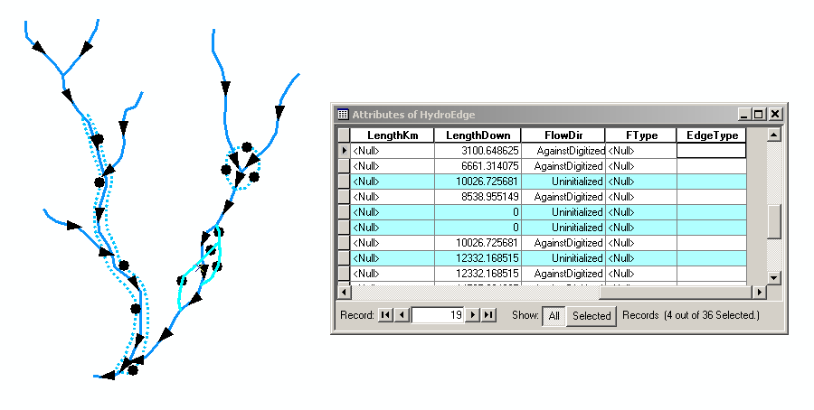
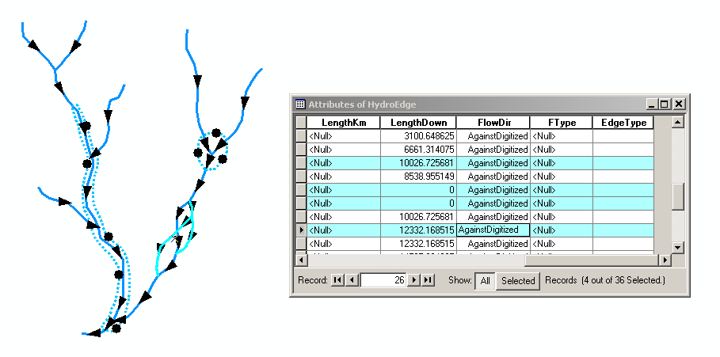
Modification of the flow direction of four selected HydroEdges. Flow direction changed from Unitialized to AgainsDigitized.
HydroJunction Next Downstream Junction
This tool populates the NextDownID field in the HydroEdge attribute table with the HydroID value of the junction located next downstream of the junction.
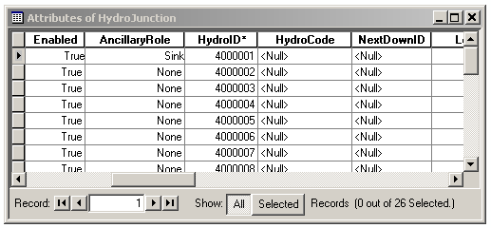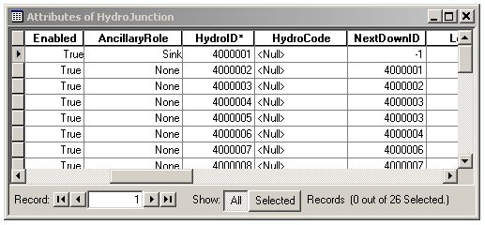
Attribute table of HydroJunction before and after populating the NextDownID field.
Distance between HydroJunctions
This tool populates a field of the HydroJunction attribute table with the value of the distance from the junction itself to the next downstream HydroJunction.
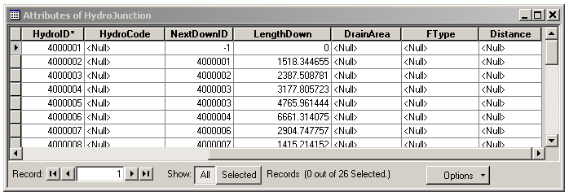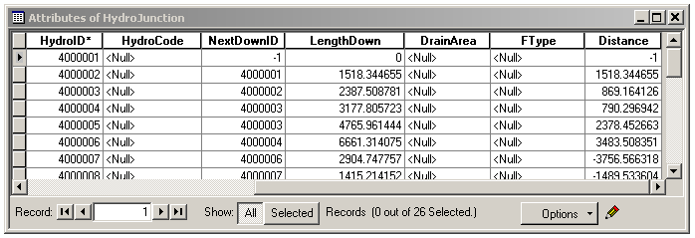
Attribute table of HydroJunction before and after populating the field where the distance to the next downstream junction is stored.
Schematic Network
This tool creates a SchematicNetwork. The SchematicNetwork is a simplification of the HydroNetwork that consists of SchematicNodes and SchematicLines. The SchematicNetwork constitutes the system representation on which the hydrologic models are applied. Both SchematicNodes and SchematicLines are HydroFeatures and, as such, have the HydroID and HydroCode attributes. SchematicNodes are selected HydroJunctions and are related to their corresponding downstream node through the HydroJunction NextDownID attribute. SchematicLines are straight lines that connect consecutive SchematicNodes and have attributes FromNode and ToNode to support HydroTracing, which is navigation based entirely on tabular data.
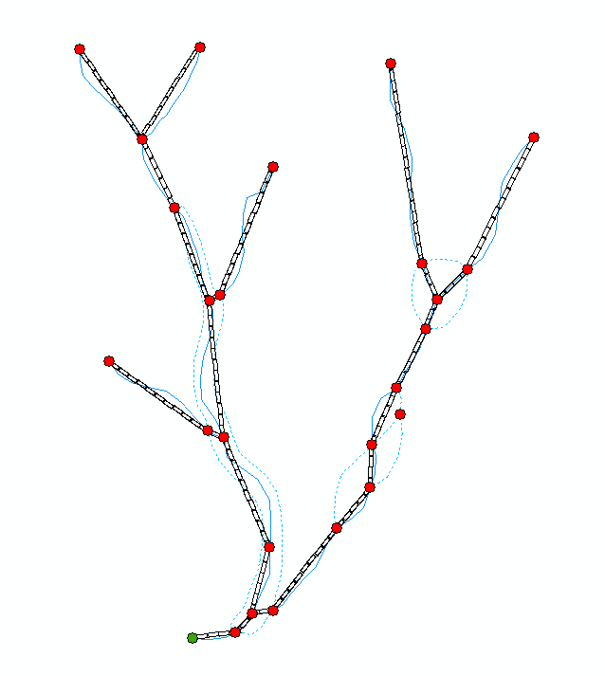
SchematicNetwork showing SchematicLines and SchematicNodes.
Area Outlets
This tool associates the polygons of a watershed Feature Class to junctions on a HydroNetwork. After intersecting the watershed polygons with the stream lines, the HydroNetwork is build with HydroJunctions at the area outlets. The tool populates a field of the watershed Feature Class with the HydroID of the HydroJunction that represents the watershed outlet.
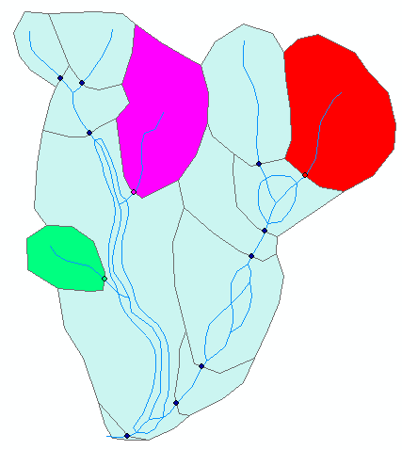
Each area is associated to its outlet junction.
Accumulate Areas
This tool populates a field of the HydroJunction attribute table with the sum of the watershed polygon areas associated to all upstream HydroJunctions.
HydroEvents
In some network applications, it is desirable to specify the location of a point along the river not as a pair of Cartesian coordinates, but as an address on the network, which is called linear reference. This is analogous to specifying that a house is located at 123 Oak Ave., rather than giving its latitude and longitude. The HydroNetwork can be marked off with numbers just as a street network can, and objects can be located according to network addresses.
Objects located by linear referencing on a HydroNetwork are called HydroEvents, which can be HydroPointEvents (i.e., an identified point of a HydroEdge) or HydroLineEvents (i.e., all points between two identified points of a HydroEdge). HydroPointEvents and HydroLineEvents are object classes that inherit from the HydroEvent object class. HydroEvents have a ReachCode attribute to locate them on a specific HydroEdge. Additionally, HydroPointEvents have a Measure attribute, while HydroLineEvents have FMeasure and TMeasure attributes, to exactly locate them on the HydroEdge.
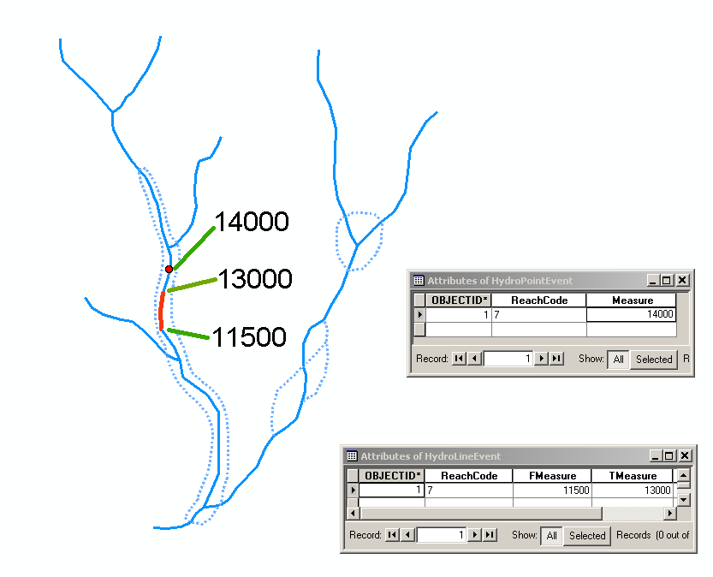
HydroPointEvent and HydroLineEvent
Storage of an event measure (i.e, Measure, FMeasure and TMeasure) can be accomplished by Absolute Addressing, which consists of using absolute distances from an arbitrarily defined origin, or Relative Addressing, which consists of using the relative distance along the HydroEdge.
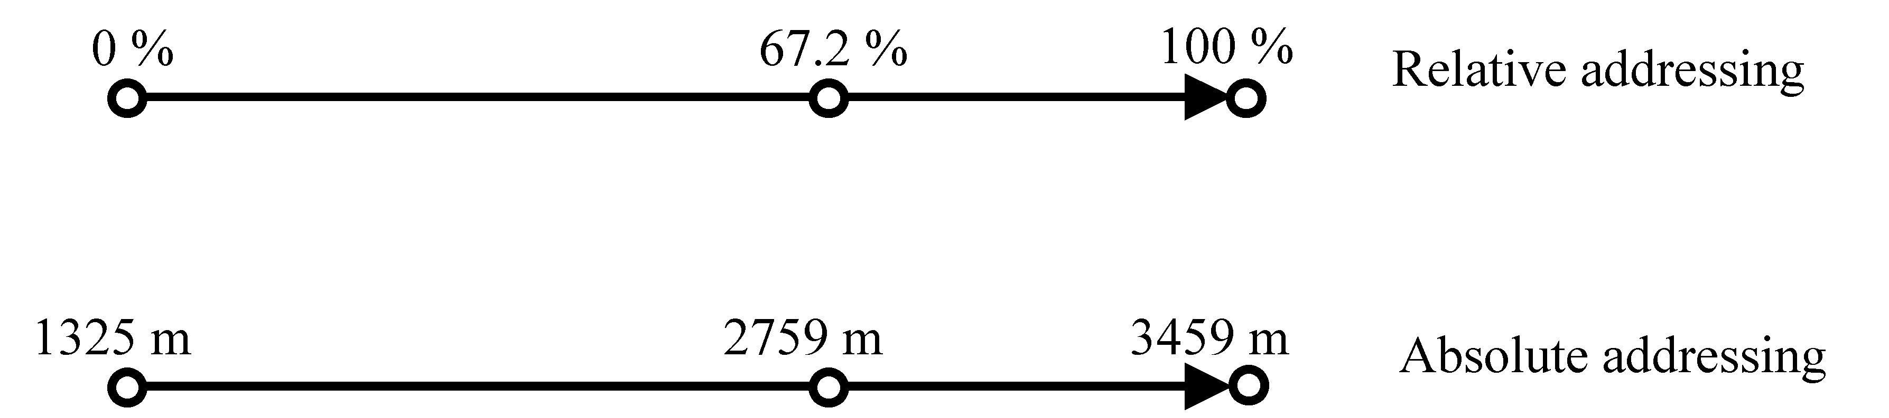
Relative and absolute addressing (arrow points upstream)
Relative Addressing has the problem that, if a HydroEdge is split in two and the two new edges keep the same ReachCode identifier, then the two new lines have ambiguous measures. However, it has the advantage that, because relative distances along lines barely change with the scale of the data, points can be uniquely located regardless of the scale of the underlying stream network dataset.
HydroNetwork Examples
HydroNetworks for the Netherlands and a segment of the Colorado River in Texas are presented below.
In the case of the Netherlands, a well-known flat area, a complex system of manmade channels governs the network. In general, edge flow direction is difficult to define, although an overall flow pattern towards the northwest is recognizable. Sinks were located at the North Sea shoreline and sources at the boundary with Belgium and Germany.
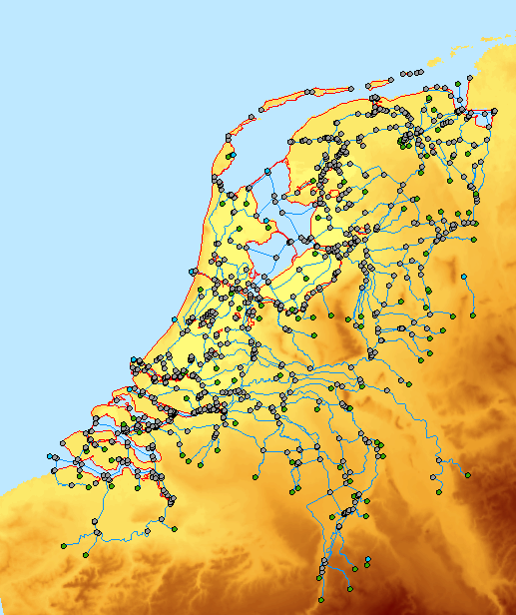
HydroNetwork for the Netherlands showing HydroEdge Flowlines (blue lines), HydroEdge Shorelines (red lines), HydroJuntion Sources (green points), HydroJunction Sinks (blue points) and HydroJunction None (gray points).
In the case of the segment Colorado River, because of the terrain topography, the HydroNetwork has a dentritic shape with definable edge flow directions. Sinks and sources were located at the upper and lower points of the Colorado River segment.
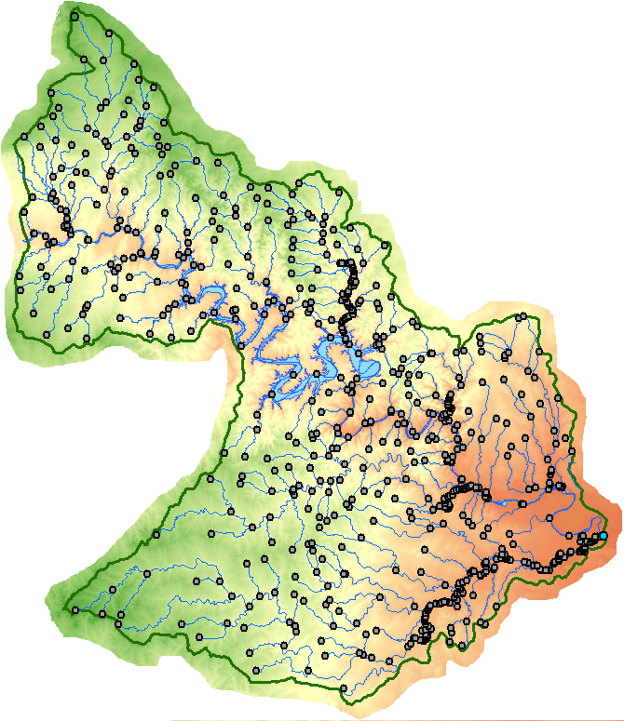
HydroNetwork for a segment of the Colorado River showing HydroEdges (blue lines), HydroJuntion Sources (green points), HydroJunction Sinks (blue points) and HydroJunction None (gray points).

