5
River Channels

River systems have been a focus of travel, industry, and human culture for millennia. Because of their importance to human activity and quality of life, engineers and scientists pursue an increased understanding of their physical properties and behaviors. A wealth of data has been collected about rivers, including their morphology, water quantity and quality, surrounding habitats, and flooding potential. The ArcGIS Hydro data model provides a way to efficiently store, manage, and retrieve these vital river system data.
In this chapter:
- Understanding rivers
- River, channel, and cross-section
- Representing channel information in a geodatabase
- Example of creating a cross-section geodatabase

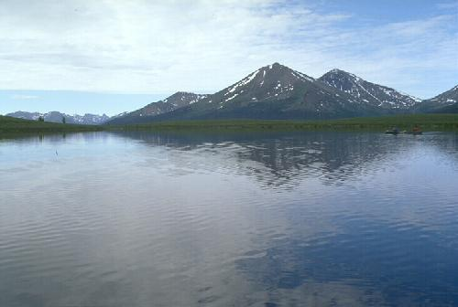

Importance of Rivers

Rivers have been a focus of human activity throughout ancient and modern times. So important to humanity are the benefits obtained from rivers, and so necessary is the protection against floods and other river disasters, that study of riverine systems has advanced in leaps and bounds. While engineers are interested in water supply, channel design, flood control, river regulation, navigation improvement, and so on, it is clear that rivers, as a part of nature, can be mastered not by force but by understanding. Rivers have been a subject of study by engineers and scientists who have been fascinated by their self formed geometric shapes and their responses to changes in nature and human interference. In addition to engineering, understanding river behavior is also necessary for environmental enhancement.
No matter what the purpose is, the success of any river study largely depends on the volume of data available and the tools available for data storage, retrieval and analysis. In recent years GIS has become an excellent tool for spatial data storage, visualization, and analysis. Water resources professionals have come to embrace this technology and customize it to suit their everyday needs. This chapter first discusses the basic concepts of river, channel and cross-section information and then describes how to represent these data using the ArcGIS Hydro Data Model.

Need for River Channel Information
Producing a cross-section of a river channel is fundamental to all river studies. Whether a professional needs to find the discharge, or examine the profile of a feature such as a meander or riffle, it is necessary to produce a cross-section of the river. Following are few examples of scientific and engineering applications where channel information plays a vital role.

River Ecology
Streams and rivers are among the most fascinating and complex ecosystems on Earth. Their roles in providing natural resources, such as fish and clean water, are well known, as are their roles in providing transportation, energy, diffusion of wastes, and recreation. What is not as well known is how they serve as integrators of broader environmental conditions reflecting the surrounding landscape. Today, with ever increasing demands being made on streams and rivers, the need to understand streams as ecological systems and to manage them effectively has become increasingly urgent.

Human activities alter the physical habitats in rivers of all sizes. Extensive channelization and diking of large river systems for flood control and transportation are the primary causes for losing many secondary channels, backwaters, and oxbows, which are important habitats for many juvenile fishes. Activities within a watershed, whether natural or anthropogenic (human-induced), influence the most basic aspects of the hydrologic cycle, which in turn, directly impact the habitat distribution, trophic structure, physical and biological processes (such as sediment transport, nitrogen cycling, and primary production), and demography of the diverse biological communities. At a local habitat scale, substratum and current velocity are probably the most important factors determining the type of macroinvertebrate taxa present. The stream substratum has obvious importance because the vast majority of stream microinvertebrates spend most of their lives attached to substrata. The particle size of inorganic matter has a large influence on microinvertebrate community structure. For example, coarser bed materials (e.g., gravel, cobbles, boulders) generally provide a more interstitial habitat for macroinvertebrates than fine sediments (e.g., sand, silt).

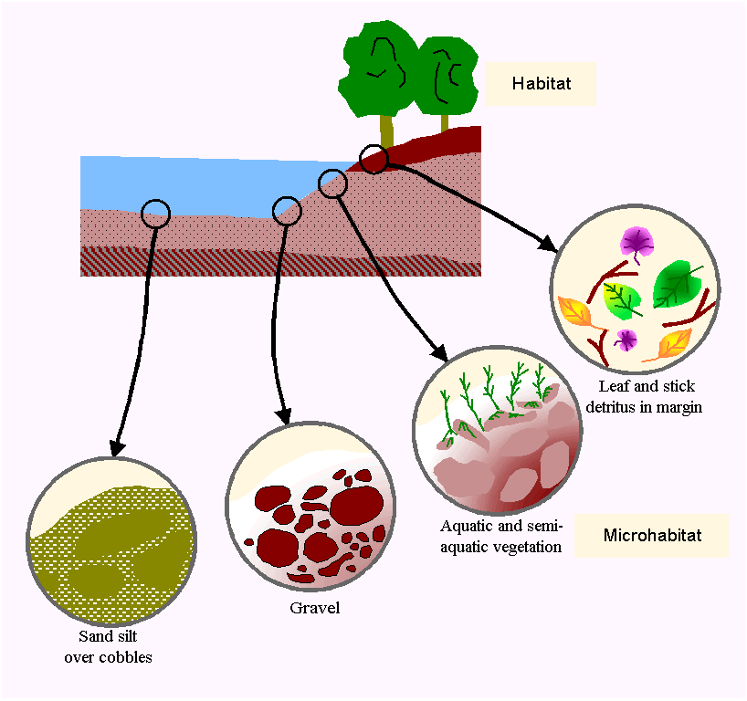
Organization of a stream system and its habitat subsystems
Source: “River Ecology and Management”, Robert J. Naiman, Robert E. Bilby (Editors)
Springer-Verlag, New York, 1998

Channel transects, depicting aquatic and semi-aquatic vegetation conditions and particle size distributions, along with river flow and water quality information, provide valuable insight about stream habitats and overall ecological conditions. In the field of ecology, rivers and streams serve as a circulatory water flow system, and the study of those rivers, like the study of blood, can diagnose the health not only of the rivers themselves but also of their surrounding environments.

River Morphology
One way to track the amount and location of erosion and deposition in a river valley is to establish a series of cross sections through the valley and survey the cross sections on a regular basis, especially before and after periods of heavy rain and flooding. When accurately surveyed on a regular basis, such cross sections help to identify regions of sediment erosion and deposition.
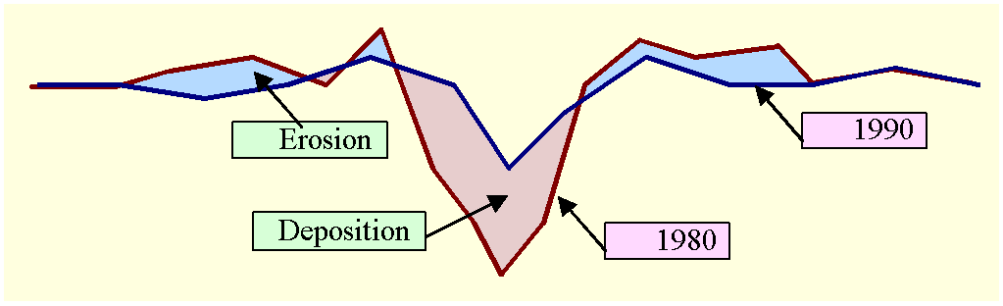
Determining the areas of erosion and deposition by comparing cross-sections

One of the most dramatic examples of rapid channel incision and widening after a volcanic eruption comes from Mount St. Helens in the North Fork Toutle River. In only two years, this channel was carved into the landslide deposit that filled the river valley to depth of 195 meters. Here, the channel is about 350 meters wide and 40 meters deep.

Floodplain Delineation
A floodplain is the normally dry land area adjoining rivers, stream, lakes, bays, or oceans that is inundated during flood events. Flooding is caused by the overflow of streams and rivers and abnormally high tides resulting from severe storms. The floodplain can include the full width of narrow steep stream valleys, or broad areas along streams in wide, flat valleys. The channel and floodplain are both integral parts of the natural conveyance of a stream. The floodplain carries flow in excess of the channel capacity. The greater the discharge, the greater is the extent of inundation.

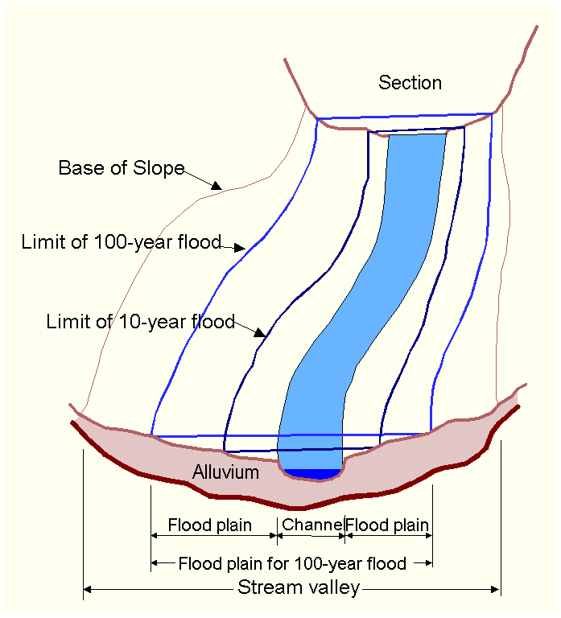
Typical sections and floodplain in a reach of stream valley

Because of its devastating nature, flooding poses serious hazards to human populations in many parts of the world. According to the Federal Emergency Management Agency (FEMA) of the United States, flooding is one of the most common and widespread of all natural disasters. The economic damages from floods have increased considerably in the last 30 years. “The Flood Disaster Protection Act of 1973”, passed by the Congress of the United States of America, required the identification of all floodplain areas within the United States and the establishment of flood-risk zones within those areas. Water resources engineers have developed methods for delineation of floodplain boundaries.

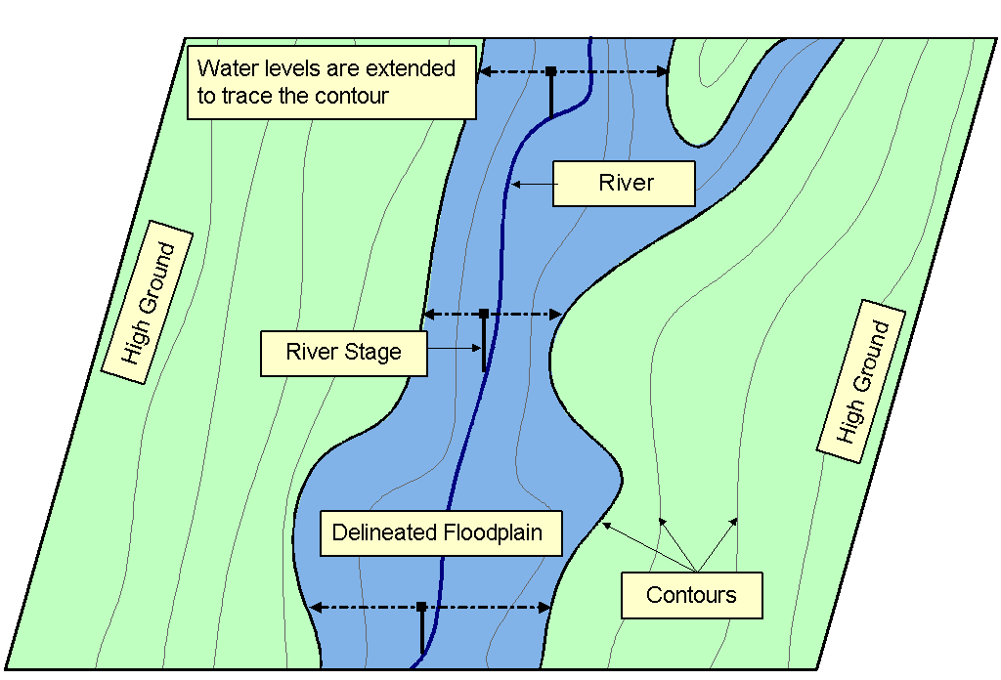
Delineation of flood plains

An automated floodplain delineation process determines inundation extent by comparing simulated water levels from a river hydraulic model with ground surface elevations. Cross-sections are required to represent channel geometry in a river hydraulic model. The accuracy of simulated water levels, and eventually the accuracy of floodplain delineation, largely depends on the shape as well as extent of these cross-sections. In a flood model it is important to specify a detailed cross-section geometry that not only extends over the floodplain, but also is truly capable of carrying the total flood discharge through it. The following River Modeling section discusses the importance of channel information for river hydraulic modeling in greater detail.

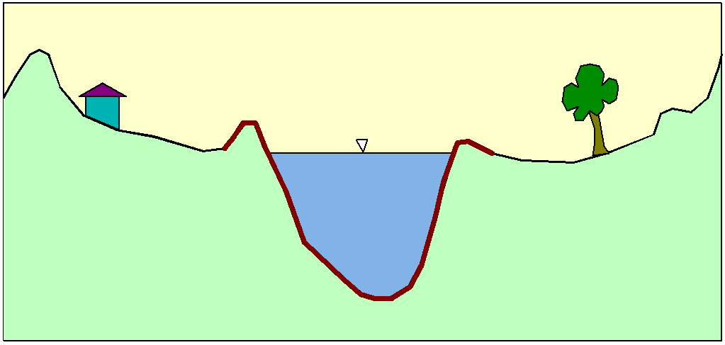
Flow in the main channel

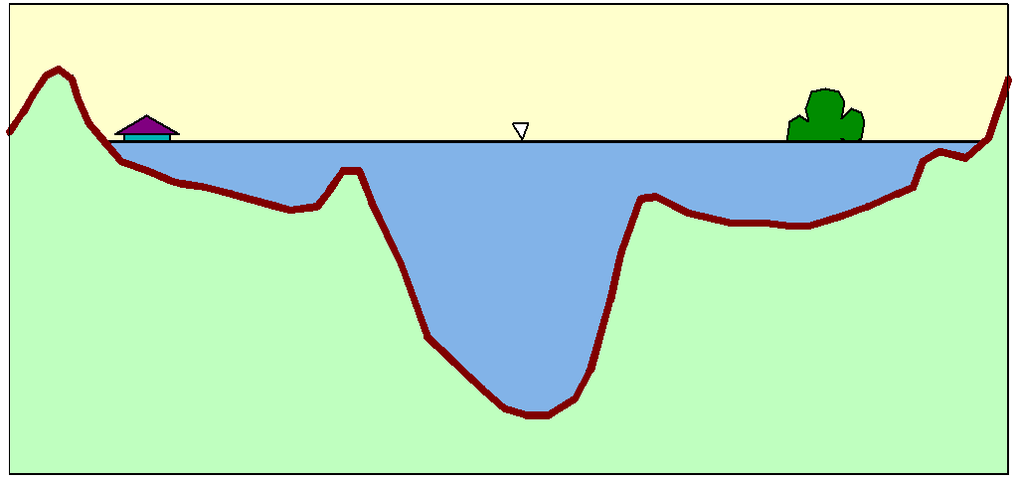
Flow in the main channel and floodplains

River Modeling
Humanity’s interest in river flow stems in part from our need to protect human life, property, and economic systems from the capriciousness of natural flow events, and to exploit their potential benefits for hydraulic energy generation, agriculture, and navigation. In this overall context, river hydraulic modeling provides a tool that professionals can use to study and gain an understanding of hydraulic flow phenomena, select and design sound engineering projects, and predict extreme flooding situations so as to be able to provide advance warning of their occurrence.

The essential quality of a river hydraulic model is its predictive capacity. In order for model predictions be accurate and useful, the model is based on hydraulic equations that represent the most important flow phenomena. But even if the flow equations used are appropriate, the model is unreliable unless correct hydraulic and topographic features are represented in a sound manner. This is perhaps the distinguishing feature of river modeling - it is incumbent upon the modeler to provide a numerical description of physical reality that is consistent with the physical laws governing water flow, and also consistent with the shape and properties of the river channel.

Data Requirements
Theoretically, any physical situation can be simulated in a river model with as high an accuracy as desired within the limits of the validity of the flow equations. The data required for river models can be grouped into two classes: hydraulic and topographic.

Hydraulic data consist of continuous measurement of discharge hydrographs, stage (or water surface elevation), tidal records, spot measurements of stage, continuous discharge and velocity, rating curves relating stage and discharge, etc. Further discussion on hydraulic data is beyond the scope of this chapter. Additional information can be found in Practical Aspects of Computational River Hydraulics by J. A. Cunge, F. M. Holly, Jr., and A. Verwey.

Topographic data describe the geometry of the simulated river system. By this we mean that they supply the elements necessary to define width, cross-sectional areas, and volume of inundated floodplains. Moreover, they should permit the establishment of the topology of the model: the definition of cells in inundated areas, channel loops, the characteristic cross-sections along channels where the computational points are to be established, the limits between main channels and floodplains, and the network of discharge exchange between the cells. The topography of river valleys may be measured with an accuracy and completeness which is limited only by cost and can be directly carried over into the precise definition of cross sections.

Topographic Data
The topographic data used to build river hydraulic models may be divided into two basic categories:
Qualitative data is a reconnaissance type of description of the river, its tributaries, and inundated floodplains. This involves the identification of the physical conditions which determine flood development patterns - the existence of berms within the floodplain, dykes, breach information, elevated roads, localized obstacles within inundated zones, preferential flow axes, etc. Qualitative data may be obtained by field investigation, inquiries, satellite and aerial photographs, and newspaper reports, etc.
Quantitative topographic data are needed for the model representation of the river and its flooded plains. Three essential kinds of quantitative topographic information required in river hydraulic models are: longitudinal profiles along banks, dykes, and roads, cross-section, or transverse profiles across the water course, and contour imagery of the inundated area.

As far as topographic data collection is concerned, it is impossible to completely enumerate ‘what is needed’, since the more that is known, the better. But let us not forget that the accuracy of model results does not depend on these data alone. If the model does not require or is not capable of evaluating detailed information, there is little benefit in putting that data in the model. Two widely used hydraulic models are HEC-RAS and MIKE 11, developed in the different parts of the world are mentioned here to describe the requirement for channel information in river hydraulic models.

HEC-RAS
HEC-RAS, developed by the US Army Corps of Engineers Hydrologic Engineering Center (HEC) of the United States, is designed to perform one-dimensional hydraulic calculations for a full network of natural and constructed channels. The current version of HEC-RAS system supports steady and unsteady flow water surface profile calculations. The basic computational procedure is based on the solution of the one-dimensional continuity and momentum equations of water flow.

One of the major steps in developing a hydraulic model with HEC-RAS is to enter the necessary geometric data, which consists of connectivity information for the stream system, cross-section data, and hydraulic structure data. Cross section data represent the geometric boundary of the stream. Cross-sections are required at representative locations throughout the stream and at locations where changes occur in discharge, slope, shape, roughness, and at hydraulic structures. The required information for a cross-section includes the river reach and river station identifiers, a description, station and elevation points, and Manning’s roughness. More information about HEC-RAS can be found at http://www.wrc-hec.usace.army.mil/.

MIKE 11
MIKE 11, developed by the DHI - Institute for Water and Environment of Denmark, is a system for the one-dimensional modeling of rivers, channels and irrigation systems, including rainfall-runoff, advection-dispersion, morphological, water quality and two-layer flow modules.

The MIKE 11 hydrodynamic module (HD) uses an implicit, finite difference scheme for the computation of unsteady flows in rivers and estuaries. The hydrodynamic module can describe sub-critical as well as supercritical flow conditions through a numerical scheme that adapts according to the local flow conditions (in time and space). The formulation can be applied to looped networks and quasi two-dimensional flow simulation on flood plains.

River branches are represented in MIKE 11 models by prescribing the shapes of river cross sections and their locations along the river axes. Floodplains and storage areas are represented in one of the two ways: either by including the properties of the floodplain within the specification of each individual cross section, or by representing the floodplains as separate flood cells and routing channels which are connected to river(s) either directly or via hydraulic structures such as weirs or flow regulators. The model allows two different types of bed resistance descriptions: Chezy, and Manning and uses this information for flow computation.

Digital Terrain Model (DTM)

Traditionally channel information is collected in the field using different surveying techniques and tools. After establishing horizontal and vertical controls, elevations are taken along a cross-section. Collecting data in this manner is time consuming and costly. Recent development of satellite based survey techniques and popularity of GIS software has opened an enormous possibility of extracting cross-section data from digital terrain models (DTMs). Creation of a DTM and its role as cross-section data source is described in this section.

A digital terrain model (DTM) is a surface model representing the topographic surface. In DTMs the ground elevations are stored using formalized data structure rules such as Triangulated Irregular Network (TIN), or Grid. Each model has advantages and limitations. A Grid is a simpler model of a surface. Digital terrain data is widely accessible in Grid format. TINs can produce a more accurate representation of surfaces and features, but usually require a more extensive data collection effort using aerial photogrammetry or other remote sensing techniques, such as Light Detection and Ranging (LIDAR). This section examines only the TIN representation of a surface.

The TIN Representation of a Surface
TINs represent surfaces as contiguous nonoverlapping triangular faces. A surface value for any location can be estimated by interpolation of elevations within a triangle. Because elevations are irregularly sampled spatially in a TIN, this data structure allows a variable point density in areas where the terrain changes sharply, yielding an efficient and accurate surface model.

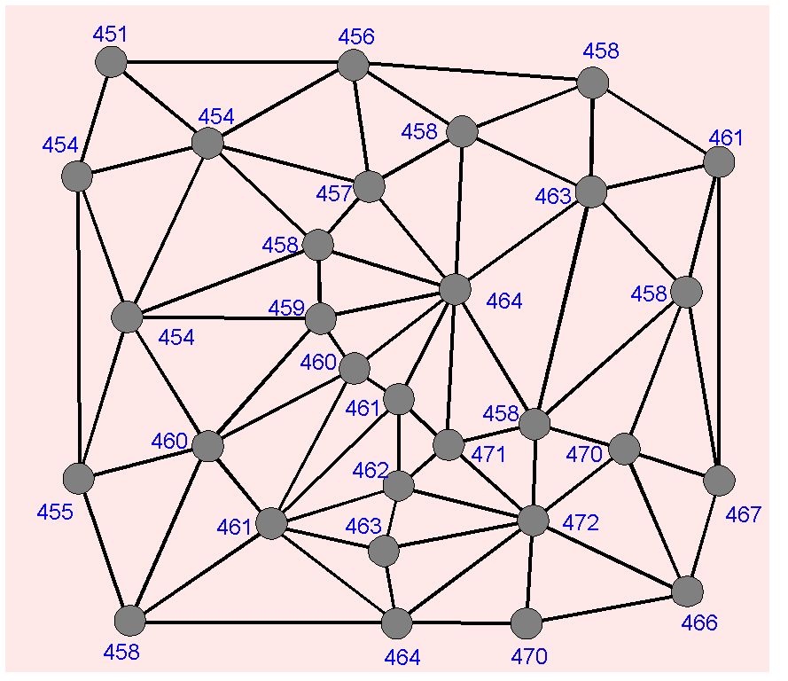
TIN representation of land surface elevation

A TIN preserves the precise location and shape of surface features. Areal features such as lakes and islands are represented by a closed set of triangle edges. Linear features such as ridges are represented by a connected set of triangle edges. Peaks and pits are represented by triangle nodes. TINs support a variety of surface analyses such as calculating elevation, slope, and aspect, performing volume calculations, and creating profiles on alignments. The disadvantage of TINs compared to Grid DEMs is that they are often not readily available and therefore require costly data collection.

Creating TINs
TINs are made from mass points, which are points with elevations collected from a variety of sources. From these input points, a triangulation is performed. In a TIN, the triangles are called faces, the points become nodes to a face, and the lines of faces are called edges.

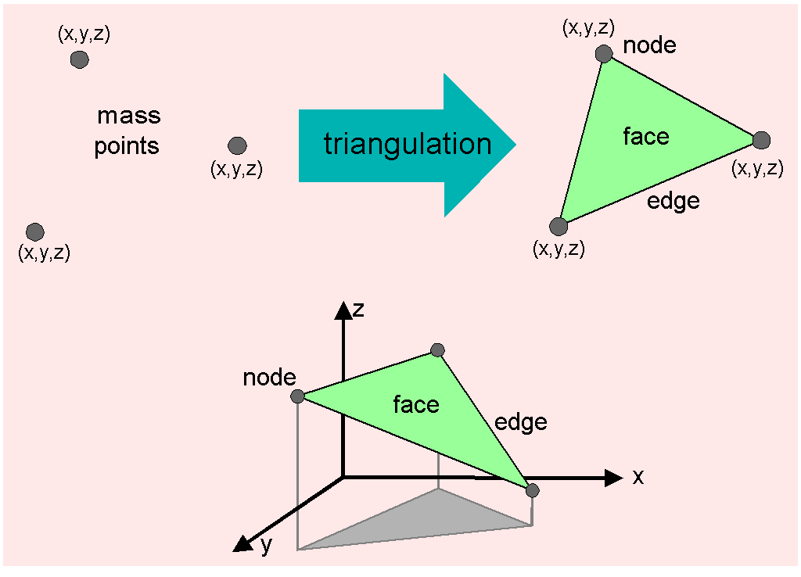
Creating a TIN from mass points

Given a set of points, many possible triangulations can be created. ArcInfo uses an algorithm called Delaunay triangulation to optimize how faces model a surface. The basic idea of this algorithm is to create triangles that collectively are as close to equilateral shapes as possible. This keeps the interpolation of elevations at new points in closer proximity to the known input points.

TINs can be created by entering surface features that represent elements of terrain such as point elevations, peaks, streams, ridges, and also man made features such as roads, embankments, etc. Point elevations are the predominant input into a TIN and form the overall shape of the surface. They can be input from contour lines if necessary, but it is better to use points collected with surveying or photogrammetric devices because the operator can do a better job of visually sampling points that reflect terrain relief. Stream, ridges, embankments, and similar surface features extracted from topographic maps or digital orthophotos are then added to refine the surface model and sharpen the changes in relief. These features are preserved in the TIN and increase the model accuracy.
The features that represent and preserve the surface morphology in a TIN are as follows:

Point surface features
Mass points represent point at which z-value is measured. After triangulation, they are preserved as nodes with the original location and elevation.

Linear surface features
Breaklines are linear features that represent natural features such as streams and ridges or man made features such as roadways. Hard breaklines represent a slope discontinuity such as a stream course. While the surface is always continuous, its slope may not be. On the other hand soft breaklines only add the imprint of a linear feature without representing a slope discontinuity.

Areal surface features
These are polygons that represent objects such as lakes or coasts. For example, replace polygons assign a single z-values to the boundary and all interior heights, while erase polygons mark all areas within a polygon as being outside the zone of interpolation for the model. Analytical operations such as volume calculations, contouring, and interpolation will ignore these areas.

Data Sources for Creating TINs
Data for TINs are commonly compiled with photogrammetric instruments that sample elevations from pairs of aerial photographs precisely aligned in a stereo model. TINs are also produced from survey data, digitized contours, Grids with z-values, point sets in file or databases, or operations on other TINs.

Use of TINs as a Cross-Section Data Source
In recent years, advances in GIS have provided many tools for extracting cross-section data from digital terrain models (DTMs). Since the TIN surface model allows variable point density on the degree of change of slope, it actually captures and represents surface features such as streams, ridges, and peaks better than a Grid surface model. In TINs these surface features are stored with precise coordinates, and provide more accurate vertical profile information. Therefore, a TIN is preferred as a cross-section data source over the Grid surface model for representation of riverine topography.
The process of extracting cross-section data from a TIN involves defining the TIN as a surface and digitizing cross-section cutlines. A cutline represents the alignment of a cross-section in (x, y) or plan view. The ground elevation beneath each vertex is then interpolated from the surface. The elevations are either stored with the cross-section cutlines as 3-D lines or exported to a table.

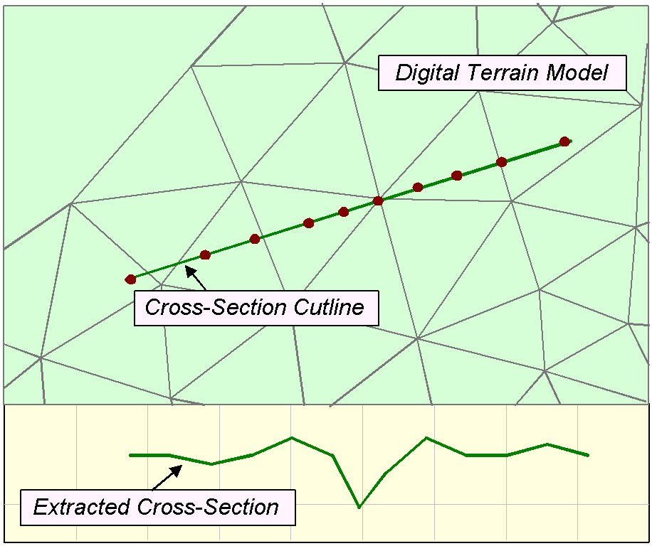
Cross-section extraction from a DTM

Combining the topographic data extracted from digital terrain models with field information, results in a better interpretation of land surface features.

River, Channel, and Cross-Section

Even though water resources engineers all over the world deal with similar elements of nature and try to solve similar problems, the way they define these elements and address the problem depends on engineering practices. Therefore, it is important that when a term is mentioned in this chapter, we actually understand and refer to the same element of the nature. To facilitate this understanding let us define here a river or stream channel and a channel cross-section.

A river or stream Channel is a conduit or water course carrying water flow under gravity. The water surface profile is sloping and the flow has a significant velocity. The width of the channel is much smaller than its length and the flow is essentially one-dimensional in the direction of the channel centerline. The channel includes the flow in the main channel of the river or stream itself and also in its floodplains to the left and right of the main channel. The channel is like a “cradle” that carries the flow. It has a complex three-dimensional geometry, and additional properties such as channel roughness. Examples of hydrographic features having channels include: river, stream, creek, canal, ditch, culvert, storm sewer.

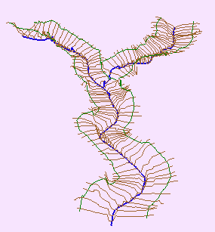
Three-dimensional view of a channel

A Cross-Section as used in this chapter refers to the section of a channel taken normal to the direction of the flow. Natural channel sections are by nature irregular. For streams subject to frequent floods, the channel may consist of a main channel carrying normal discharges and one or more side channel sections for accommodating overflows.

The geometry of a cross-section is represented by a series of points specified by a pair of m and z values. The value m denotes the measure, or distance of the point along the cross-section from one end. The ground elevation above a datum is denoted by z. The thalweg is defined as the lowest point of the main discharge carrying portion of a cross-section. A cross-section is typically identified by the channel name, and station (a measure value along the channel flowline) and located by geographic coordinates.

Computations involving flow in open channels commonly require an evaluation of the resistance characteristics of the channel. The Manning and the Chezy equations have been used extensively as an indirect method for computing discharge or depths of flow in natural channels. In 1889 the Irish engineer Robert Manning presented a formula, which was later modified to its present well-known form
V = (1.49/n) R^{2/3}S^{1/2}
Where V is the mean velocity in ft/s, R is the hydraulic radius in ft (cross sectional area divided by the length of the wetted perimeter), S is the slope of energy grade line (often taken equal to the bed slope), and n is the coefficient of roughness, known as Manning’s n.

Since the Manning and Chezy equations both require bed roughness along with cross-section parameters such as area, hydraulic radius, it is useful to define channel roughness as a parameter of cross-sections.

Elements of a Cross-Section
The geometry and the associated properties of a cross-section are the elements of a cross-section and can be grouped as follows:

Geometry: The geometry or shape is the most vital component of a cross-section and is defined by a series of distance-elevation points along the cross-section. However, without proper identification and position of the cross-section, this geometry is nothing but a set of numbers.

Identifier: Traditionally a cross-section is identified by the name of the channel and the station at which the survey took place. If the cross-section is extracted from a DTM, the name of the channel intersected by the cross-section cutline and the station of the point of intersection become the identification. In a river hydraulic model, a cross-section is referred to and positioned by this identifier.

Georeference: The location of a cross-section in real world coordinates. A series of XY coordinates that represents the alignment or the 2-D view of cross-section cutline as shown on a map. When a cross-section cut line is drawn in a GIS, it is automatically georeferenced. However, this element is missing in many of the traditionally surveyed cross-sections. Recently the use of GPS allows capturing and storing of this information during survey operations. Huge databases of traditionally surveyed cross-sections exist in many organizations. These cross-sections must be georeferenced in order to be useable in a GIS.

Property: Channel roughness is the primary property of a cross-section used for flow computation. No matter how this information is stored the roughness values are usually associated to the segments of a cross-section rather than with specific points on a cross-section. The land use type, soil type, and flow zone are river properties that could be stored in a similar manner.

Supplementary: Additional information such as the heights of the embankments, breaches, etc. are useful for better understanding the flow process through a cross-section. The locations of left bank, right bank and thalweg (lowest point on a cross-section), and the extent of flooding are few examples that could be stored with a cross-section. In addition to help in solving flow problems, these supplementary data can also be used to generate the longitudinal profile of a channel.

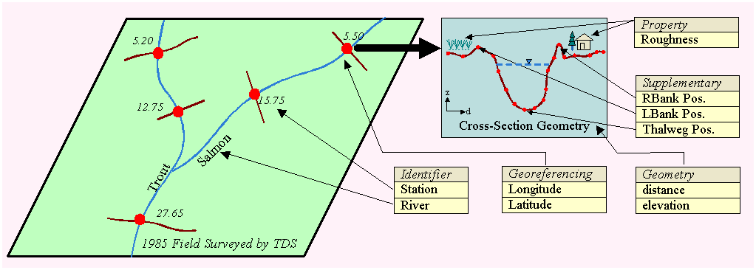
Elements of a channel cross-section

The alignments of a river network together with the elements of cross-section mentioned in this section provide the basic channel information for water resources professionals. The following section describes how these elements are conceptually represented in GIS using the ArcGIS Hydro data model.

Representing Channel Information in a GeoDatabase

The part of the ArcGIS Hydro data model that stores and manages channel information consists of two feature classes and an object class. Feature classes are derived from ChannelFeature abstract class, which inherits properties from HydroFeature class. The feature classes are: CrossSection, and ProfileLine. The object class CrossSectionPoint is derived from ESRI object. Collectively these classes provide a standardized way of representing the channel profiles and cross-sections, and make it easier to visualize and extract channel information in ArcGIS.

ChannelFeature
The ChannelFeature abstract class is derived from HydroFeature. The purpose of this abstract class is to gather attributes that are common to channel features such as thalweg, cross-sections etc. The attributes are: ReachCode and RiverCode. All channel features derived from this abstract class automatically inherits these attributes.

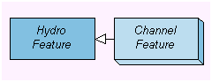
ChannelFeature is derived from HydroFeature class

ReachCode is a user-defined identifier of type string. This identifier is unique for each reach.

RiverCode is a user-defined identifier of type string. This identifier is unique for each river.

CrossSections
The shape a cross-section can take in a GIS primarily depends on how it is georeferenced. Cross-sections digitized as cutlines in a GIS or surveyed as a series of (x, y) coordinates may form a polyline representing the true alignment of the cross-section. Since elevations are measured or extracted from a DTM for each of the points on the cross-section, the cross-section actually forms a 3-D line where each vertex has x, y, and z coordinates.
As mentioned earlier, DTMs are becoming a major data source for creating cross-sections. The process requires obtaining elevation values from a DTM defined as a surface at all vertex locations of the line that represent the alignment of the cross-section. This can be achieved in two different ways. Cross-section cutlines digitized as 2-D lines can be used to extract elevations from a DTM and to output a layer of 3-D lines. The alternative interactive method creates 3-D lines as the line being digitized. In both cases the river network layer and the DTM along with other geographic features are displayed in the background to help digitizing the cross-sections at desired locations.
ArcGIS allows an m value, or linear measure, to be assigned at each point in a point, multipoint, polyline, or polygon. This means that a point may have x, y, z and m coordinates. The built in feature geometry system has functions to interpolate m values for x, y points along a path or to calculate x, y positions from an m value along a path. By taking advantage of this additional geometry attribute, the distance of each point along the cross-section can either be assigned or computed and stored as m values. As a result, 3-D line cross-sections with x,y,z, and m coordinates are readily available for exporting and/or displaying in the traditional distance-elevation format. It also makes it easier to transform a cross-section with distance and elevation values into a 3-D line.

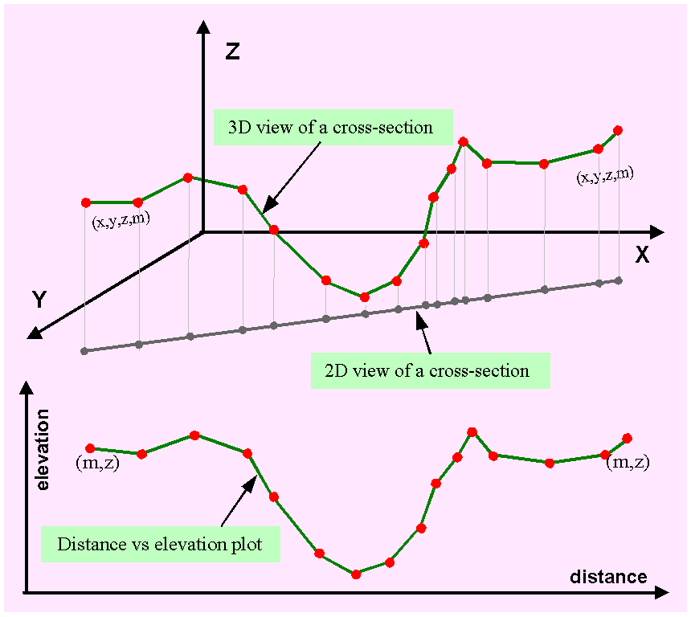
Three-dimensional view of a cross-section

In this data model the CrossSections are linear features that define the shape of the channel transverse to the direction of river flow. A CrossSection line has vertical measure (Z) and linear measure (M) values at each vertex. Vertical measure (Z) represents elevation of channel bottom with respect to a datum such as mean sea level. Linear measure (M) represents distance of each vertex along the cross-section. Usually distances are measured from the left end of a cross-section, where left is interpreted by looking in the downstream direction of flow in the channel.

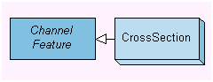
CrossSection is derived from ChannelFeature class

The basic attributes of a CrossSection are: CSCode, JunctionID, CSOrigin, and ProfileM.

CSCode is a user-defined cross-section identifier. This identifier is unique for each cross-section.

JunctionID of a cross-section identifies the HydroJunction at the equivalent hydrologic location as the cross-section even though the precise geographic location may vary slightly.

CSOrigin identifies the source of data and the method used to capture the shape of the cross-section. It may also include information on how a surveyed cross-section is transformed into a CrossSection polyline feature with linear measure (M) and elevation (Z) values. CSOrigin can be specified using a coded value domain such as: 3Dtype = 0, PolylineType = 1, LineType = 2, PointType = 3, and LocationType = 4.

ProfileM is the station value of a cross-section. The value of ProfileM is used to locate the position of the cross-section using linear measure (M) along a ProfileLine. Depending on the convention the station values are measured either from the upstream or downstream end. However, in this case the convention used for ProfileM has to be consistent with the direction of ProfileLine measure.

Additional attributes can be added to satisfy the specific requirement of an organization or a particular project. For example a DatumAdjustment attribute may store correction values that could be used to transfer elevations to a common datum before exporting to a river hydraulic model. A StructureCode will relate a hydraulic structure with the cross-section. Special notes regarding a cross-section such as ecological significance, accuracy of the measurement, or hydraulic condition of the channel at that location can be stored in a Remark field. These are not included as part of the basic ArcGIS Hydro Data Model but can easily be added by the user.

CrossSectionPoint
CrossSectionPoint stores traditionally surveyed cross-sections for which the (x,y) locations of the points are not known. A CrossSectionPoint is relationally connected using CSCode to a CrossSection line feature, which may just be drawn as a marker line across a channel if the station value is known.

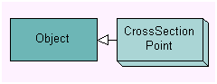
CrossSectionPoint is derived from ESRI Object class

The basic attributes of a CrossSectionPoint are: CSCode, CrossM, and Elevation.

CSCode is a user-defined cross-section identifier. This identifier is unique for each cross-section. This is the “key field” through which a CrossSectionPoint is connected to a CrossSection feature line.

CrossM denotes the location of a CrossSectionPoint along a cross-section at which the elevation is known.

Elevation stores the elevation of a CrossSectionPoint above a datum such as mean sea level.

While a single CrossSection line represents a cross-section, it requires several CrossSectionPoints to represent the geometry of a cross-section. Therefore, one-to-many (1-M) relationship exists between a CrossSection feature line and CrossSectionPoints. In order to avoid confusion, the elevation (Z) and measure (M) field values of a CrossSection feature line should be set to NaN (not a number) if the cross-section geometry is stored as CrossSectionPoints.

CrossSection Events
The geometry of a cross-section is not sufficient for most water resources applications. For instance, a river model for hydraulic simulations requires roughness values along a cross-section as well as the location of the left bank and the right bank. Cross-section properties like roughness values, land use type, zone type, and the locations of the left bank, right bank, thalweg, left floodplain, right floodplain, etc. can be stored in a table corresponding to measure values along a cross-section. If necessary, these locations (points) and a section of the cross-section (segments) can be displayed in GIS as “point events” and “line events” respectively using dynamic segmentation or linear referencing utilities.

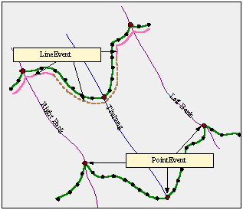
Cross-section properties as point and line events

It is imperative that all information associated with a cross-section, such as geometry and properties are linked together. This is achieved by maintaining a “key field” in the “tables”. By establishing a relation using the “key field” one can extract properties information from the property table for desired cross-sections.

The HydroEvent objects such as HydroPointEvents or HydroLineEvents or similar objects are used to define properties at particular points or along particular regions of the cross-section. Examples of these events are: location of left bank, channel roughness along a section, etc. The CSCode, instead of the ReachCode, should be used as the “primary key” to maintain relationship between a CrossSection and its events.

The location of a cross-section event alone is not very informative unless we know the type of the event and if applicable, the value of the property. Consider the line event that represents the change in channel bed roughness along a cross-section. We must know roughness values in order to make proper use of this information. However, it is almost impossible to make a comprehensive list of the types or properties and associated information and to make it a part of the basic model. Users can add additional attributes as necessary. For example a Substrate or Habitat specified along transects (cross-section) is essential for ecological studies. A Type attribute is useful to define the type of event, and the cross-section property values such as channel roughness could be stored in CSPValue.

ProfileLine
To determine the flow pattern through a river system it is necessary that we combine the geometries and properties of cross-sections with the channels they represent. It is also important to relate other features such as embankments and the extent of inundation with the main channel itself and see everything as an integrated system rather than as individual components. A longitudinal profile of a channel provides useful information regarding breaches or identifies the locations of possible over spilling. Historical flood extent information is very useful for checking the validity of a flood model. The longitudinal view of a channel is represented in the model as ProfileLines.

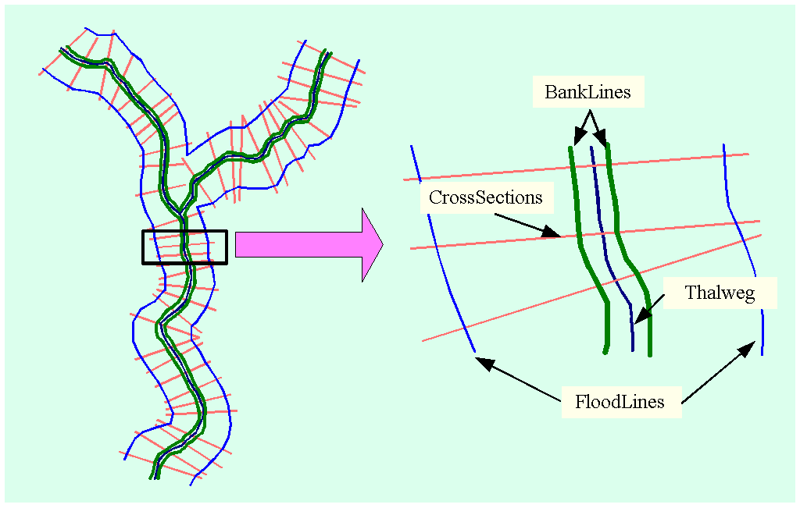
Features of a channel network

ProfileLines are linear features that define the longitudinal profile of the channel parallel to the direction of flow. Currently five different features of a channel are represented as ProfileLines. They include thalweg, left bank, right bank, left flood line, and right flood line. Left flood line and right flood line represent the extent of inundation in the left and right floodplains respectively.

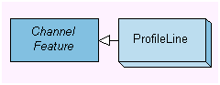
ProfileLine is derived from ChannelFeature class

In addition to the properties inherited from ChannelFeature class a ProfileLine has two more attributes. These attributes are: FType and ProfOrigin.

FType is the code specifying the feature represented by a ProfileLine.

ProfOrigin simply identifies the source of data and the method used to capture the shape of the ProfileLine.

Banklines can be digitized from high-resolution digital orthophotos or maps. Despite the fact that field surveying is expensive and time consuming it is not uncommon to survey the alignment of the embankments using GPS and other tools. An alternative approach could be to display the bank positions as events on cross-sections and then digitize bank lines by connecting those event points along the channel. A similar approach could be applied for floodlines. Historical records, satellite and radar images, simulation results of extreme events from river hydraulic models, etc. are valuable sources of inundation extent.

Depending on the scale of the map, it has become customary to represent narrow rivers by a single blue line whereas wide rivers are drawn as polygons filled in blue bounded by left and right banklines. Water bodies such as lakes are usually represented by polygons. However, in practice the schematic diagram of a river network is drawn using flowlines. A flowline is a line through the center of a channel reach or a water body, which defines the main direction of flow. Flow properties such as discharge, water surface elevation and constituent concentrations can be attached to locations on the flowline. Since the water by nature flows though the lowest points of the river, it is quite logical to use the thalweg line connecting thalwegs as the flowline. Therefore, the thalweg profilelines in this model also serve the purpose of flowlines. Once the linear measure values (m) are assigned from the network, the flow properties such as discharge, salinity level, etc. can be attached to a thalweg profileline. The thalweg profileline is then used to assign station measures to cross-sections.

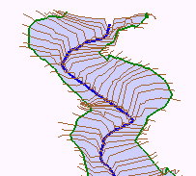
The thalweg line represents the flowline through channels

Deriving Channel Information

It goes without saying that the main purpose of a database is to store information. But the suitability and success of a data model largely depends on the ease and efficiency of the data retrieval process. In order to derive and export channel information one must be able to display all the features of a channel along with cross-section geometry and properties. It should also be possible to draw longitudinal profiles along a channel. Let us briefly examine how these tasks can be performed using this data model.

Displaying Channel Features
Since profilelines and crosssections are georeferenced feature layers, they are automatically overlayed in a GIS. For occasions where multiple representations of the same profile type exist in the database, the attribute ProfOrigin comes into play. For example, if a channel shifts through time, and these alignments are stored in the database, then each alignment has a different ProfOrigin. The user can then display embankments, cross-sections, etc. relevant to a particular channel alignment by selecting the features using ProfOrigin and the corresponding ReachCode. The channel geometry can also be displayed in 3-D perspective using 3-D cross-section lines.

Drawing Transverse and Longitudinal Profiles
In the data structure cross-section points of a CrossSection are defined by x, y, z, and m coordinates. As mentioned earlier the x, and y coordinates locate a cross-section point on the ground and z represents the elevation of the point with respect to a datum. The last coordinate m represents the linear measure of the point along the cross-section. Using the m and z coordinates from each point, a transverse profile or geometry of a cross-section can be drawn as a 2-D distance-elevation graph.

In the case of a traditionally surveyed cross-section, where the cross-section geometry is stored as CrossSectionPoints, drawing a transverse profile requires three steps. First of all the points are selected for a given CSCode. These points are then sorted on CrossM in ascending order. Finally the CrossM and Elevation values are used to draw a 2-D distance-elevation graph. Whether or not the points need to be sorted depends on the type of the graph used to plot the geometry.

If elevation values are not attached to the vertices of a ProfileLine, drawing the longitudinal profile of channel requires more work than a simple transverse profile. Let us consider that we want to draw a longitudinal profile of a thalweg. First of all the CrossSections that will provide elevations are selected using ReachCode. Then the lowest point of a cross-section is assumed as the thalweg. The elevation of the thalweg position is read from the elevation (z) field of the CrossSection 3-D line. Finally, the elevations are brought back to the ProfileLine and plotted with the stations of cross-sections. Longitudinal profile for banks or other features can be drawn in a similar manner. Bank and thalweg profiles are very important for determining the flow pattern and reaches where river water spills over into the floodplains.

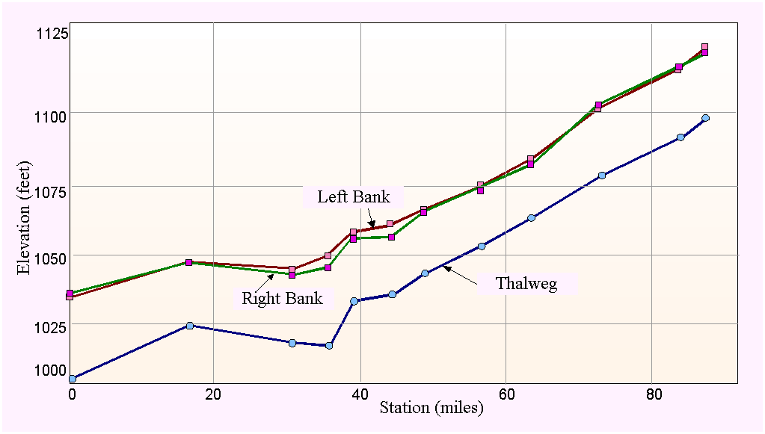
Longitudinal profiles along a channel

Getting Cross-Section Properties
Every CrossSection 3-D line has a unique CSCode and its properties in the event table are linked with it through this CSCode. The linear measure (m) coordinate of the cross-section points is used to determine a position based on the measure value stored in the event table. By treating the CrossSection as a “route” and the “event table” the property locations can be displayed as events of a cross-section using linear referencing.

Example of Creating a Cross-Section GeoDatabase

The previous sections have discussed different aspects of channel information and provided a conceptual description of a river channel data model. The following example illustrates how all of these are put together. The steps provided in this example demonstrate the key issues that are involved in the process.

Assume that a water resources consulting company is anticipating a project and decides to create a cross-section database using the ArcGIS Hydro data model. The company wants to concentrate on a portion of the river network system in the Waller Creek watershed in Austin, Texas. The river system includes Upstream and Downstream reaches of the Main channel and a single reach of the channel Branch. The company has also collected a digital terrain model and a digital image of the watershed for this purpose.

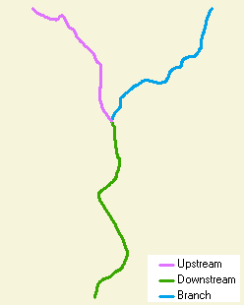
Waller Creek watershed river system

As the GIS specialist of that company you could follow these steps in order to complete your project. This example assumes that you already have a geodatabase created based on the ArcGIS Hydro data model and one trying to put channel information in it. It also assumes that you have built-in tools at your disposal to perform each task.

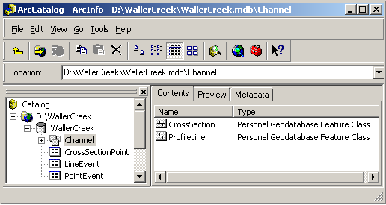
Cross-section geodatabase for Waller Creek watershed

Exploring Input Data
The digital image of the Waller Creek watershed shows the alignment of the river network including banks, building and other spatial features. This can be used as a background for digitizing profilelines and cross-section cutlines.

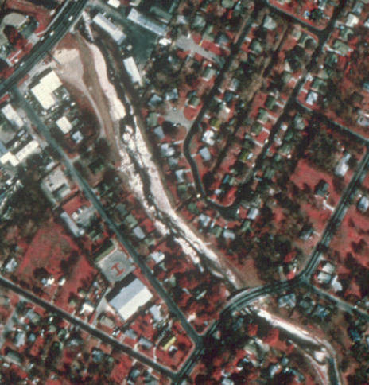
Digital image of Waller Creek watershed

The digital terrain model is a TIN, which has been created from interpretation of aerial photogrammetry using mass points and breaklines. The TIN represents the topography of the watershed and is the source of ground elevations for cross-sections and profile lines. In this example, elevations for cross-sections are extracted from the TIN.

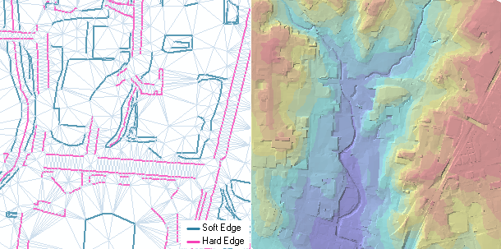
Digital terrain model (DTM) of Waller Creek watershed

Defining ProfileLines
The required profilelines that must be digitized are: flowline or thalweg, banklines, and floodlines. Display the image in the background and digitize lines following the center of Main and Branch rivers. This task is done best by careful examination of a digital orthophoto of the channel. For simplicity, let us assume that the line you have digitized is the thalweg. To be consistent with the profileline value domain as specified in the model you should assign a type value of 1 for these lines. Then you digitize left and right bank lines. You should also assign a unique ReachCode for each branch and its associated banks and flood lines.

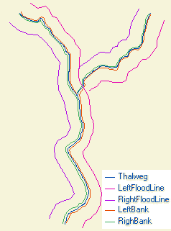
Digitized ProfileLines

The flood lines are intended to show where the water will flow when the channel overflows its banks. A simple way to locate them is to buffer the thalweg line by an arbitrary distance. However, in a river whose main channel has wide meanders through a broad river valley, the floodlines should follow the direction of the river valley not the main channel.

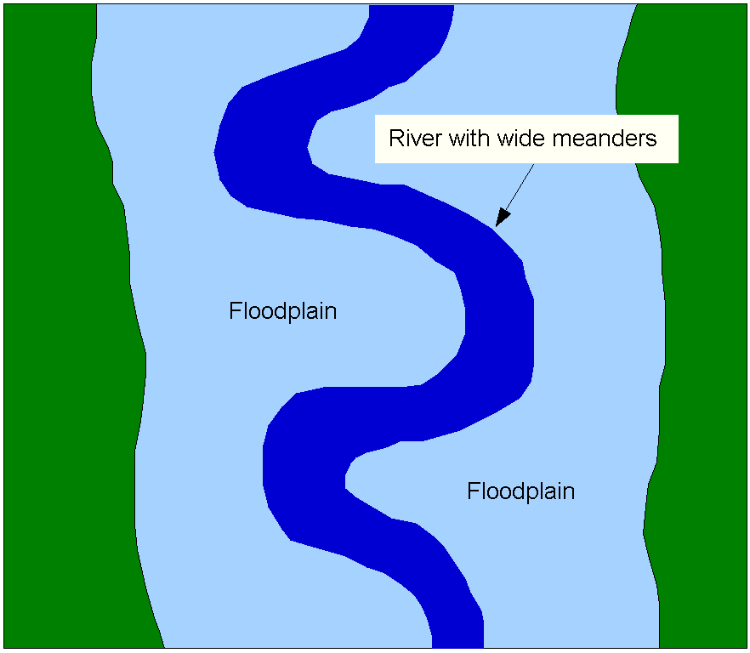
Floodlines follow the direction of river valley in the case of a wide meandering river

Defining Cross-Section Cutlines
The purpose of the cross-sections is to define channel geometry. You can digitize as many cross-sections as are necessary. As a guideline, you can have widely spaced cross-sections in a straight reach but may prefer to add more around bends to capture the changes in geometry. The floodlines help to decide the extent of cross-sections over floodplains. Cross-sections should have a unique CSCode and the ReachCode from the branch they are representing. Once you are done with digitizing cross-sections, the features in the database should look similar to the following figure.

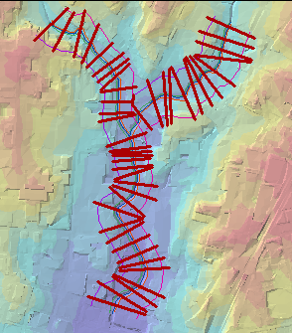
Cross-section cutlines and profilelines

Extracting Elevations from the TIN
ArcInfo provides utilities to extract elevations from a surface using features. Specify the TIN as a surface and use cross-section cutlines and profilelines to extract ground elevations from the surface. The tool assigns z value to each vertex and thus converts two-dimensional lines into three-dimensional lines.

Assigning Measures to Linear Features
In this step you will add the linear measure value (m) at each vertex using linear referencing. You can either compute m values from x, y coordinates or you can assign those values interactively. In the case of a cross-section, the measure (m) values are consistent with its length and therefore, it would be easier to let the system compute m values for you. On the other hand, for rivers and embankments the actual length or the stationing may vary from the length of the feature you have digitized. In that case, assigning m values interactively at critical points might be more appropriate.

Creating Cross-Section Events
Once you have assigned measure values to cross-sections, you can determine the position of any property point along the cross-section. On the other hand if you know the measure value of a property point, you can locate that position on the cross-section using linear referencing. Now it is time to create cross-section events, which are similar to HydroEvents. You can create a point events table to store the location of the thalweg, banklines and floodlines and a line event table to store properties like channel roughness. The CSCodes of the events should match with the CSCodes of the cross-sections they are on. The event tables may look similar to the following figures.

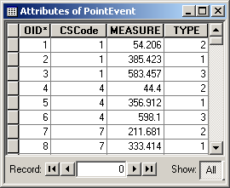
Example of a point event table

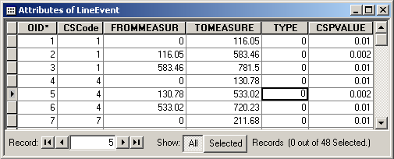
Example of a line event table

Retrieving Data from the Database
Finally it is time to retrieve the channel information from the geodatabase. Using all these CrossSections you can display the channel morphology by creating a perspective view in three-dimension.

Three-dimensional view of Waller Creek river system

You can display the shape of a cross-section or plot any profile along a profileline (thalweg, banks, and floodlines) using measure and elevation values.

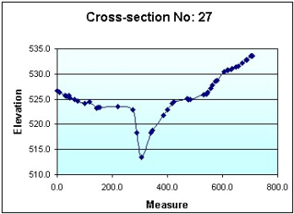
Geometry of a cross-section

By taking the advantage of linear referencing and event tables, you can also display point and linear events along cross-sections.

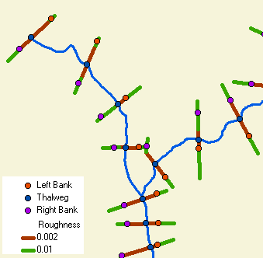
Displaying cross-section properties from an event table

Other Sources of Cross-Section Data

So far we have discussed extracting cross-sections from digital terrain models (DTMs) in a GIS or by surveying cross-section as a series of xyz points using traditional methods or advanced surveying tools like GPS. But cross-sections have been surveyed and used in water resources analysis for decades prior to the advent of computer based GIS or even river hydraulic models. These cross-sections are extremely valuable for the study of river morphology or for simulating historical events. This section briefly introduces some of these data sources and discusses how these data can help to improve the channel shape representation extracted from DTMs.

Historic Drawings
Traditionally cross-sections were presented and stored in the form of drawings prepared by draftpersons based on survey information. Many water resources related organizations have archived a lot of historical information in this form. In order to bring these data into this model, these drawing must be transferred into distance-elevation formats. Transferring such data is time consuming and may not be cost effective for many projects if the corresponding stationing of the cross-section along the river is only known approximately.

Cross-Section Files from Hydraulic Models
Another important source of cross-section data are the hydraulic models themselves. The cross-section information is stored either as an integrated part of a model or as input file to a model. However, in both cases, cross-section geometries are most likely stored in a distance-elevation format with reach name and station as identification.

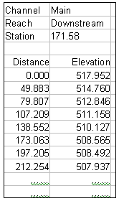
Cross-section data file prepared for a hydraulic model

The main advantage is that this cross-section information is in digital format. Using linear referencing and other utilities available in GIS, these cross-sections can be imported into the ArcGIS Hydro data model with reasonable effort.

Improving Channel Shape Representation
Currently the digital terrain models (DTMs) or digital elevation models (DEMs) available from different organizations usually depict the general land surface topography of a watershed. Because of the lower resolutions these DTMs fail to provide very detailed information, which is acceptable and probably desired for most river channel applications. However, it is not the case for cross-section extraction from DTMs. A DTM provides sufficient information on the floodplain but does a poor job in the river. However, a surveyed cross-section represents the main channel shape much better but it typically does not cover a considerable length over the floodplain. These two data sources, if combined appropriately, can improve channel shape representation significantly.

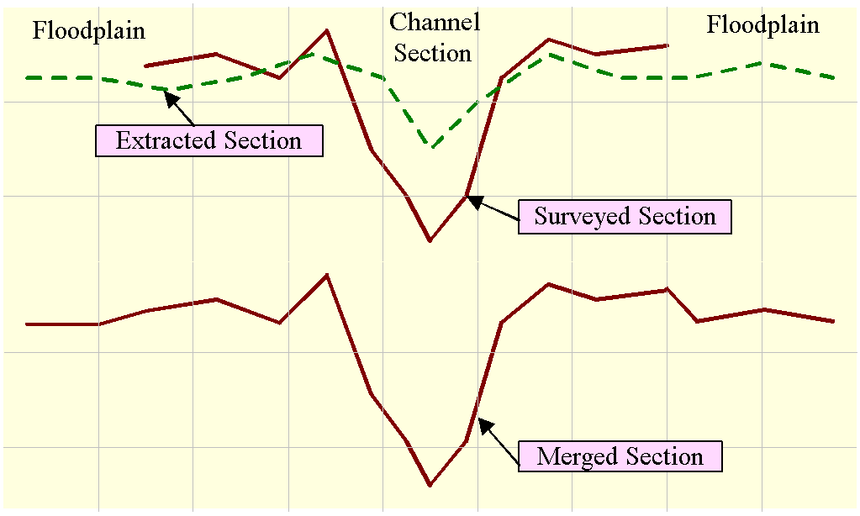
Combination of surveyed and extracted cross-sections provides a better channel representation

Data Model Object Diagram for Channel Representation



